PROJECT 3 - CATCH THE IMPOSTER:
Anomaly Detection over the Shepherd's Gate Health Cooperative Authentication Log
Author: Sareena Challuri
Course: System Administration & Maintenance
Repository: https://github.com/srujanachalluri/SystemAdministartion/tree/main/CatchTheImposter

1. The System and the Data:
Shepherd's Gate Health Cooperative runs three clinics, a billing office, and a small IT team. Every login, file access, and role change is written to an authentication log (code/auth_events.csv).
There is answer key (code/ground_truth.csv) that marks which events are real attacks and log file.
Command I ran:
Result / Screenshot:
head -6 code/auth_events.csv
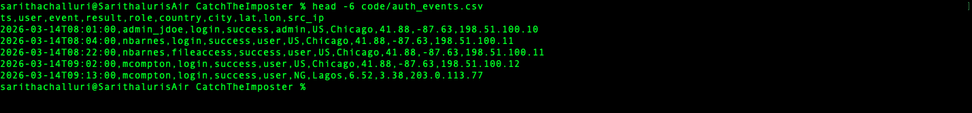
cat code/ground_truth.csv
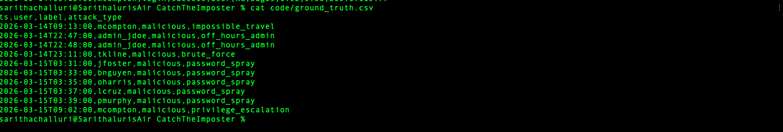

2. Reading the Log File:
The first thing my program does is read the log into a clean structure. Real log files always have some broken lines (we need to do preprocessing to get better results), so I built a parser code which is used to skip bad rows and keep going instead of crashing.
I tested it by adding two broken lines to a copy of the log:
Command I ran:
cp code/auth_events.csv /tmp/test.csv
printf 'this,is,a,broken,line\n2026-03-14T99:99:99,x,login,success,user,US,C,1,2,1.1.1.1\n' >> /tmp/test.csv
python3 catch.py /tmp/test.csv
Result: It says "skipped 2 malformed line(s)" and still runs - it does not crash.
Result / Screenshot:
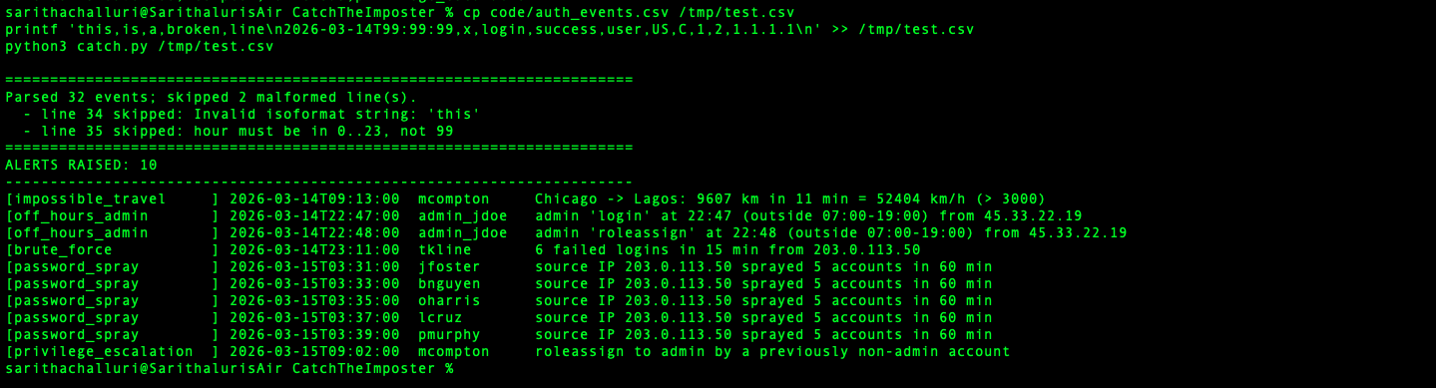

3. Authentication vs. Authorization
These are two different ones:
- Authentication asks ‘are you really you?’ A failure looks like a wrong password (result=failure) or a login from a place the real person could not be able to do.
- Authorization is like asking ‘are you allowed to do this?’ A failure looks like an account gaining powers it should not have or using admin powers at a strange time.

Command I ran:
grep failure code/auth_events.csv
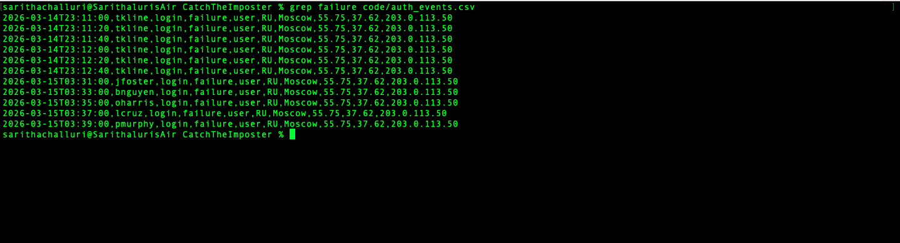
grep roleassign code/auth_events.csv
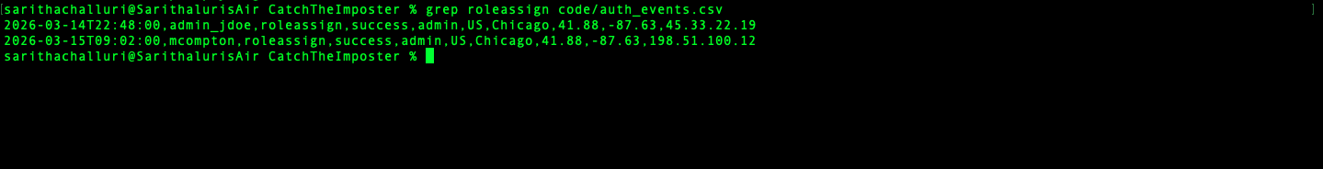

4. The Detectors:
Every detector is having a simple rule :
For detection, I used config.json so I can adjust the fields like (speed limit, business hours ect..,)

4.1 Impossible Travel:
For each user, I compare each successful login to their previous one. I measure the real distance between the two cities (using the round-Earth 'haversine' formula) and divide by the hours in between to get an implied travel speed. If that speed is impossibly high, the same account is being used from two places at once.
Command I ran:
python3 -c "import catch; e,_=catch.parse_log('code/auth_events.csv'); [print(a['user'], a['detail']) for a in catch.detect_impossible_travel(e, 3000)]"
Result / Screenshot:

4.2 Off-Hours Admin
Admins are expected to work between 07:00 and 19:00. Any admin activity outside those hours get notified as a malicious activity, except accounts on my allow-list (like backup, the automatic backup job that legitimately runs at 2 a.m. by taking downtime).
Command I ran:
python3 -c "import catch; e,_=catch.parse_log('code/auth_events.csv'); [print(a['user'], a['detail']) for a in catch.detect_off_hours_admin(e, 7, 19, ['svc_backup'])]"
Result / Screenshot:

4.3 Brute Force
I group failed logins by account. If one account gets five or more failures inside a 15-minute window, I wrote code to identify someone is hammering that one password. I report it once, at the first failure.
Command I ran:
python3 -c "import catch; e,_=catch.parse_log('code/auth_events.csv'); [print(a['user'], a['detail']) for a in catch.detect_brute_force(e, 5, 15)]"
Result / Screenshot:

4.4 Password Spray
This is the mirror image of brute force. I group failed logins by the source IP address. If one IP fails against five or more different accounts in a 60-minute window (a few tries each, not many against one), that's a spray - the attacker is trying one common password across everyone.
Command I ran:
python3 -c "import catch; e,_=catch.parse_log('code/auth_events.csv'); [print(a['user'], a['detail']) for a in catch.detect_password_spray(e, 5, 60)]"
Result / Screenshot:
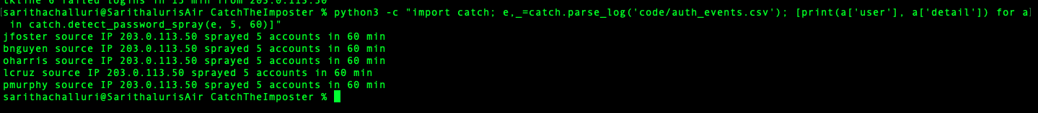

4.5 Privilege Escalation:
I keep track of each account's role over time. If an account that was never an admin suddenly grants itself the admin role, I flag it.
Command I ran:
python3 -c "import catch; e,_=catch.parse_log('code/auth_events.csv'); [print(a['user'], a['detail']) for a in catch.detect_privilege_escalation(e)]"
Result / Screenshot:
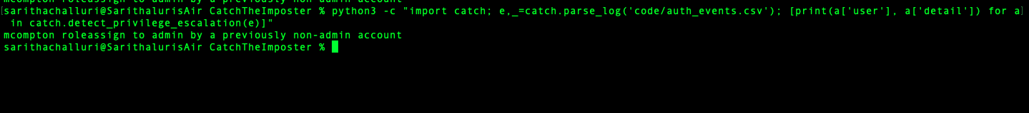

5. The Judgment Call: Tuning Impossible Travel
At the default speed limit of 900 km/h, written code flagged two users:
- mcompton - Chicago to Lagos, 9,607 km in 11 minutes = 52,404 km/h.
This is a real stolen account (it's in the answer key).
- vp_kpatel - Denver to Chicago, 1,478 km in 40 minutes = 2,216 km/h.
This is NOT in the answer key - it's a normal user(legitimate), so flagging it would be a false alarm.
My decision: I set the speed limit to 3,000 km/h. Location data can be a little off for normal users in the same country, so 3,000 is high enough to leave vp_kpatel alone.
Command I ran:
python3 code/impossible_travel.py code/auth_events.csv --threshold-kmh 900
python3 code/impossible_travel.py code/auth_events.csv --threshold-kmh 3000
Result / Screenshot:
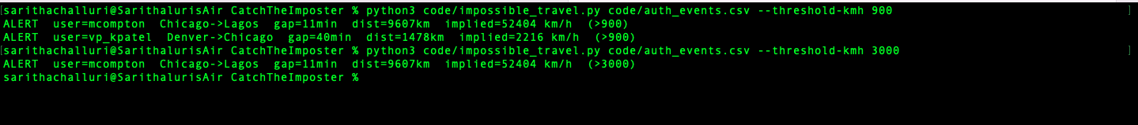

6. Results
Running the full program against the log and scoring it against the answer key:
Events parsed: 32
Correct catches: 10
False positives: 0
Alerts raised: 10
Precision score: 1.0
Recall score: 1.0
I report precision and recall, not ‘accuracy.’
When attacks are rare, a detector that flags nothing would still look ‘accurate’ while catching nothing.
Precision (how many of my alarms were real) and recall (how many real attacks I caught) are the honest measures.
Command I ran:
python3 catch.py code/auth_events.csv --truth code/ground_truth.csv
Result / Screenshot:
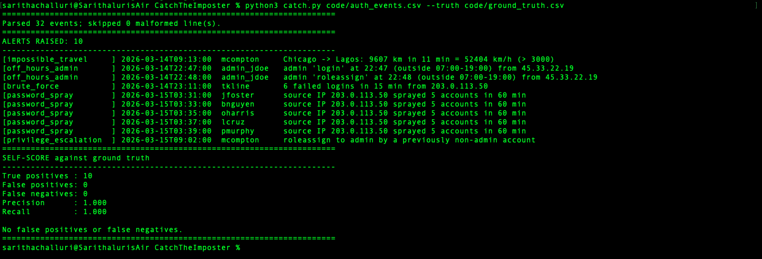

7. Defending Against the Threat:
My detector catches an account being misused, but the deepfake fraud that inspired this project skips the login completely, it fakes a trusted person to approve an action.

Phishing:
- Use passkeys (hardware security keys) for all admin accounts. These are tied to the real website, so a fake login page or deepfake can't steal and reuse them
- Stop using text-message and email codes for admins, those can be intercepted or talked out of people.

Out-of-band verification:
- Any big action (money transfer, granting admin, changing a vendor's bank details) must be confirmed and verifies by like calling back a known phone number, not replying to the request.
- Make it a rule that no big action is ever approved on a video or voice call alone. The face can be fake; a callback to a number you already trust cannot be faked by the attacker.

8. How to Reproduce
From the repository folder:
python3 catch.py code/auth_events.csv --truth code/ground_truth.csv
All the settings and the allow-list are in config.json.

9. AI Usage Disclosure
- I used an AI assistant Chat GPT to know the haversine distance formula and to check my precision/recall reasoning after I drafted the code.
- For code writing syntax and to get basic idea, I used some other resources (w3 schools).

