REPORT - Final Project (Capstone)
Architect the 2030 Organization
Project 14 | Chapter 16 - The AI-Native Enterprise
Course: System Administration and Maintenance
Student: Sareena Challuri Date: 08/14/2026
Repository: https://github.com/srujanachalluri/SystemAdministartion (folder: 16-ai-native-capstone)
________________________________________________________________________________________________
PART 1 - EXECUTIVE SUMMARY (the one page the board reads)
Cornerstone Relief International is a 600-person Christian relief organisation with a nine-person HQ IT team, offices on four continents, and a board mandate with two halves: use AI to do far more with nine people, and never again put the people we serve at the mercy of a tool we did not govern. This submission is the architecture that team will run on.
The design
TWO SERVING LANES ON ONE CONTROL PLANE. A self-hosted lane, with no route to the internet, serves the case-note assistant that reads beneficiaries' names, locations and medical details. A commercial API lane serves staff productivity and operations, where no restricted data is ever permitted. Above both sits one identity plane; beneath both, one OpenTelemetry and WORM-audit backbone; across both, a written autonomy ladder that states what a machine may do without asking a human.
Three decisions the board should know it has made
- SELF-HOSTING THE CASE-NOTE MODEL COSTS US$70,320 PER YEAR MORE THAN the commercial alternative - about 0.6 of a field post. It is not a cost decision; it buys residency and verifiable deletion for data about vulnerable people. The full arithmetic is in cost-analysis.txt and the argument is in decision-memo.docx.
- AUTONOMY IS GRANTED BY NAME, NOT BY DEFAULT. Ten operational actions sit on four rungs. Restarting a stateless pod is automatic. Rotating a credential requires out-of-band verification. Deleting beneficiary data, changing payment details, touching logging or backup, or contacting a beneficiary can never be automated - there is no promotion path. Turning autonomy up needs a signature; turning it down needs nothing, and any of the nine may pull the kill switch.
- THE THREE INCIDENTS FROM LAST YEAR EACH HAVE A NAMED CONTROL. The US$240,000 deepfake: out-of-band wire verification on a channel the caller cannot own. The ransomware weekend: five-zone segmentation plus an immutable backup copy in an account no production identity can reach, restore-tested quarterly. The chatbot paste: egress DLP and blocked consumer chatbot domains - together with a sanctioned internal assistant in the same click, because blocking without providing just creates shadow IT.
The deliverable set
File | What it is
architecture.docx | Document 1 - two-lane design, the organ table with both halves filled, request walkthrough, trust boundaries
ai-strategy.txt | Document 2 - what CRI uses AI for, what it runs, model tiers, refused uses, build-vs-buy-vs-self-host
automation-plan.txt | Document 3 - AIOps design and the autonomy ladder, ten actions across four rungs
security-plan.txt | Document 4 - traditional controls plus OWASP LLM Top 10 to MITRE ATLAS, and the indirect prompt-injection kill chain
cost-analysis.txt | Document 5 - VRAM and KV-cache sizing, three scenarios, the crossover, and a utilisation sensitivity table
governance.txt | Document 6 - the ten-row control set and the EU AI Act Art. 14 / Art. 12 / NIST RMF mapping
decision-memo.docx | Hard tier - the architect's judgment to the board, with the conditions that would reverse it
agent-log.txt | Required - every task delegated to the agent, what it produced, where it was wrong, and where the architect intervened
code/ | The four adapted reference configs
Where the judgment lives
The agent decides how. The autonomy ladder decides whether. When an automated action causes harm, the accountable person is the human named on that action's row - which is why the names are written into the YAML rather than left to an org chart.

PART 2 - VERIFICATION LOG (commands run in GitHub Codespaces)
Every command below was run in the GitHub Codespace for the repository. Run each one, then paste the terminal output (or a screenshot) into the red placeholder underneath it.
HOW TO FILL THIS IN: run the command, select the output in the Codespaces terminal, copy it, then click the red [ ... ] block below and paste over it. Set the pasted text to Consolas 9pt so it stays readable.
Step 1. Confirm the environment and the repository
Why this step: Establishes that the work was done in the GitHub Codespace and shows which repository it was committed to.
Command:
cd /workspaces/SystemAdministartion
pwd
git --version
python3 --version
git remote -v
Output:
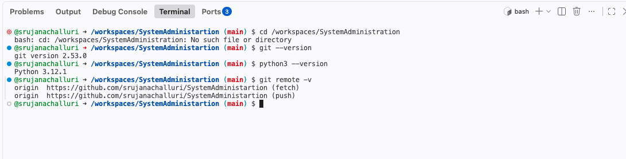
Screenshot: results/step-01-environment.png
Step 2. Show the project structure
Why this step: Shows the full deliverable set: the six documents, the reference configs, REPORT.docx and agent-log.txt.
Command:
cd /workspaces/SystemAdministartion/16-ai-native-capstone
ls -R
find . -type f | sort
Output:
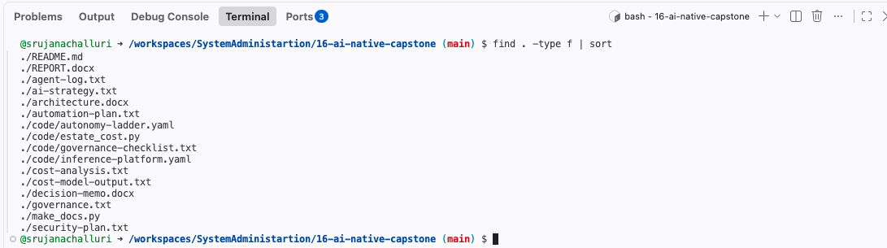
Screenshot: results/step-02-structure.png
Step 3. Validate the two YAML configs actually parse
Why this step: A config that does not parse is not a config. This proves both adapted files are valid YAML and reports what is in them.
Command:
cd /workspaces/SystemAdministartion/16-ai-native-capstone
pip install --quiet pyyaml python-docx
python3 -c "import yaml,sys; d=yaml.safe_load(open('code/autonomy-ladder.yaml')); print('autonomy-ladder.yaml OK -', len(d['actions']), 'actions,', len(d['never_automate']['actions']), 'never-automate entries')"
python3 -c "import yaml; d=yaml.safe_load(open('code/inference-platform.yaml')); print('inference-platform.yaml OK - lanes:', [k for k in d['platform'] if k.startswith('lane')])"
Output:
Screenshot: results/step-03a-install.png
Screenshot: results/step-03b-autonomy-ladder.png
Screenshot: results/step-03c-inference-platform.png
Step 4. Prove every autonomy rung is populated and every action has an owner
Why this step: The rubric requires at least one action on each of observe / recommend / approve / act, and a named human on every governed row. This checks it mechanically instead of asserting it.
Command:
cd /workspaces/SystemAdministartion/16-ai-native-capstone
python3 - <<'PY'
import yaml
d = yaml.safe_load(open('code/autonomy-ladder.yaml'))
tiers = {}
for a in d['actions']:
tiers.setdefault(a['tier'], []).append(a['name'])
for t in ['observe','recommend','approve','act']:
print(f"{t:10s} {len(tiers.get(t,[]))} action(s): {', '.join(tiers.get(t,[]))}")
missing = [a['name'] for a in d['actions'] if not a.get('owner')]
print('actions with no named owner:', missing or 'NONE')
PY
Output:
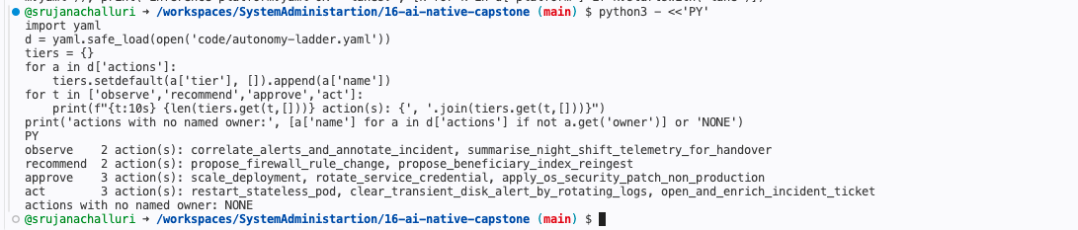
Screenshot: results/step-04-rungs-and-owners.png
Step 5. Run the cost and sizing model
Why this step: Produces the VRAM sizing with the KV-cache term, the three growth scenarios, the self-host-vs-API crossover, and the utilisation sensitivity table. These are the numbers quoted in cost-analysis.txt and decision-memo.docx.
Command:
cd /workspaces/SystemAdministartion/16-ai-native-capstone
python3 code/estate_cost.py
Output:
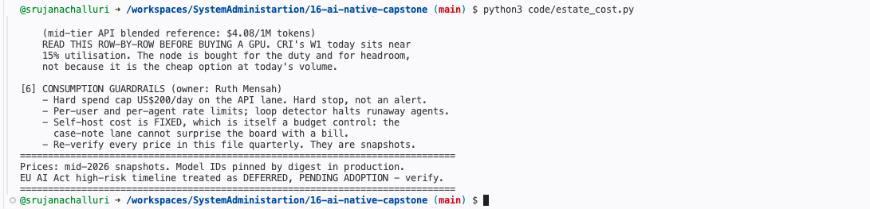
Screenshot: results/step-05-cost-model.png
Step 6. Save the model output into the repository as evidence
Why this step: The grader can see the exact figures the documents rely on without having to run anything.
Command:
cd /workspaces/SystemAdministartion/16-ai-native-capstone
python3 code/estate_cost.py > cost-model-output.txt
head -20 cost-model-output.txt
wc -l cost-model-output.txt
Output:
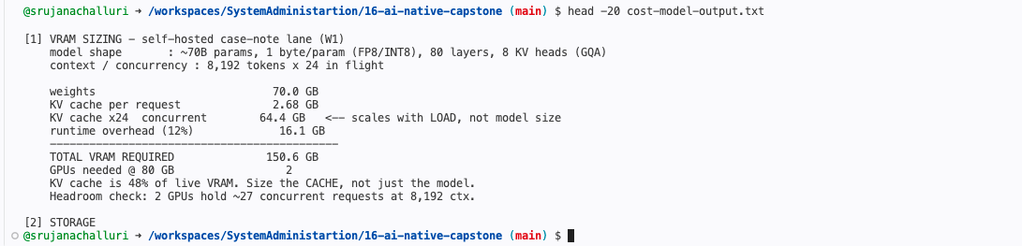
Screenshot: results/step-06a-output-head.png
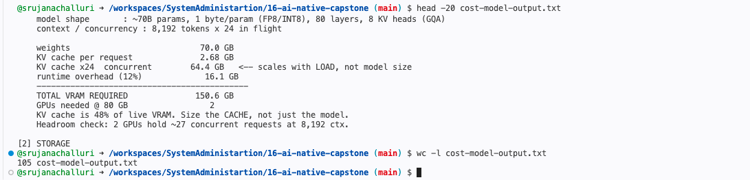
Screenshot: results/step-06b-output-wc.png
Step 7. Check that every named owner actually appears in the document set
Why this step: "A control without a controller is decoration." This shows all nine people own something, and where.
Command:
cd /workspaces/SystemAdministartion/16-ai-native-capstone
for n in Adeyemi Okoro Raman Santos Kim Weber Bello Mensah Novak; do
printf '%-10s %s\n' "$n" "$(grep -ril "$n" . | tr '\n' ' ')"
done
Output:
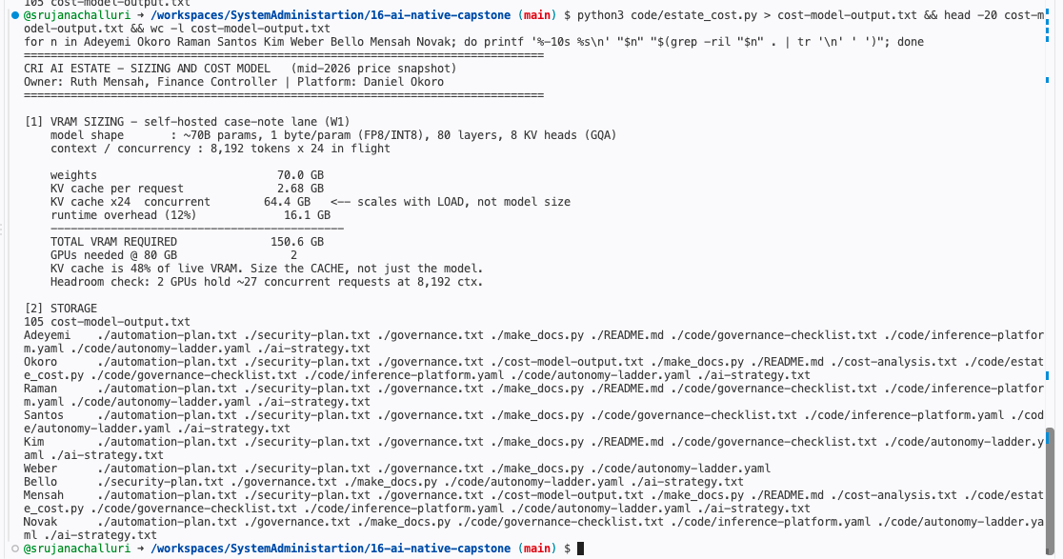
Screenshot: results/step-07-owner-coverage.png
Step 8. Generate the three Word documents
Why this step: architecture.docx, decision-memo.docx and REPORT.docx are generated from the same source of truth as the configs, so the document set can be rebuilt from a clean checkout and cannot silently drift.
Command:
cd /workspaces/SystemAdministartion/16-ai-native-capstone
pip install --quiet python-docx
python3 make_docs.py
ls -lh *.docx
Output:
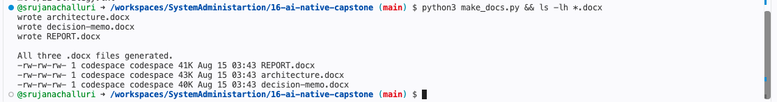
Screenshot: results/step-08-generate-docx.png
Step 9. Commit the work
Why this step: Shows the deliverables entering version control as one reviewable change.
Command:
cd /workspaces/SystemAdministartion
git add 16-ai-native-capstone
git status
git commit -m "Final project: AI-native architecture for CRI (Project 14)"
Step 10. Push and confirm
Why this step: Confirms the public repository the professor will open actually contains the submission.
Command:
cd /workspaces/SystemAdministartion
git push origin main
git log --oneline -5

