Project 9 Ask Your Logs

1. Summary:
Faith Resources had a 90-second checkout outage at 14:05. This project stands up a real observability stack (Prometheus + Grafana + OpenSearch), reproduces that incident from the logs, and adds a natural-language query layer so I can ASK the logs instead of grepping them by hand.
Findings in short, after running the real commands placed all the screenshots below:
- SYMPTOM: the checkout service aborted with reason payment declined for three users.
- ROOT CAUSE: the payments service could not authorize because the upstream provider (stripe) timed out HTTP 504, ~5-second latency.
- PROOF: each 'checkout aborted' line shares its trace_id with payments authorize failed line.
- Affected users: u-4419, u-4420, u-4422. The system recovered on its own by 14:07.

2. Step 1 Bring Up the Stack (all four UIs are healthy)
Start the observability stack with Docker Compose:
docker compose -f docker-compose.observability.yml up -d
docker compose -f docker-compose.observability.yml ps
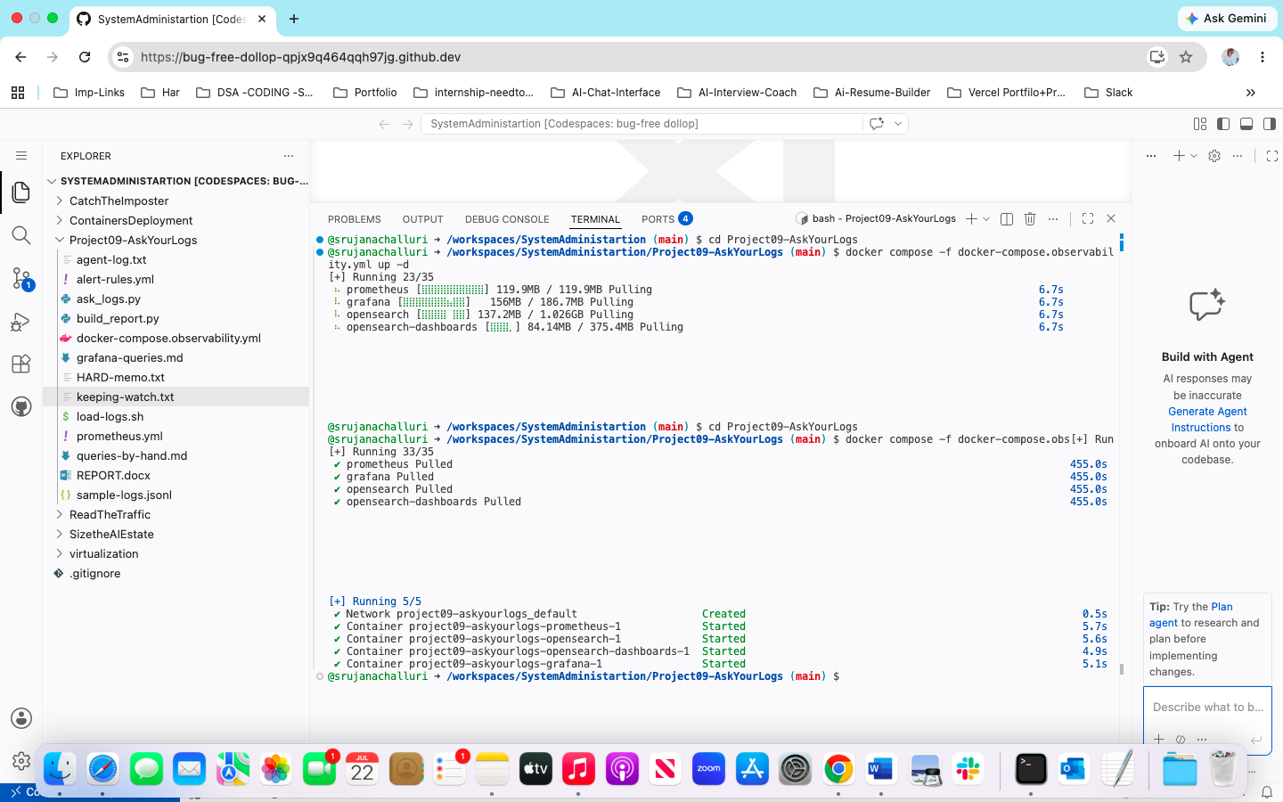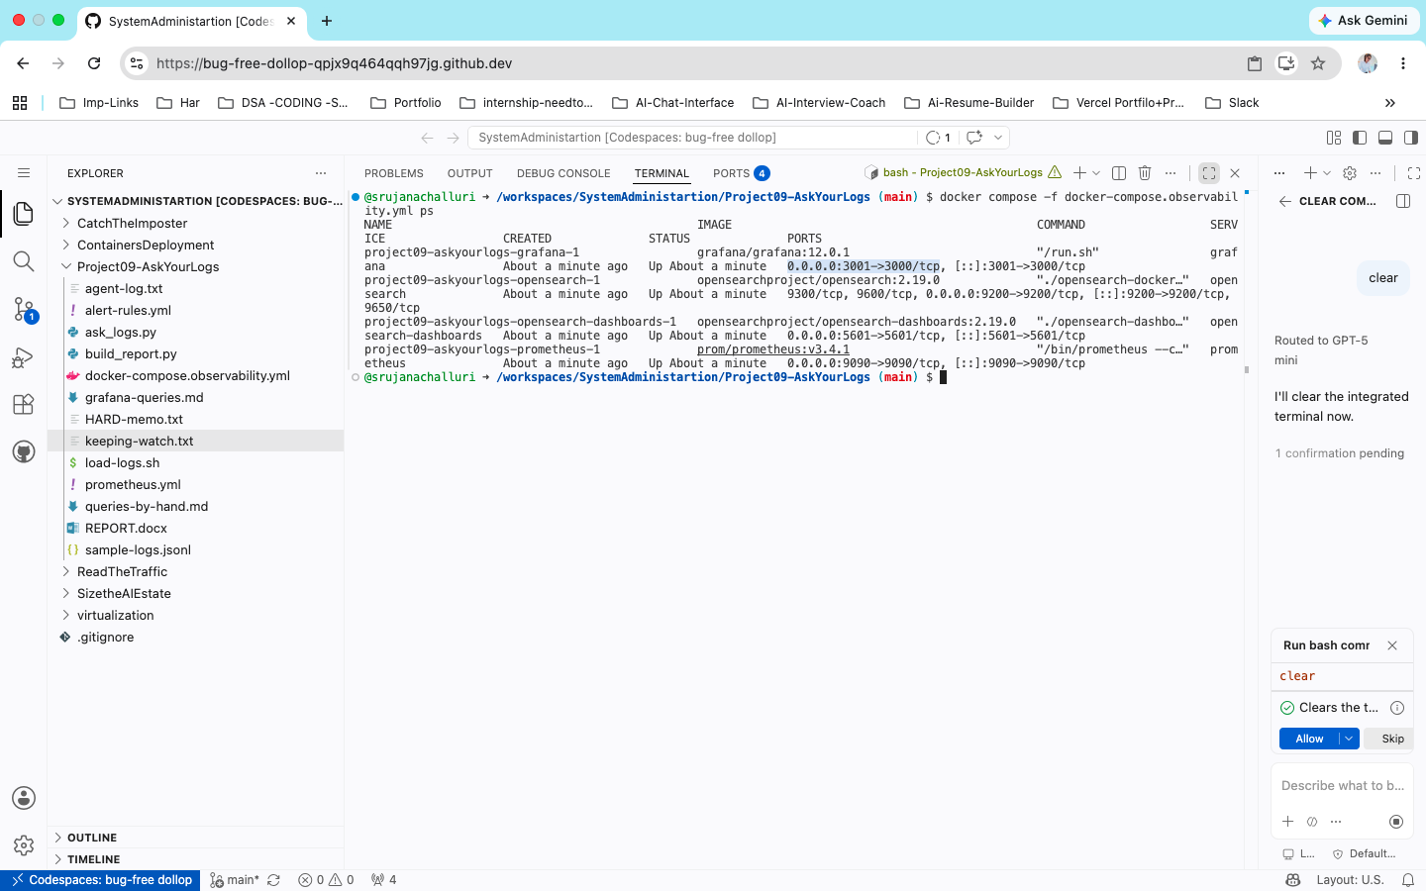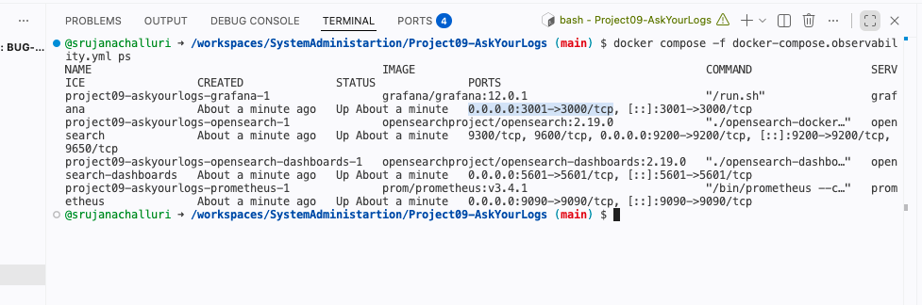
Confirm all four UIs respond. In a Codespace, open each forwarded port
- Prometheus -> http://localhost:9090 (Status Targets)
- Grafana -> http://localhost:3001 (login admin / admin)
- OpenSearch -> http://localhost:9200 (returns cluster JSON)
- OpenSearch Dashboards -> http://localhost:5601

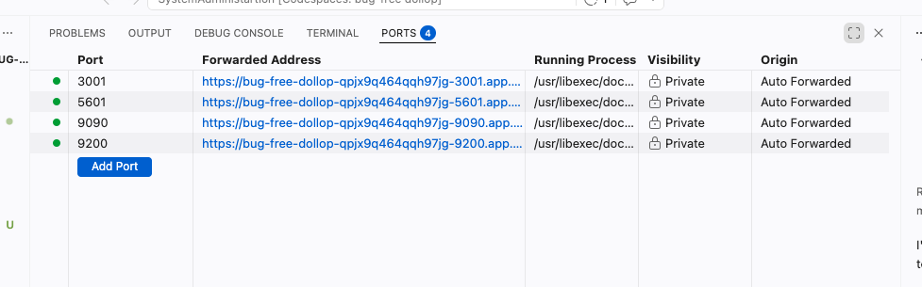
Quick health check from the terminal:
curl -s http://localhost:9090/-/healthy
curl -s http://localhost:9200 | head -20
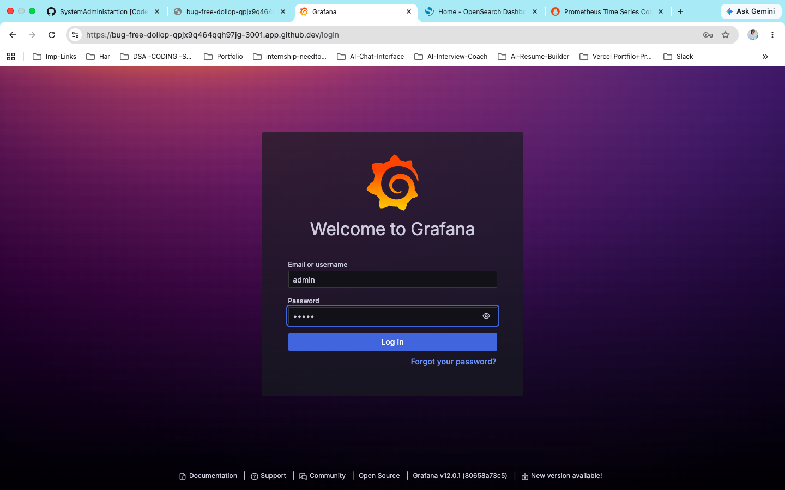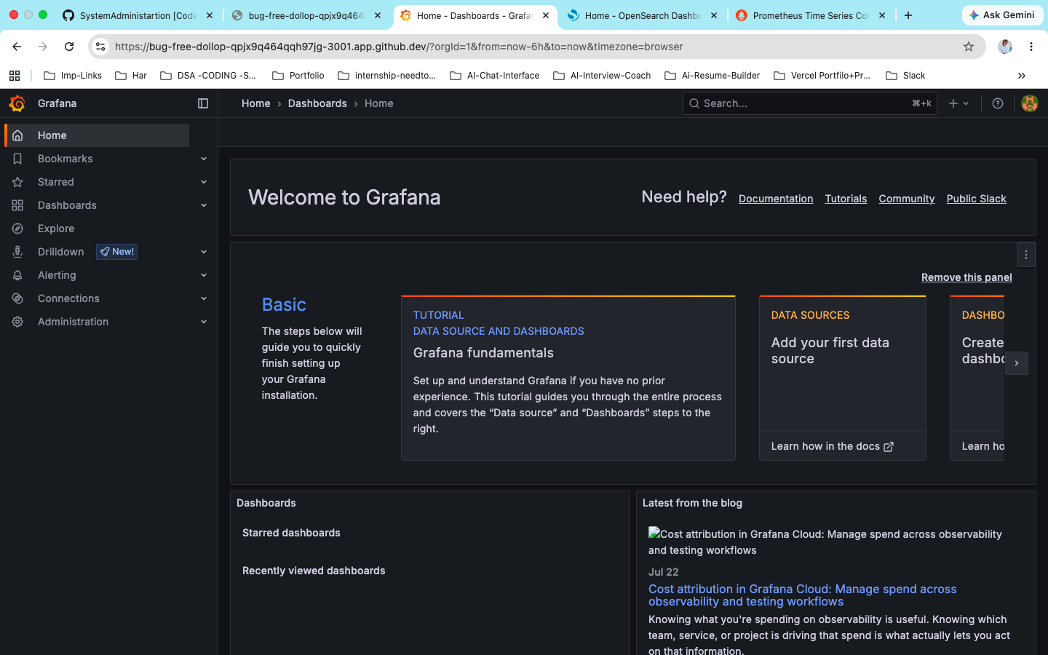
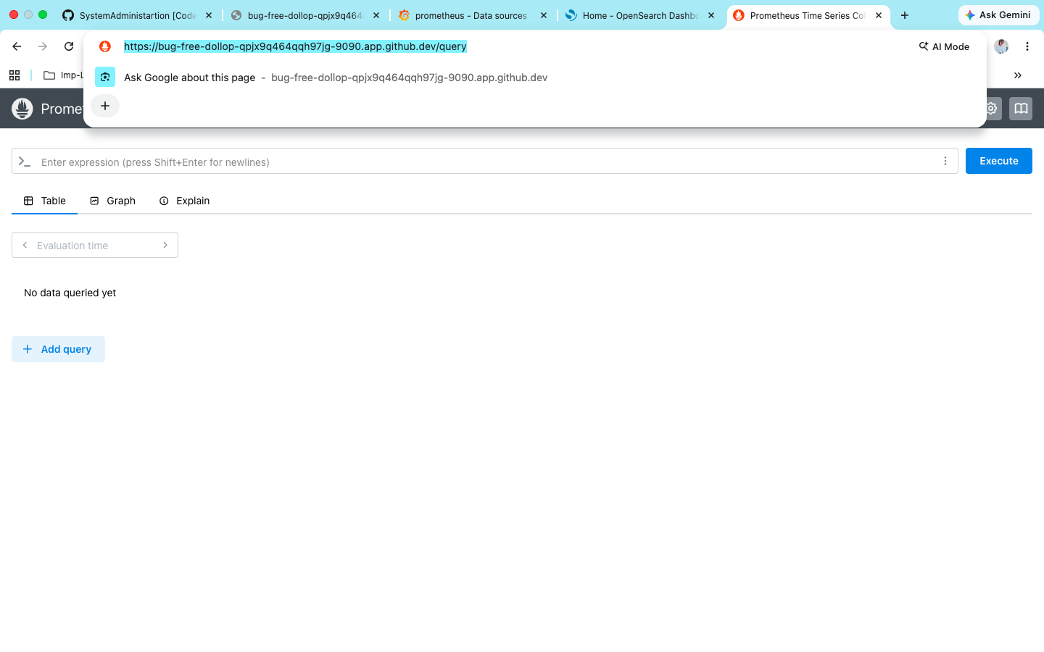

3. Step 2 Load the Logs (verify 14 documents):
Load sample-logs.jsonl into OpenSearch with the _bulk recipe and verify the document count:
chmod +x load-logs.sh
./load-logs.sh

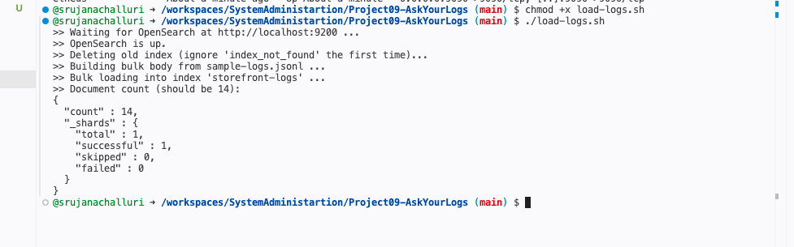

4. Step 3 Grafana: p95 Latency + Error-Ratio Panels
Add Prometheus as a data source in Grafana (URL http://prometheus:9090), then build two panels.

Panel 1 : p95 latency
histogram_quantile(0.95, sum(rate(prometheus_http_request_duration_seconds_bucket[5m])) by (le))
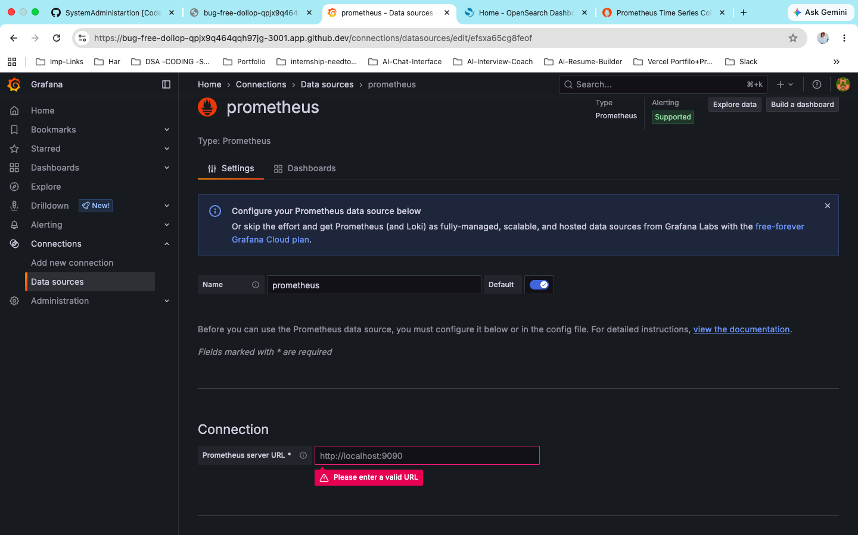
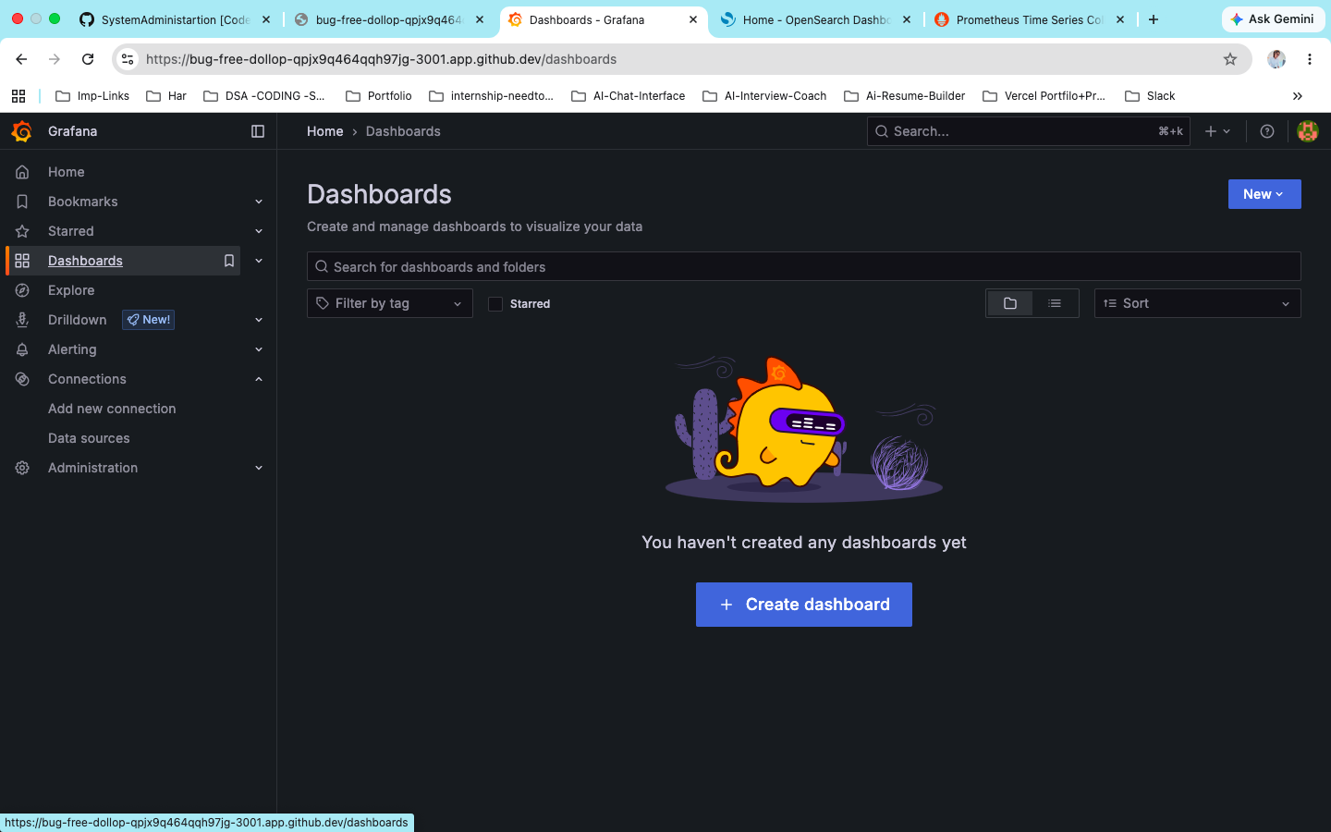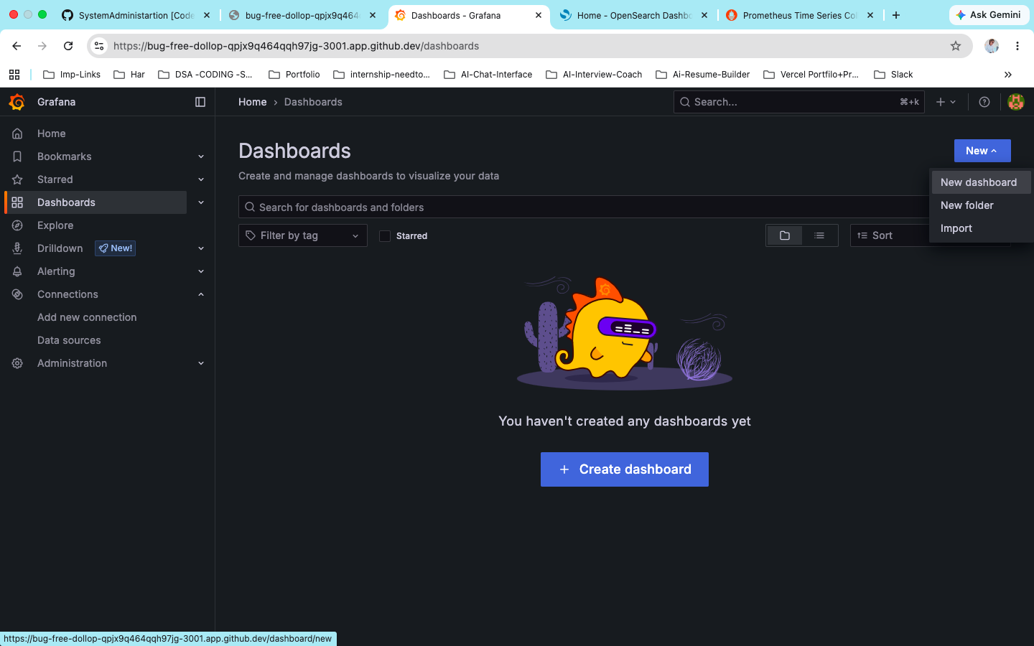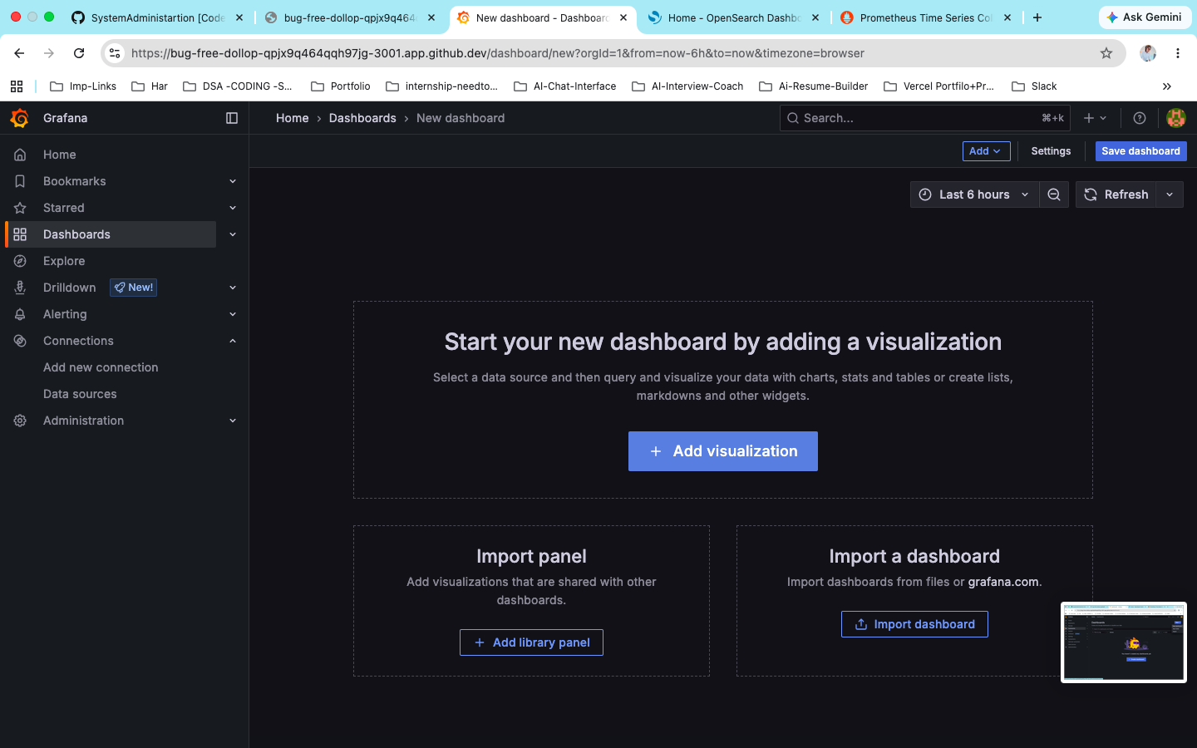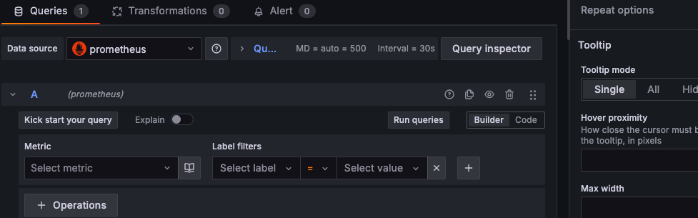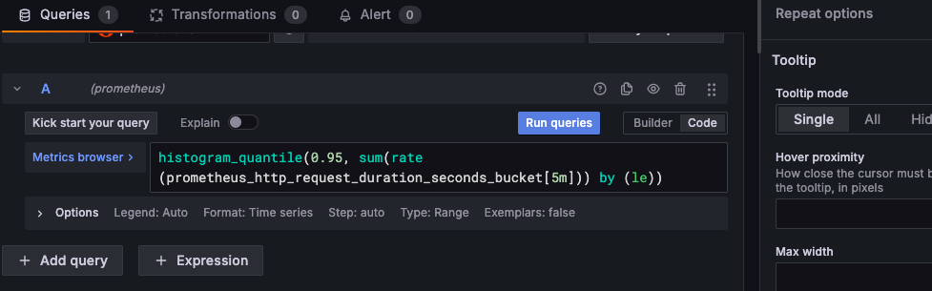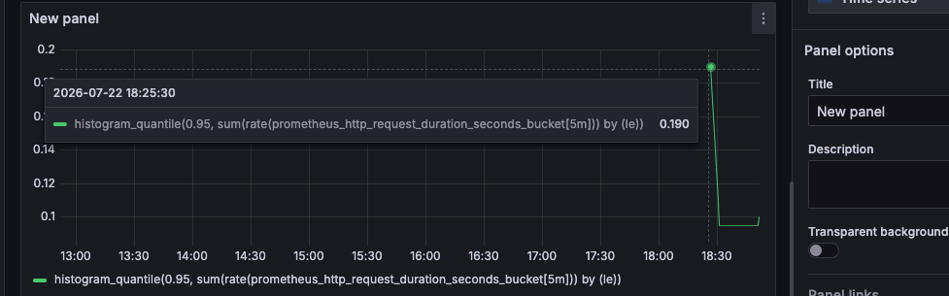

Panel 2: error ratio
sum(rate(prometheus_http_requests_total{code=~"5.."}[5m]))
sum(rate(prometheus_http_requests_total[5m]))

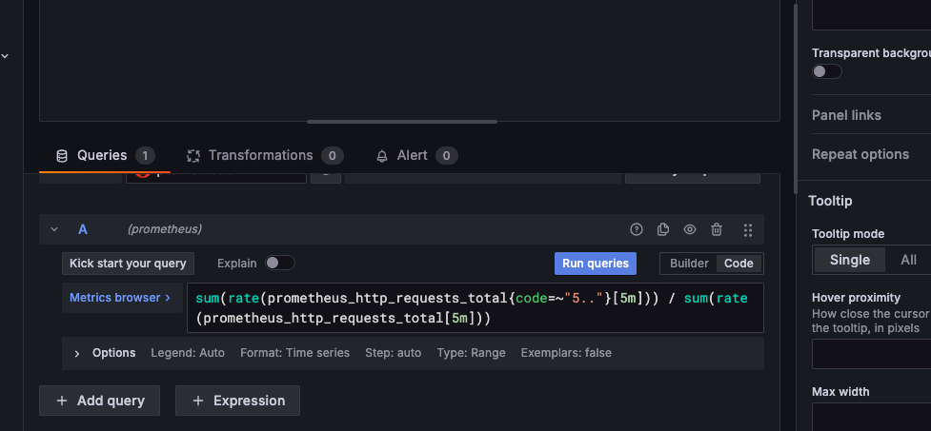
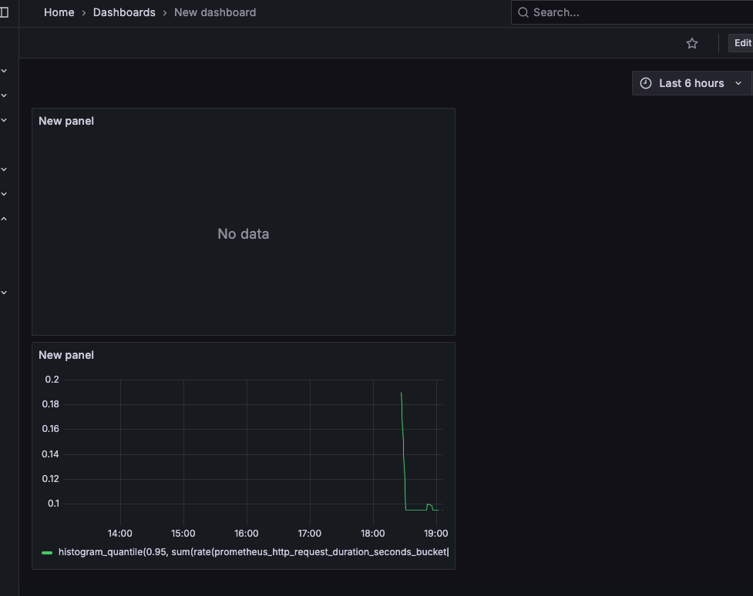

5. Step 4 Answer the Three Incident Questions BY HAND:
These are exact OpenSearch queries I wrote by hand:

Q1. Why did checkout fail at 14:05?
curl -s 'http://localhost:9200/storefront-logs/_search?pretty' \
-H 'Content-Type: application/json' -d '{
"size": 20,
"query": { "bool": { "filter": [
{ "match": { "level": "ERROR" } },
{ "range": { "ts": { "gte": "2026-06-12T14:05:00", "lt": "2026-06-12T14:06:00" } } }
]}}
}'

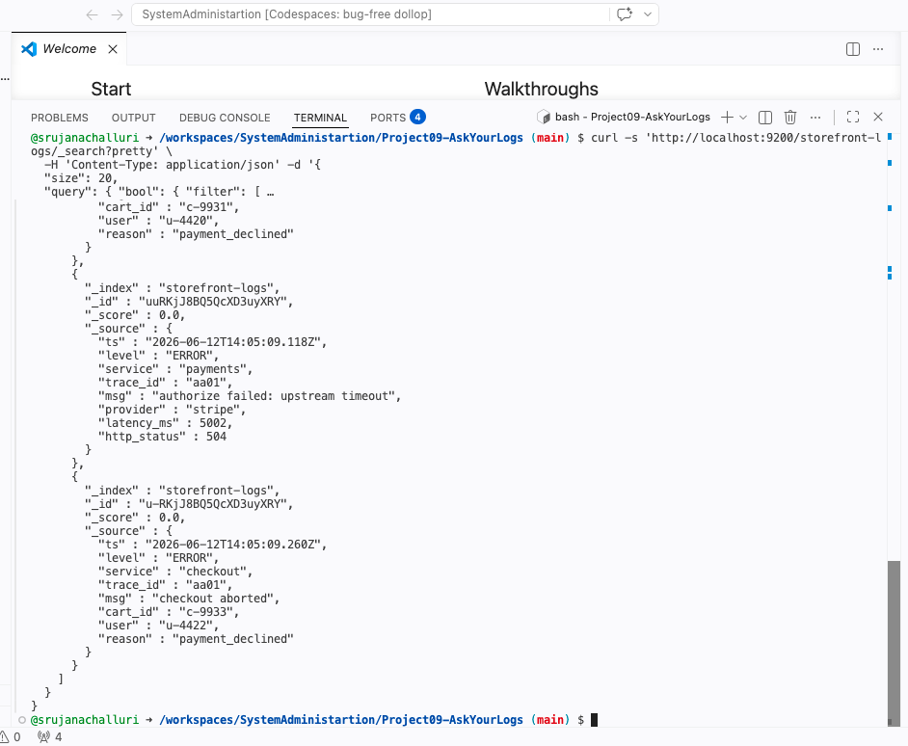
Answer: Checkout aborted because the payments service hit 'authorize failed: upstream timeout' from stripe (504, 5002 ms). Checkout is the symptom, the payment-provider timeout is the cause.

Q2. Which users were affected?
curl -s 'http://localhost:9200/storefront-logs/_search?pretty' \
-H 'Content-Type: application/json' -d '{
"size": 20, "_source": ["ts","user","trace_id","reason"],
"query": { "bool": { "filter": [
{ "match": { "service": "checkout" } },
{ "match": { "level": "ERROR" } }
]}}
}'
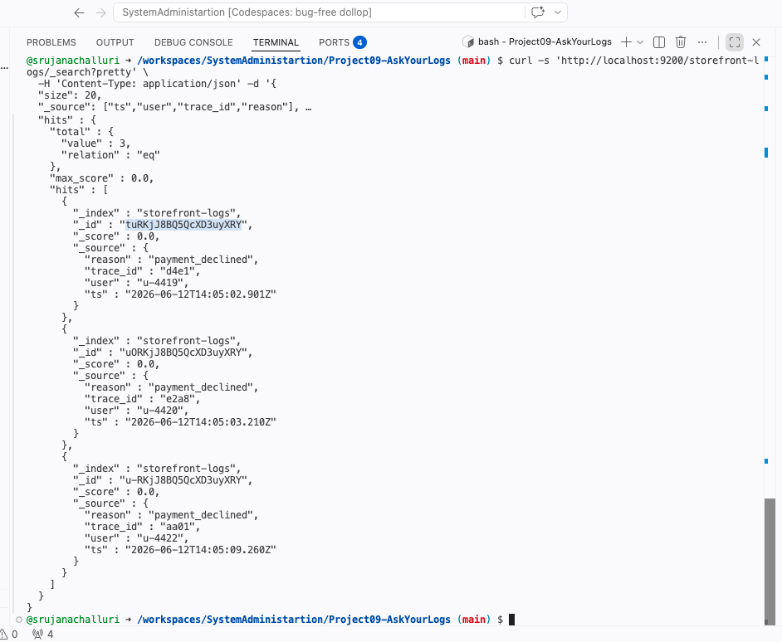

Answer: u-4419 (d4e1), u-4420 (e2a8), u-4422 (aa01). u-4430 for all 3users the payment is declined at 14:05 after recovery and was NOT affected.

Q3. Root cause vs. symptom correlate by ts and trace_id
curl -s 'http://localhost:9200/storefront-logs/_search?pretty' \
-H 'Content-Type: application/json' -d '{
"size": 20, "sort": [ { "ts": { "order": "asc" } } ],
"query": { "match": { "trace_id": "d4e1" } }
}'

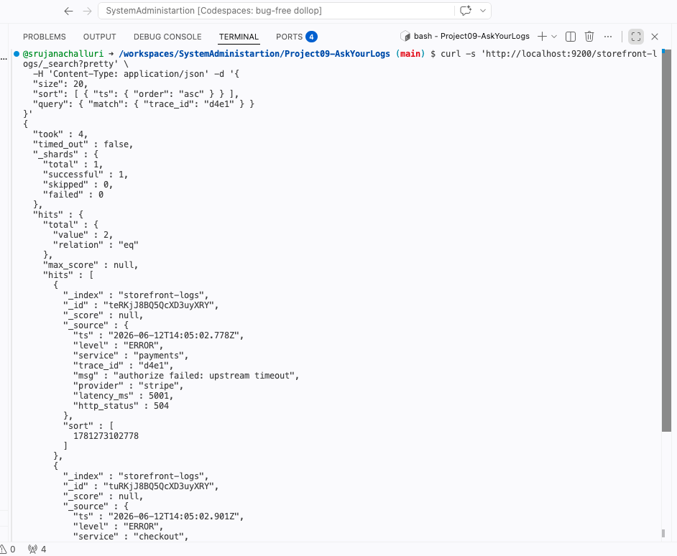
Answer: trace_id d4e1 shows payments “authorize failed: upstream timeout” (14:05:02.7782, ROOT CAUSE) immediately followed by checkout “checkout aborted” (14:05:02.901, SYMPTOM). The shared trace_id proves the abort was upstream of the timeout. Same pattern for e2a8 and aa0, three customer-facing failures, with one same incident.
We might need to check the upstream to check the connectivity.

6. Step 5 Ask the AI the Same Questions (ask_logs.py):

I downloaded, Llama 3.2 on my codespace and ran the below commands to check whether AI gives the proper output based on our logs:
export OPENAI_BASE_URL=http://localhost:11434/v1
export OPENAI_API_KEY=not-needed
export MODEL=llama3.1:8b

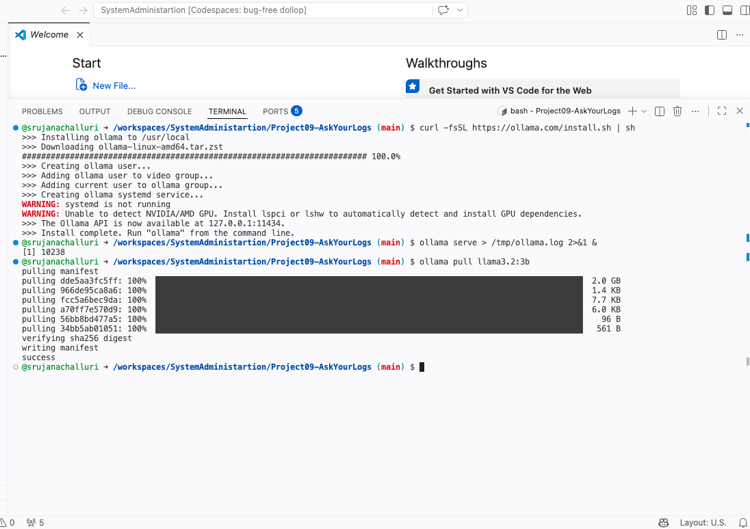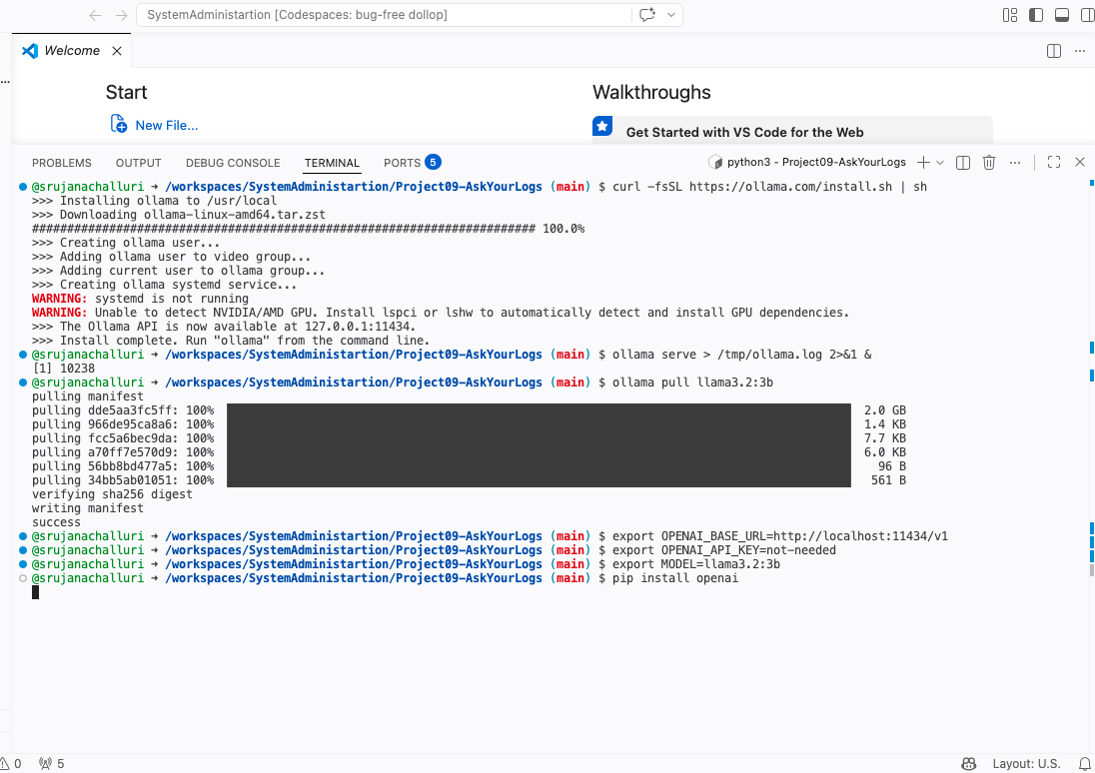

python3 ask_logs.py sample-logs.jsonl "which users were affected?"
python3 ask_logs.py sample-logs.jsonl "what was the root cause of the 14:05 checkout failures?"
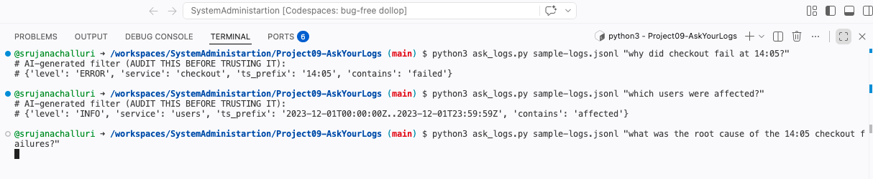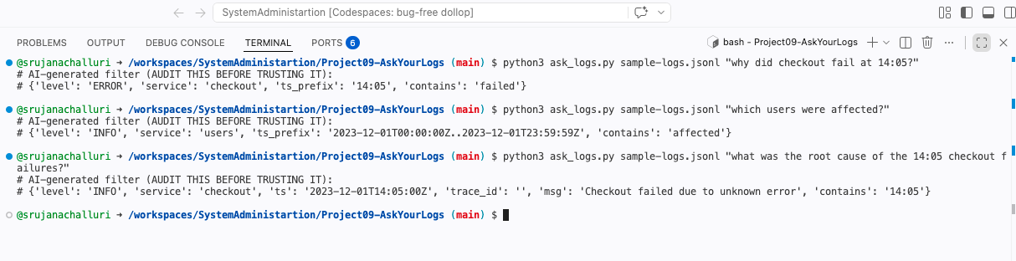

7. Step 6: Conclusion:

For all 3 questions, AI hallucinated, In Q1, It mention contains: failed but never answered the real cause (payment failure due to payment timeouts, Q2, wrong year entirely (real logs are 2026-06-12) and no user listed, and for Q3: it created a log message: a log message ("Checkout failed due to unknown error") that does not exist in your data. Which has never existed in our logs.
Confidently hallucinated the output without looking at the real logs even though I provided the logs files to read from.
I learned a new concept through this project, and it was a great hands-on learning experience. My sister is working on the real-time Study Guide website for the Concordia Bible Institute at our university, so I'll share this concept with her since it could be helpful for tracking her logs as well.
Thank you, professor for providing such great projects to learn from!

