Project 14 Maintenance and the Lifecycle of Things
System Administration and Maintenance
Sareena Challuri
github.com/srujanachalluri/SystemAdministration → Project14-Maintenance-Lifecycle/

Overview
Week 14 is a conditioning week: eleven reps plus a capstone, with no separate project. Each rep is a small runnable piece of a real model maintenance plan, and the capstone assembles them into LIFECYCLE_PLAN.txt a document that could be handed to a team that has to run the service without me.
The service used throughout is ministry-rag-summarizer, a retrieval-augmented summarizer for donor correspondence. Every rep uses that same system so the model card, the AIBOM, the migration runbook, and the registry all describe one coherent thing.
Repository contents
LIFECYCLE_PLAN.txt | The capstone patch policy, change policy, asset lifecycle, governance artifacts, framework map, retirement plan
agent-log.txt | Honest record of what AI drafted, where it was wrong, and where I intervened
reps/ | Eleven rep files with the work and the written reflections
code/ | Chapter 14 starter files patch_triage.py, cve_feed.json, model_card.yaml, migration runbook
ansible/ | Five-task baseline playbook used for the drift check

Environment
Run in a GitHub Codespace. Ansible is the only dependency the project installs; everything else uses the Python 3 that Codespaces already provides.
cd Project14-Maintenance-Lifecycle
ls -lr

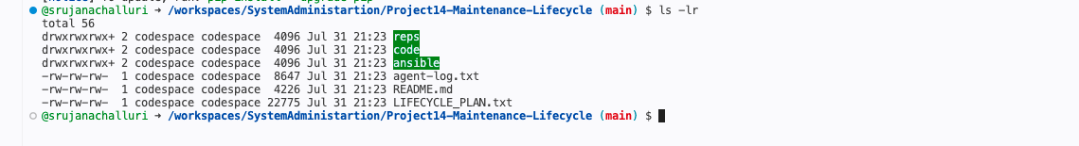
Project structure reps, code, and ansible directories alongside the capstone plan
python3 -m pip install --quiet ansible
ansible --version

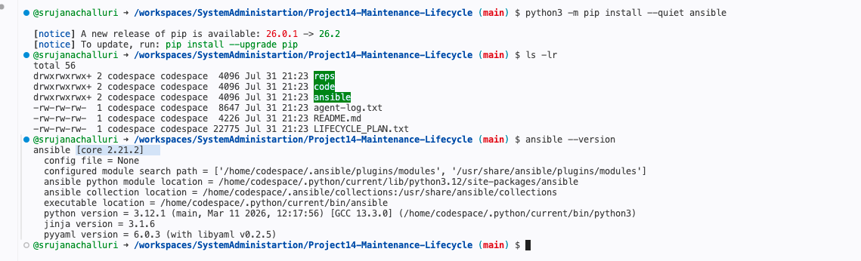
Ansible core 2.21.2 on Python 3.12.1

Reps 1–3: Patch and Change Discipline

Rep 1 Triage a CVE feed deterministically
I wrote my prediction before running the scorer: CVE-2026-10122 would land in EMERGENCY, because it is the only advisory where all four of the scorer's levers push the same way CVSS 9.8, on CISA's KEV list, internet-facing, and a vendor fix exists.
cat reps/rep01-triage-prediction.md
python3 code/patch_triage.py code/cve_feed.json

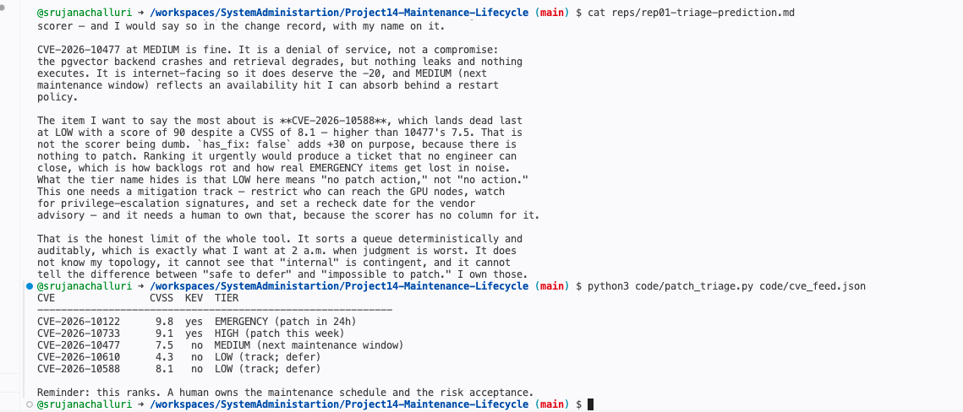
The prediction, then the actual triage table
The prediction was right, but I underestimated the gap. Working the arithmetic by hand: CVE-2026-10122 scores −9 and CVE-2026-10733 scores 15, so only one item crosses the EMERGENCY threshold of 10, and it crosses by 19 points. The 20-point internet-facing penalty is what separates two CVEs that are both above CVSS 9 and both actively exploited.
The result I want to defend is CVE-2026-10588 landing dead last at LOW despite a CVSS of 8.1 higher than CVE-2026-10477's 7.5. That is not the scorer being wrong. has_fix: false adds +30 on purpose, because there is nothing to patch. Ranking it urgently would produce a ticket no engineer can close, which is how real EMERGENCY items get lost in noise. LOW here means "no patch action," not "no action" it needs a mitigation track, and the scorer has no column for that. A human does.

Rep 2 Triage the same feed with AI, then judge the gap
I pasted the same feed into a copilot and asked it to rank the advisories and recommend a patch schedule.
cat code/cve_feed.json

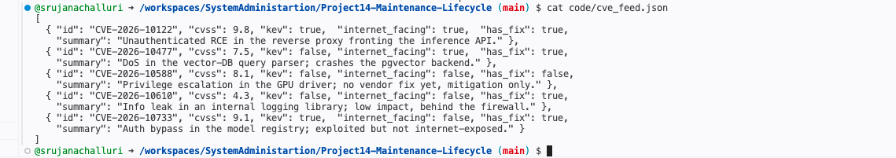
The feed as given to the AI
The AI agreed on CVE-2026-10122 at the top and produced genuinely useful rollback notes. It also invented two facts about infrastructure it could not see a load balancer that would need connection draining, and a claim that the GPU driver flaw was reachable from the container runtime. Neither appears anywhere in the five fields the feed actually has.
The important failure was CVE-2026-10588. The AI read has_fix: false, then reasoned past it ranking the item second while advising "patch as soon as a fix ships," which is a scheduling instruction that cannot be executed. I acted on the patch_triage.py ranking instead, because it is deterministic and auditable: I can re-run it in six months, get the identical ordering, and show an auditor the exact arithmetic. A ranking I have to fact-check line by line is not a ranking, it is homework. The human owns the schedule because the schedule is a risk acceptance, and a model cannot be accountable for a decision it will not remember making.

Rep 3 Make a change reviewable and reversible
A one-page change record, CR-2026-0714, for applying the EMERGENCY patch from Rep 1. It answers who, what, why, when, how to roll back, and who accepted the risk for the CVE I chose to defer.
cat reps/rep03-change-record.md

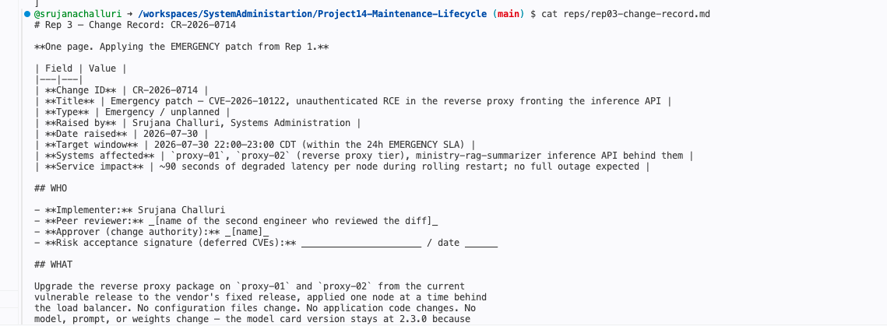
The change record note the risk acceptance signature line, left blank
Rollback is specified before the change starts, not judged during the incident: named trigger conditions, the exact prior version string captured at snapshot time (rollback is "to this version," never "to the last version"), and rollback authority held by the implementer, because a change whose reversal requires a meeting is not reversible.
The field an AI must never fill is the risk acceptance signature. An AI can legitimately draft everything else on that page the rollback steps, the window, the CVE summary because each of those is a recommendation, and a recommendation is checkable. A signature is a different kind of object: it is not information about the change, it is a person assuming consequences for it. That is exactly what separates a decision from an accident. Both look identical in production a vulnerability sits unpatched but in the first case someone weighed the trade-off and can be asked about it, and in the second nobody knows whether it was a choice or an oversight. A signature from a language model is a signature from nobody, and it makes the audit trail claim a decision was made when none was.

Reps 4–5: Configuration Drift

Rep 4 Detect drift with a dry run
A five-task Ansible playbook enforces a baseline: the app directory exists, a package is installed, a config file has exact contents, the file is not world-writable, and an unmanaged override marker is absent.
Step 1 converge the host to baseline:
ansible-playbook -i ansible/inventory.ini ansible/site.yml

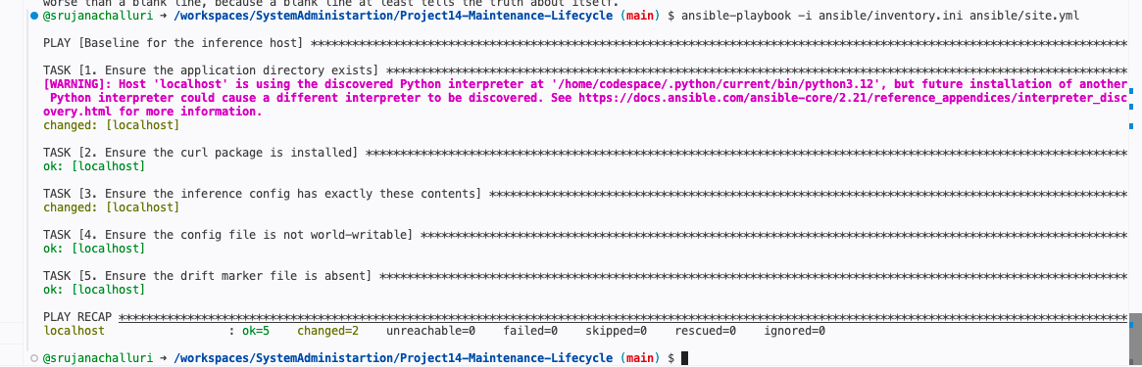
changed=2 the directory and the config file were created
Step 2 dry run on a clean host:
ansible-playbook -i ansible/inventory.ini ansible/site.yml --check --diff

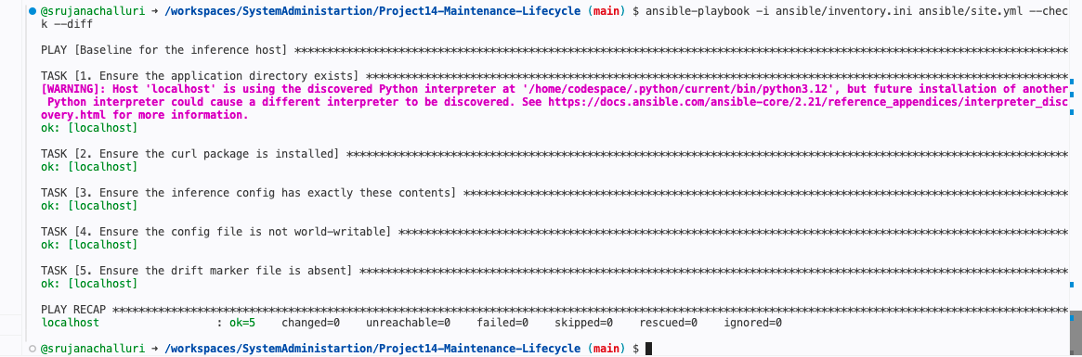
changed=0 the host matches its declared baseline

Step 3 introduce drift by hand, the way a 2 a.m. hotfix would:
echo "temperature=1.0" >> /tmp/rep4-demo/inference.conf
chmod 666 /tmp/rep4-demo/inference.conf
touch /tmp/rep4-demo/UNMANAGED_OVERRIDE

Step 4 detect the drift without fixing it:
ansible-playbook -i ansible/inventory.ini ansible/site.yml --check --diff

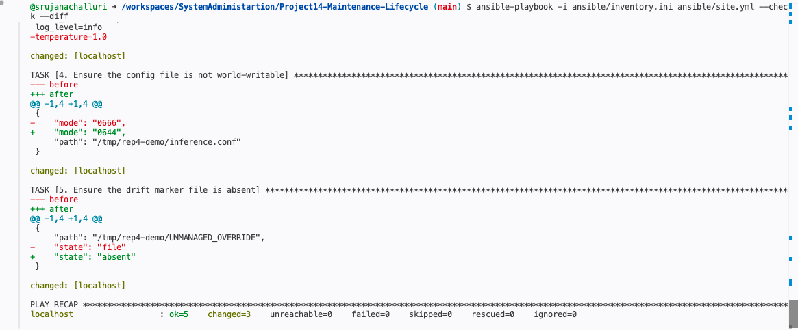
changed=3 three tasks disagree with reality, and nothing was written
Reading the diff: the minus lines are what exists on disk, the plus lines are what the playbook intends. −temperature=1.0 is the drift and note what it actually does. The file now has temperature=0.2 on line 3 and temperature=1.0 on line 6, and most config parsers take last-wins, so this host is silently serving at a completely different sampling temperature than every other host in the fleet. Nothing is down. Nothing alerts. "mode": "0666" → "0644" is the permissions drift, and UNMANAGED_OVERRIDE going from state: file to state: absent is the marker file.
The line to read correctly is changed: [localhost]. In a normal run it means "I changed it." Under --check it means "I would change it" nothing was written. So changed=3 in the recap is a drift counter, and changed=0 earlier was a dated, reproducible statement that the host matched its baseline.
--check is the right default for detection because detection and remediation are two different decisions, and collapsing them takes the decision away from me. That temperature=1.0 might be a careless edit or it might be the on-call engineer's mitigation for a degenerate-output incident that nobody has written up yet. A plain run reverts it silently and the incident returns with no obvious cause. Sometimes reality is right and the baseline is wrong, and only a dry run gives me the chance to notice. A dry run is also safe to schedule fleet-wide nightly, because it cannot mutate anything so detection becomes routine while remediation stays gated.
Honest limit: a dry run only detects drift in what the playbook declares. My five tasks say nothing about kernel version, firewall rules, or which model alias the registry resolves to, so changed=0 means "no drift in what I check," never "no drift."

Rep 5 Drift that changes model behavior
Three configuration changes in an AI serving stack that alter output or throughput while every traditional health metric stays green:
- A quantization-library version bump. Weights are byte-identical and the model ID is unchanged, but rounding during weight packing shifts, so logits shift, so borderline completions change. Monitoring misses it because the service is often measurably faster.
- A serving-engine flag change (vLLM batching, KV-cache, or sampling defaults). Continuous batching means the same prompt can produce different completions depending on what else was in its batch, so a bug report becomes unreproducible. Monitoring misses it because throughput went up.
- A GPU driver or CUDA runtime upgrade. New cuBLAS/cuDNN kernels change reduction order and floating-point results, which compound through layers into different tokens. Monitoring misses it because the change closed a real CVE and the patch dashboard turned green.
That third one collides directly with Rep 1: CVE-2026-10588 is a GPU driver flaw. Patching it is correct and patching it without re-running the eval suite silently changes model behavior, while the change record truthfully says "no application code changed."
Configuration management for AI has to version the whole behavior-producing stack because in an AI system the application code is a small and not especially influential part of what determines the output. Pin only the top layer and you have pinned the least important input. The failure this creates is specific: you cannot reproduce your own evaluation. The model card claims groundedness 0.93, but that number was produced by a whole stack on a particular day, and if only the model version was recorded there is no baseline to diff against six months later. An eval you cannot reproduce is a claim, not evidence.
This is the prompt-versioning trap from §14.5 with the ceiling raised. That trap is the discovery that a prompt is code, not documentation. The stack argument says the behavior surface does not stop at the prompt it runs down to the driver. Both errors come from drawing the boundary of "the system" around what looks like software. So a model version is not a weights hash, it is a stack manifest, and any change to any layer in it re-triggers the eval gate including a security patch.

Reps 6–8: The AI Asset Lifecycle

Rep 6 Fill out a governance-grade model card
I re-created the structure of the starter card by hand for ministry-rag-summarizer and extended it in three places: a serving_stack manifest (because Rep 5 showed the starter versions the model but not the stack that produces its behavior), a gate_thresholds block (the starter has gate_passed: true but never says what the gate is, and a boolean with no threshold behind it is an opinion), and measured-vs-target tagging on every number.
cat reps/rep06-model_card.yaml

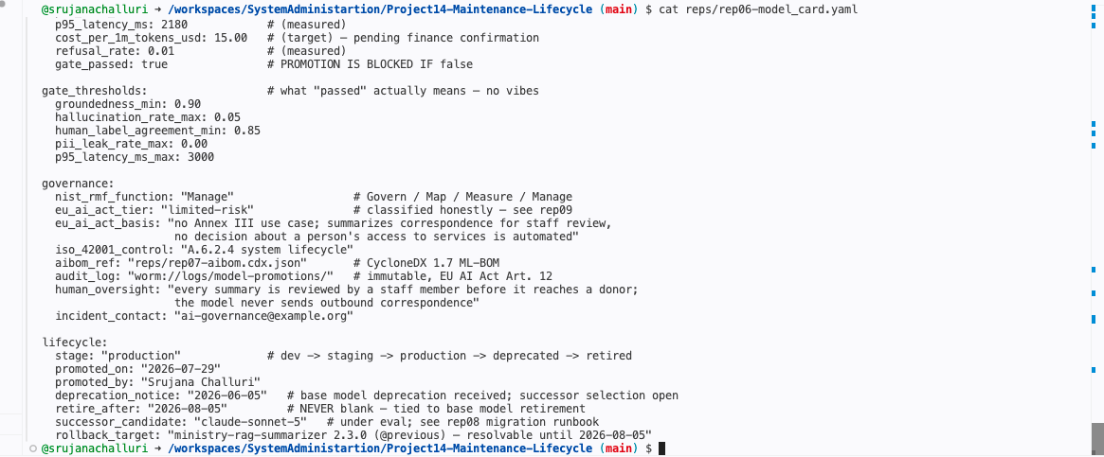
Gate thresholds, governance block, and lifecycle dates
python3 -c "import yaml; yaml.safe_load(open('reps/rep06-model_card.yaml')); print('model card YAML is valid')"

The card parses
The base model ID is pinned as claude-opus-4-1-20250805 the exact dated API string, not "Claude Opus 4.1" and its retirement date was verified against Anthropic's deprecation page rather than copied from the starter file.
Fields that would block promotion: gate_passed: false, groundedness below 0.90, hallucination above 0.05, and pii_leak_rate above 0.00 all fail the gate outright. The PII threshold is zero rather than "low" on purpose the corpus is restricted consented donor correspondence, so a single leaked name is a reportable privacy incident, not a quality regression. A blank approver, a null retire_after, or a marketing-name base model ID block for a different reason: they mean nobody is accountable, or that the estate cannot be inventoried when the base model retires.
human_label_agreement is on the card because it validates every other measured number on it. Groundedness 0.93 and hallucination 0.04 are produced by an LLM judge, not by a human reading 412 letters so those numbers are the judge's opinion, and the card is quietly asking me to trust a model's assessment of a model. Without a measured agreement against human raters, the evaluation section is circular: a judge that has drifted toward leniency, or that shares a base model with the system under test and therefore shares its blind spots, will happily report 0.93 on a model that is inventing donor details. That failure is invisible unless something measures the measuring instrument. It also makes the evaluation falsifiable to an outsider the difference between a claim and a measurement.

Rep 7 Build a minimal AIBOM and diff the formats
A CycloneDX 1.7 ML-BOM inventorying the weights, the dataset reference, and four dependencies vLLM, pgvector, the embedding model, and the CUDA runtime.
cat reps/rep07-aibom.cdx.json

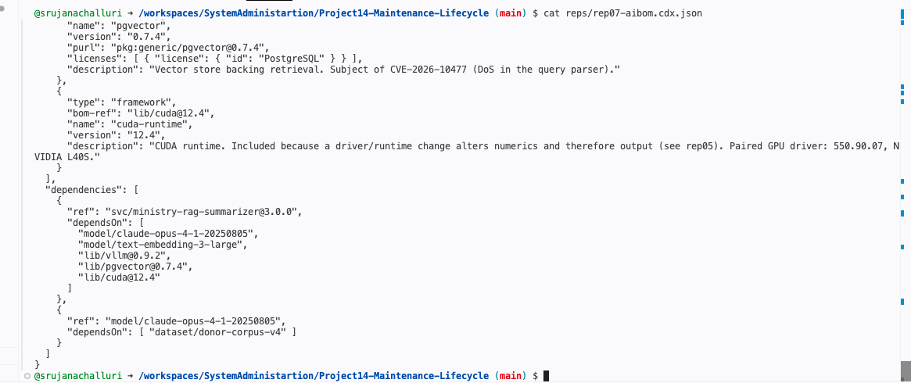
Components and the dependency graph
python3 -m json.tool reps/rep07-aibom.cdx.json > /dev/null && echo "AIBOM is valid JSON"

Well-formedness check
The rep file also sketches the same inventory as an SPDX 3.0 (AI + Dataset profile) view. The two formats differ in shape: CycloneDX keeps one component list plus a dependency graph, while SPDX splits everything into typed elements with explicit relationship triples and promotes the dataset to a first-class element. CycloneDX is what I would generate in CI and feed to a scanner; SPDX is what I would hand to a lawyer asking where the data came from and under what license. They are not competitors.
Without the AIBOM, a deprecation notice starts a search grep the repos I remember, ask in Slack, check the Terraform. Every answer is provisional, because I can only ever prove I found references, never that I found all of them. With it, the notice becomes a lookup: the model ID is a bom-ref, and the dependency graph scopes the migration before I have opened a single repo. The difference is not really speed. It converts an open-ended question "can I find everything?" into a checkable one: "does reality match the recorded inventory?" The second one fails loudly and early instead of silently on retirement day.

Rep 8 Write and dry-run a deprecation migration runbook
Anthropic issued a deprecation notice on 2026-06-05 for claude-opus-4-1-20250805, retiring 2026-08-05. The Step-0 inventory grep runs against this repository the model card, the AIBOM, and the registry are the estate being inventoried.
Pass 1 the scoped grep:
grep -rn "claude-opus-4-1\|claude-sonnet-4-0" . \
--include="*.py" --include="*.yaml" --include="*.tf" --include="*.json"

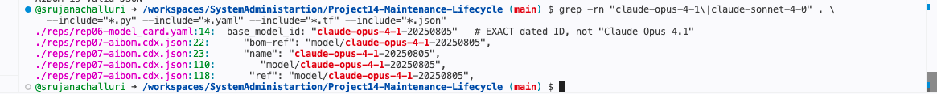
5 references in 2 files and zero hits on claude-sonnet-4-0
Pass 2 drop the file-type filters:
grep -rl "claude-opus-4-1\|claude-sonnet-4-0" .

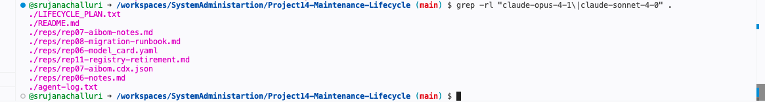
9 files the scoped pass missed more than three quarters of the estate
That zero in Pass 1 is wrong, and finding out why is the content of this step. Two things were broken. First, the registry lives in Markdown, so --include skipped it entirely and in a real estate the registry is a database or a UI export, which a filesystem grep cannot see at all. Second, and worse: the registry did not record base model IDs. My own fine-tuned derivative was unfindable by any string search, not because the grep was scoped badly, but because the fact was never written down. I fixed it the Rep 11 registry table now carries base_model_id and Derivative columns on every row, and the widened grep surfaces donor-tone-classifier, a fine-tuned derivative of claude-sonnet-4-0 running in production.
The lesson is not "write a better grep." A grep is a verification step, not a discovery step. The registry and the AIBOM are the authoritative inventory; the grep exists to catch drift between what they claim and what the estate contains and when they disagree, as they did here, the disagreement is the finding.
Fine-tuned derivatives are hunted first because they are the only items where the deadline is not a deadline but a point of no return. Every other reference is a string edit: miss it and the API errors on 2026-08-05, I get paged, I change the string. The cost is an outage. A derivative is made out of the base those tuned weights are a delta on something that will cease to exist, and there is no string to change because the dependency is not textual. Re-creating it needs the original training data, hyperparameters, and eval harness, and if any of those were not preserved the model is simply gone. The cost is permanent capability loss.
The "inference-only until the base retires, then irrecoverable" trap works by being completely quiet. After deprecation a derivative usually keeps serving normal throughput, unchanged quality, no alert. What you have silently lost is the ability to make it again: you cannot re-tune on a deprecated base, cannot fix a bug in it, cannot adapt it. It looks alive and it is actually a fossil. Then the retirement date arrives and it stops being frozen and starts being deleted, at the exact moment every remedy has expired. Which is why the check belongs in the registry as a permanent field monitored like a certificate expiry, not on a migration checklist you only read once you are already inside the window.
Reps 9–11: Governance Frameworks

Rep 9 Map one system across all three frameworks
NIST AI RMF the card touches all four functions. Govern is owner, approver, audit log, and human oversight. Map is task, provenance, PII class, risk tier, and the stack manifest. Measure is the evaluation block, with gate_thresholds making those numbers decision-relevant. Manage is the lifecycle block plus the migration runbook. The card's declared function is Manage, because the system is in production and the live work is maintenance.
EU AI Act limited risk, not high risk. The system summarizes donor correspondence for internal staff review. It is not a safety component of a regulated product, and I walked Annex III point by point. The nearest miss is point 5, access to essential services, and it misses for a specific reason: no output determines whether any person receives anything, a staff member makes every donor-facing decision, and the model never sends outbound correspondence. Two honest caveats: if the system were extended to score or rank donors for eligibility, the analysis changes and I would re-classify so the tier is pinned to the current intended use. And "a human reviews everything" is a real control only while it is real; rubber-stamp review at volume is how limited-risk systems drift without anyone filing a change. Limited-risk removes AI Act high-risk duties, not GDPR duties.
ISO/IEC 42001 control A.6.2.4, AI system lifecycle. The evidence is concrete: an explicit dev → staging → production → deprecated → retired progression, gate_thresholds defining what a promotion actually requires, promoted_on and promoted_by recording who moved it and when, and a documented retirement procedure in the Rep 8 runbook.
These are layers, not competitors. NIST gives the vocabulary and the risk-thinking process, which the other two do not the Act says what is required but never how to think, and ISO says to have a system but not what good reasoning looks like inside it. The EU AI Act gives legally binding obligations with penalties and dates, which neither other has, since NIST is voluntary and ISO certification is a market signal rather than a legal duty. ISO 42001 gives an auditable, certifiable management system the policy, roles, internal audit, and continual improvement machinery that neither other provides. The Act sets the floor, 42001 is the machinery that clears it repeatably, and NIST is the reasoning done inside it.

Rep 10 Track the moving regulation
Answer dated 2026-07-30. The original statutory date for high-risk obligations was 2 August 2026. The Digital Omnibus defers stand-alone Annex III high-risk systems to 2 December 2027 a 16-month deferral. It has been formally adopted: the European Parliament endorsed it on 16 June 2026, the Council gave final approval on 29 June 2026, and it entered into force on 27 July 2026 as Regulation (EU) 2026/1744.
The honest answer to "has it been formally adopted yet" changed three days before I wrote this, and would have been "no provisional agreement only" in early July. That is the lesson of the rep, not a footnote. Worth noting too: the deferral applies to stand-alone Annex III systems. Prohibitions, AI-literacy duties, GPAI obligations, and the Article 50 transparency rules are already applying on their own timetable, so "the deadline moved" is true of one slice, not the whole law.
"The regulation is fixed" is a maintenance bug for the same reason "the server is patched" is: both are statements about a moment being treated as statements about a state, and both decay silently with no alert. Compliance gets modeled as a build-time property instead of a runtime one you classify the system, write the date into the model card, pass the audit, and the field is now a cached value with no invalidation strategy. Notice the direction this one moved: later, which is the sneaky case. Teams keep burning sprint capacity on a date that no longer exists, or they hear "it got delayed" and never learn the deferral does not cover the prohibitions already in force.
So I would schedule a quarterly regulatory review with a named owner, producing a dated written finding even when the finding is "no change": re-read the consolidated text on EUR-Lex, re-confirm the dates, re-validate each system's tier against the current Annex III asking specifically whether its use has drifted, and date-stamp the model cards. Between reviews, alerts routed to a ticket queue rather than an inbox, because an email nobody owns is not a control.
This is structurally the same control as re-checking a CVE feed. Regulation is a feed with a slower clock: it has dated publications, it has severity (a prohibition is EMERGENCY, a deferral is LOW-but-track), it even has a has_fix: false analogue in a rule that applies before any conforming standard exists. In both cases the clock is invisible and external, and "nobody told us" is not a defense. The one asymmetry: you can roll back a bad patch. You cannot roll back a missed statutory deadline.

Rep 11 Capacity and retirement
Nine versions retained across three services: 3 live, 2 rollback-reserve, 4 cast away. Every cast-away entry gets retire_after: 2026-08-15 a 16-day window to object, then archive to WORM storage and removal from the active registry. Archive is not delete: the weights, config, model card, and eval results are retained for the audit trail, and what is removed is the catalog entry, which is the thing that creates confusion about what is live.
The policy behind it: keep the champion, keep exactly one rollback-reserve, archive everything else within 90 days of being superseded. Two is the right rollback depth, because if @previous cannot save me the problem is not the model version. And every entry carries a non-null retire_after from creation, including the champion, whose date is tied to its base model's retirement.
Three of the nine expire in six days because a supplier's calendar, not mine, decides when they stop existing. Retirement is happening to this registry whether I plan it or not.
The cost of keeping past the season: disk is trivial and the wrong reason to act. Catalog clutter is real a registry with no retire_after dates is a pile, and "what is running?" reverts to archaeology. Audit surface is the cost nobody budgets for: every retained version is a question I have volunteered to answer, and the 2025 versions have model cards written before I added stack manifests and gate thresholds, so they are retained and I cannot fully account for them. Confusion about what is live is what causes the 2 a.m. incident someone under pressure rolls back to a version that predates the current retrieval index and cannot retrieve anything, because it was there and it looked like a valid target. And there is a fifth: keeping creates the illusion of optionality. I told myself I kept the old versions "just in case," but most of them stop being runnable when the base retires I was never holding options, only paying for them.

Capstone LIFECYCLE_PLAN.txt
The eleven reps assemble into one coherent plan for the ministry-rag-summarizer service, in the order the assignment requires:
- Patch and vulnerability policy the deterministic triage rule, the four tiers and their SLAs, the has_fix: false mitigation track, and who signs risk acceptances at each tier
- Change and configuration policy what counts as a change (any line in the stack manifest, including a security patch), reversibility requirements, and drift detection for both infrastructure and AI behavior
- The asset lifecycle five stages with an explicit gate at each promotion, and the published thresholds that define what passing means
- Governance artifacts model card, AIBOM, change records, and the WORM audit trail
- The framework map NIST RMF function, EU AI Act tier with a dated current-status note, ISO 42001 control, and the quarterly regulatory review task
- Deprecation and retirement the migration runbook, the derivative-first rule, and a non-null retire_after on every registry entry
cat LIFECYCLE_PLAN.txt

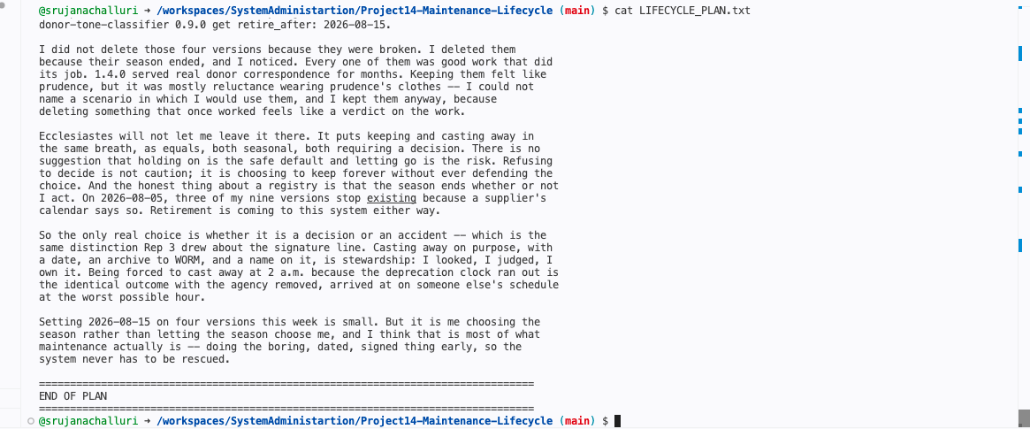
The closing theological footnote
The plan closes by tying Ecclesiastes 3:1 and 3:6 to one specific decision in it the four versions given retire_after: 2026-08-15. I did not delete those because they were broken. I deleted them because their season ended and I noticed. Keeping them felt like prudence, but it was mostly reluctance wearing prudence's clothes: I could not name a scenario in which I would use them and kept them anyway.
Ecclesiastes puts keeping and casting away in the same breath, as equals, both seasonal and both requiring a decision. There is no suggestion that holding on is the safe default. Refusing to decide is not caution it is choosing to keep forever without ever defending the choice. And the season ends whether or not I act: on 2026-08-05, three of my nine versions stop existing because a supplier's calendar says so. So the only real choice is whether it is a decision or an accident, which is the same distinction Rep 3 drew about the signature line. Casting away on purpose, with a date and an archive and a name on it, is stewardship. Being forced to cast away at 2 a.m. because the deprecation clock ran out is the identical outcome with the agency removed, on someone else's schedule, at the worst possible hour.

Sources
Verified 2026-07-30.
- Anthropic model deprecations docs.anthropic.com/en/docs/resources/model-deprecations. claude-opus-4-1-20250805: deprecation notice 2026-06-05, retirement 2026-08-05.
- EU AI Act Digital Omnibus Regulation (EU) 2026/1744, in force 2026-07-27. Parliament endorsed 2026-06-16, Council approved 2026-06-29. Consolidated text on EUR-Lex.

