Project 6 - Carve the GPU
Sharing one NVIDIA H100 80GB GPU among four tenants at Concordia Lakes University
Course: System Administration and Maintenance

A note on how I ran this
I do not have a real data-center GPU, so the nvidia-smi captures in this project are a careful simulation. I built them in the same format as the chapter's sample file and checked them against the real H100 slice rules.

1. The situation
Concordia Lakes University owns exactly one NVIDIA H100 80GB GPU, and four groups need it at the same time. They do not all need the same thing:
- CS department - an 8B chat assistant for coursework. Needs about 18 GB of GPU memory.
- Library - a small embedding model for catalog search. Needs about 3 GB.
- Registrar - a classifier that reads student records. This data is FERPA-protected, so by law it must be kept separate from everything else on the card.
- Research student - a notebook used for a few hours a week. Bursty, and does not need to be kept separate from anything.

2. Ranking the needs before I touch anything
The four needs are not equal, so I put them in order first:
- 1. Registrar (FERPA) - a hard legal rule. Must have true hardware separation. This decides everything else.
- 2. CS chat - a size rule. It needs a slice big enough to actually hold an 18 GB model.
- 3. Library - easy. Fits the smallest slice with lots of room.
- 4. Research - no separation needed. The cheapest option that works is fine.

3. My plan for splitting the card
NVIDIA's MIG feature splits one GPU into smaller, walled-off GPUs called slices. The H100 gives out at most 7 slices. Here is how I spend them:
- Registrar -> its own small slice (1g.10gb = 1 slice), fully separated.
- CS chat -> a medium slice (2g.20gb = 2 slices), because an 18 GB model will not fit the small 10 GB slice.
- Library -> its own small slice (1g.10gb = 1 slice).
- Research -> a small slice (1g.10gb = 1 slice) that I share over time (time-slicing) so bursty use does not waste dedicated hardware.
Total: 2 + 1 + 1 + 1 = 5 slices out of 7.
Two slices are left over on purpose, as room to grow. The commands that do this are in gpu_partition.sh
sudo nvidia-smi mig -i 0 -cgi 14,19,19,19 -C
(14 = the medium 2g.20gb slice for CS; each 19 = a small 1g.10gb slice.)

4. Making sure each model actually fits
A model needs room for its weights, plus its running memory, plus some overhead - always more than the raw model size. I wrote vram_math.py to check this. Here is what it prints when I run it:
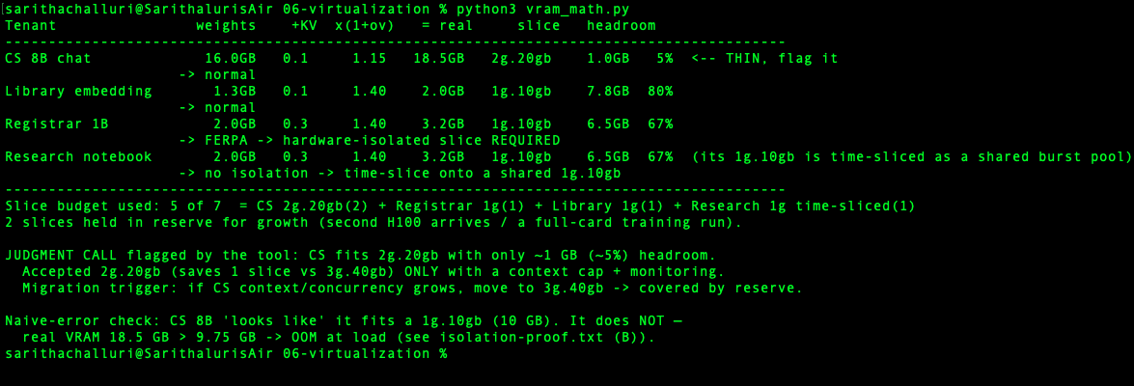
The important result: the CS 8B model needs about 18.5 GB, which fits the 2g.20gb slice but only barely (about 1 GB to spare). I chose to accept that tight fit because it saves a slice, but I keep the CS context short and watch its memory. If CS grows, I move it to the bigger 3g.40gb slice, which the two spare slices easily cover. I did the trade-off on purpose, both ways: accepted the tight 2g.20gb today, rejected wasting a bigger slice before I need it.

5. What happens if I size it wrong
To prove the sizing matters, I put the 18 GB CS model on the small 10 GB slice. It fails immediately when the model loads (full capture in isolation-proof.txt):
torch.OutOfMemoryError: CUDA out of memory. Tried to allocate 2.00 GiB.
GPU has a total capacity of 9.75 GiB of which 512.00 MiB is free.
The slice cannot magically create memory it does not have. This is exactly why CS gets the 2g.20gb slice, and why I size to real memory use, not to the model's headline size.

6. Proving the registrar is really separated

I prove it two ways (full capture in isolation-proof.txt):
- I pin the registrar's program to its slice by ID. When it asks how much GPU memory it can see, it reports about 9.75 GB - only its own slice, not the full 80 GB card.
- When that same program tries to reach the neighbor slice, it gets 'invalid device ordinal' - the neighbor does not even exist as far as it is concerned. Separate memory, separate crash zone. That is real hardware separation.
Time-slicing (what the research student gets) shares memory and would NOT give this. That is why the registrar is never time-sliced - only a dedicated slice keeps the promise.

7. Checking my choices against the class tool
The chapter provides gpu_sharing_picker.py, which suggests a sharing mode. I ran it for each tenant and compared its suggestion to my own decision. For the registrar:
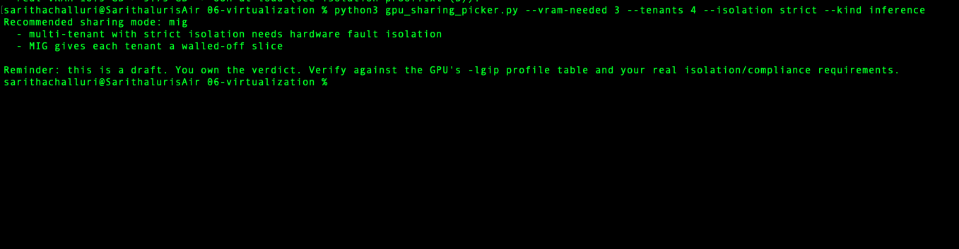
It agrees with me: strict separation means MIG. For the research student:
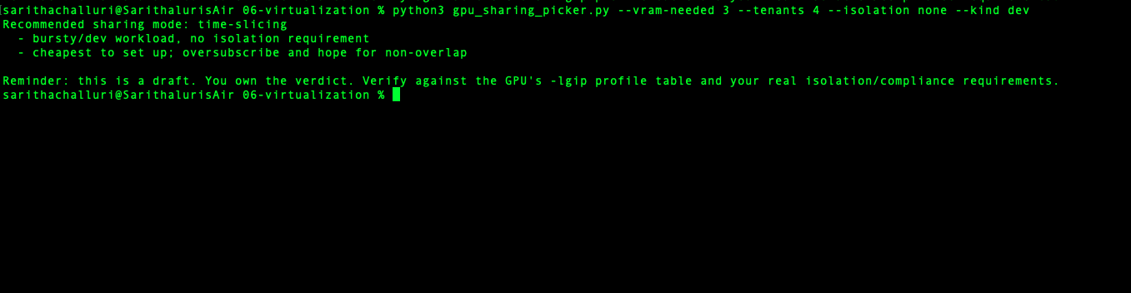
It agrees again: no separation needed means time-slicing is fine. For the CS and library models the tool suggested MPS, but I overrode it and used dedicated MIG slices instead, because on a shared card I still want them walled off from the registrar's protected data. The tool drafts a suggestion; I own the final decision. The full log is in picker-runs.txt.

References:
For writing Python files Python vram_math.py, gpu_sharing_picker. Py
I used W3Schools, Python Tutorial https://www.w3schools.com/python/ (general syntax)
For Sizing math: https://huggingface.co/docs/transformers/en/model_memory_anatomy

