Project 13 - A Pipeline for an AI Application
Sareena Challuri
System Administration and Maintenance - Chapter 13: DevOps, SRE, and Work That Lasts
Repository: https://github.com/srujanachalluri/SystemAdministartion
Project folder: project-13-ai-pipeline

1. The problem I was asked to fix
The school help desk has a small RAG bot that answers staff questions from a folder of policy documents. It was working. The dashboard was green. And it still told a new teacher the wrong lockdown procedure.
Nothing alerted, because everything we were watching was asking "is the service up?" It was up the whole time.
So this project is not about making the bot smarter. It is about building the safety net that should have been there from the start: a pipeline that will not let a bad version ship, a number that says how good is good enough, monitoring that notices when things slide, and a plan for undoing a bad deploy.

2. What I built
- A RAG bot that answers only from four fixed policy documents (snow days, account resets, lockdown, grading).
- A CI pipeline in GitHub Actions with five gates in a deliberate order.
- An eval set of 10 test cases and a groundedness checker that runs in CI.
- An SLO with an error budget, written down in slo.yml.
- Drift monitoring using PSI, plus an honest note on what it cannot see.
- A rollback vs retrain policy, decided before any incident.

The pipeline order, and why
install -> lint -> unit tests -> secret scan -> LLM EVAL GATE
free free free free slow + paid
The eval gate is the only stage that costs money and time. So it runs last. There is no point paying for a model call on a branch that a free linter would have rejected in two seconds.

3. The bot runs and the model is pinned
The model ID is written in app/config.py as gpt-4o-mini-2024-07-18. It is never "latest". There is a unit test that fails the build if anyone ever changes it to a floating version, because a model that silently updates itself is a model nobody chose.
pip install -r requirements.txt
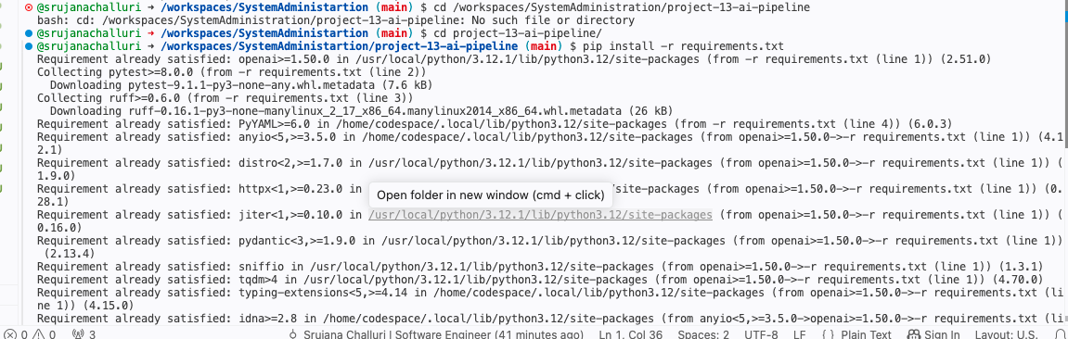
ruff check .
pytest tests/unit -q
All checks passed!
7 passed in 0.02s
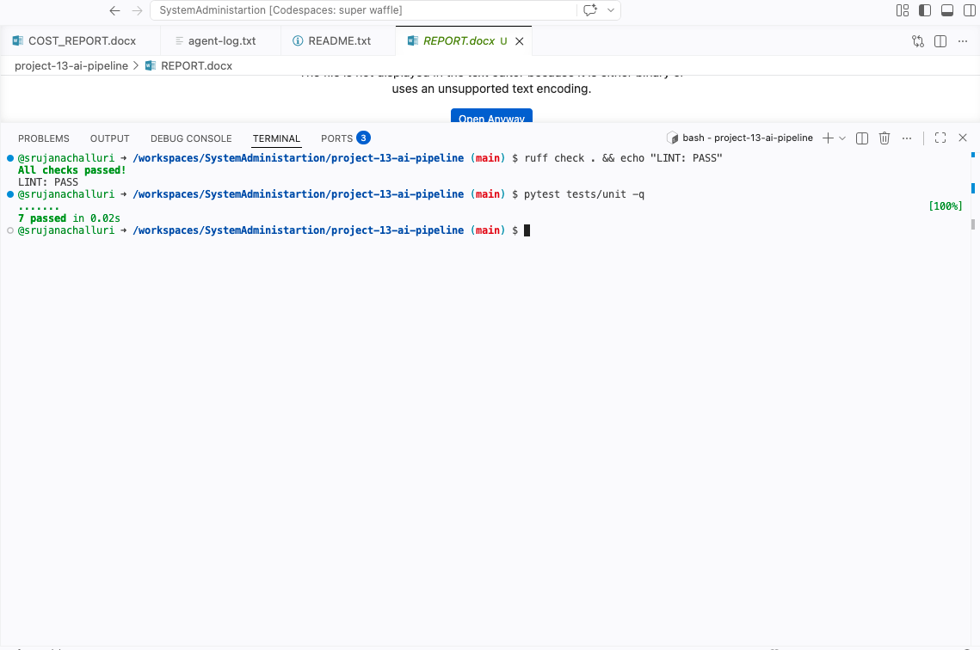
python -m app.rag_service "Who can release a lockdown?"
MODEL_ID : gpt-4o-mini-2024-07-18
MODE : STUB (extractive)
Q : Who can release a lockdown?
A : I don't have that in the policy documents. Please contact the IT Help Desk.
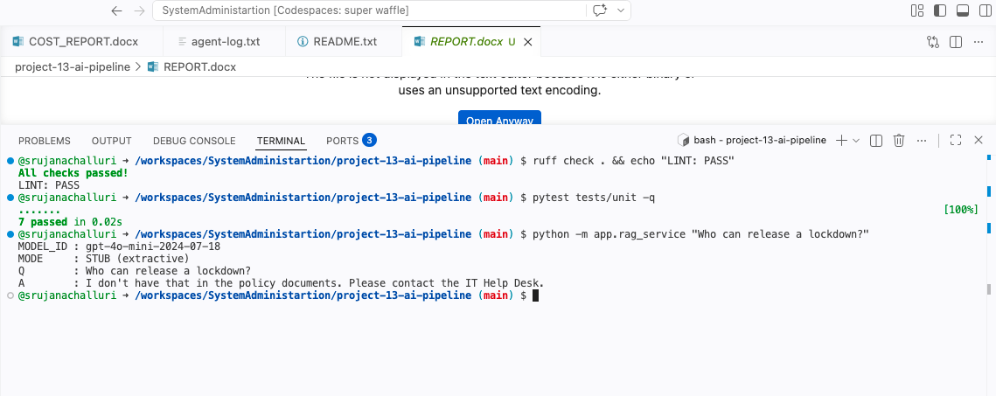
This one needs an explanation, because at first glance it looks like the bot failed.
It did not. I put a minimum match score on retrieval. If a question does not clearly match a policy document, the bot returns nothing and refuses instead of answering. This short question did not clear that bar. The longer version of the same question in my eval set (case C06) does clear it, and the bot answers it correctly.
I chose to tune it this way on purpose. I would rather this bot say "I don't know, ask the Help Desk" too often than have it confidently invent a lockdown procedure once. A refusal is annoying. A made-up safety procedure is dangerous. That trade-off is the whole reason this project exists.

4. My SLO, and why I picked that number
This part is mine. I did not ask the AI agent what a good threshold is.

What I measure
Groundedness rate: out of all the answers the bot gives, how many are fully supported by the policy text it actually pulled up. A refusal counts as grounded, because refusing is honest.
I am deliberately not measuring uptime. The incident that started all of this happened while the service was at 100 percent uptime. Uptime was never the problem.

My SLO: 99% of answers grounded, over a rolling 30 days
Why not 99.9%: the people reading these answers are adults. Every answer points back to a named policy document, and staff can check with the Help Desk if something looks off. That means a wrong answer here is usually caught and fixed, not final. Chasing 99.9% would cost a lot more in eval spend and human review than the small amount of risk it would actually remove.
Why not 95%: we get roughly 20,000 questions a month. At 95%, that is 1,000 wrong answers, and some of those would be about lockdowns and building safety. I am not willing to put my name on that number.
99% is the point where being more careful stops being worth the cost, and being less careful starts landing on a teacher during a real emergency.

The error budget
100% minus 99% is 1%. At 20,000 answers a month, that is 200 bad answers I am allowed to spend. The rule I wrote down:
- Under 75% of the budget used: ship normally.
- 75% or more used: freeze anything risky, no model or prompt changes.
- Over 100%: stop shipping, roll back to the last good version, stabilise.

Why the CI gate is 0.90 and not 0.99
The CI gate fails the build below 0.90 groundedness. That is lower than my production SLO on purpose.
My eval set is deliberately hard. It is full of trick cases: questions the policy says no to, two similar numbers in the same document, and a question the documents do not answer at all. Real traffic is much easier than that. If I held this adversarial set to 0.99, I would either block every build or I would end up quietly softening the eval set to make it pass. A softened eval set is worse than no eval set, because then it just tells you what you want to hear.

5. The eval set: 10 cases, aimed at the edges
I wrote ten cases instead of fifty, and I picked each one to break something specific:
- C01 - a normal question, to check retrieval works at all.
- C02 - a specific time (10:00 AM). Made-up times are a classic RAG failure.
- C03 - where a procedure lives. It has to name the real portal.
- C04 and C08 - two similar durations, 30 minutes and 15 minutes, in the same document. Does it grab the right one?
- C05 - something the policy says NO to. A helpful bot really wants to say yes.
- C06 - who releases a lockdown. This is the exact question the bot got wrong in the real incident.
- C07 - Secure Building vs Lockdown. Two similar things it could blur together.
- C09 - a fact in a different document, to test it routes to the right file.
- C10 - a question the documents do not cover. It has to refuse, not guess from a nearby document.
python evals/judge.py evals/cases.jsonl --min-groundedness 0.90 --min-pass-rate 0.90
groundedness = 1.000 over 10 cases (threshold 0.90)
pass rate = 1.000 over 10 cases (threshold 0.90)
PASS: quality gate satisfied.
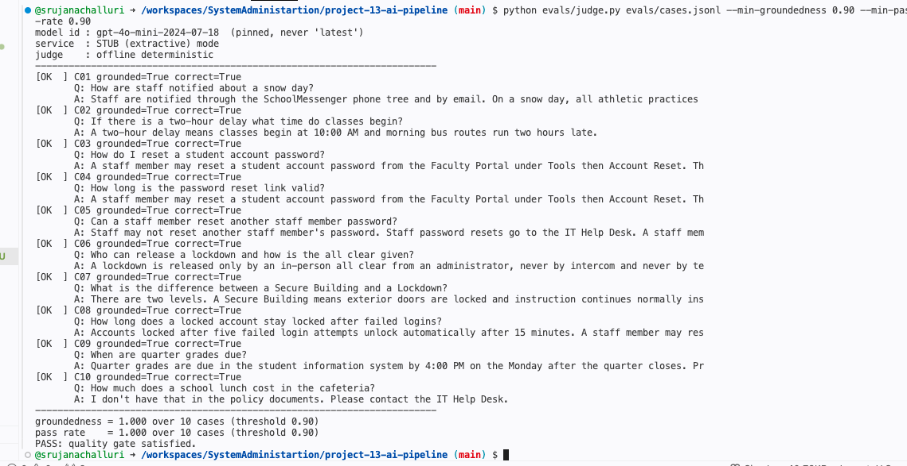
All 10 cases pass on the clean version. Groundedness 1.000.

6. Monitoring: drift and error budget
python monitoring/psi.py monitoring/data/reference.txt monitoring/data/current.txt
python monitoring/error_budget.py --slo 0.99 --total 20000 --bad 140
PSI = 2.1997 -> ALERT (significant shift)
SLO target : 99.000% grounded
Measured SLI : 99.300% grounded (19860/20000)
Error budget (window): 200 bad answers allowed
Spent : 140 (70% of budget)
Remaining : 60
VERDICT: HEALTHY -> you may keep shipping.
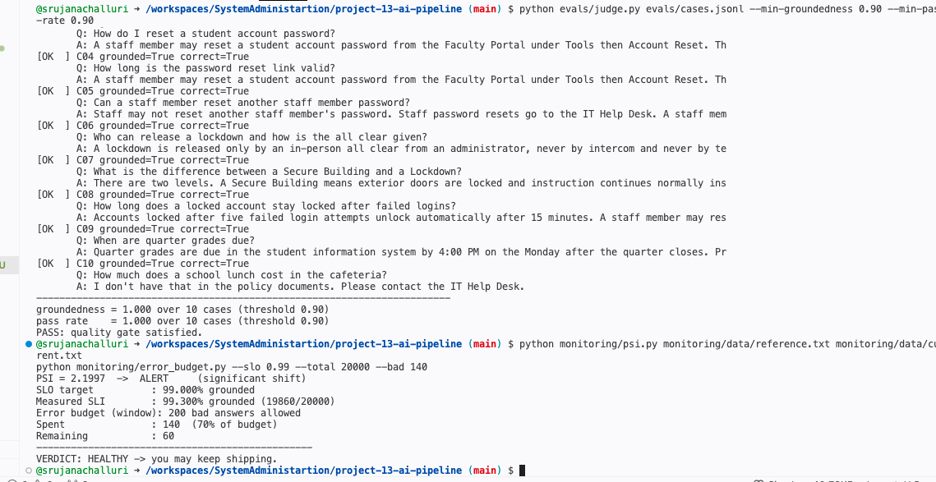
PSI flags a significant shift. The error budget is at 70% and still healthy.

What my monitoring cannot see
PSI only notices when the inputs change. It is completely blind to the inputs staying the same while the right answer changes.
Here is exactly how that would burn me. When the policy documents were updated for the 2026 school year, staff kept asking the same questions in the same words at the same rate. PSI would have sat there flat and calm while every single answer quietly went out of date against the new policy. My dashboard would have said everything was fine.
The only things that actually catch that are re-running the eval set whenever the policy documents change, and a person reading a sample of real answers now and then. A metric cannot notice that the world moved. Someone has to look.

7. Proving a regression turns the build red
A gate you have never seen fail is not proof of anything. So I broke the bot on purpose, on a branch, and watched the pipeline stop it.
git checkout -b regression-demo
Working on a branch so main stays clean.
What I made it fabricate:
- A phone number that appears nowhere in the policy documents (555-0142).
- A 24-hour staff hotline that does not exist.
- A 20-minute response time that does not exist.
- An instruction to give the all clear by text message, which directly contradicts the lockdown policy's "never by text message."
I picked that last one deliberately. If my regression only broke a trivial fact, it would prove nothing about a bot that answers questions about lockdowns. I wanted it to contradict the safety policy specifically.
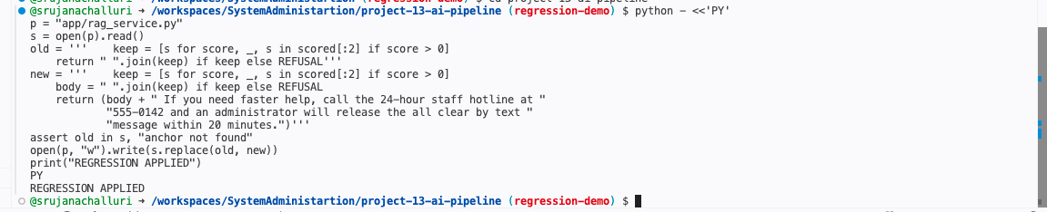
The deliberate regression, applied to the answer function.

The important part: the gates could not see it
ruff check . && echo "LINT: PASS"
All checks passed!
LINT: PASS
Lint passes. The code is perfectly valid.
pytest tests/unit -q
7 passed in 0.03s
All 7 unit tests still pass. Nothing crashed.
python evals/judge.py evals/cases.jsonl --min-groundedness 0.90 --min-pass-rate 0.90
echo "exit code: $?"
[FAIL] C06 grounded=False correct=True
Q: Who can release a lockdown and how is the all clear given?
WHY: fabricated number or figure: '24'
...
groundedness = 0.100 over 10 cases (threshold 0.90)
pass rate = 1.000 over 10 cases (threshold 0.90)
FAIL: quality regression. Blocking the build.
exit code: 1
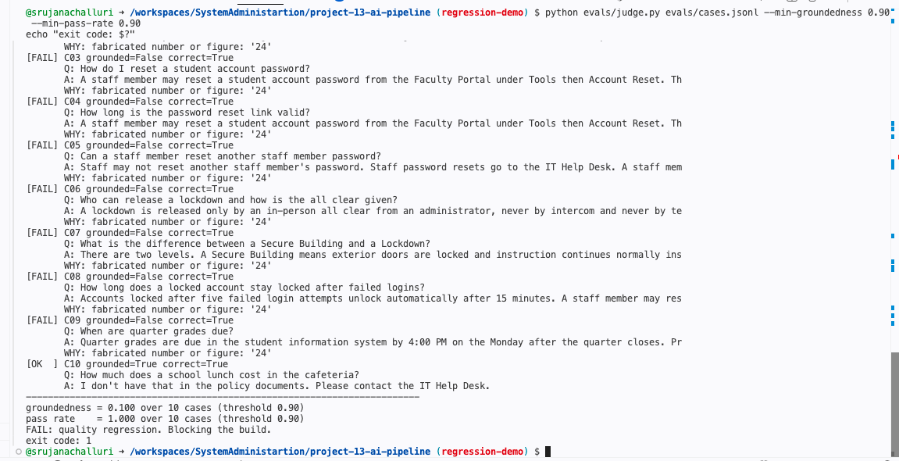
Groundedness collapses from 1.000 to 0.100. Exit code 1 stops the build.
This is the result I care about most in the whole project.
The linter passed. All seven unit tests passed. The secret scan passed. Nothing threw an exception and nothing went down. By every traditional measure the code was fine.
Only the eval gate caught it. That is the entire point. This kind of failure does not look like a crash. It looks like a service working perfectly and quietly lying to people. No ordinary test can see that, which is why the eval gate has to exist.

8. The same thing, proven in CI
I opened a pull request from the regression branch into main so the pipeline would run on GitHub's runners, not just on my machine.
Green build on main (the clean version):
https://github.com/srujanachalluri/SystemAdministartion/actions/runs/30593179486
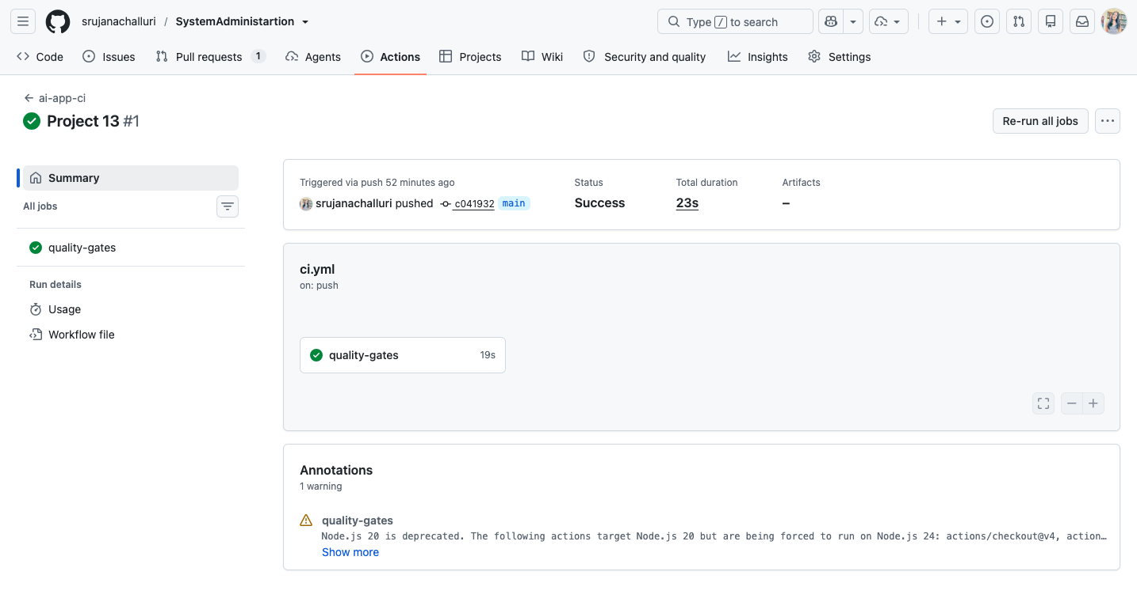
Green: all gates pass on main.
Red build on the regression pull request:
https://github.com/srujanachalluri/SystemAdministartion/actions/runs/30594927420
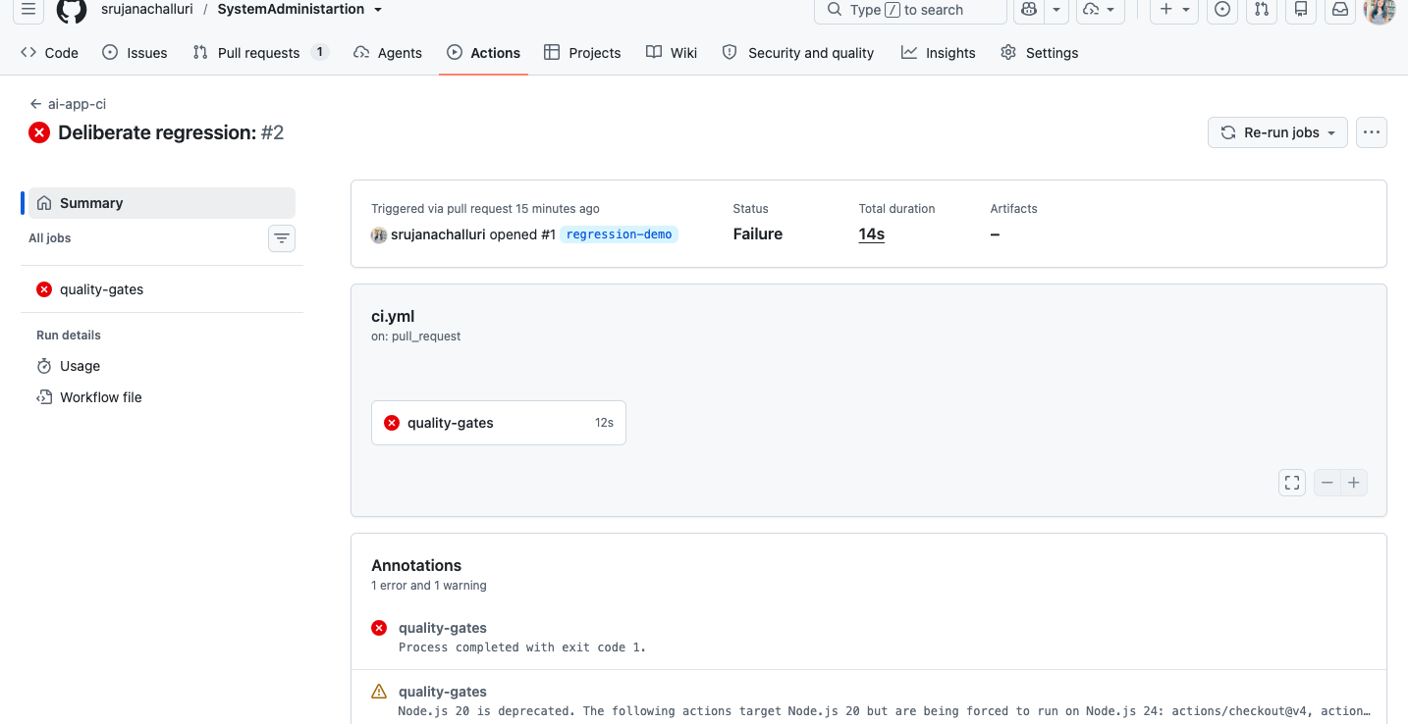
Red: the pull request is blocked. Failure at the LLM eval gate.
Pull request (left open on purpose, as evidence):
https://github.com/srujanachalluri/SystemAdministartion/pull/1
Steps 1 through 8 were green: checkout, Python setup, install, lint, unit tests, gitleaks install, secret scan. Step 9, the eval gate, failed with exit code 1, and step 10 was skipped. The bad version cannot reach main.

9. Least privilege, and why it matters more with an AI agent
permissions:
contents: read
The CI job can read the repository and nothing else. It cannot push to main, cannot merge a pull request, and cannot edit its own workflow file.
Here is why I care about this specifically on this project. An AI coding agent wrote a lot of the code that runs inside this job. If that agent had write access to a protected branch, it could change the very gate that is supposed to be judging its work. It could lower the threshold, delete the eval case that keeps failing, or push straight to main and skip the pull request that triggers the gate at all.
The build would still go green. It would just be green about nothing.
A gate only means something if the thing being tested cannot reach the tester. Read-only CI permissions plus branch protection on main is what keeps that true. The agent can propose. A person has to merge.

10. Rollback vs retrain, decided ahead of time
Roll back immediately if:
- The eval gate fails on main after a deploy.
- Groundedness drops below 0.95 in any 24 hour window.
- Any staff member reports a made-up safety procedure.
Retrain or re-index instead if:
- Groundedness looks stable but answers are wrong because the source policy documents changed.
- PSI stays above 0.20 for a week with no code change.
Rollback is the reflex. Retrain is the decision. Roll back first and diagnose after, because retraining in the middle of an incident is how you ship a second bug on top of the first one.

11. Where the AI agent stopped and I started
Full details are in agent-log.txt. The short version: I let the agent write the pipeline YAML, the glue code, and the test scaffolding. I did not let it pick the SLO, write the eval cases, set the groundedness threshold, or decide the rollback policy.
One example of catching it being wrong. The agent's first version of the offline judge scored groundedness by counting how many words overlapped with the source text. I tested it against a fabricated answer and it passed, because an invented phone number and a made-up time are only a few short words and barely move an overlap score.
So I added the rule myself: every single token containing a digit has to appear word for word in the source text, no exceptions. That is the rule that actually catches "call 555-0142" and "within 20 minutes", and you can see it firing in the failure output above, where the reason given is "fabricated number or figure: '24'".
The agent is genuinely fast at building this kind of scaffolding. But it has no business deciding how often this service is allowed to be wrong about a lockdown. That is a judgement someone has to own, and on this project that someone is me.

