Network Traffic Analysis Report
Project 5 - Read the Traffic | Chapter 5: Network Services and the Watch on the Wire
Sareena Challuri
I am the network "watchman." I first learned what normal traffic looks like for each computer on the campus network (from 30 days of data). Then I looked at one suspicious hour and found three problems. Below I show each command I ran, a screenshot of its output.

Step 1 - The files in my project
This shows the code and data files that make up my project.
Command to run:
Ls-la:
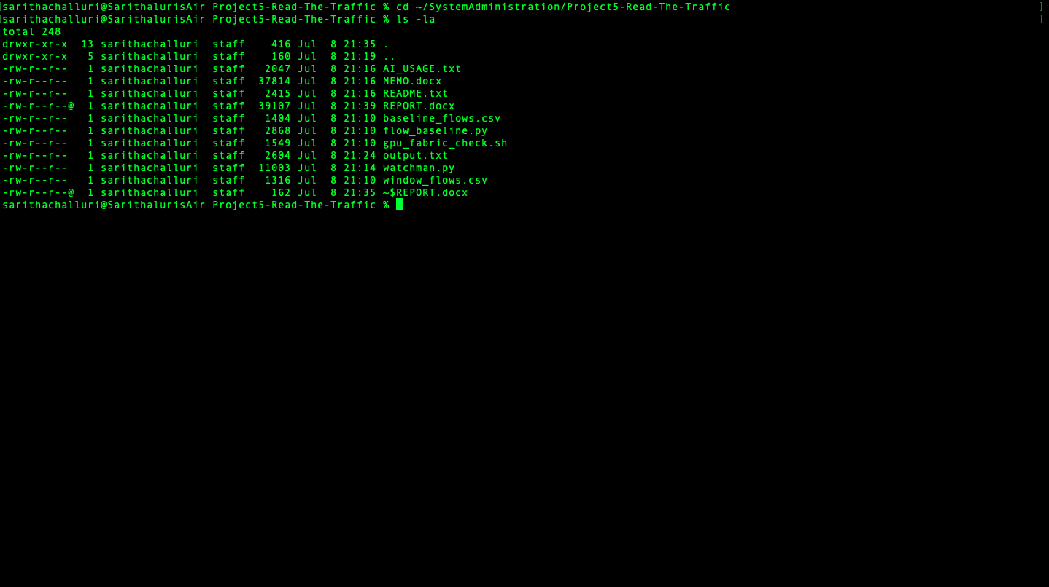

Step 2 - What "normal traffic" looks like (the baseline)
This file is 30 days of normal traffic, boiled down. It is my "ground truth." I never call anything suspicious until I know what normal looks like. Notice at the bottom it says: no normal computer ever talks to an outside address on a high port at a fixed timer.
Command to run:
cat baseline_flows.csv
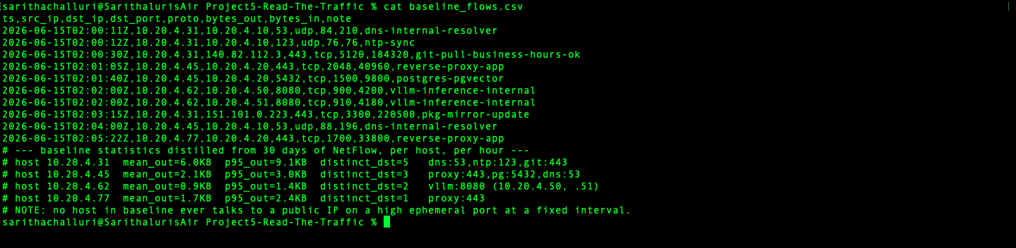

Step 3 - The one suspicious hour
This is the single hour the IT director said "felt off." Three attacks are hidden inside it. My job is to find all three and prove why each one is bad.
Command to run:
Cat window_flows.csv
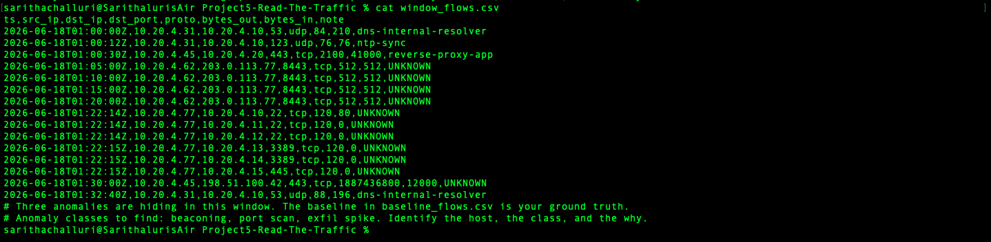

Step 4 - Run my detector:
This is my program. It builds a profile of each computer's normal behavior, then compares the suspicious hour against each computer's OWN normal - not one single rule for everyone. For every alert it prints a "WHY" line so a human can double-check it.
Command to run:
Python3 watchman.py baseline_flows.csv window_flows.csv

What I found (3 problems):

Problem 1 - A computer "phoning home" (beaconing)
- Computer 10.20.4.62 (the AI server) messaged an outside stranger (203.0.113.77) once every 5 minutes exactly, sending the same tiny message each time. This computer normally only talks to two computers inside our own network. A perfect timer to a brand-new outsider is how remote-control malware checks in. WHY IT'S BAD: the destination is new AND the timing is robotic like repeating after every 5 minutes which is suspicious.

Problem 2 - Rattling the locked doors (port scan)
- Computer 10.20.4.77 connected to 6 different computers on their "admin" doors (remote-login ports 22, 3389, 445) all within one single second, and got no real answers back. This computer normally only ever talks to one other computer. WHY IT'S BAD: it is scanning for a way to spread, something it has never done before.

Problem 3 - Shipping out a huge box of data (exfil)
- Computer 10.20.4.45 (near our database) sent about 1.8 gigabytes of data out to the internet in one transfer. It normally sends only a couple of kilobytes - this is roughly 750,000 times larger than normal. WHY IT'S BAD: that is the size of someone copying our data off-site.

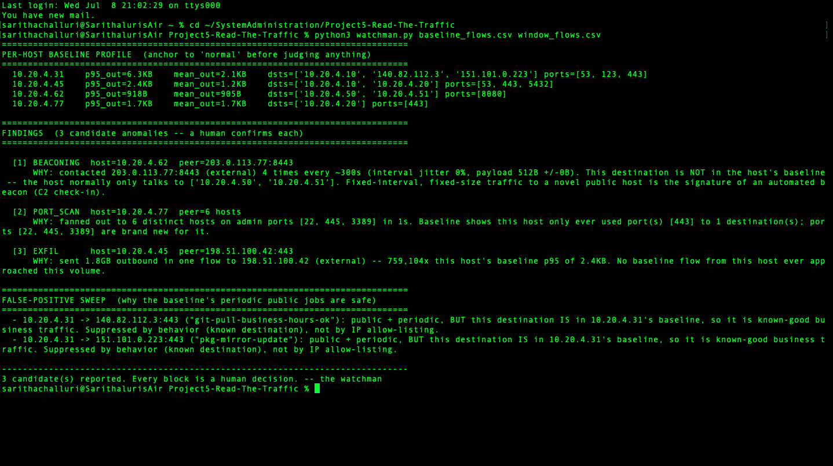

Why I did NOT raise a false alarm
The baseline has some normal jobs that also talk to the outside on a timer - software updates and code downloads (git pull, package mirror). A lazy detector would wrongly flag those as "phoning home." I did not, and NOT by ignoring their addresses. I ignored them because their behavior is known-good: those outside addresses already appear in that computer's normal baseline. The beacon in Problem 1 is different because its address is brand new. Reading the destination, not just the timing, is what tells them apart.

My recommendation to the IT director
There are three real problems on three different computers. My suggested order:
- First, check the 1.8 GB transfer (Problem 3): ask if it was an authorized backup before taking the donation/database server offline - we don't want a false alarm on a Sunday. If no one owns it, isolate that computer.
- Second, quarantine the AI server (Problem 1) now - a 5-minute "phone home" has no innocent explanation and it is low-risk to unplug.
- Third, review the scanning computer (Problem 2) to see what program was running at 1:22 AM.

References: I used w3schools to understand the syntax and logic to write the watchman.py python file, I also used CHATGPT to get the basic logic idea of the project.

