Grace and Mercy Lutheran Ministries: AI Estate Sizing
Project 4, Chapter 4 (Storage Administration)
Prepared by: Sareena Challuri
Date: July 2026

1. Summary and Recommendation
My though is to run the 13B model at INT8 precision on the 48 GB graphics card the ministry already owns. When it is running it needs about 16 GB of card memory, which leaves plenty of room, the quality is essentially full quality, and it costs nothing new in hardware. The 70B model only fits a single 48 GB card in its most compressed form, and even then, only for short prompts and one user at a time, so it would fail under real use.
For the document search system, I recommend storing the vectors in the halfvec format, which uses two bytes per number instead of four. My plan sets aside about 48 GB for that vector store. This is important, because when I built a small version of the database and measured it, the real size was about two and a half times larger than the simple textbook estimate. The whole AI system needs about 75 GB of primary storage, and closer to 150 to 200 GB once you include backups and disaster recovery.
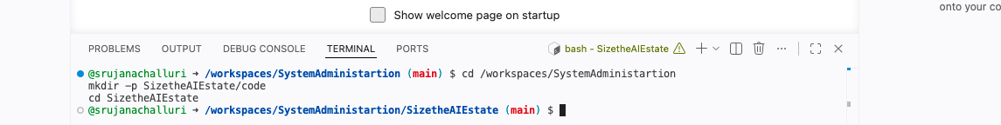
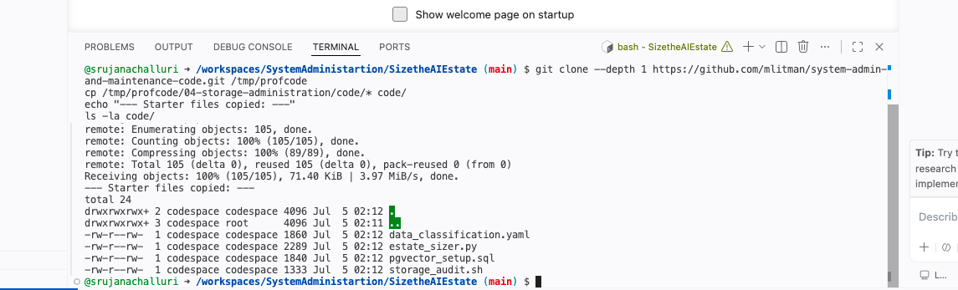

2. Model Sizing
A 13B model stored at INT8 takes about 12 GB on disk. When it is running it needs more memory than the file size, because the model also holds the conversation in a working memory, plus some overhead from the serving software. That adds roughly 30 percent, so about 16 GB of card memory in practice. And I think, ministry’s 48 GB card handles this comfortably.
The 70B model is a different story. At INT8 the weights alone are about 65 GB, which is already larger than the 48 GB card, so it would need two cards or a single 80 GB card. It only fits one 48 GB card if you compress it all the way to INT4, about 33 GB, and even then, the working memory leaves almost no headroom. The lesson is that the file size on disk is not the memory a model needs to run. A budget built on the file size alone buys a card that runs out of memory. The full arithmetic is in SIZING.txt files.
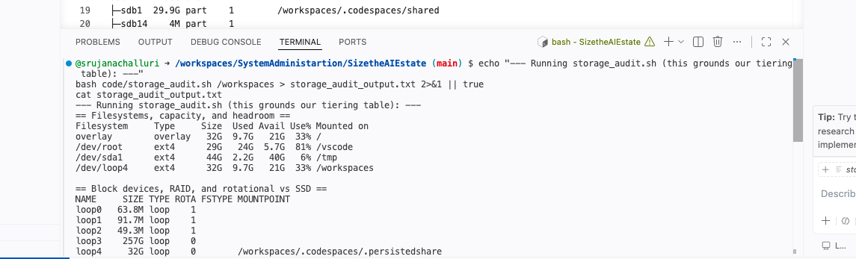

3. The pgvector Proof: Predict, Then Measure
I did not guess the size of the vector store. I built a real one. I started a Postgres database with the pgvector extension, created the table with a 1536-dimension half vec column, loaded 50,000 real vectors, which is one percent of the planned five million, built a real search index, and then measured what it took on disk.
My simple prediction was about 165 MB. The databae used 398 MB, Of that, only about 4 MB was the main table, 202 MB was the vector data itself.
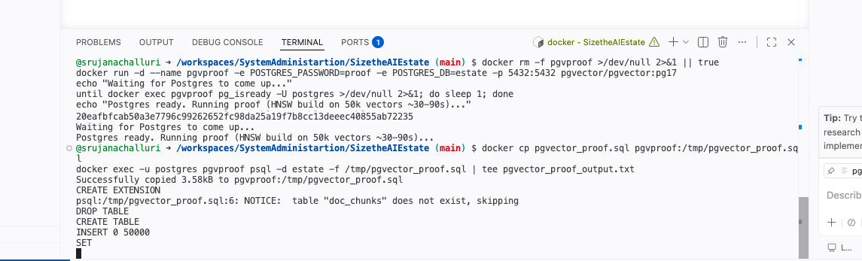
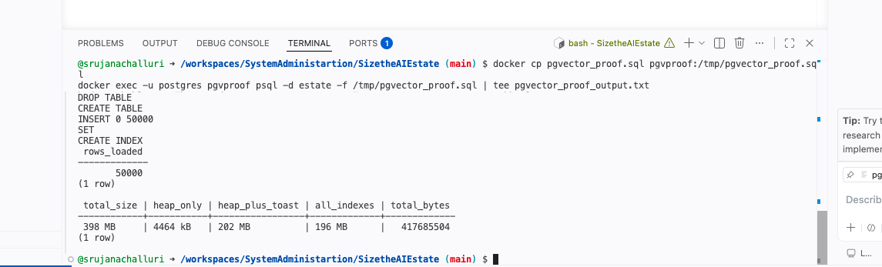
The measured size was more than double my simple prediction, index stores its own full copy of every vector.
Scaling this up to the real five million chunks, the store works out to about 39 GB for the vectors and index, plus about 9 GB for the real chunk text, so about 48 GB in total.

4. Grounding the Storage Tiers in Real Output
I ran the read only storage audit script to check the real disk which showed that the working volume is solid state, while some of the raw disk’s report as spinning, so I verified the media instead of guessing.
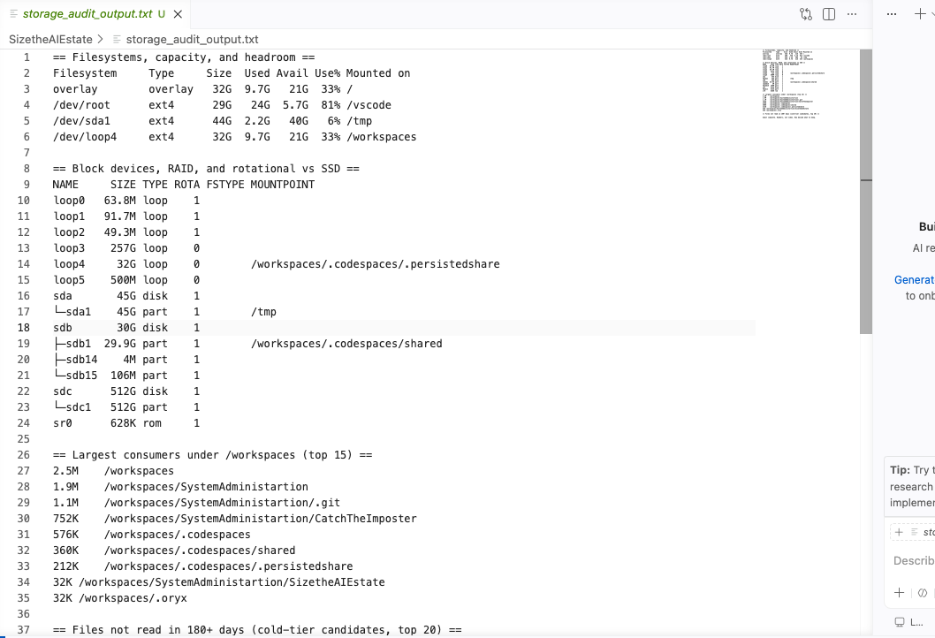
Based on this, the model weights and the search index go on they are read constantly, and users are waiting on them. The original documents and the logs go on slower and cheaper storage, because they are read rarely. The full tiering table is in SIZING.txt file.

5. Quantization Trade Study for the 70B
If the ministry ever runs the 70B model, the precision it is stored at changes both the cost and the quality. As of 2026 the rough picture is as follows.
Full precision is about 130 GB on disk and about 170 GB to run. It has the best quality but needs a three-card server.
INT8 is about 65 GB on disk and about 85 GB to run. Its quality is almost identical to full precision, and it needs two 48 GB cards or one 80 GB card.
INT4 is about 33 GB on disk and about 42 GB to run. It has a small but real quality drop on harder questions, and it fits a single 48 GB card, but only just. My recommendation is that if the 70B is ever used, INT8 is the ost, but it does require a second card. INT4 is only worth it if a single 48 GB card is a hard budget limit, and the work is short drafting tasks.
7. Policy Memo to Ministry Leadership:
What to Keep and What “a time to keep, and a time to cast away.” Ecclesiastes 3:6 Every asset falls into one of three groups. Some things are irrre lost they are gone for good. Some are reproducible, meaningif they are lost we can rebuild them. And some are a liability, meaning keeping them too long is itself a risk.
The irreplaceable things are the fine-tuned model, which can only be made again from the private training data, and the original ministry documents such pastoral notes, which may exist nowhere else. These get kept in the reproducible things are the base model, which we can downlohich we can rebuild in a few hours, and the vector data, whichwe can regenerate from the source documents. These are kept while they are in service and simply rebuilt if lost.
The liabilities are the private training data, which contains personal information, and the usage logs. Holding personal data longer than needed is a legexposure, so the training data is kept encrypted for a bounded g enough to retrain the model once if needed, and then deleted. The time for the high-risk rules is still in flux as of 2026, with a de late 2027, so I treat those dates as provisional and something to reconfirm rather than rely on.
The hardest decision is the private training data. Keeping it is the only way to rebuild the irreplaceable fine-tuned model after a change, but every dayhold personal data is a risk. Software can suggest a label from the file details, but it cannot weigh this the people whose information this is. A person must make that call.
8. AI Usage:
I worked the sizing math from the Chapter 4 formulas and checked it two ways, against the estate_sizer.py script and against a live database measurement that I ran myself.
I used an AI assistant to help set up the docker, Postgres database and check my arithmetic calculations.

