Project 2: Diagnose the Failure Twice
Project 2 – Diagnose the Failure Twice
Sareena Challuri | Week 2 | Jun 28, 2026
Incident A: The memory crash:
- Root cause: ollama (PID 8423) using 15994208 KB (~16 GB)
When I ran the process list, I saw one program, ollama model server, consumed ~16 GB of memory while pinne at 98.7% CPU. The system ran out of RAM and the kernel killed it.
I verified these log files below attached the screenshots for reference:
evidence/sample-incident.log, evidence/sample-dmesg.log, evidence/sample-ps.txt
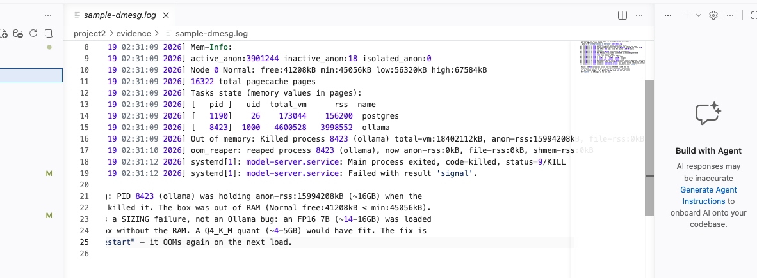
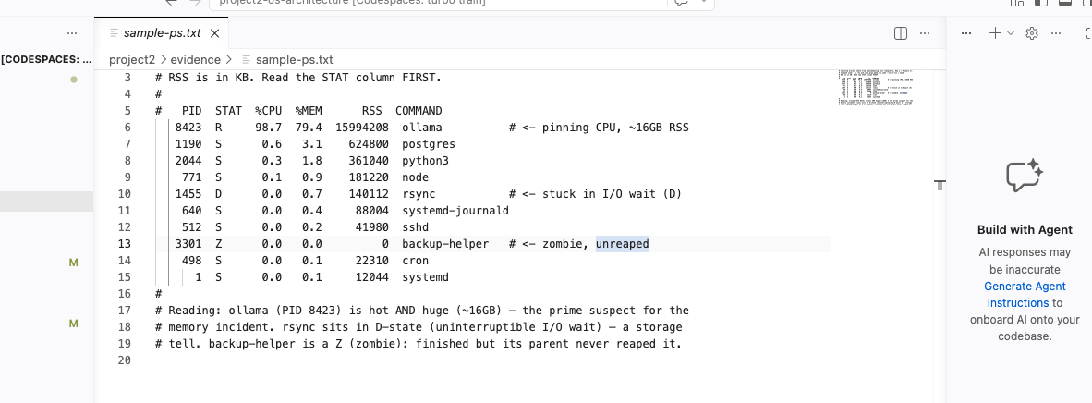
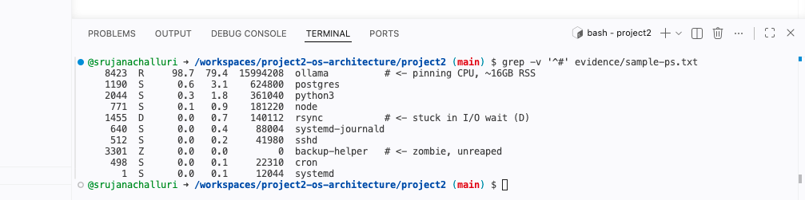
- Bottleneck: It's a memory problem
The bottleneck is memory because the process was killed for running out of RAM, and it then crash-looped (it died, restarted, and died again):
WARN KV cache pre-allocated for context=32768, batch=4
Out of memory: Killed process 8423 (ollama) ... anon-rss:15994208kB
Out of memory: Killed process 8590 (ollama) ... anon-rss:15991002kB (the loop)
- Smoking gun:
Out of memory: Killed process 8423 (ollama) ... anon-rss:15994208kB
This is the line from the kernel log that proves it and the OS itself says it killed ollama because it was out of memory provided the screenshot below:
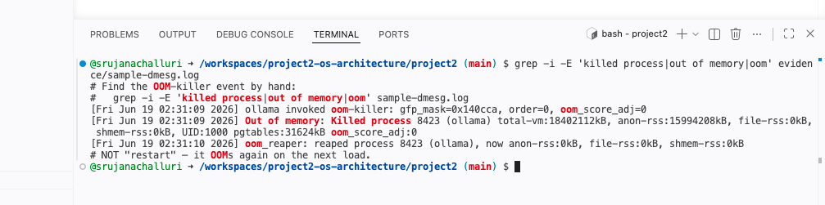
- The fix:
I think, Just restarting server wouldn't help it would crash again on the next load (that's why I saw two kills on loop). The real fix is to use a smaller size model which consumes less space or add more RAM. I confirmed this with the sizing math by python code: the model needed about 31.91 GiB but the box only had ~16 GB, so it does NOT fit on a 16 or 24 GB box.

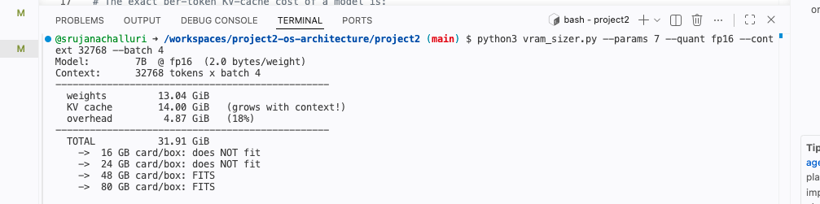
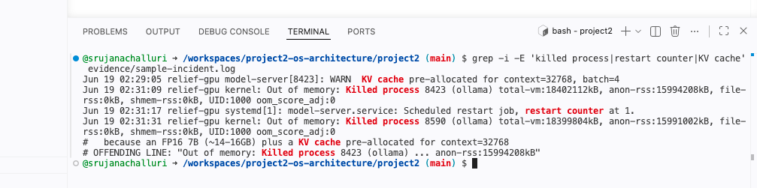
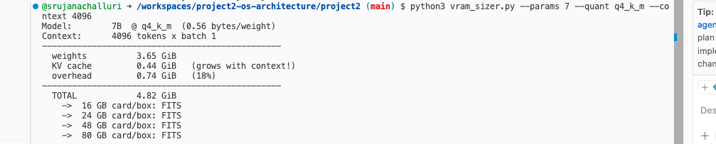
Incident B (the dead service):
- Root cause: The service kept restarting because of a wrong database password.
The case-notes app kept crashing and restarting in a loop because it could not log in to its own database.
- Bottleneck: A dead/failed service and it is a configuration problem, not a code error.
This one is a failed service caused by a configuration mistake, the wrong credentials, not anything broken in the program itself.
- Smoking gun: FATAL: password authentication failed
Jun 19 09:02:12 ... ERROR could not connect to database: FATAL: password authentication failed for user "casenotes"
Jun 19 09:02:12 ... FATAL startup aborted: database unavailable
The very first error line shows the real cause — the password authentication failed. Every restart after that is just the same failure repeating.

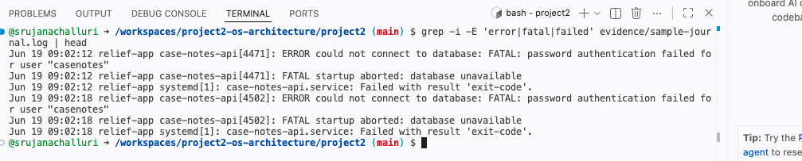

- The fix: Correct the database password and restart the service. Once the login works, the restart loop stops.

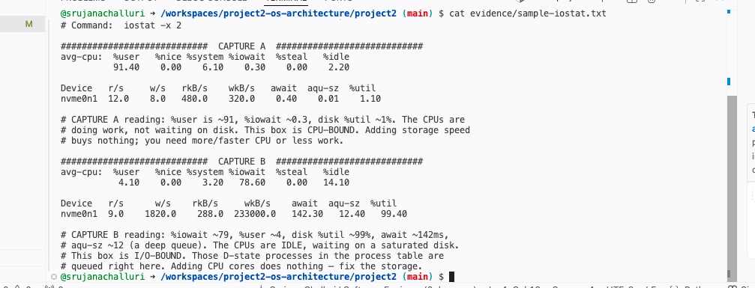

The differences between my method of identification and the AI's response:

- I worked from the raw output up using commands running in the terminal and looking carefully at the log files provided. I ran the commands like ps, grep, vram_sizer.py and read each column myself.
- The AI only worked from the text I pasted into it, and it never touched the machine.
- I also tried to prove the fix with math but the AI just assumed it.
- I ran the sizing calculator and saw 31.91 GiB vs a 16 GB box.
- The AI said just said that "the model is too big” but didn't actually calculate the real numbers.
- For database password, AI might make mistake and access to real database might breach the data at later point of time.
- The AI was very confident, with no doubt at all. buT I checked every line it quoted against the real log before trusting it.

From this project what I understood was, for errors like this reading the STAT column and the memory number first from the log files, which are like an out-of-memory crash is really a math/sizing problem, and that we should never trust an AI's confidence without checking the raw logs.

AI usage

- AI used: Claude (claude-opus-4-8)
- Used for: A second-opinion diagnosis of both incidents.
- Did I override it: It agreed with my hand diagnosis, so I didn't need to override it, but I verified every line it quoted against the raw logs before trusting it.

