Project 1: From Runbook to Copilot:
Author: Sareena Challuri
Course: System Administration and Maintenance · Date: 2026-06-25
Lab: GitHub Codespaces (Ubuntu Linux + Docker)
1.What I built:
As the only system administrator for St. Augustine Lutheran School and Parish, I oversaw the giving portal and parish website ("ministry-web"). For that service, I created a proven, runnable recovery procedure. I next investigated whether an AI copilot could be relied upon to design the same procedure. Ubuntu and Docker are running on a GitHub Codespace in my lab. I launched ministry-web as a tiny nginx container on port 8080 with a true health endpoint at /healthz as Codespaces does not use systemd. This gave my runbook something authentic to check against. A hand-verified runbook, a runnable restart script, the unedited AI draft, a line-by-line verdict, a hardened linter, an AI-usage policy, and this report are the seven artifacts that I delivered.
2. The service is real (proof):
The health endpoint returns a real answer, so "healthy" means the page actually responds: curl -i http://127.0.0.1:8080/healthz
HTTP/1.1 200 OK
Server: nginx/1.30.3
Date: Thu, 25 Jun 2026 23:53:09 GMT
Content-Type: application/octet-stream
Content-Length: 3
Connection: keep-alive
Content-Type: text/plain
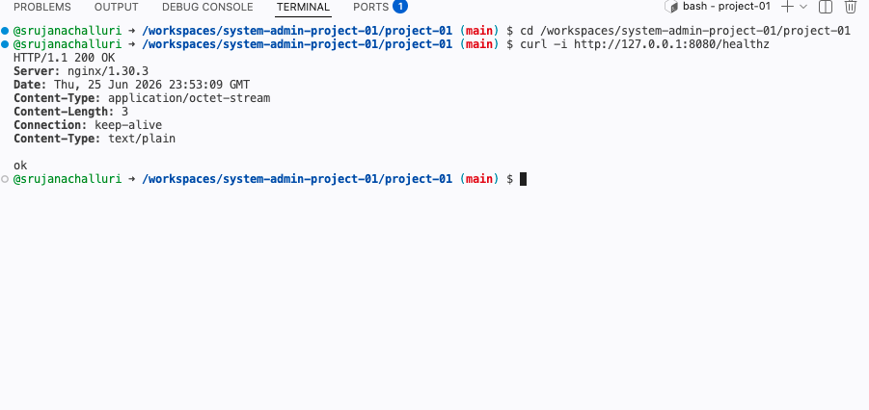

3. The verified runbook and the script:
I wrote runbook-verified.txt by hand in the confirm , capture, change, verify shape: it confirms the container exists before touching it, captures the current logs as evidence before any change, restarts the container, then verifies health by calling /healthz and requiring HTTP 200 with body "ok". I ran every step and pasted the real output under each, so the runbook is proven, not imagined. I then turned it into restart-service.sh, adapted from the course starter (which targeted systemd) to my Docker setup. A normal run ends healthy with exit code 0:
./restart-service.sh; echo "exit=$?"
2026-06-25T23:54:14+00:00 [restart-service] Restarting ministry-web ...
2026-06-25T23:54:18+00:00 [restart-service] OK: ministry-web is healthy (HTTP 200, body 'ok')
exit=0
To prove the script never mistakes "started" for "healthy", I deliberately made /healthz return 503. The container still started, but the script printed FAIL and exited non-zero (2); healing it returned exit 0:
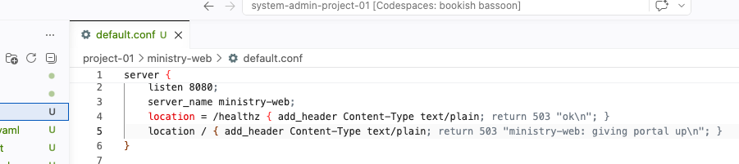
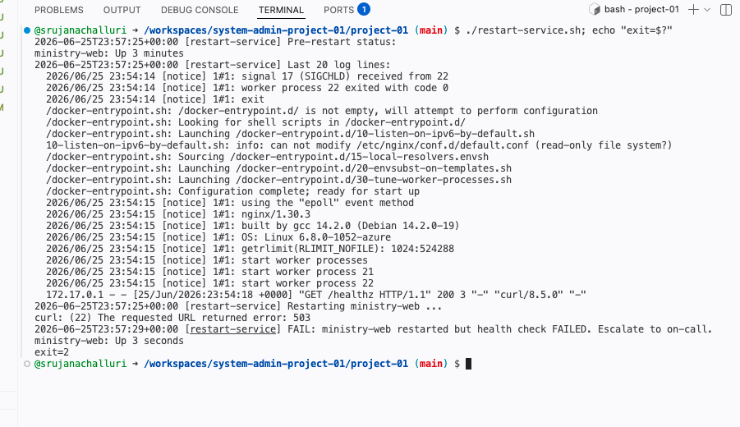
This is the project's central lesson, which is started is not healthy.

4. Where the AI helped:
Used as a first-draft generator. It produced a plausible, well-structured runbook in seconds and reminded me of the general shape of an incident response check status, restart, watch logs, verify, escalate. To avoid a blank page, it saved time.
5. Where the AI hallucinated (with examples) :
The AI draft (runbook-ai.txt, Claude Opus 4.8) was confident but wrong in ways that would have caused real damage.
- Wrong platform: every step assumed systemd (systemctl, journalctl); my box runs Docker, so none would manage ministry-web.
- Hallucinated identifier: it restarted "ministry-webserver.service"; the real service is "ministry-web", so the restart would hit nothing.
- Started ≠ healthy: it "verified" success with systemctl is-active, which only proves the process started, not that the page responds.
- Confident-but-wrong number: it set nginx worker_connections to 999999, an absurd value far beyond the file-descriptor limit, from a guessed root cause.
- Destructive: it ran sudo rm -rf /var/log/journal/*, deleting the logs needed for a postmortem.
- Invented syntax: it set Restart=always-immediately, which is not a valid systemd value and would fail to load.
I recorded every line in verdict.txt as verified, wrong, or unsafe with its error class and my final call.

6. The hardened linter (and why each new rule exists) :
verify_runbook.py is the course starter linter, which I hardened with four new rules beyond the shipped set. Each rule's intent:
- systemctl/journalctl - flags an unverified systemd assumption (my host is Docker).
- is-active - flags "started" used as a health check instead of a real endpoint.
- ministry-webserver - flags the wrong service name that would restart nothing.
- nginx -s reload - flags reloading after an unverified config edit.
Run against the AI draft, it produced 11 flags:
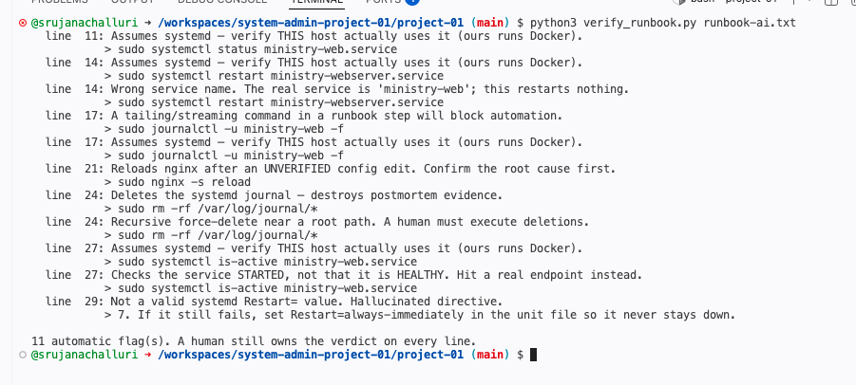
The linter is not my judgment; it catches mechanical traps so I can spend attention on the subtle ones.
7. My verdict on trusting this copilot :
I would not trust this copilot to act on ministry-web unsupervised. Of its eight steps, none were correct as written for my host, one was acceptable with a fix, four were wrong, and three were unsafe. It is valuable as a drafting aid at rung 1, but every line needs human verification against the real host. My copilot_policy.yaml encodes exactly that.

8. AI usage note (honest):
I used Claude (Opus 4.8) to help set up the Codespaces lab, and to generate the unedited AI draft I then critiqued. I wrote the verified runbook completely myself, ran every command on the lab box, and made all the verdict calls. The mistakes in the AI draft are real examples of unverified AI output and catching them was my work.
Sareena Challuri

