**Validation Results**

**Srujana Damarla**

**11293448**

1. **Validation results for Assignment 1 (Home Page)**

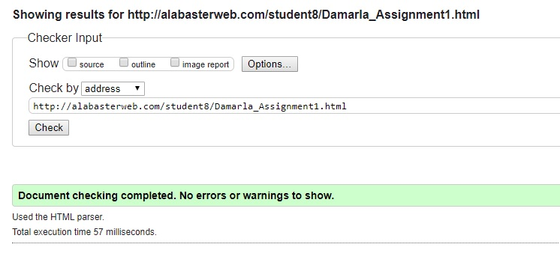

1. **Validation results for Assignment 2 (Contact Page)**

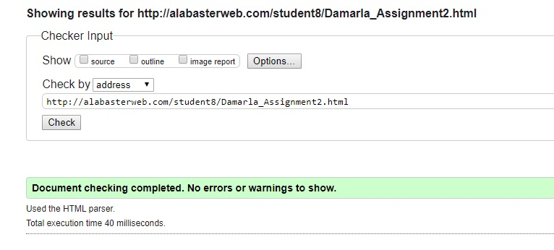

1. **Validation results for Assignment 3 (Registration Form Page)**

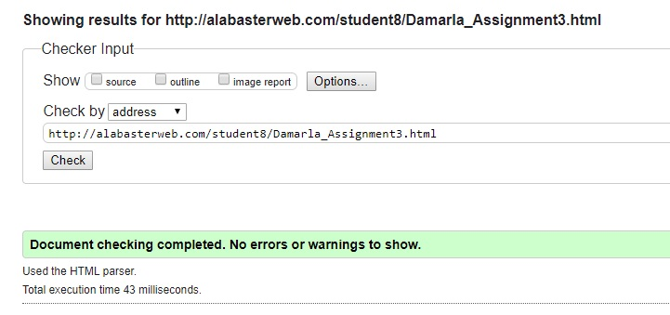

1. **Validation results for Assignment 5 (Movie Trailers Page)**

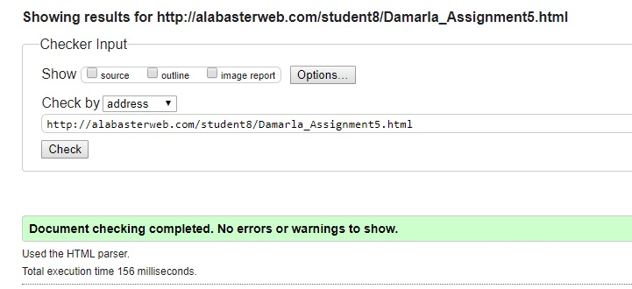

1. **Validation results for Final Project (About Page)**

