

## April 2024

Air Quality Inspection Using MQ-135

*Project Report Submitted to*

## MANIPAL ACADEMY OF HIGHER EDUCATION

*For Partial Fulfilment of the Requirement for the Award of the Degree*

*Of*

## Bachelor of Technology

*in*

## Information Technology

*by*

## Abhisar Yadav, Srujana Madiraju, AryaSai Koyyana, Aditya Kumar

## 220911350, 220911352, 220911354, 220911364

*Under the guidance of*

Dr. Satyajit Mahapatra Dr. Pankaj Kumar

Assistant Professor Assistant Professor

Department of I&CT Department of I&CT

Manipal Institute of Technology Manipal Institute of Technology

Manipal, Karnataka, India Manipal, Karnataka, India

# ABSTRACT

The primary objective of this project is to develop an Air Quality Inspection System using the LPC1768 microcontroller to regulate air quality within a predefined range. The system employs an MQ-135 air quality sensor to monitor pollutant levels and adjusts a ventilation fan's speed accordingly. In contemporary scenarios, the MQ-135 sensor is instrumental in measuring various air pollutants, providing essential safeguards against indoor air contamination and thermal damage to sensitive components such as batteries.

The design process involves integrating the MQ-135 sensor onto a breadboard and connecting its three pins (voltage, analog output, and ground) to the LPC1768 microcontroller using jumper wires. To ensure adequate power supply, a transistor and an external battery source are incorporated, complementing the microcontroller's voltage output. Internal circuit integration is facilitated, with a 1K resistor enabling voltage adjustment. The fan operates on a temperature-controlled basis, with the microcontroller enabling the Analog-to-Digital Converter (ADC) clock, selecting the appropriate ADC channel, powering it up, and executing ADC conversions. Upon temperature calculation, if the measured air quality surpasses a predefined threshold, typically set at hazardous levels, the microcontroller activates the fan by setting the respective pin high, effectively mitigating air pollution.

This project exemplifies the versatile applications of microcontrollers, particularly in environmental monitoring and regulation. With proper implementation, the Air Quality Inspection System can prevent air contamination, safeguard essential materials, and maintain optimal air quality within enclosed spaces. Furthermore, it underscores the potential for microcontrollers to regulate environmental conditions, highlighting their role in promoting healthier and safer living environments.

This project not only addresses the immediate need for air quality monitoring but also sets a precedent for sustainable environmental practices. By utilizing readily available components and implementing a cost-effective solution, it underscores the accessibility of such systems for widespread adoption.

Therefore, this project serves as a scalable model that can be adapted and deployed across various settings, contributing to healthier living environments and sustainable development initiatives.

# CONTENTS:

|  |  |  |
| --- | --- | --- |
| **S No.** | **Title** | **Page No.** |
| **1.** | **Introduction** | **4** |
| **2.** | **Methodology** | **5** |
| **2.1** | Components Required | **5** |
| **2.2** | Block Diagram | **6** |
| **2.3** | Description about connection | **6** |
| **2.4** | Method | **7** |
| **3.** | **Results and discussions** | **9** |
| **4.** | **Conclusion and Future Work** | **11** |
| **5.** | **References** | **11** |
| **6.** | **C code** | **12** |
| **7.** | **Similarity Report** | 1**5** |

1. **INTRODUCTION:**

In today's rapidly evolving landscape of environmental awareness and health concerns, precise monitoring and management of air quality have become paramount. At the forefront of this endeavor is the MQ-135 air quality sensor, a sophisticated device engineered to detect a wide spectrum of air pollutants and provide invaluable insights into environmental conditions. Leveraging the capabilities of the LPC1768 microcontroller, this project aims to integrate the MQ-135 sensor seamlessly, ushering in a new era of air quality inspection systems.

The MQ-135 sensor operates on the principle of detecting various gases and volatile organic compounds (VOCs) through changes in electrical conductivity. This dynamic response enables it to identify pollutants such as carbon monoxide, ammonia, benzene, and smoke, among others, making it a versatile tool for comprehensive air quality monitoring.

By harnessing the processing power and communication interfaces of the LPC1768 microcontroller, this project enables real-time data acquisition and analysis from the MQ-135 sensor. This integration facilitates precise measurement and quantification of air pollutants, empowering industries and communities to make informed decisions regarding air quality management and mitigation strategies.

The collaboration between the MQ-135 sensor and the LPC1768 microcontroller represents a synergy of advanced sensor technology and sophisticated control systems. Together, they offer a robust platform for monitoring indoor and outdoor air quality in diverse settings, ranging from industrial facilities and commercial buildings to residential homes and public spaces.

As environmental concerns continue to mount and regulatory standards become more stringent, the need for reliable air quality inspection systems has never been greater. Through this project, we embark on a journey to harness the capabilities of the MQ-135 sensor and LPC1768 microcontroller to address these pressing challenges, ensuring healthier and safer environments for current and future generations.

# METHODOLOGY

* 1. **Components required:**

## Hardware Requirements:

1. MQ-135 Air Quality Sensor
2. LPC1768 Microcontroller
3. 16x2 LCD Display
4. Breadboard
5. Jumper Wires
6. Resistors
7. Transistor
8. External Power Supply
9. PCB (Printed Circuit Board) (optional)

## Software Requirements:

1. Language: C
2. 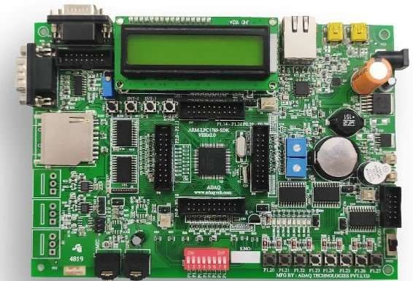Application: Keil Micro-Vision ,Flash Magic

**Figure 1: Hardware of LPC 1768 Kit**

# Block Diagram

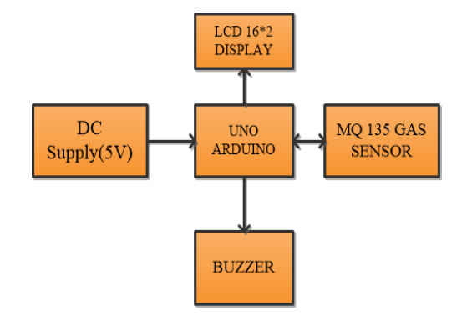

**Figure 2: Block Diagram of MQ-135 with LPC1768**

# 2.3. Description about connection

To establish the connection between the MQ-135 air quality sensor, LPC1768 microcontroller, and LCD display for air quality monitoring, begin by powering the MQ-135 sensor with a 5V source and connecting its analog output to an analog input pin on the LPC1768. For the LCD, link its RS, EN, and data pins to GPIO pins on the LPC1768 as specified in the code, alongside connecting its VCC and GND pins to power and ground. Implement voltage dividers if necessary for signal compatibility. In the code, configure the LCD pins and corresponding GPIOs, then program the microcontroller to read sensor data, process it, and display air quality readings on the LCD. Finally, validate the system's functionality through testing to ensure accurate and real-time air quality monitoring.

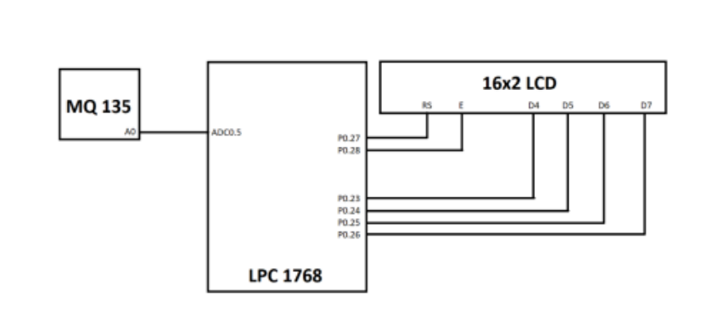

**Figure 3: Circuit Diagram of The Implementation [3]**

# 2.4 Method

Working Principle:

## LPC1768 Microcontroller:

The LPC1768 is a microcontroller based on the ARM Cortex-M3 architecture. Its primary function is to process digital and analog inputs, execute program instructions, and interact with various peripheral devices. The working principle of the LPC1768 involves the following key aspects:

* Central Processing Unit (CPU): The microcontroller's CPU executes program instructions stored in its flash memory. It performs arithmetic and logical operations, controls program flow, and manages data.
* Input/Output (I/O): The LPC1768 has various digital and analog input and output pins. It can read digital signals from sensors, control external devices, and interface with peripherals like displays, sensors, and communication modules.
* Memory: The microcontroller has both flash memory for program storage and RAM for data storage. It uses flash memory to store the program code that it executes.
* Peripherals: LPC1768 has various built-in peripherals, including UART, I2C, SPI, PWM, and ADC. These peripherals allow it to communicate with other devices and perform tasks like analog-to-digital conversion (ADC) to read analog sensor data.
* Programming: The microcontroller is programmed using a programming language like C/C++ and a development environment like Keil or Mbed. The programmer writes code to define the microcontroller's behavior, which is then compiled and loaded onto the microcontroller's flash memory.[2]

## .MQ-135 air quality sensor

## The MQ-135 sensor operates by heating a semiconductor material to a specific temperature, causing chemical reactions with gases in the environment. As certain gases are absorbed onto the semiconductor surface, they alter its conductivity, resulting in a change in the sensor's electrical resistance. This change in resistance corresponds to the presence and concentration of specific gases, allowing the sensor to detect and distinguish between different types of pollutants. Through calibration to establish a relationship between resistance and gas concentration, the MQ-135 sensor provides a reliable means of monitoring air quality and detecting harmful gases in various environments.

**AQI = ((I_high - I_low) / (C_high - C_low)) * (C - C_low) + I_low**

1. **Output through LCD:**

The data obtained from the MQ-135 temperature sensor is transformed into actionable insights through various output mechanisms in collaboration with the LPC1768 microcontroller:

**LCD**: Real-time temperature values are showcased on a LCD, offering a continuous and comprehensive overview of the environmental air quality.

In summary, the LPC1768 microcontroller manages the operation of the MQ-135 air quality sensor, processing its analog output to generate meaningful air quality measurements. The MQ-135 sensor, utilizing its ability to give precise air quality readings. The combined system effectively communicates temperature information through an LCD providing users with versatile tools for accurate and timely decision-making in various applications.

# RESULTS AND DISCUSSIONS:

The MQ-135-based air quality inspection system, calibrated within a predefined range, showcases unique responses to varying pollutant levels utilizing an LCD display for real-time monitoring. When exposed to high levels of pollutants, the analog values from the MQ-135 trigger alerts on the LCD, serving as a robust warning mechanism. This indicates poor air quality that requires immediate attention. In scenarios with moderate pollutant levels, the LCD displays values within an acceptable range. Conversely, in environments with low pollutant levels, the LCD indicates cleaner air. This dual-response system with the MQ-135 sensor and LCD display ensures accurate and timely feedback for effective air quality management, providing users with valuable insights based on real-time pollutant data.

1. **Analog Reading and Air Quality Determination:**

* The MQ-135 sensor detects air pollutants and provides analog readings.
* Air quality is determined based on the sensor readings, triggering corresponding actions.

1. **LCD updates:**

* The LCD displays real-time air quality values, allowing for continuous monitoring.

1. **Data Logging for Analysis:**

* The system logs air quality data, enabling long-term analysis.
* Data logging facilitates trend analysis, aiding in understanding air quality patterns over time.

1. **Ringing of buzzer:**

* When the AQI value is high then the buzzer is activated which indicates that the air quality is bad enough.

AQI>300 is the limit for average air quality.

## Relevance:

This project featuring the MQ-135 air quality sensor, LPC1768 microcontroller, and LCD display offers practical applications in real-world scenarios, particularly in maintaining optimal indoor air quality. By automatically detecting and displaying pollutant levels, the system empowers users to take proactive measures to improve air quality, such as adjusting ventilation systems or using air purifiers when necessary. With its ability to provide real-time feedback and data logging capabilities for trend analysis, this system contributes to creating healthier and safer indoor environments. Furthermore, its versatility allows for integration into various settings, from residential spaces to industrial facilities, highlighting its significance in promoting better air quality management practices and enhancing overall well-being for dynamic adjustments, showcasing the versatility of this integration in providing automated solutions for temperature regulation in various settings.

**DEMONSTRATION OF AIR QUALITY VALUE USING LPC1768 AND MQ-135**

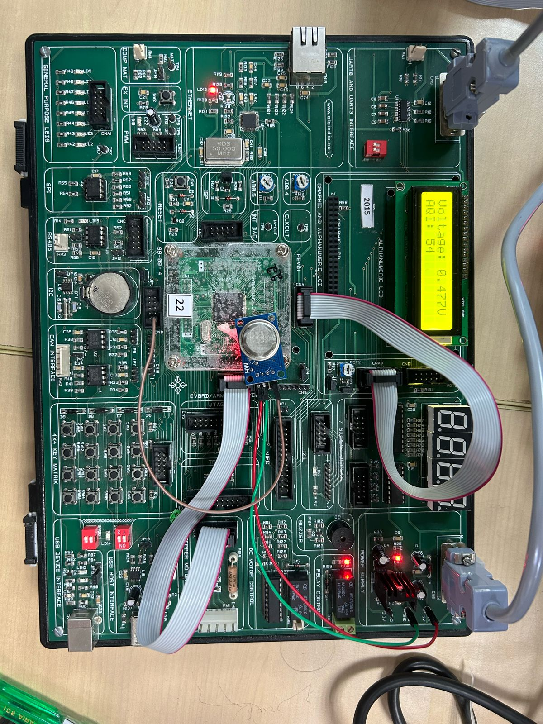

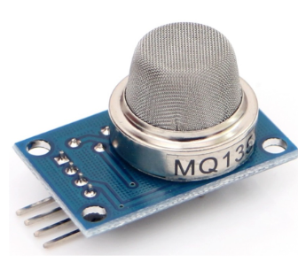

# 4. CONCLUSION AND FUTUREWORK:

The project focusing on air quality inspection utilizing the MQ-135 sensor exhibits a commendable achievement in developing a robust system for real-time monitoring and management of indoor air quality. Through the integration of the LPC1768 microcontroller and the MQ-135 sensor, the system efficiently detects pollutant levels, provides accurate air quality data, and initiates automated responses tailored to environmental conditions. Similar to the temperature-based stepper motor control system, this innovative project ensures precise measurement of air quality parameters and dynamically adjusts ventilation or purification systems based on pollutant levels detected by the MQ-135 sensor. Real-time air quality data is displayed on an LCD screen, facilitating continuous monitoring and informed decision-making by users. Additionally, the system automatically triggers actions such as activating ventilation fans or air purifiers when pollutant levels exceed predefined thresholds, contributing to maintaining healthy indoor environments. The successful implementation of this project underscores the team's proficiency in sensor integration, data processing, and microcontroller programming. Overcoming challenges during development highlights the team's adaptability and problem-solving abilities in addressing complex environmental monitoring requirements. As advancements in sensor technology and microcontroller capabilities continue to evolve, the knowledge and experience gained from this project lay a solid foundation for future innovations in air quality management systems and IoT applications. This project's contribution to enhancing indoor air quality monitoring and management exemplifies its significance in promoting healthier living environments and advancing environmental sustainability initiatives.

## FUTURE SCOPE:

Several future opportunities for this technology:

The project showcasing air quality inspection using the MQ-135 sensor presents promising avenues for future development and expansion. Some potential future scope includes:

**Enhanced Sensor Integration:** Integrating additional sensors for measuring various air quality parameters such as carbon monoxide (CO), nitrogen dioxide (NO2), sulfur dioxide (SO2), and particulate matter (PM) can provide a more comprehensive understanding of indoor air quality.

**IoT Connectivity:** Implementing Internet of Things (IoT) capabilities to enable remote monitoring and control of the air quality inspection system. This would allow users to access real-time data and receive alerts or notifications regarding air quality status via mobile applications or web interfaces.

* + .

# REFERENCES:

# ] Saha, Arnab Kumar, et al. "A raspberry Pi controlled cloud based air and sound pollution monitoring system with temperature and humidity sensing." 2018 IEEE 8th Annual Computing and Communication Workshop and Conference (CCWC). IEEE, 2018.

# [2] Choiri, Aulia, et al. "Real Time Monitoring Approach for Underground Mine Air Quality Pollution Monitoring System Based on IoT Technology." 2021 IEEE International Conference on Automatic Control & Intelligent Systems (I2CACIS). IEEE, 2021.

# [3] Shah, H. N., Khan, Z., Merchant, A. A., Moghal, M., Shaikh, A., & Rane, P. (2018). IOT based air pollution monitoring system. International Journal of Scientific & Engineering

# C CODE with comments:

#include <lpc17xx.h>

#include <stdio.h>

#define refVtg 5

#define digitalMax 0xFFF

#define RS_CTRL 0x00000100 //P0.8

#define EN_CTRL 0x10000200 //P0.9

#define DT_CTRL 0x000000F0 //P0.4 TO P0.7

unsigned long int init_command[] = {0x30,0x30,0x30,0x20,0x28,0x0c,0x06,0x01,0x80}; // Initial commands to initialize the LCD

unsigned long int temp1 = 0, temp2 = 0, i, j, var1, var2; // Variables for storing temporary data

unsigned char flag1 = 0, flag2 = 0; // Flags for differentiating between command and data mode

unsigned char msg[] = {"Voltage:"}; // Message to be displayed on LCD

unsigned char msg2[] = {"AQI: "}; // Additional message to be displayed on LCD

unsigned long int step_pos[] = {0x2,0x1,0x8,0x4}; // Step positions for LCD write

void lcd_init(void);

void lcd_write(void);

void port_write(void);

void delay(unsigned int);

void lcd_print_msg(void);

void lcd_print_msg2(void);

int main(void) {

unsigned int mqReading, i;

float analogVtg;

char analogVtgStr[14], digitalValStr[14];

SystemInit(); // System initialization

SystemCoreClockUpdate(); // Update system clock

LPC_PINCON->PINSEL1 |= 1<<14; // Configure P0.23 for AD0.0

LPC_SC->PCONP |= (1<<12); // Enable power supply for ADC

LPC_GPIO0->FIODIR = DT_CTRL | RS_CTRL | EN_CTRL; // Configure pins as output for LCD control

lcd_init(); // Initialize LCD

lcd_print_msg(); // Print message on LCD

lcd_print_msg2(); // Print additional message on LCD

LPC_GPIO2->FIODIR = 1 << 13; // Configure P2.13 as output for controlling the fan

while(1) {

LPC_ADC->ADCR = (1<<0) | (1<<21) | (1<<24); // Select channel 0, power on, start conversion

while(((mqReading = LPC_ADC->ADGDR) & 0X80000000) == 0); // Wait for conversion to complete

mqReading = LPC_ADC->ADGDR;

mqReading >>= 4;

mqReading &= 0x00000FFF; // Extract ADC value

analogVtg = (((float)mqReading * (float)refVtg))/((float)digitalMax); // Calculate analog voltage

sprintf(analogVtgStr, "%0.3fV", analogVtg); // Convert analog voltage to string

sprintf(digitalValStr, "%d", (mqReading / 7)); // Convert digital value to string

temp1 = 0x89; // Set cursor position for analog voltage

flag1 = 0;

lcd_write();

delay(800);

i=0;

flag1=1;

while(analogVtgStr[i]!='\0') {

temp1 = analogVtgStr[i];

lcd_write();

i+= 1;

}

temp1 = 0xC5; // Set cursor position for digital value

flag1=0;

lcd_write();

delay(800);

i=0;

flag1=1;

while(digitalValStr[i]!='\0'){

temp1 = digitalValStr[i];

lcd_write();

i += 1;

}

if(mqReading >= 490) { // If air quality index exceeds threshold, turn on fan

LPC_GPIO2->FIOPIN = 1 << 13;

delay(50000); // Delay for fan operation

LPC_GPIO2->FIOCLR = 1 << 13; // Turn off fan

}

}

}

void lcd_init(void) {

unsigned int x;

flag1 = 0; // Command Mode

for(x=0;x<9;x++) {

temp1 = init_command[x]; // Send initialization commands to LCD

lcd_write();

}

flag1 = 1; // Data Mode

}

void lcd_write(void) { // Write data or command to LCD

flag2 = (flag1 == 1) ? 0 : ((temp1 == 0x30) || (temp1 == 0x20)) ? 1 : 0; // Check flag to determine data or command mode

temp2 = temp1 & 0xf0; // Extract most significant 4 bits

port_write(); // Write to LCD

if (flag2==0) { // Write least significant 4 bits only for data other than 0x30/0x20

temp2 = temp1 & 0x0f;

temp2 = temp2 << 4;

port_write();

}

}

void port_write(void) { // Write to LCD port

LPC_GPIO0->FIOPIN = temp2;

if (flag1 == 0)

LPC_GPIO0->FIOCLR = RS_CTRL; // Command mode

else

LPC_GPIO0->FIOSET = RS_CTRL; // Data mode

LPC_GPIO0->FIOSET = EN_CTRL; // Enable LCD

delay(25);

LPC_GPIO0->FIOCLR = EN_CTRL; // Disable LCD

delay(30000);

}

void delay(unsigned int r1) { // Delay function

unsigned int r;

for(r=0;r<r1;r++);

}

void lcd_print_msg(void) { // Print message on LCD

unsigned int a;

for(a = 0; msg[a] != '\0'; a++) {

temp1 = msg[a];

lcd_write();

}

}

void lcd_print_msg2(void) { // Print additional message on LCD

temp1 = 0xC0; // Set cursor position

flag1 = 0;

lcd_write();

delay(800);

i = 0;

flag1 = 1;

while(msg2[i]!='\0'){

temp1 = msg2[i];

lcd_write();

i += 1;

}

}

