Applied Artificial Intelligence

Project 2

SHELTER

A PERSONAL BUDGET ASSISTANT EXPERT SYSTEM FOR HOUSING

INDEX

|  |  |
| --- | --- |
| **Topic** | **Page number** |
| Abstract | 3 |
| Features | 3 |
| Rules and Descriptions | 4 |
| Usage Manual | 5 |
| Sample runs (Run #1, #2 and #3) | 6-7 |

# Abstract:

Shelter is an AI application developed using jess. It takes various parameters into consideration from a person who whats to buy a house in the city of chicago. Based on his necessary requirements, this application gives an estimate on how much to spend to buy a house which could satisfy the person’s needs and also be the best fit for him by falling into all the required parameters of the peron. It evaluates based on peron’s needs such as type of house, etc as well as based on value he can afford by not running into finansial crisis.

# Features:

1. The system cosiders the city of chicago as 2 parts( downtown area, suburbs) and based on each part it gives an estimate.
2. The system calculates total savings the person has based on bank money and asset values.
3. The system computes all forms of checks over the input if they are correct or not for example, all nagetive inputs are treated as wrong and the same is displayed.
4. The system does lot of math based on the persons parameters, and all kind of exceptions are avoided by proper evaluation of input values.
5. The system also evalutes if the person is eligible for finanasing by taking loan from any bank based on his asset value or income.
6. The system gives you of a rough estimate of amount we can invest in buying the house, this is a range or a single value depending on the user input.
7. The system is also capable of identifying if the person can not put any money because he is in debts.
8. Ths system also considers the number of bedrooms and bathrooms the user needs and depending on these the price varies accordingly
9. The system gives a rough estimate on how much loan can also be taken from the bank so as to improve in the budget to get a new home
10. Loan amount and Budget estimator are the main outputs the system provides taking into consideration of the area, number of bedrooms, bathrooms, total savings and debts, any slight change to any of the parameters this change can be seen in the output.

# Rules and descriptions:

|  |  |  |
| --- | --- | --- |
| **#** | **Rule Name** | **Description** |
| 1 | initialize-fuzzy-variables | It is used to initialize all the fuzzy variables and add fuzzy terms to each variable |
| 2 | Area-Validity | Check is correct area is entered or not |
| 3 | Area-Setter1 | Checks if area is 1, assigns its respective values based on this area |
| 4 | Area-Setter2 | Checks if area is 2, assigns its respective values based on this area |
| 5 | BedNo-Validity | Check is correct number of beds entered is entered or not |
| 6 | BedNo-Setter1 | Checks is number of beds selected is 1, depending on this it changes the variables used to set budget |
| 7 | BedNo-Setter2 | Checks is number of beds selected is 2, depending on this it changes the variables used to set budget |
| 8 | BedNo-Setter3 | Checks is number of beds selected is 3, depending on this it changes the variables used to set budget |
| 9 | BedNo-Setter4 | Checks is number of beds selected is 4, depending on this it changes the variables used to set budget |
| 10 | BathNo-Validity | Check is correct number of bath rooms entered is entered or not |
| 11 | BathNo-Setter1 | Checks is number of bathrooms selected is 1, depending on this it changes the variables used to set budget |
| 12 | BathNo-Setter2 | Checks is number of bathrooms selected is 2, depending on this it changes the variables used to set budget. |
| 13 | BathNo-Setter3 | Checks is number of bathrooms selected is 3, depending on this it changes the variables used to set budget |
| 14 | Income-Validity | Check is correct Income entered is entered or not |
| 15 | Income-Setter1 | Checks is Income selected is less, depending on this it changes the variables used to set budget |
| 16 | Income-Setter2 | Checks is Income selected is more, depending on this it changes the variables used to set budget |
| 17 | Savings-Validity | Check is correct savings entered is entered or not |
| 18 | Savings-Setter1 | Checks is Savings selected is less, depending on this it changes the variables used to set budget |
| 19 | Savings-Setter2 | Checks is Savings selected is more, depending on this it changes the variables used to set budget |
| 20 | Assets-Validity | Check is correct assets entered is entered or not |
| 21 | Assets-Setter1 | Checks is Assets selected is less, depending on this it changes the variables used to set budget |
| 22 | Assets-Setter2 | Checks is Assets selected is more, depending on this it changes the variables used to set budget |
| 23 | Debt-Validity | Check is correct assets entered is entered or not |
| 24 | Debt-Setter1 | Checks is debts selected is less, depending on this it changes the variables used to set budget |
| 25 | Debt-setter2 | Checks is debtss selected is more, depending on this it changes the variables used to set budget |
| 26 | Validity | Checks if any error occured or not in total |
| 27 | FinalPrice | Calculates the price based on the parameters enters |
| 28 | LoanEligibility | Checks if eligible for loan or not, based on the parameters entered |

# Usage Manual:

## Instructions:

1. Create a new Java project in eclipse. Make sure you include the JAR file “fuzzyJ-2.0.jar” under New Project > Libraries.

2.Copy the file Project2.clp to the Java project.

3. In the run configurations of the file, change “jess.Main” to “nrc.fuzzy.jess.FuzzyMain”. Run the project.

4.Run the program

# Sample runs:

## Run #1

Input1

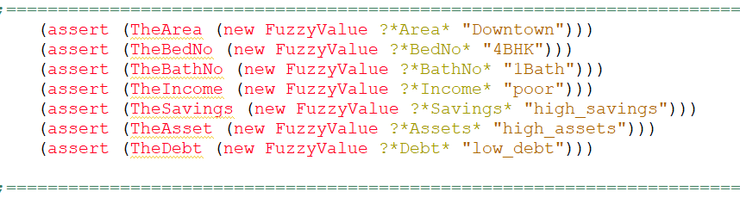

Output 1:

## 

## Run #2

Input 2:

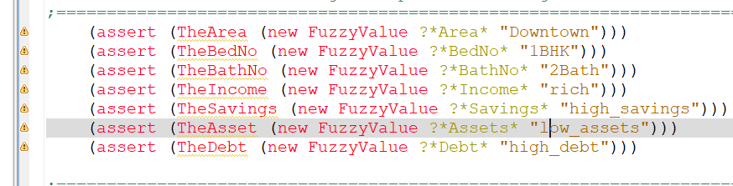

Output 2:



## Run #3

Input 3:

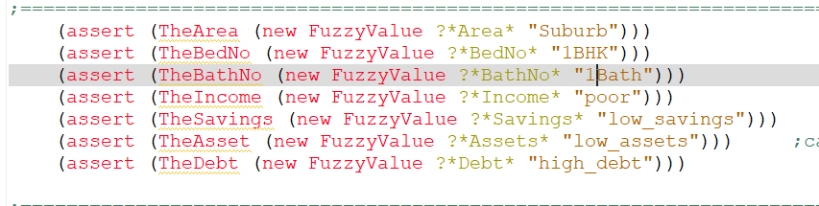

Output 3:

