Title: Snake Game

Team Members:

|  |  |
| --- | --- |
| Name | SRN |
| Srujan Vasudevrao Deshpande | PES2201800105 |
| Safa Hurayn | PES2201800392 |
| Aditya M Shetty | PES2201800169 |

The game we are building is called Snake. It is a modern take on the classic game played on old phones.

This game is built using HTML and PHP, and designed using CSS and Bootstrap.

The game itself runs in Javascript and is displayed using CSS properties. CSS is also used to beautify the website and better the User Experience.

There is a main bar which contains the instructions button, the game name, the login and sign up buttons.

Below that a navigation bar is present which contains the buttons/links to new game, pause/play game, get lives, similar games, support and about us.

The main game area is located in the bottom left centre of the screen. Below the navigation bar in the right side, the current score and current lives are displayed. Below the current score, we have a tab displaying the global high scores and below that, another for local high scores.

The global high scores will be taken across all the users and will be stored using DBMS.

The local high scores will be stores on the users system using cookies.

In the instruction page the user can go through the instructions to play the game.

Clicking the Login button asks the user for their email ID and password.

Clicking the Sign up button asks the user for the name, email and password. This data will be stored using DBMS.

In the game, the snake is going to eat objects randomly emerging on screen and if successful in eating then it becomes larger in size and gains score. Food is provided at several coordinates of the screen for the snake to eat. One food appears each time. Everytime the snake eats the food its length will be increased by one element along with the score.

The player has to change the direction of the snake by pressing left, right, top, down arrows for getting the food. When you have collected enough food you progress onto the next level, where your snake gets longer and number of obstacles increase.

Press "ESC" to pause the game at any time.

You get scored according to length of the snake and number of 'x' obstacles on the screen. The speed increases every level.

There are 3 lives. The player loses a life when the snake either runs into the border or hits an obstacle or its body.

When the game ends a pop window is displayed which shows the score and asks the user to enter his name.

The object snake position has been set random, so whenever player starts the game the snake will appear at random location everytime.

The snake object will appear in green colour and its food appears in red colour. There are five levels and each is unlocked after clearing the previous. The difficulty increases with each level.

Get lives button allows the user the pay money to get lives.

Similar Games directs the user to a page displaying similar games

Support page consists of a form with name, email, phone and comments. This can be used to submit any comments or suggestions.

The About Us page displays information about the creators of the game.

Main Game Screen

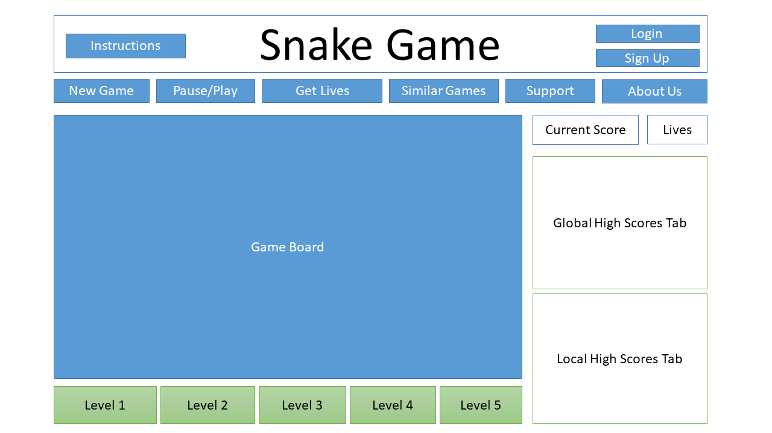

Sample Game Screen

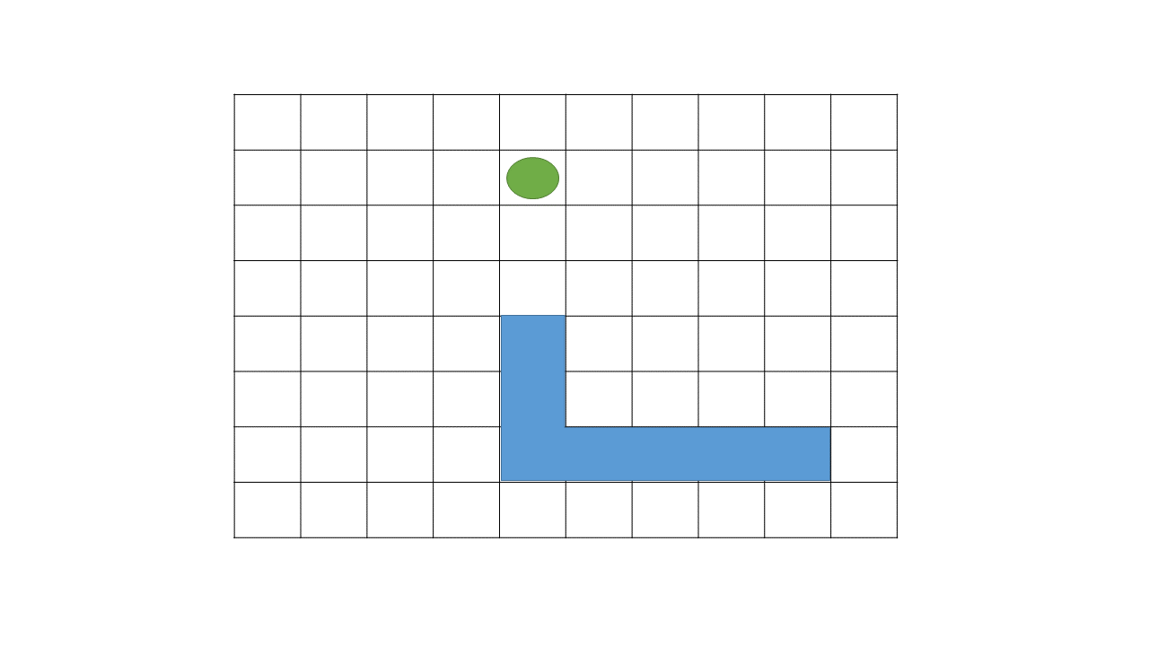

Instructions

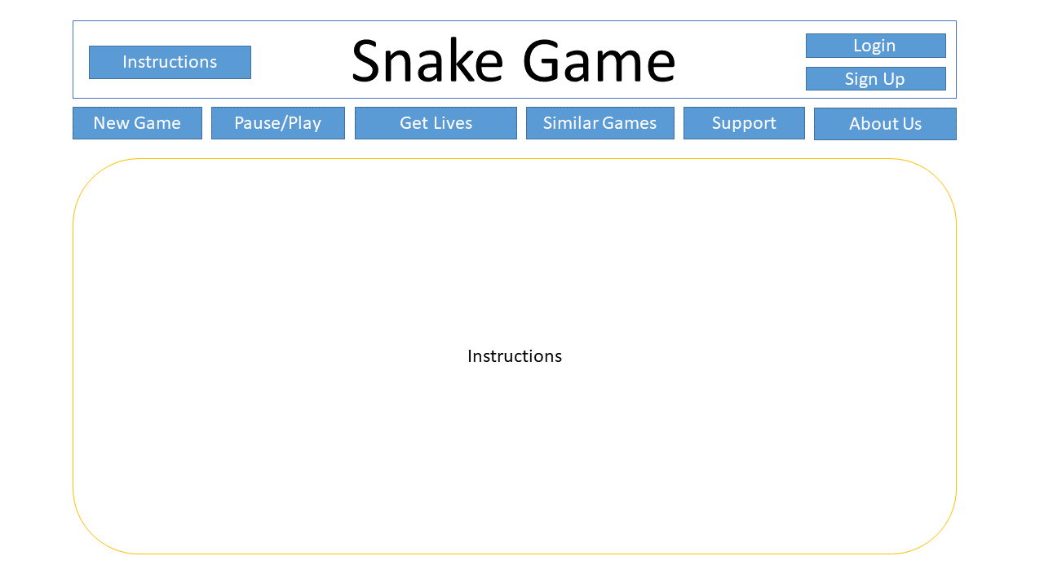

Login

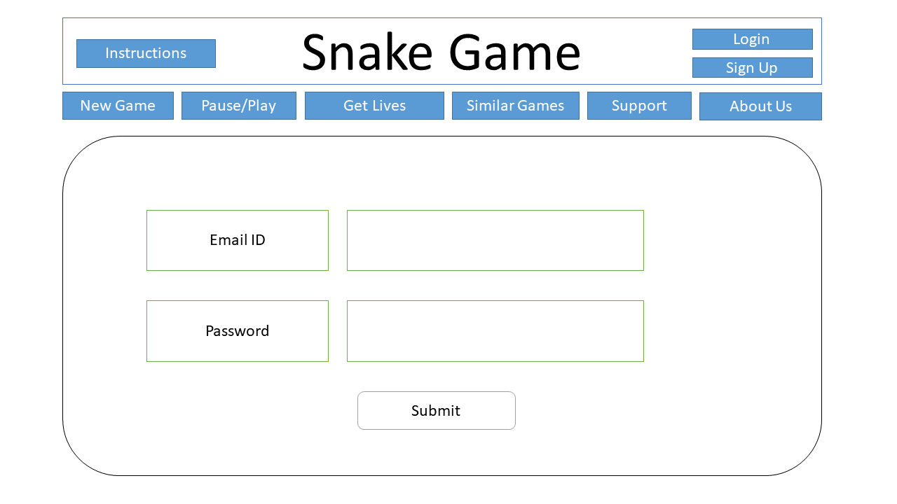

Sign Up

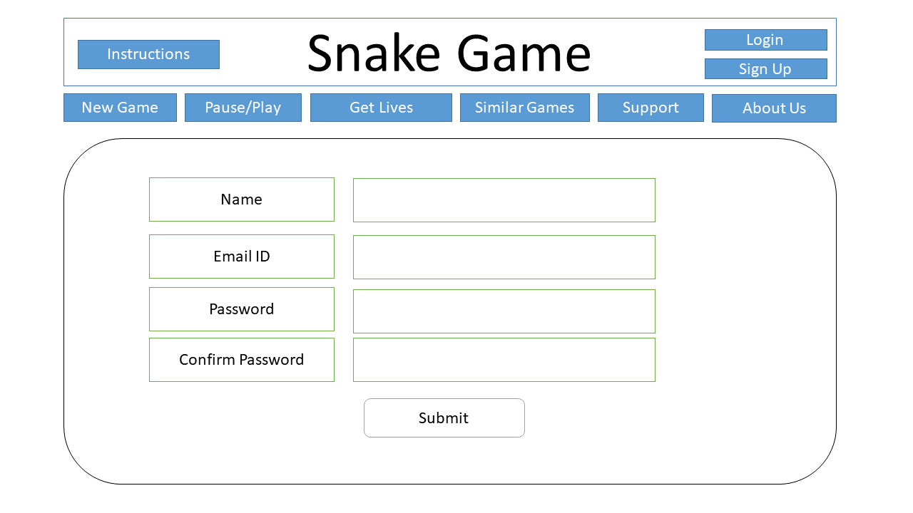

Support

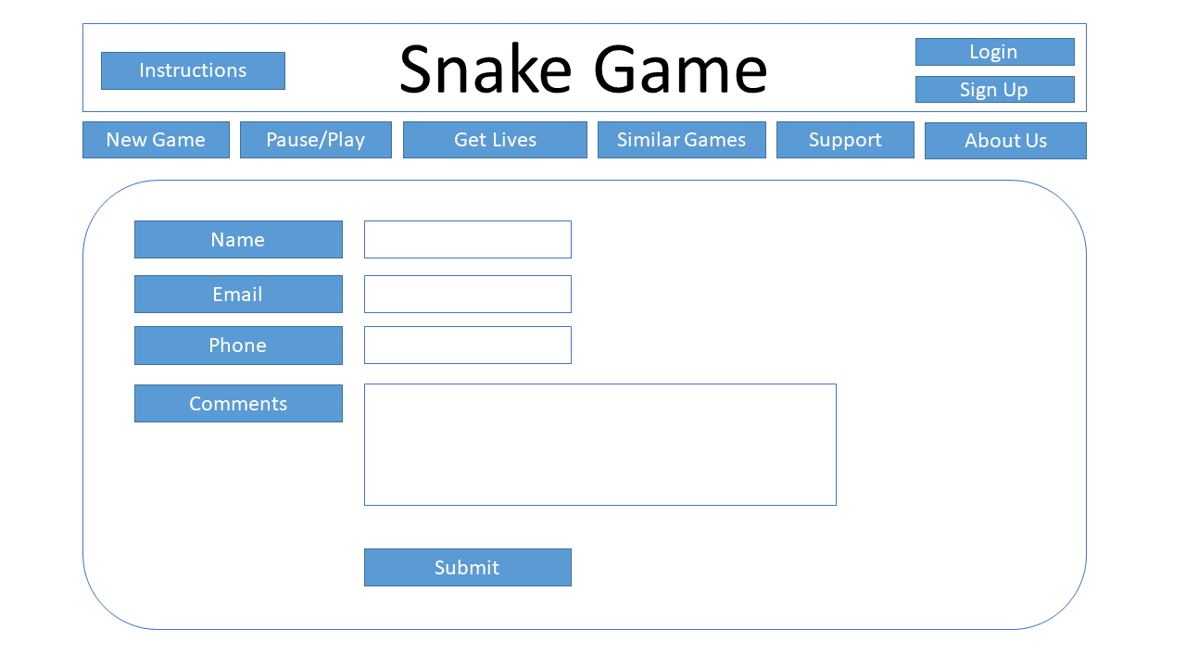

Get Lives

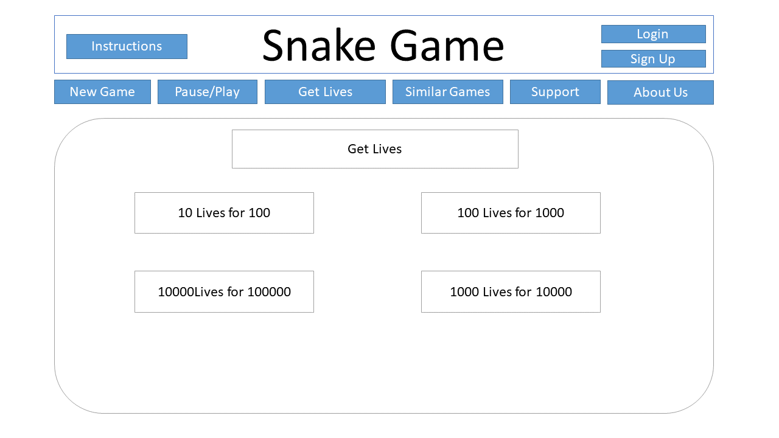

About Us

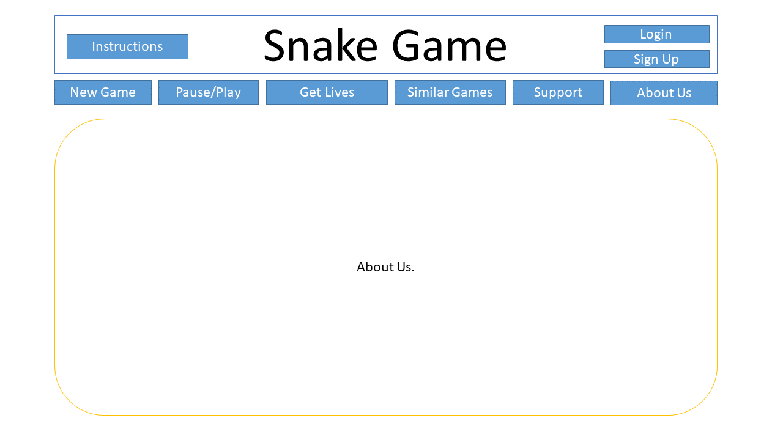

Links to similar Games

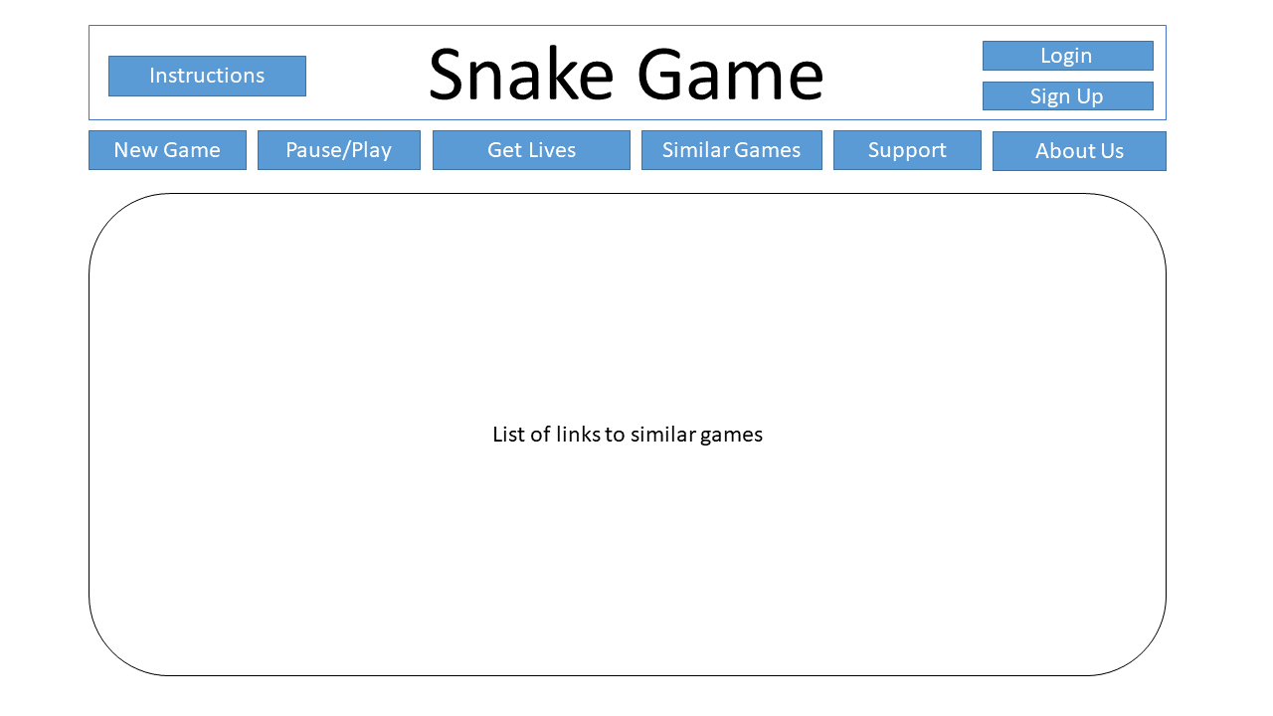

Payment Page for buying lives

