DBMS EXPERIENTIAL LEARNING / LEVEL 3
ARENARANK
COMPETITIVE ESPORTS
MATCHMAKING & ELO
LEADERBOARD PLATFORM
Skill-aware pairings. Auditable ratings. Seasonal competition.

DEPARTMENT OF COMPUTER SCIENCE AND ENGINEERING
DBMS Experiential Learning – Level 3 Project
SUBMISSION DETAILS | INFORMATION
Institution | PES University
Student 1 | Srujan Javaregowda · PES2UG24CS526
Student 2 | [Enter full name and SRN]
Course Instructor | Dr. Nagasundari S.
Academic Year | 2026–2027

PROJECT PACK
Report · ER Diagram · SQL Implementation · MongoDB Design · Next.js Application · Test Plan
Submission finalization: confirm title uniqueness, enter the second member details, and replace planned test outcomes with actual execution evidence.

Contents
Abstract
1. Introduction and Problem Definition
2. User Roles and Requirements
3. System Architecture
4. Database Selection and Justification
5. Database Design
6. Elo Rating and Matchmaking Algorithms
7. Advanced SQL and NoSQL Features
8. Application and API Implementation
9. Testing and Validation Plan
10. Setup and Execution
11. Security and Ethical Considerations
12. Limitations and Future Work
13. Team Contributions
Conclusion and Submission Checklist
Included technical appendices: data dictionary, MongoDB design, architecture notes, SQL queries, test cases, seed instructions, and source code in the companion ZIP package.

Abstract
Competitive esports platforms need more than player registration and static leaderboards. They need to pair players of comparable skill, maintain transparent ratings after completed matches, prevent inconsistent results, and preserve enough history to explain rating movement. ArenaRank is a web-based academic prototype that addresses these needs through rating-aware matchmaking and per-game, per-season Elo rankings.
The application uses Next.js and TypeScript for the web interface and API layer. PostgreSQL stores user identity, profile data, games, seasons, ratings, matchmaking queue entries, matches and rating history. Its relational constraints, indexes, triggers, view, transaction boundaries and stored Elo function enforce consistency. MongoDB stores flexible match telemetry and append-only activity events, where fields may vary by game or event type.
When an administrator finalizes a match, the database locks the match and relevant rating rows, calculates both Elo changes, updates player records, inserts two rating-history entries and marks the match complete in one transaction. Automated Elo unit tests and a manual integration test plan are included. Actual integration and build outcomes must be recorded after executing the steps on the submission machine.

1. Introduction and Problem Definition

1.1 Problem statement
Players in competitive esports need fair opponents and a leaderboard that reflects match results rather than manual edits. A simple application that only performs insert, display, update and delete operations does not reliably handle simultaneous queue requests, ensure that a declared winner is a participant, keep ratings consistent with match results, or reconstruct rating changes.
ArenaRank matches eligible players in the same game and active season when their Elo ratings are within a configurable range. A match remains pending until an administrator confirms the winner. PostgreSQL then calculates and commits rating movement alongside the official result. Leaderboard positions derive from committed records, and rating history explains how each rating changed. MongoDB stores variable telemetry and activity details without forcing game-specific metrics into relational columns.

1.2 Objectives
- Build a functional Next.js interface with player and administrator workflows.
- Design a normalized relational schema with entities, keys, relationships, checks and indexes.
- Implement rating-aware matchmaking with transactional queue management.
- Implement Elo-based rating updates and immutable per-match rating history.
- Demonstrate transactions, a view, stored function, triggers, indexes, full-text search, aggregates and window functions.
- Integrate MongoDB for flexible event documents and telemetry, including indexes and aggregation examples.
- Implement authentication, authorization, validation and environment-based configuration.
- Provide reproducible setup instructions, SQL queries, diagrams, test cases and team contribution evidence.

1.3 Scope
The prototype supports one active season at a time, multiple games, two-player head-to-head matches, a simplified Elo variant, a rating-gap queue, an admin-controlled result workflow, a player directory and an activity feed. It does not connect to real game servers, automatically verify outcomes, manage tournaments or teams, support draws, or process live telemetry. Seed records are synthetic.

2. User Roles and Requirements
ROLE | MAIN CAPABILITIES | RESTRICTIONS
Player | Register, sign in/out, view own stats, browse/search leaderboard, join/leave queue, inspect match history. | Cannot assign self the admin role or finalize official results.
Administrator | View platform-wide pending matches, finalize results, inspect activity feed and recent matches. | Must be authenticated; result endpoint checks role server-side.

2.1 Functional requirements
ID | REQUIREMENT
FR-01 Account management | Validate email, username, display name and password; hash password using bcrypt.
FR-02 Authentication | Issue a signed HTTP-only session cookie after valid sign-in; support sign-out.
FR-03 Authorization | Enforce PLAYER and ADMIN; protect queue and result endpoints.
FR-04 Game / season | Support multiple titles and separate ratings for each game and season.
FR-05 Leaderboard | Rank by Elo, then wins, then display name; show rating, peak, W/L, win rate.
FR-06 Matchmaking | Pair the nearest rating candidate in the same game/season within ±300 Elo.
FR-07 Queue cancellation | Allow a player to remove their own queue entry.
FR-08 Official result | Only an admin can finalize a pending match; winner must be a participant.
FR-09 Rating history | Store old rating, new rating and delta for both players.
FR-10 Search | Search player handles, display names and profile text.
FR-11 Activity/telemetry | Store activity documents and flexible game-specific telemetry in MongoDB.

2.2 Non-functional requirements
QUALITY | DESIGN RESPONSE
Integrity | Foreign keys, check constraints, unique constraints, stored function and transactions.
Security | Hashed passwords, signed HTTP-only cookie, server-side roles, environment-based credentials.
Usability | Dashboard cards, table filters, player search, queue controls and clear match state.
Maintainability / demo | Clear UI/API/data separation, documentation, tests and repeatable Docker Compose services.

3. System Architecture
The browser communicates with Next.js Route Handlers over JSON requests. The API verifies a signed session, checks role requirements, validates input, and accesses both databases from the server. PostgreSQL is the authoritative store for official competitive state; MongoDB stores supplementary event and telemetry documents. The browser never connects directly to either database.
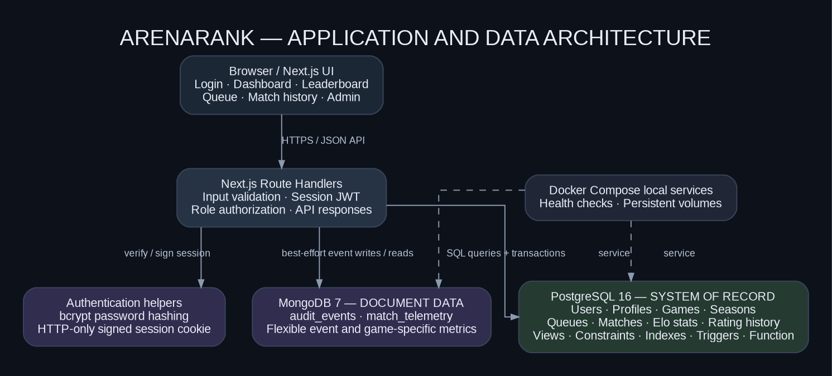
Figure 1. Application and data architecture (generated from docs/architecture.dot).

3.1 Matchmaking flow
1. A player selects a title and requests to join its queue.
2. The API begins a PostgreSQL transaction and validates the active game and season.
3. The API obtains current Elo and looks for a same-game, same-season candidate within ±300 points.
4. Candidates are ordered by smallest rating difference and then queue age; a candidate row is locked to reduce duplicate pairings under concurrency.
5. If matched, a pending match is created and both queue records are deleted before commit; otherwise, the entrant is queued.
6. After commit, an activity event is written to MongoDB on a best-effort basis.

3.2 Result finalization flow
1. An administrator selects one of the two participants as winner.
2. The API calls `finalize_match` inside a PostgreSQL transaction.
3. The function locks the match and both rating records, validates the winner, computes rating changes, updates counters, inserts two history rows and completes the match.
4. Any database validation error aborts the transaction, so the match cannot be half-updated.
5. After commit, the API writes the activity event to MongoDB and the leaderboard reflects the SQL state.

4. Database Selection and Justification

4.1 PostgreSQL — required SQL database
PostgreSQL is appropriate for official match state because entities have strong relationships and integrity requirements. Foreign keys connect players, games, seasons and matches. Check constraints enforce valid ratings and valid result fields; unique constraints prevent duplicate identities and repeated player-match history. Transactions ensure the result, rating counters and history move together. A stored function performs the Elo update close to the data, while a view and window function provide reusable rankings.

4.2 MongoDB — NoSQL database
MongoDB is appropriate for optional telemetry and activity documents whose shape can evolve between games. A tactical FPS may report maps, rounds, assists, plants and defuses, while other games may record goals, saves or possession. MongoDB stores such details without adding every possible game-specific field to a relational table. Official winner, match status and Elo remain in PostgreSQL.

4.3 Why no vector database is used
The core operation depends on numeric rating gap, game, season and queue time, not semantic similarity across long text. A vector database would not improve core matching and would be unjustified. PostgreSQL full-text search with a GIN index supports the small player directory search need.

5. Database Design

5.1 ER diagram
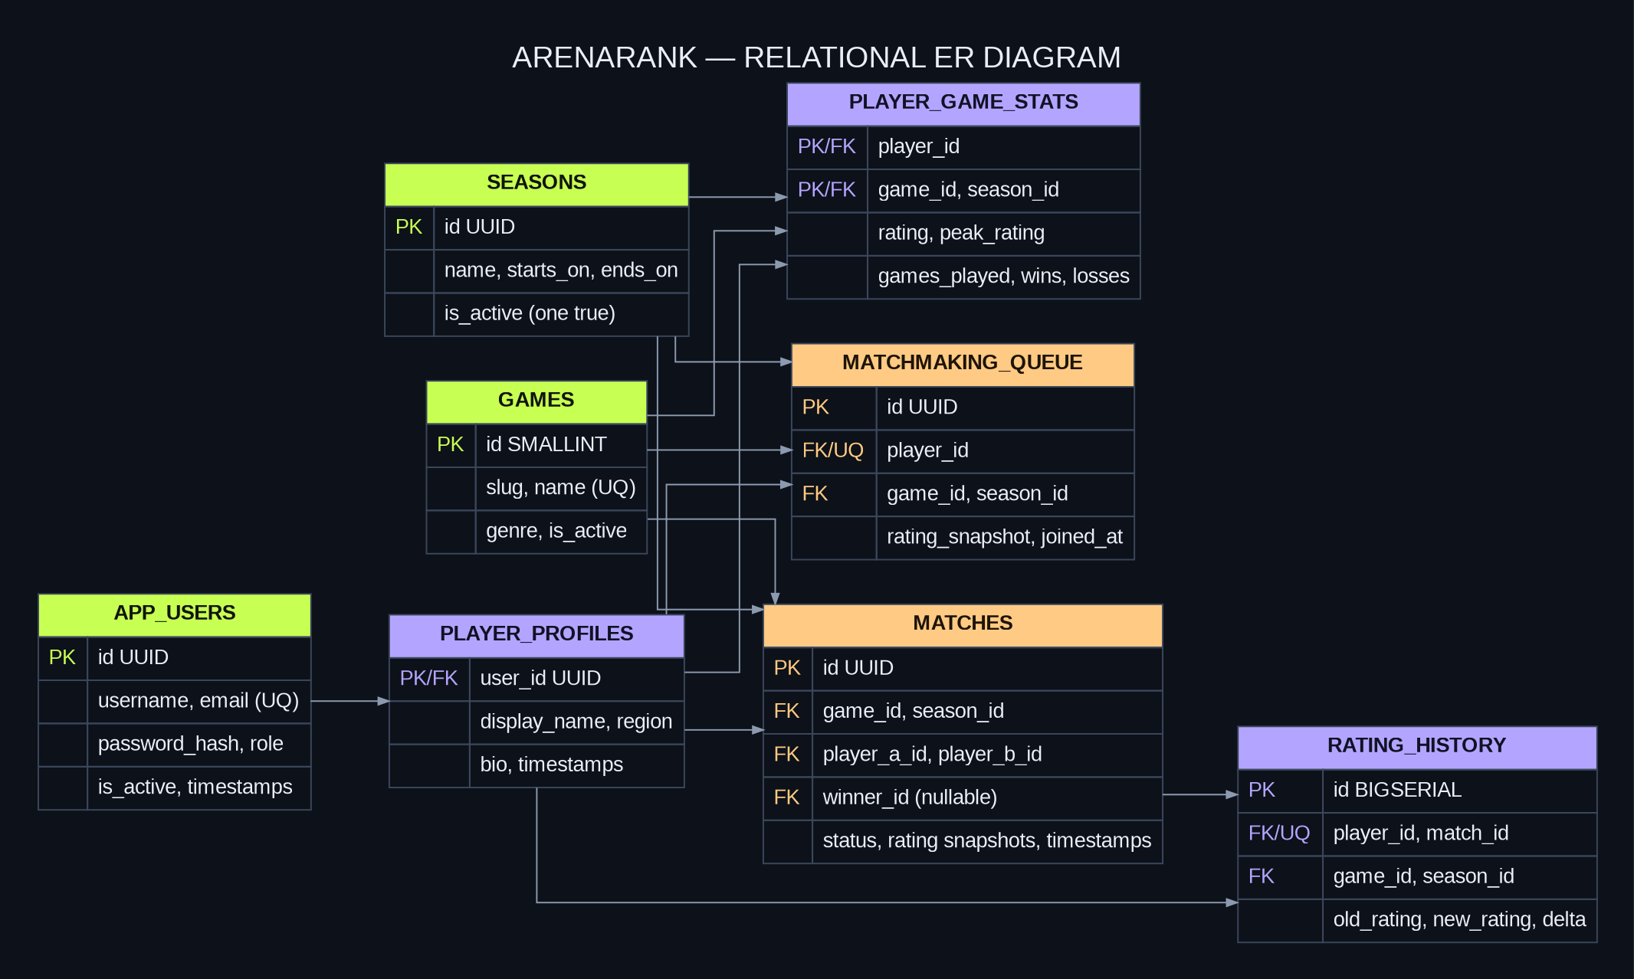
Figure 2. Relational ER diagram. MongoDB collections are documented separately.

5.2 Main entity relationships
- One app user may have zero or one player profile; an administrator does not require a profile.
- A profile has multiple rating records, one per game and season. Each stats row belongs to exactly one player, game and season.
- A player has zero or one active queue record. A queue row refers to one game and one season.
- Each match has two distinct participants, one game and one season; the winner remains null until finalization.
- A completed match has two rating-history entries, one per participant. The leaderboard is a view rather than a separately duplicated table.

5.3 Relational schema
TABLE | PRIMARY KEY | IMPORTANT RELATIONSHIPS / ATTRIBUTES
app_users | id UUID | username/email unique; password_hash; role; active flag; timestamps
games | id SMALLSERIAL | unique slug/name; genre; availability flag
seasons | id UUID | unique name; dates; one-active-season partial unique index
player_profiles | user_id UUID | FK to app_users; display_name, region, bio
player_game_stats | player_id + game_id + season_id | current/peak Elo, games, wins, losses; three FKs
matchmaking_queue | id UUID; player_id unique | player, game, season, Elo snapshot, queue timestamp
matches | id UUID | game, season, players A/B, optional winner, status, before/after rating fields
rating_history | id BIGSERIAL | player, match, game, season, old/new rating, delta; unique player + match

5.4 Normalization and integrity
Identity, profile, game, season, match and rating history are separate relations to reduce duplicated facts. Current per-game/per-season rating is stored in player_game_stats; historical movement is recorded in rating_history. The leaderboard view calculates ranks at read time. Database rules include unique username/email, basic email and handle checks, role check, rating bounds, wins + losses = games played, distinct match participants, winner-is-participant, one active season, rating delta consistency and completed-match field consistency. A trigger rejects updates and deletes to rating history, and restrictive foreign keys preserve historical evidence.

6. Elo Rating and Matchmaking Algorithms

6.1 Elo calculation
For player A rating R_A and player B rating R_B, the expected score of A is:
E_A = 1 / (1 + 10^((R_B - R_A) / 400)) and E_B = 1 - E_A

A win receives score 1 and a loss receives score 0. With K-factor 32:
R'_A = R_A + 32 × (S_A - E_A) and R'_B = R_B + 32 × (S_B - E_B)

The database rounds rating output to integers and clamps it to 100–4000. The prototype supports no draws and uses a constant K-factor for demonstration; a production policy could vary K by experience or tournament rules.

6.2 Pairing policy
1. Filter queued players to the same game and active season.
2. Exclude the entrant and retain candidates within an absolute 300-point rating difference.
3. Sort by rating gap ascending and queue timestamp ascending.
4. Lock the selected queue row with `FOR UPDATE SKIP LOCKED` to reduce concurrent duplicate pairings.
5. Create a pending match and remove both queue records in one transaction, or insert the entrant into the queue if no candidate exists.

7. Advanced SQL and NoSQL Features
CONCEPT | IMPLEMENTATION | RELEVANCE
DDL | CREATE statements; `db/ddl_demo.sql` demonstrates ALTER, index creation and DROP on a temporary table. | Schema lifecycle demonstration without deleting project data.
Constraints | PK, FK, UNIQUE and CHECK constraints. | Stops invalid and orphaned state.
Transactions | Queue/match creation and match result finalization. | Prevents half-created pairs or partial rating updates.
View | leaderboard_view with per-game/per-season RANK(). | Reusable ranked output without storing stale positions.
Stored function | finalize_match(match_id, winner_id). | Centralizes rating logic and history writes.
Triggers | set_updated_at; validate_match_participants; prevent_rating_history_mutation. | Maintains timestamps, validates matches, and protects append-only rating history.
Indexes | B-tree queue/history indexes and GIN full-text index. | Supports candidate selection, histories and text search.
Aggregation / window | COUNT, SUM, AVG, GROUP BY, HAVING and RANK(). | Supports performance summaries and seasonal ranking.
MongoDB indexes / aggregation | Actor/date and entity/date indexes; group audit actions and inspect game telemetry. | Supports variable documents and operational summaries.

7.1 MongoDB collections
`audit_events` stores actor ID/name, action, entity type/ID, flexible details and creation time. `match_telemetry` stores match ID, game slug, duration, map and a nested metrics document whose fields may vary by title. Indexes support recent events by actor, events by entity, telemetry by match and telemetry by game. The API reads the eight most recent events for the admin console. Example aggregation queries are in `docs/nosql_design.md` and `docs/nosql_examples.js`.
Consistency boundary: a single distributed transaction is not used across PostgreSQL and MongoDB. PostgreSQL is authoritative. Mongo writes happen after SQL commit and are best-effort; a production extension should use a SQL transactional outbox and retrying worker.

8. Application and API Implementation
The Next.js App Router provides the responsive browser UI and server-side Route Handlers. Authentication uses bcrypt password hashes and a signed JWT in an HTTP-only cookie. Public registration assigns the PLAYER role; an admin-only result endpoint checks the session role before invoking the database function.
METHOD / ROUTE | ACCESS | RESPONSIBILITY
POST /api/auth/register | Public | Validate registration; hash password; create user/profile and initial active-season stats.
POST /api/auth/login | Public | Verify password hash and set session cookie.
POST /api/auth/logout | Signed in | Clear cookie and record activity.
GET /api/auth/me | Session-aware | Check session token and account status.
GET /api/dashboard | Signed in | Stats, leaderboard, queue state, matches; admin-only pending matches and audit feed.
GET /api/players | Signed in | Search handles/profile text; use SQL text search where applicable.
POST /api/queue/join | Player | Create queue entry or pair a candidate transactionally.
POST /api/queue/leave | Player | Delete caller queue record.
POST /api/matches/{id}/result | Admin | Finalize match through the PostgreSQL Elo function.

8.1 User interface pages / states
- Authentication page: sign-in and player registration with client-friendly validation.
- Overview: selected title, Elo and peak, played matches, win rate, queue status, top contenders and recent match ledger.
- Leaderboard: searchable player directory with rank, region, rating, W/L record, win rate and played count.
- Matchmaking: chosen title, rating gap policy, queue state and join/leave action.
- Match history: pending/completed/cancelled state and recorded winner/rating snapshots.
- Admin console: pending match result controls and MongoDB activity feed.

8.2 Demo data
The seed script creates three game titles, one active season, an admin, five players, per-title initial ratings, six illustrative completed matches, MongoDB indexes, sample activity events and synthetic telemetry. Fixture matches are inserted only if the SQL matches table is empty. These values are for demonstration and must not be represented as actual competition history.

9. Testing and Validation Plan
The repository contains automated Elo tests in `tests/elo.test.mjs`. Execute `npm run test:elo`, `npm run typecheck` and `npm run build`. The manual test matrix covers authentication, validation, role checks, matchmaking, database integrity, rating history, leaderboard refresh, Mongo events and schema-feature demonstrations.
ID | TEST | EXPECTED OUTCOME | STATUS
TC-01 | Valid player sign-in | HTTP 200; dashboard and session cookie. | Not run
TC-02 | Wrong password | HTTP 401; no valid session. | Not run
TC-03 | Valid registration | HTTP 201; player role/profile/stats created. | Not run
TC-04 | Invalid registration fields | HTTP 400; no user inserted. | Not run
TC-05 | Player attempts to finalize a match | HTTP 403; no data changed. | Not run
TC-06 | Player joins queue | Single queue row and rating snapshot. | Not run
TC-07 | Compatible second player joins | Pending match; both queue rows deleted. | Not run
TC-08 | Incompatible rating gap | No pairing; entrant stays queued. | Not run
TC-09 | Admin finalizes valid match | Winner, ratings and two history rows committed. | Not run
TC-10 | Non-participant declared winner | Request rejected; transaction rolled back. | Not run
TC-11 | Finalize same match twice | Second attempt rejected; no duplicate history. | Not run
TC-12 | Mongo activity event | Audit document appears after an API action. | Not run
TC-13 | SQL / DDL demo | View query works; temp DDL demo rolls back. | Not run
TC-14 | Elo unit tests / build | Test suite, typecheck and build complete. | Not run

The actual-result field deliberately remains “Not run” until each case is executed on the project machine. Full steps and screenshot evidence checklist are in `docs/test_cases.md`. Include real terminal and database outputs in the final submission rather than claiming unexecuted tests passed.

10. Setup and Execution

10.1 Prerequisites
- Node.js 20 or later and npm
- Docker Desktop with Docker Compose enabled
- Terminal opened in the project folder

10.2 Windows PowerShell
Copy-Item .env.example .env
# Edit .env and replace SESSION_SECRET with a random value of at least 32 characters.
docker compose up -d
npm install
npm run seed
npm run dev

Open http://localhost:3000. The README includes Linux/macOS commands, database reset guidance, schema re-application instructions and troubleshooting notes.
ROLE | LOCAL DEMO EMAIL | PASSWORD
Administrator | admin@esports.local | Admin123!
Player | player1@esports.local | Player123!
Player | player2@esports.local | Player123!

Local seed credentials are for academic demonstration only. They must not be reused in a public deployment. The `.env` file contains local-only database passwords and is excluded by `.gitignore`.

10.3 Useful commands
npm run test:elo
npm run typecheck
npm run build
# Disposable local reset only (deletes local database volumes):
docker compose down -v
docker compose up -d
npm run seed

10.4 Suggested live demo
1. Explain the ER diagram and justify PostgreSQL versus MongoDB.
2. Sign in as a player and show dashboard, leaderboard and match history.
3. Join the same title queue from two player sessions to create a pending match.
4. Sign in as admin and finalize a result; show the new ratings and two history rows.
5. Run leaderboard view and aggregate/search queries; inspect constraints, indexes, triggers and function.
6. Show MongoDB audit and telemetry documents, then run the Elo unit tests and safe DDL demo.

11. Security and Ethical Considerations
- Passwords are stored as bcrypt hashes, never as plaintext.
- Session tokens are signed and stored in an HTTP-only cookie; production cookies become Secure when NODE_ENV=production.
- Registration hard-codes the PLAYER role; result finalization checks the ADMIN role at the server API.
- Database connection strings and the session key are environment variables; `.env` is git-ignored.
- Constraints and database transaction logic remain authoritative rather than trusting the browser.
- Synthetic ratings, fixture match outcomes and telemetry are identified as demo data. They should not be represented as real competitive outcomes.
This academic prototype does not include email verification, login throttling, complete CSRF/rate-limiting protection, anti-cheat verification, managed secrets, or tested backup/restore automation. Before public deployment, use HTTPS, rotate local credentials, store secrets using a managed service, add rate limits and monitoring, verify match results from a trusted source, and create operational backups. For stronger SQL/Mongo audit consistency, add an outbox and retry worker.

12. Limitations and Future Work
- The pairing engine handles two-player matches with a fixed ±300 Elo window.
- Official results are manually entered by an administrator; trusted game API or tournament verification is future work.
- Elo uses K=32, integer ratings and no draw state; a production rating policy may be more nuanced.
- Region is stored but is not yet part of candidate selection; ping-aware pairing is future work.
- Telemetry is schema-flexible with synthetic examples; no live telemetry ingestion pipeline is included.
- Future additions could include season administration, rating-window widening over wait time, teams, tournament brackets, player reports, anti-cheat flags, richer analytics and automated integration tests.

13. Team Contributions
The companion file `docs/team_contributions.md` contains a matrix covering requirements, relational design, SQL implementation, MongoDB, Next.js, testing and report preparation. The team must replace the second member placeholder and edit the matrix to match the actual contribution record. Each person should contribute to both database and application development, and individual commits should demonstrate authentic work.
For the detailed workstream matrix, replace the placeholders in `docs/team_contributions.md` with the actual member names, responsibilities and evidence. Do not claim responsibilities that are not reflected in the project work and repository history.

Conclusion and Submission Checklist
ArenaRank addresses a substantive competitive-platform problem through rating-aware matchmaking and a reproducible Elo-rating workflow rather than a basic CRUD interface. PostgreSQL enforces official relational state; a view produces seasonal rankings; a stored function performs atomic rating updates; triggers, constraints and indexes protect and support the data; and MongoDB stores evolving telemetry and activity. The companion project package includes the source application, database setup, seed routine, diagrams, schema/query documentation, test cases and a demonstration guide.
- Replace the Student 2 placeholder and confirm project-title uniqueness with the instructor.
- Run the app locally and verify the player, matchmaking and admin result journeys.
- Execute test cases and replace “Not run” with actual Pass/Fail and evidence.
- Capture original screenshots and insert them in the report appendix.
- Add both members’ real contribution details and ensure GitHub commit history reflects them.

