Activiyt-6
Design and implement all three types of linked list in Python
Linked list: A linked list is a sequence of data elements, which are connected together via links. Each data element contains a connection to another data element in form of a pointer. Python does not have linked lists in its standard library.
The three types of Linked list are:
- Singly linked lists.
- Doubly linked lists.
- Circular linked lists

- Singly linked list: Singly Linked List. A singly linked list contains a single pointer connected to the next node in the linked list. We have to store the data and pointer for each node in the linked list. The last node in the linked list contains null as the next pointer to represent the ending of the linked list.
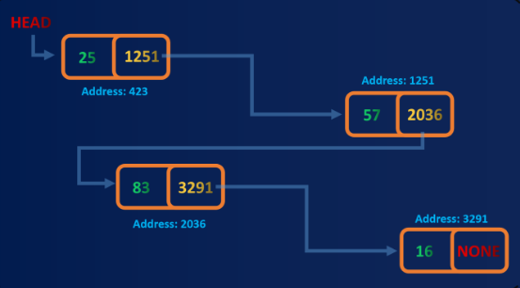
- Doubly linked list: Doubly Linked List contains a link element called first and last. Each link carries a data field(s) and two link fields called next and prev. Each link is linked with its next link using its next link. Each link is linked with its previous link using its previous link.
