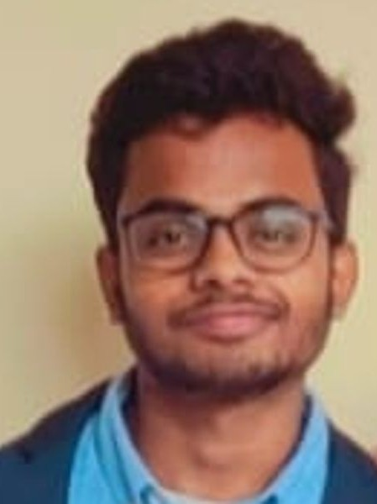



CSE SENIOR AT PES UNIVERSITY

**ộ** BANGALORE,INDIA **O** 08310666757 **@** [srujan019@gmail.com](mailto:srujan019@gmail.com)



 [Kothuri Venkata Srujan](https://www.linkedin.com/in/kothuri-venkata-srujan-2044ba250/)  [srujankothuri](https://github.com/srujankothuri)



 [SRUJAN_KOTHURI](https://leetcode.com/u/SRUJAN_KOTHURI/)















Python,C,C++,Java,R

Motivated and ambitious computer science undergraduate with a strong foundation in programming, problem-solving, and software development. Proficient in Python, Java, and C++, with experience in software applications, machine learning models, and end-to-end solutions. Skilled in natural language processing, computer vision, and data analysis, with projects including legal case summarization systems and chatbot development. Eager to leverage technical expertise and analytical thinking to contribute to research-driven projects and deliver impactful, scalable solutions. Committed to continuous learning, collaboration, and utilizing emerging technologies to excel in the field of computer science.



8.81 CGPA BTECH (CSE)





94.1%(Class 12 Board Exams) Class 11 & 12





92.6% (10th Board Exams) Until Class 10





Secured the scholarship for 5 times in a row with a GPA of 8.81. The scholarship is awarded to the top 20% of the University





Solved 250+ problems on combined platforms of Leetcode,GeeksforGeeks and HackerRank



Secured 95 percentile in 2021 JEE Mains and a rank of 2019 in the 2021 KCET Examinations







The project proposes an automated system using NLP and ML to streamline legal processes by predicting case judgments, summarizing lengthy legal texts, and a Legal Chatbot that answers common legal questions.



This project makes use of ResNet ,Transfer Learning and CNN to find similar fashion products to the one given as an input by the user



ScripSketch is an AI-powered app that turns a one-sentence idea into a complete movie concept, including a synopsis, title, cast, and cover art, using the OpenAI API with ChatGPT for text and DALL-E for visuals.



This project utilizes OpenCV's computer vision library to detect and identify faces in images and videos. It uses image processing techniques and machine learning to accurately detect and recognize individual faces



Earned Google Cloud certifications in AI and machine learning, covering topics like generative AI, image captioning, transformers, BERT, LLMs, image generation, and responsible AI, showcasing a strong foundation in modern AI technologies.

**** [link](https://www.cloudskillsboost.google/profile/badges)





Earned AWS Educate badges in cloud fundamentals, including compute, networking, storage, serverless, and databases, demonstrating a solid understanding of core AWS cloud services and infrastructure.

**** [link](https://www.credly.com/users/pes2ug21cs236-kothuri-venkata-srujan/badges)





Achieved HackerRank Problem Solving (Intermediate) certification, demonstrating strong problem-solving skills, algorithmic thinking, and proficiency in data structures.

**** [link](https://www.hackerrank.com/certificates/4b3aa3f951ae)