

**CHEP - Gateway Provisioning**

**USER MANUAL V1.0**

**TABLE OF CONTENTS**

1.0 GENERAL INFORMATION 3

1.1 SYSTEM OVERVIEW 3

1.2 ABBREVIATIONS 3

2.0 SYSTEM SUMMARY 4

2.1 PROCESS FLOW 4

3.0 GETTING STARTED 7  
3.1 PRE CONSIDERATIONS 7

3.2 SNOW UI 7

3.3 FIELD LEVEL INFORMATION 9

3.4 REQUESTS 11

3.4.1 REQUEST TYPE: ADD 11

3.4.2 REQUEST TYPE: MODIFY 15

3.4.3 REQUEST TYPE: TERMINATION 17

3.5 SPECIAL CASES 21

3.5.1 ADD AN EXISTING USER 21

3.5.2 MODIFY USER WITH NO CURRENT EXISTENCE 23

3.6 NOTIFICATIONS 25

3.6.1 SAP ACCESS REQUEST 25

3.6.2 SAP TERMINATION 26

3.6.3 SNOW APPROVAL REQUEST 27

**GENERAL INFORMATION**

1. **GENERAL INFORMATION**

Currently, the new user creation for all SAP FIORI applications is handled through SNOW and Curion.

The existing process does not allow the following activities:

* A new user to request access for multiple plants at a time.
* An existing user to request access for an additional plant(s).
* An existing user to request access for additional role(s).
* A non-plant user to request access to non-plant roles.

Curion causes several production issues and is cumbersome to support.

## Organization of the Manual

This manual is divided into 3 major sections which are defined below.

1. - General Information: This section contains the basic information about the system
2. - System Summary: This section provides a general overview of the system.
3. - Getting Started: This section provides a general walk-through guide to the system.

**1.1 SYSTEM OVERVIEW**

The system is designed to enhance the existing process flow by eliminating the Curion from the process and including the below mentioned functionalities:

* A new user to request access for multiple plants at a time
* An existing user to request access for an additional plant(s)
* An existing user to request access for an additional role(s)
* A non-plant user to request access to non-plant roles

The system has ServiceNow as the front end and SAP as the back end.

User requests will be generated through Service Now which will be sent to SAP Gateway for plants/role access.

## 1.2 ABBREVIATIONS

* SNOW - ServiceNow
* SAP - System, Applications, Product
* YMS - Yard Management System
* FDE - Forklift Driver Enablement
* ESP - Easy SAP Portal

**SYSTEM SUMMARY**

**2.0 SYSTEM SUMMARY**

Users are provided with a SNOW GUI to interact with SAP to complete below mentioned activities: -

* A new user to request access for multiple plants at a time
* An existing user to request access for an additional plant(s)
* An existing user to request access for an additional role(s)
* A non-plant user to request access to non-plant roles

## 2.1 PROCESS FLOW

**ACCESS REQUEST**

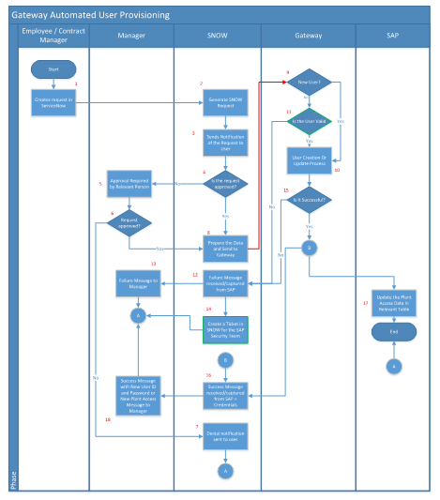

**TERMINATION REQUEST**

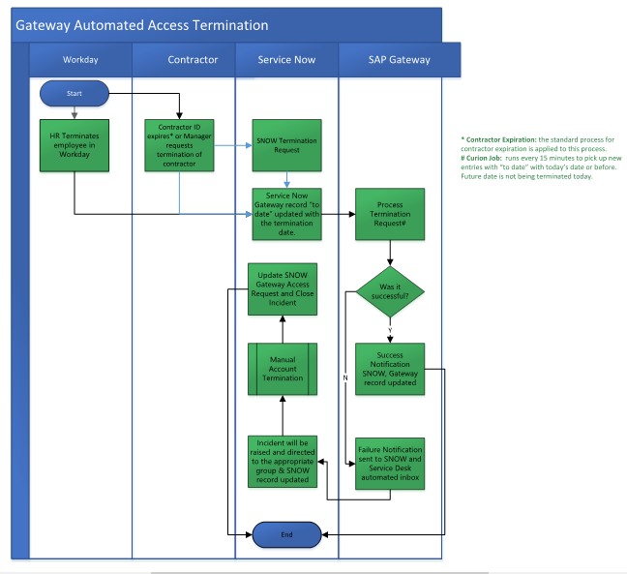

1. Employee or a Contract Manager creates the request for:

• New plant user access (plant field mandatory and only display plant roles on SNOW form)

• New non-plant user access (plant field optional and only display non-plant roles on SNOW form)

• Additional role to existing user

o SAP Gateway must provide the roles associated with existing user via API, allowing to select the one he/she currently does not have.

• Additional plant to existing user

o SAP Gateway must provide via API the plants associated with existing user, allowing him to select the one he currently does not have (maximum 10 plants per request).

o SAP Gateway will provide a way to feed the plant’s list on SNOW. It can be daily updates.

2. SNOW will generate a ServiceNow Ticket for the request with a Request ID

3. SNOW sends notification of the request to user

4. Check if request is approved.

• If the request was made by the employee’s manager, the system will auto-approve the request

5. If the request was made by someone other than the user’s manager, the system will send the approval request to the user’s manager

6. Manager will decide whether to approve/reject the request

7. Denial notification will be sent to the user

8. SNOW captures the data and send to Gateway

9. Gateway checks whether the request is created for new user or Existing user

10. If the request is for New user, then process the data*

*SAP Gateway will check if the user already exists in the user master data. If so, SAP Gateway will generate an error and stop the processing of the user creation. A notification will be sent back to the user’s manager instructing him to create a new request to update the existing user and a failure status will be sent back to SNOW.

If No, SAP gateway will proceed with the creation of the user.

11. Check if the exiting user is valid in SAP. If the user is valid, then user create or Update Process (10)

12. If the user is not valid then send the failure status to SNOW*

*SAP Gateway will check if this user already exists in the user master data.

13. SNOW will trigger the failure message to user’s manager

14. SNOW will create an incident reporting the failure to the appropriate team (SAP Security) and reference the original request along with details.

15. Check if the request was successfully processed.

16. If the request is successfully processed, then a success status will be passed to SNOW with credentials.

17. Update Plant/User relationship in SAP Plant Access Table

18. Success message will be sent to user’s manager with credentials.

**GETTING STARTED**

**3.0 GETTING STARTED**

**3.1 PRE-CONSIDERATIONS**

* Add Attachments functionality beside the “Submit” button is not implemented
* The functionality with User Type – OTHERS is not implemented
* For Request Type – TERMINATION, current implementation is not capturing the response.
* Email notifications from SAP to be enabled by Andrew Johnston
* AD should have correct set of usernames with no duplicates from where the data will be pulled.
* In SNOW Form, new employee ID is auto generated for the same user in every instance.
* The accessed plant and role data is received from SAP in case of MODIFY request.

**3.2 SNOW UI**

Enter the URL <https://cheptest.service-now.com>

User is required to login the Service Now application with valid credentials.

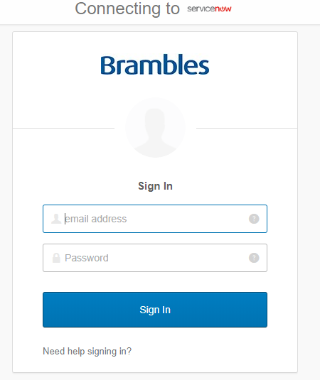

The first sign in process by the user requires the multifactor authentication set-up. User can do this activity via Okta Verify/Security Key (U2F)/SMS Authentication/Voice call authentication.

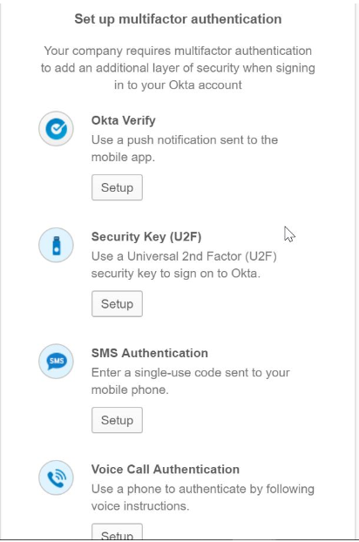

Upon the successful completion of the setup, the user can login the application.

Go to the Service Portal home page and navigate to the Gateway Screen as mentioned below:



**Gateway screen**

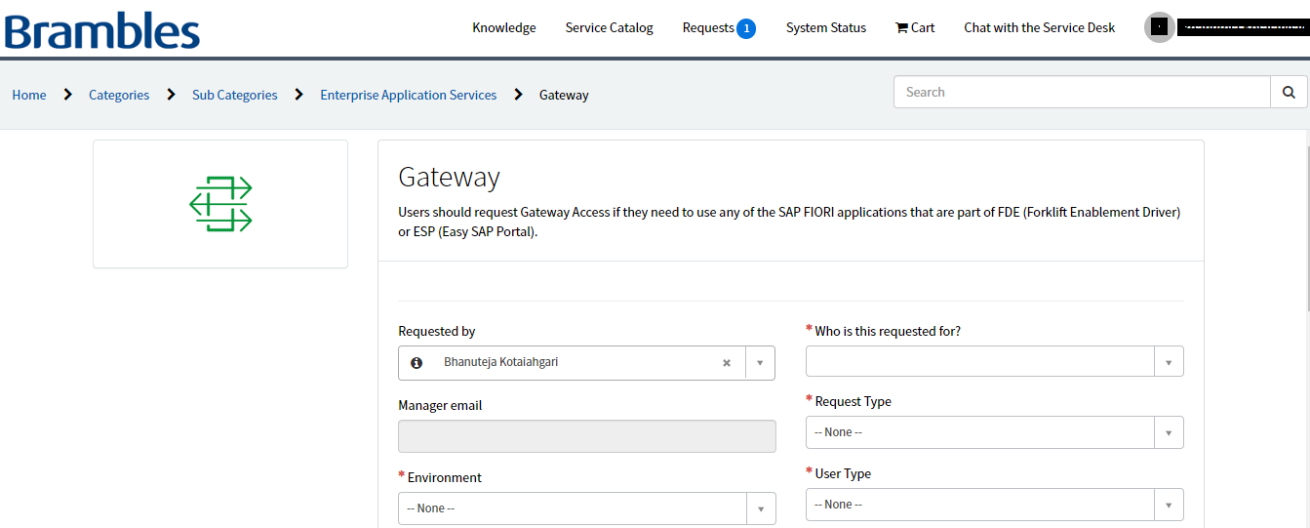

**3.3 FIELD LEVEL INFORMATION**

1. **Requested By:** By default, the logged in username will appear. This can be modified from the drop-down list if required.
2. **Who is this requested for:** This is a mandatory field and a user is required to be selected from the drop down list
3. **Manager Email:** This will auto populate based on the selection done in ‘Who is this requested for’. It will be read-only.
4. **Request Type:**

This field is mandatory and have below data: -

* Add
* Modify
* Termination

1. **Environment:**

This field is mandatory and have below data: -

* TST
* PRD

1. **User Type:**

This field is mandatory and have below data: -

* Plant
* Others

1. Below mentioned fields will auto-populate and will be read only:

* First Name
* Last Name
* Employee ID
* Department
* Location
* Country
* Title/function
* Telephone

1. **Date Pickers:**

**From Date:**

This should auto-populate to current date/system date.

**To Date:**

User should be able to select it from calendar/manual entry in correct format.

From Date <= To Date. If not, validation message should be displayed.

1. **Plant Code:**

Plant code should be a mandatory field with a label - Search by Plant Code. You can select a maximum of 10 Plants. User should be able to select/deselect single/multiple plant codes.

The list items under plant code should auto populate alphabetically and user should be able to select a minimum of 1 and a maximum of 10 plant codes.

If user selects more than 10 plants and submit the form (provided the mandatory data in the form), a validation message should pop up - Please select a maximum of 10 Plants

Partial search functionality is enabled so that user can search either by plant code or location.

1. **Select Role(s):**

It is a mandatory field and a single role selection is must. User should be able to select/deselect single/multiple roles. Role description should be displayed upon mouse hovering the roles.

1. **Comments/Notes:**

It should have a label - If you have any additional comments or information for the technician, please fill them in here. User should be able to enter the comments

1. **Submit**:

This button should be displayed at the bottom of the page. System should submit the form if all the data is valid in the fields along with the data in the mandatory fields.

Upon successful submission, button label should turn as SUBMITTED and a soft confirmation message should display on the top as –

Created SNOW ID GATXXXX - Track using requests in the header or click here to view.

Managers can perform below request types for the users to whom role/plant access is to be granted: -

* Add
* Modify
* Termination

**3.4 REQUESTS**

User can make requests in SNOW on behalf of the person to whom access is to be granted for the multiple plants and roles.

**3.4.1 Request Type: ADD**

User can perform an ADD request on behalf of the user to whom request is to be granted for the access of plants and roles.

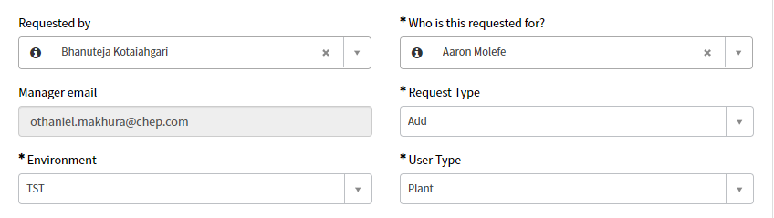

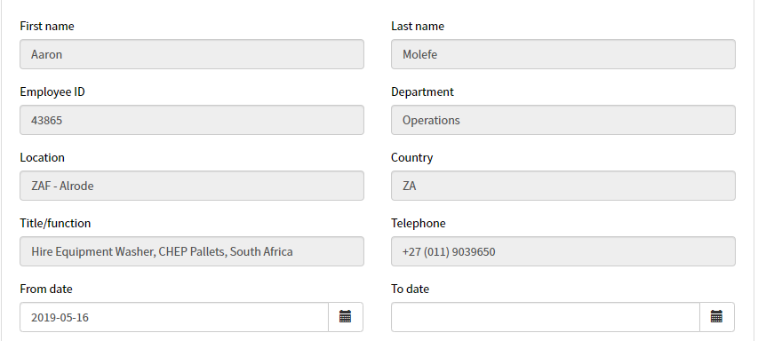

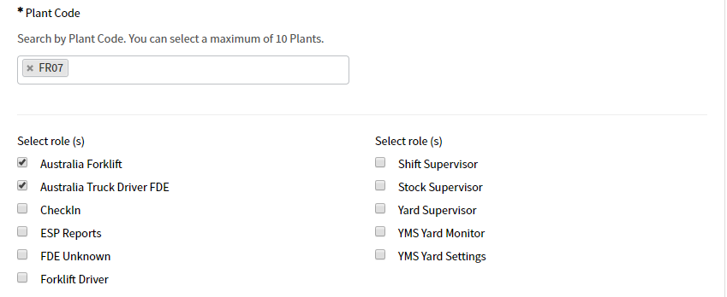

User submits the request by clicking on “SUBMIT” button which submits the form successfully. The status of the request changes to **SUBMITTED** and SNOW# gets generated.

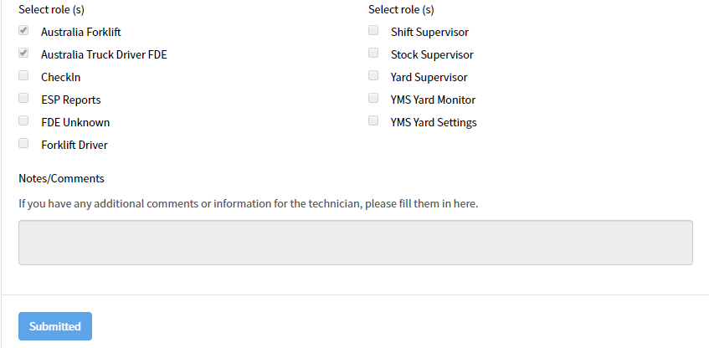

Manager gets the request in his/her portal and the approval is required in order to grant access to the plants and roles. Alternatively, manager will receive an email post form submission for the approval with all the details.

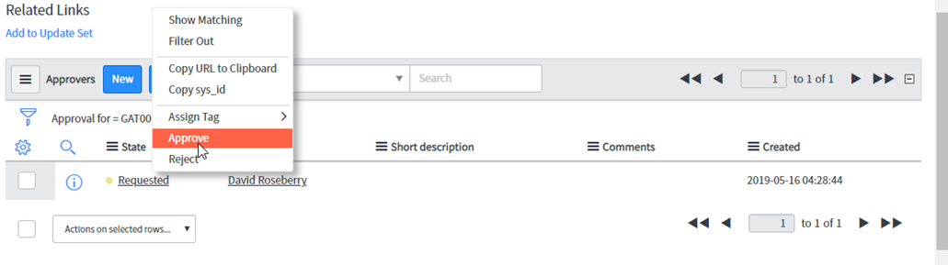

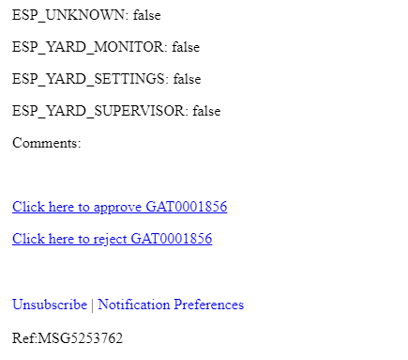

Response Message - User created successfully

Response Status – Success

Email notification will be received by the manager.

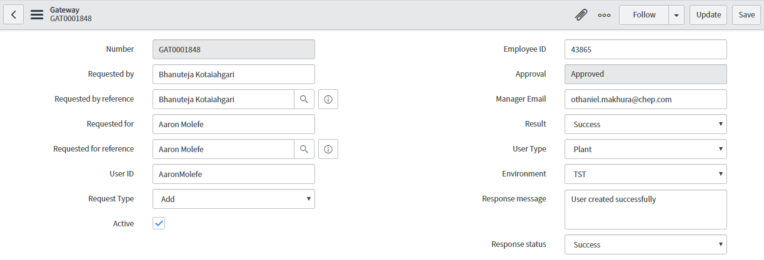

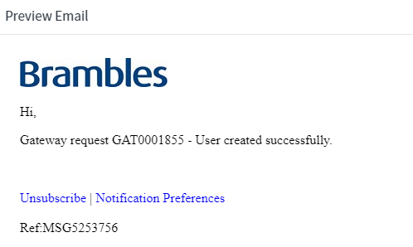

**SAP Screen for the ADD request**



**3.4.2 Request Type: MODIFY**

User can perform MODIFY request on behalf of the user to whom request is to be granted for the access of plants and roles.

System should display the existing data of the user i.e. accessed plants and roles

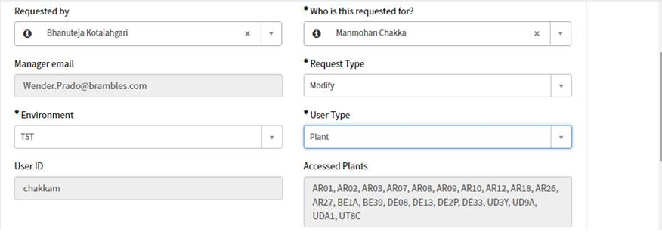

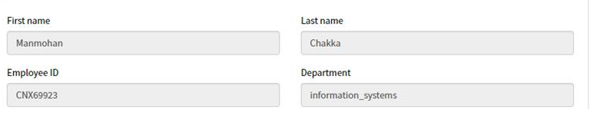

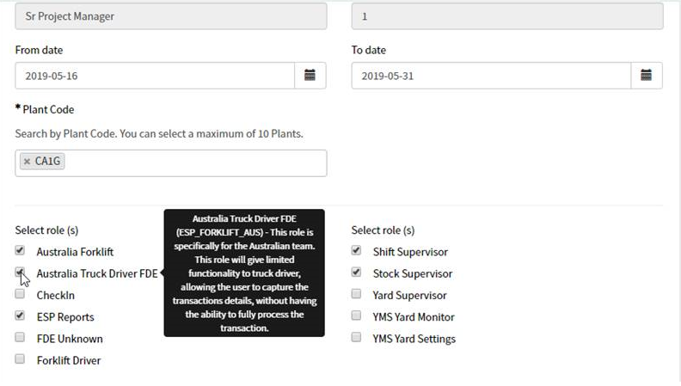

User submits the request by clicking on “SUBMIT” button which submits the form successfully. The status of the request changes to **SUBMITTED** and SNOW# gets generated.

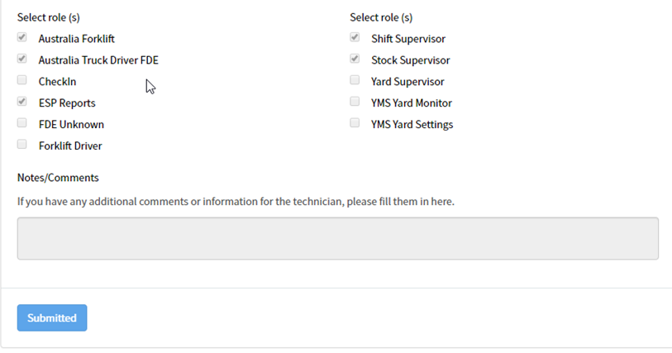

Manager gets the request in his/her portal and the approval is required in order to modify the access to the plants and roles which was requested. Alternatively, manager will receive an email post form submission for the approval with all the details.

Response Message - User changed successfully

Response Status – Success

Email notification will be received by the manager.

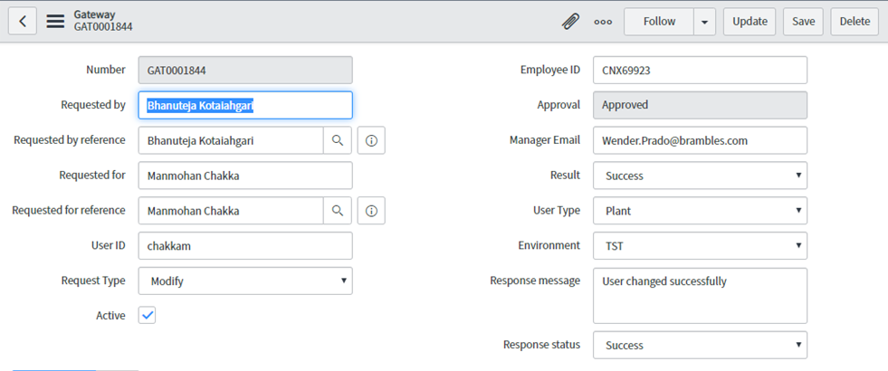

**SAP Screen for the MODIFY request**

cid:image002.png@01D50BF5.83FE93D0

**3.4.3 Request Type: TERMINATION**

User can perform TERMINATION request on behalf of the user to whom request was granted for the access of plants and roles. Users will be terminated post the success of the request.

System should not allow the user to modify the plants and roles.

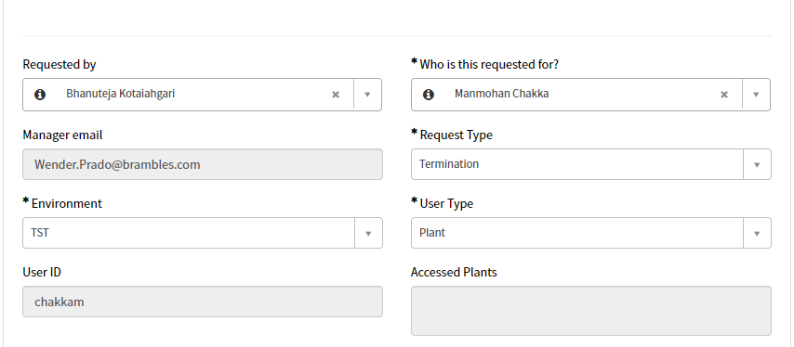

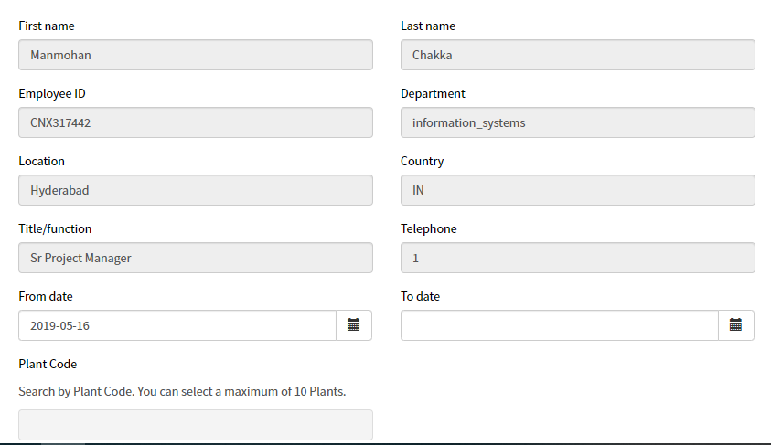

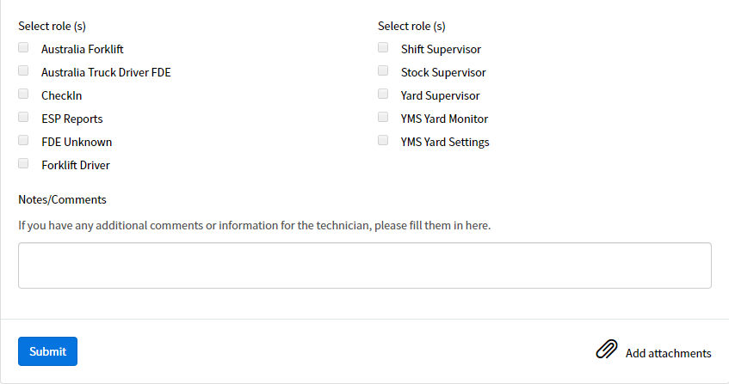

User submits the request by clicking on “SUBMIT” button which submits the form successfully. The status of the request changes to **SUBMITTED** and SNOW# gets generated.

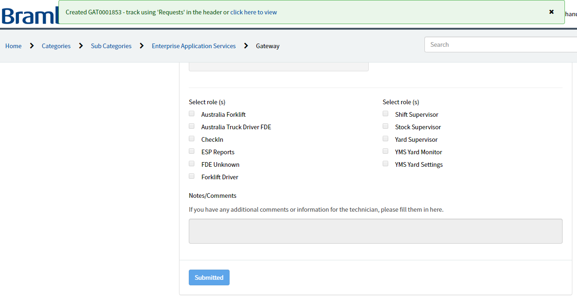

Manager gets the request in his/her portal and the approval is required in order to modify the access to the plants and roles which was requested. Alternatively, manager will receive an email post form submission for the approval with all the details.

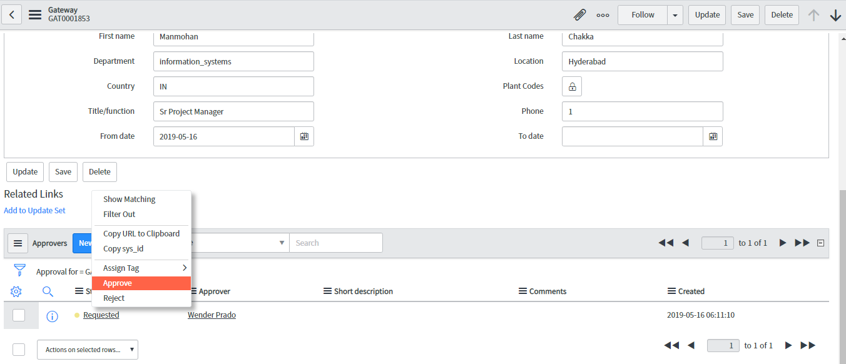

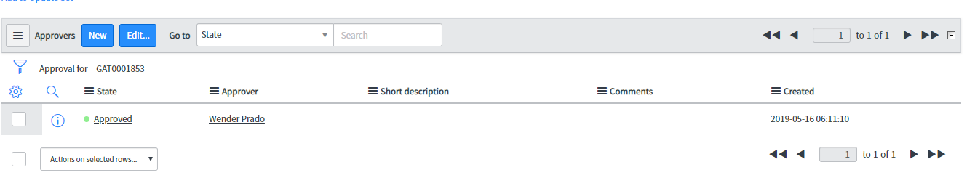

Response Message - NIL

Response Status - NIL

Email notification will be received by the manager.

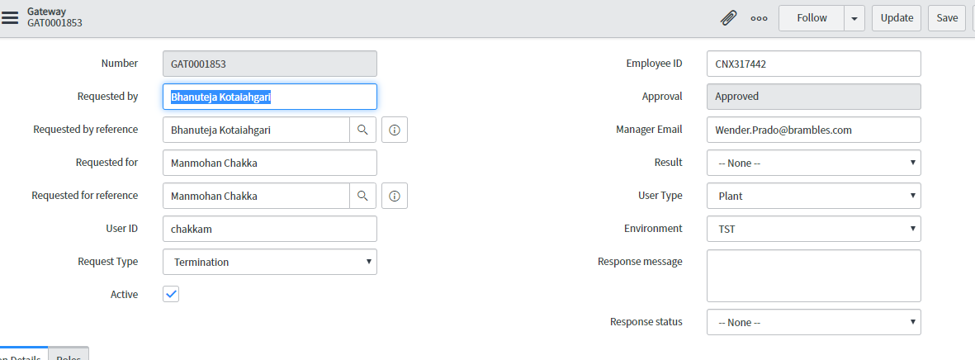

**SAP Screen for the TERMINATION request**



* 1. **SPECIAL CASES**

**3.5.1 Add an existing user**

Add a user which is already existing in the system. By doing so, system will notify the user through an email notification that – USER ALREADY EXISTS.

User can modify the existing request and change the plants/roles selection.

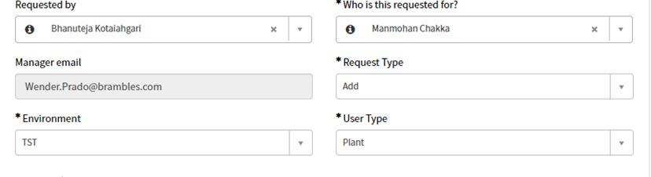

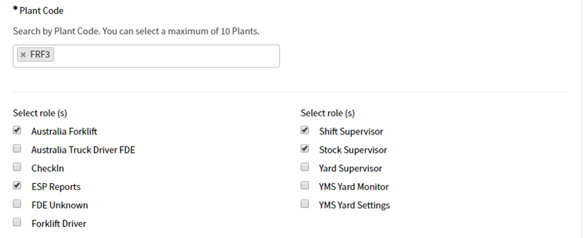

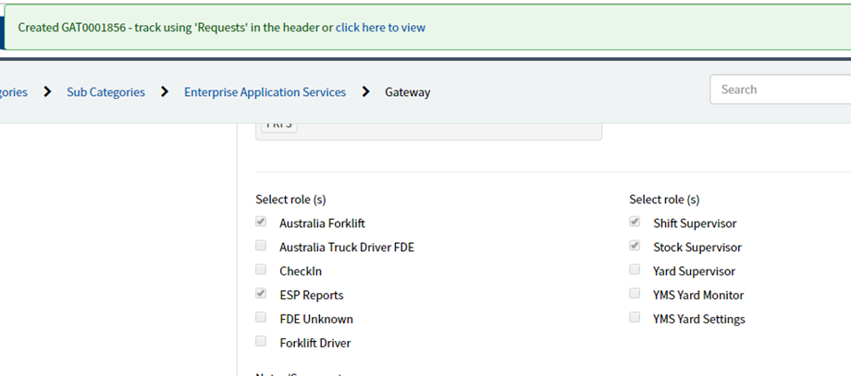

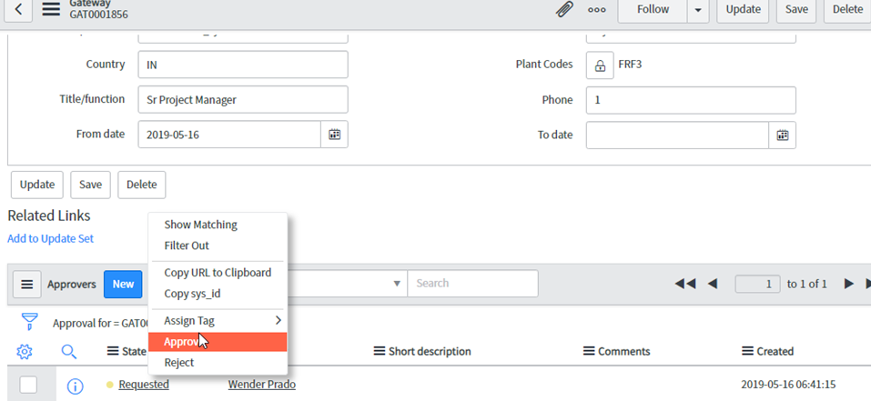

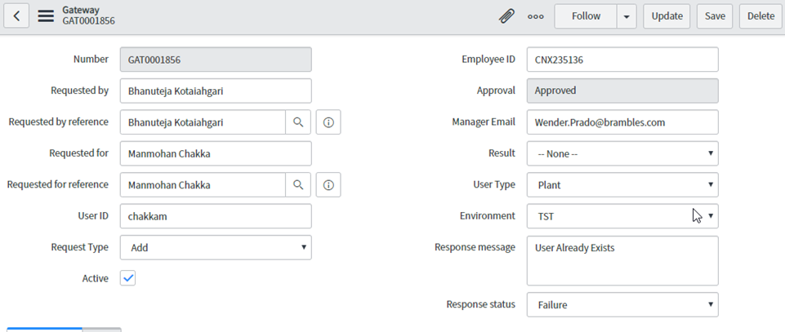

* + 1. **Modify user with no current existence**

Modify a user which is no longer existing in the system. By doing so, system will notify the user through an email notification that – USER DOES NOT EXIST.

User can add a new request and select the plants/roles.

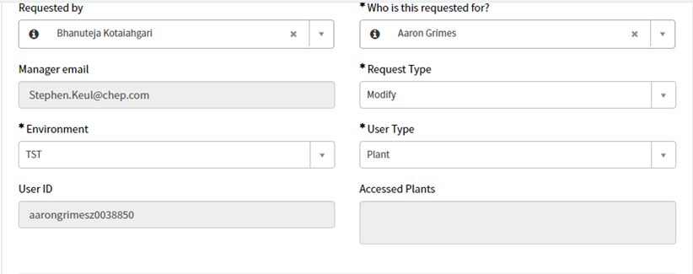

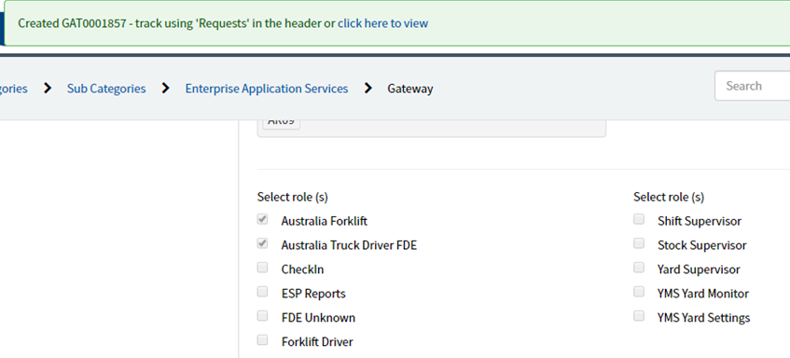

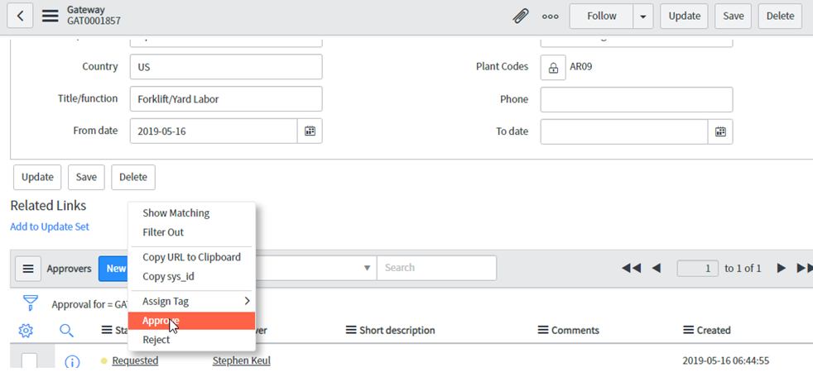

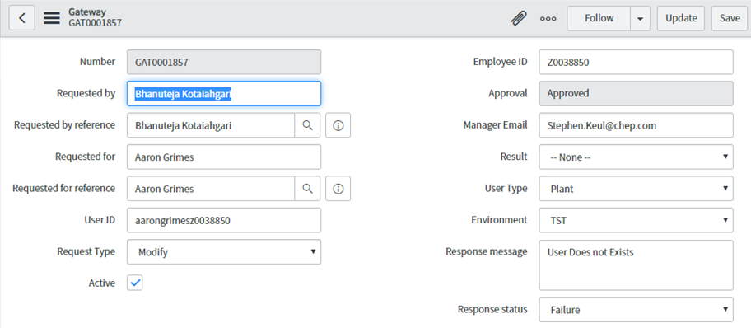

**SPECIAL CASES - SAP Screens**



* 1. **NOTIFICATIONS**

Notifications will trigger to the manager’s email ID of the user for whom the above-mentioned requests are made.

**3.6.1 SAP ACCESS REQUEST**

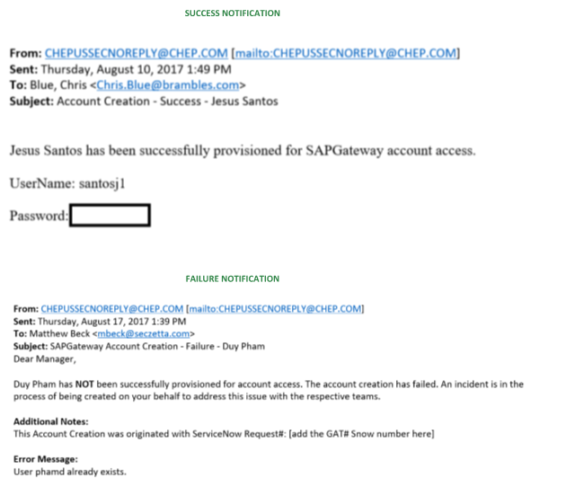

**3.6.2 SNOW TERMINATION**

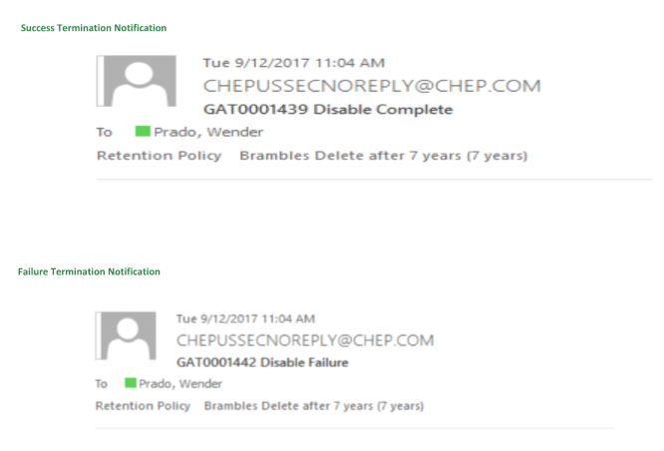

**3.6.3 SNOW APPROVAL REQUEST**

