1. Develop a Spring REST controller which should support multiple data formats when called the same URI. It should support JSON, XML and TEXT formats as response back.

a) JSON Report:

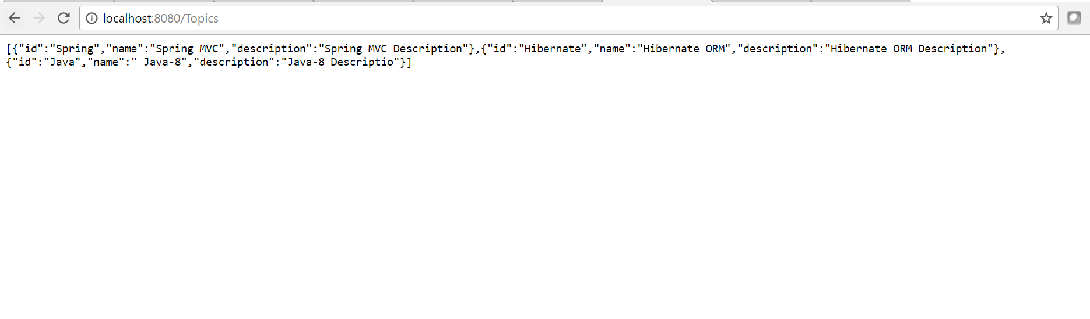

b) XML Report:

