Improve performance of Quick Sort by introducing Insertion Sort

Srujan Pothina (800965600)
Bharat Pothina (800937640)

ITCS 6114 – 091 (Fall 2017)
Algorithm and Data Structures

12/11/2017

Table of Contents
Table of Contents 2
Problem Statement 3
Current State 3
Quick Sort 3
Insertion Sort 4
Approach for solution 4
Quick Sort with cut-off to insertion sort 4
Experiment Results 5
What is the experiment? 5
For K = 100 6
For K = 1000 8
For K = 10000 10
For K = 100000 12
Conclusion 14
Does the optimal value M depend on K? 14
References 14

Problem Statement

One way to improve the performance of QuickSort is to switch to InsertionSort when a subfile has <= M elements instead of recursively calling itself. Implement a recursive QuickSort with a cutoff to InsertionSort for subfiles with M or less elements. Include counters in the codes, empirically determine the value of M for which it performs fewest total number of key comparisons on inputs of 10000 random natural numbers each less than K for K=100, 1000, 10000, 100000. You should repeat the experiments 1000 times before making conclusions. Does the optimal value M depend on K?

Current State

Quick Sort
Quick sort follows the divide-and-conquer principle based on the idea of choosing one element as a pivot and thereby partitioning the array around it such that:
- Left side of pivot contains all the elements that are less than the pivot element &
- Right side contains all elements greater than the pivot.

In terms of the average time complexity we will have O(N logN) comparisons to perform the intended algorithm and from a worst case scenario perspective it is O(N²).

Following is the algorithm to carry out the quicxk sort operation.

int partition ( int A[],int start ,int end) {
int i = start + 1;
int piv = A[start] ; //make the first element as pivot element.
for(int j =start + 1; j <= end ; j++ ) {
if ( A[ j ] < piv) {
swap (A[ i ],A [ j ]);
i += 1;
}
}
swap ( A[ start ] ,A[ i-1 ] ) ;
return i-1;
}

void quick_sort ( int A[ ] ,int start , int end ) {
if( start < end ) {
int piv_pos = partition (A, start, end) ;
quick_sort (A,start , piv_pos -1); //Left side of pivot will be sorted.
quick_sort ( A,piv_pos +1 , end) ; //Right side of pivot will be sorted.
}
}

Insertion Sort
Insertion Sort is a simple sorting algorithm which moves elements one at a time into their correct position. This can be very fast and efficient when used with smaller arrays. However, it loses this efficiency when dealing with large amounts of data.
From time complexity perspective, on an average this sorting technique has an overall complexity of O(N²).

Following will be the basic layout how this works.
void insertionSort(int arr[], int n)
{
int i, key, j;
for (i = 1; i < n; i++)
{
key = arr[i];
j = i-1;

/* Move elements of arr[0..i-1], that are
greater than key, to one position ahead
of their current position */
while (j >= 0 && arr[j] > key)
{
arr[j+1] = arr[j];
j = j-1;
}
arr[j+1] = key;
}
}

Approach for solution

As per the given problem statement, we need to empirically determine the value of M, for which it performs the lowest possible total number of comparisons on inputs of 10000 random natural numbers. And each of the input chosen must be for values less than K where K=100, 1000, 10000, 100000. Below is the approach that was followed in deducing a solution for the given use case.

Quick Sort with cut-off to insertion sort
Quick Sort algorithm has a complexity of O (N log N). This will be a best fit for large number of will definitely not be the most efficient algorithm. So, we introduce Insertion Sort to counter this. Insertion Sort is suitable and even outperforms Quick Sort for a small amount of data but it is inefficient for large quantities of data.
So, we modify the Quick Sort algorithm to cut-off to insertion sort whenever the sub-file has less than or equal to M elements. This leads to a decent performance improvement for Quick Sort while sorting a large amount of data.

QuickSort(A,start,end,cutOff)
{
If((end-start)<cutOff)
{
InsertionSort(A,start,end)
}
pIndex <- Partition(A,start,end)
QuickSort(A,start,pIndex-1,cutOff)
QuickSort(A,pIndex+1,end,cutOff)
}

Experiment Results

What is the experiment?
For each K value, we ran our solution multiple times and here in this report we provide the experiement results for 3 sample runs (for each K value).
Each run contains the following:
- 10 rounds of experiements wherein the M value ranges between 1 to 500 in each round
- By doing this, we deduce the value of M which ends up having the least number of comparisons

In the next few pages we are showing the results from the runs as mentioned above.

For K = 100
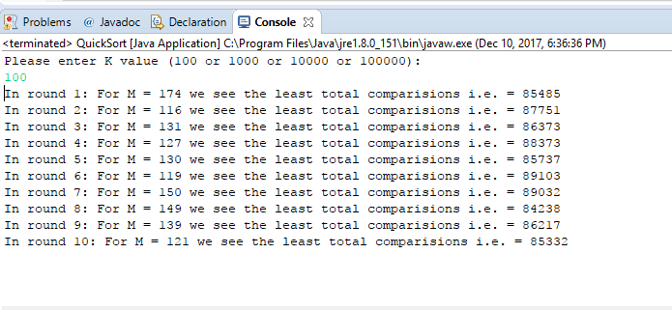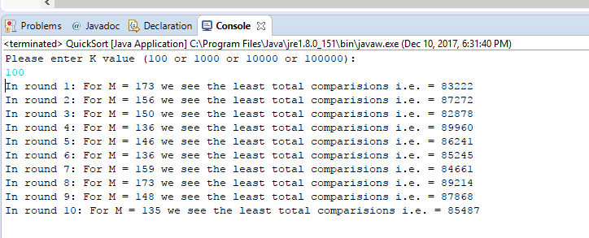

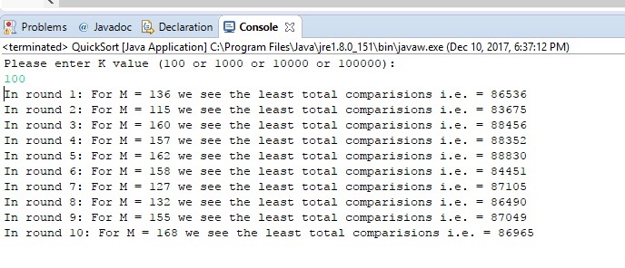

Our experiment for K = 100, resulted in values of M = 173, 149, 158 (from each run) wherein we saw the least number of comparisons.

For K = 1000
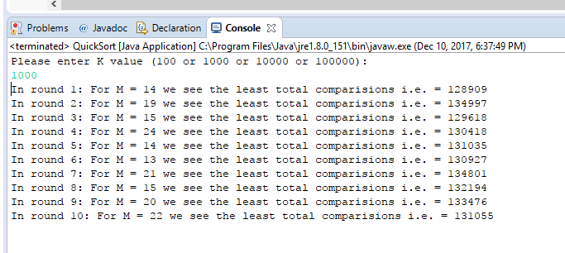

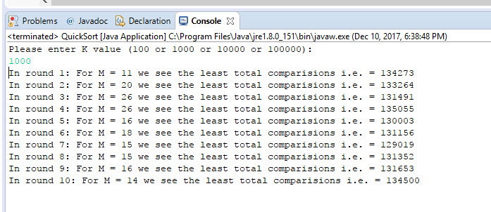

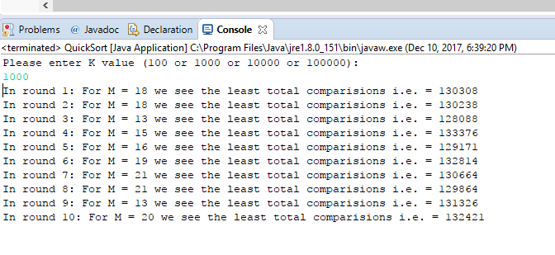

Our experiment for K = 1000, resulted in values of M = 14, 15, 13 (from each run) wherein we saw the least number of comparisons.

For K = 10000
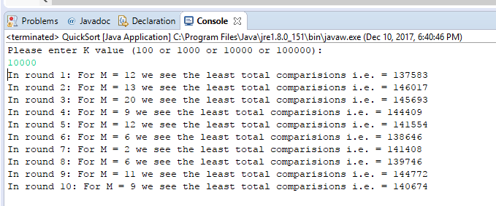

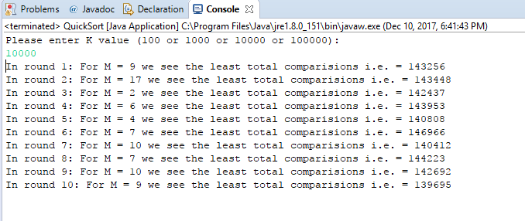

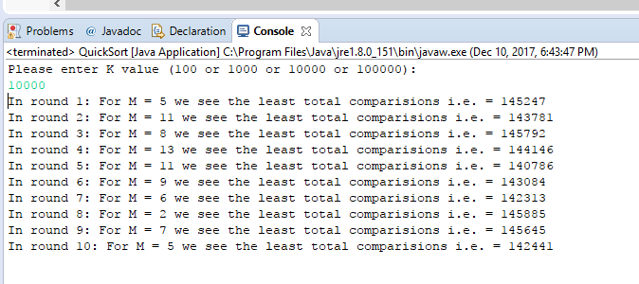

Our experiment for K = 10000, resulted in values of M = 12, 9, 11 (from each run) wherein we saw the least number of comparisons.

For K = 100000

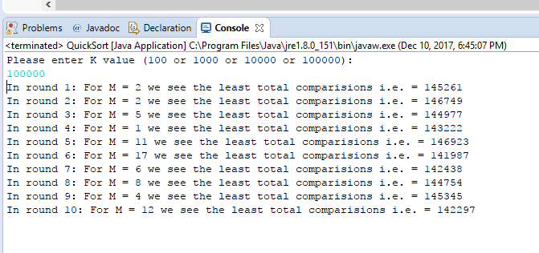

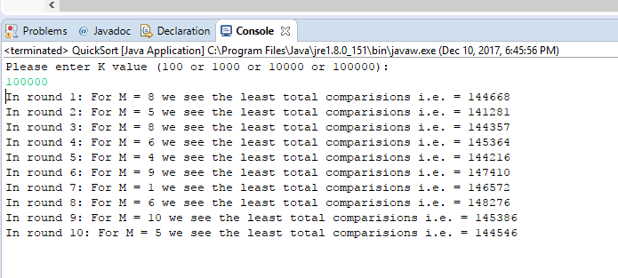

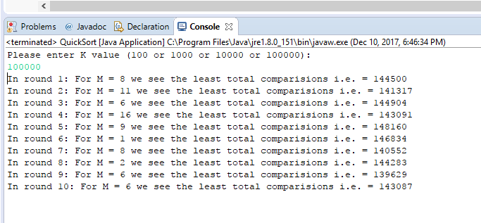

Our experiment for K = 100000, resulted in values of M = 17, 5, 6 (from each run) wherein we saw the least number of comparisons.

Conclusion

Does the optimal value M depend on K?
Yes, from all the above experiement results provided in this report and also from the multiple runs of our solution we can definitely say that as the value of K increases the value of M decreases. Thereby, we can conclude that the optimal value of M depends on K.

References

https://www.hackerearth.com/practice/algorithms/sorting/quick-sort/tutorial/

http://www.geeksforgeeks.org/insertion-sort/

Note: Attached the Java Code solution file and output screenshots along with this report. Please refer it.

