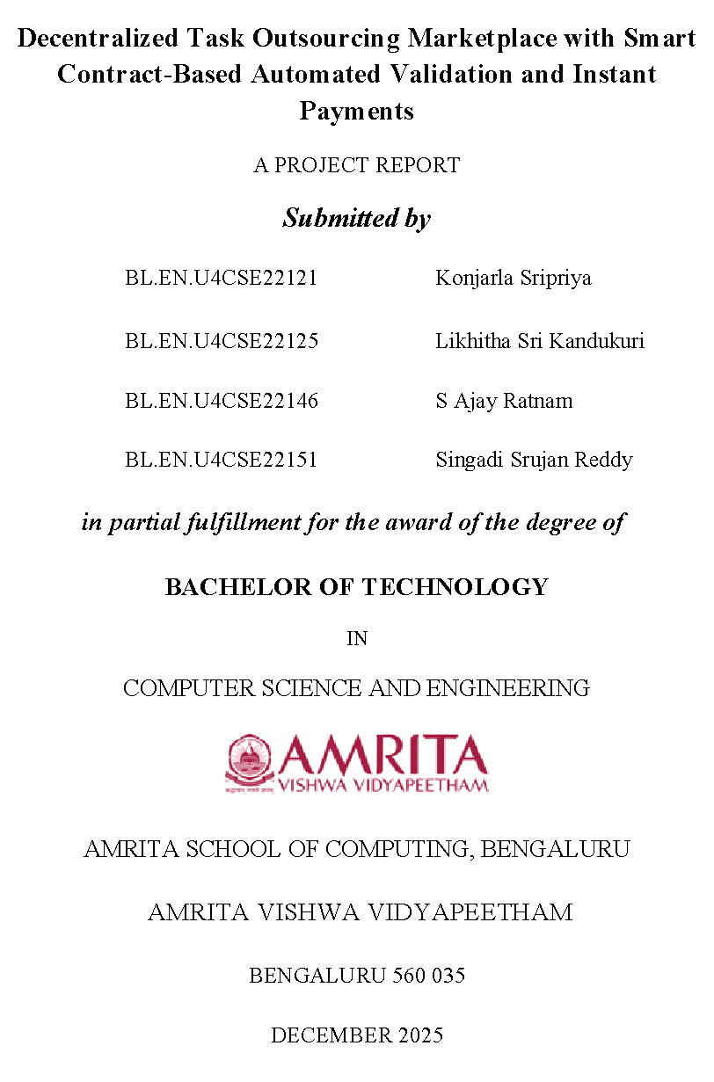

ACKNOWLEDGEMENTS
The satisfaction that accompanies successful completion of any task would be incomplete without mention of people who made it possible, and whose constant encouragement and guidance have been source of inspiration throughout the course of this project work.
We offer our sincere pranams at the lotus feet of “AMMA”, MATA AMRITANANDAMAYI DEVI who showered her blessing upon us throughout the course of this project work.
We owe our gratitude to Prof. Manoj P., Director, Amrita Vishwa Vidyapeetham Bengaluru Campus. We would like to place our heartfelt gratitude to Dr. Gopalakrishnan E.A., Principal, Amrita School of Computing and Amrita School of Artificial Intelligence, Bengaluru for his valuable support and inspiration.
It is a great pleasure to express our gratitude and indebtedness to our project guide Dr Niharika Panda, Assistant Professor, Department of Computer Science and Engineering, Amrita School of Computing, Bengaluru for her valuable guidance, encouragement, moral support, and affection throughout the project work.
We would like to thank express our gratitude to project panel members for their suggestions, encouragement, and moral support during the process of project work and all faculty members for their academic support. Finally, we are forever grateful to our parents, who have loved, supported and encouraged us in all our endeavors.

ABSTRACT
DATOM (Decentralised Automated Task Outsourcing Marketplace) is an evolving digital platform that aims to remove limitations imposed by conventional intermediaries through enhanced security, more effective dispute resolution and improved processing times for the entire freelance business model. Through a combination of a state of the art full-stack Web architecture (React Frontend + Python FastAPI Backend), next-gen cryptography and Ethereum-compatible Blockchain technology, DATOM leverages an innovative "trustless" verification method that takes away the need for clients to verify sensitive deliverables. Central to the platform's new ability is the development of a Real Zero Knowledge Proof (ZKP) System built on the Mathematical Hardness of the Discrete Logarithm Problem; the system leverages the binding and hiding properties of Pedersen Commitments as well as Schnorr-like Range Proofs so that a freelancer is able to cryptographically prove to a prospective client that they have met specific requirements for a deliverable (file size, naming convention etc.) while never revealing the contents of the file or any of its associated Metadata thus guaranteeing total confidentiality and compliance. This Cryptographic Assurance is linked to a Custom smart contract called PartialPaymentEscrow which is deployed on an Anvil Network and automatically processes payments based on the validity of the proof provided. DATOM provides streamlined fraud-resistant environment that delivers the seamless integration of privacy-preserving cryptography and automated financial settlement. By facilitating granular transactional logic, this technology enables partial payment of approved milestones, automatic refunds of escrowed funds upon task completion, and robust auto-approval protection mechanisms. Therefore, all valid work is instantly recognized and paid for, without human intervention, which represents an evolution in the way automated digital cooperation works. Hence, a new standard for secure, equitable and efficient digital collaboration has been established by DATOM in the era of Web3.
TABLE OF CONTENTS
ACKNOWLEDGEMENTS I
ABSTRACT II
LIST OF FIGURES IV
CHAPTER - 1 1
INTRODUCTION 1
1.1 Background 1
1.2 Motivation 1
1.3 Problem Statement 2
1.4 Objectives 3
1.5 Scope and Limitations 4
1.6 Contributions 5
1.7 Organization of the Report 6
CHAPTER - 2 7
LITERATURE REVIEW 7
CHAPTER – 3 15
3.1 Software requirements 15
3.2 Hardware requirements 16
3.3 Functional requirements 17
3.4 Non Functional Requirements 18
CHAPTER - 4 21
SYSTEM DESIGN 21
4.1 High Level Design (HLD) 21
The High-Level Design describes the core modules, actors, and how components interact across the Web2 and Web3 environments. 21
4.2 Low Level Design (LLD) 23
4.3 Security Design 25
CHAPTER – 5 27
SYSTEM IMPLEMENTATION 27
5.1 Development Environment 27
5.2 Smart Contracts Implementation 28
5.3 Backend Service Implementation 29
5.4 Frontend Implementation 31
5.5 System Integration and Deployment 32
CHAPTER - 6 34
SYSTEM TESTING 34
6.1 Testing Strategy and Environment 34
6.2 Smart Contract Testing 35
6.3 AI-Verification Testing 35
6.4 Integration and System Testing 36
6.5 Performance and Security Testing 37
6.6 User Acceptance Testing 38
6.7 Test Summary 39
CHAPTER – 7 40
RESULTS AND ANALYSIS 40
7.1 Overview of Implemented System 40
7.2 User Interface and Workflow Results 40
7.3 Functional Capabilities and Verification Results 46
7.4 System Performance Analysis 51
7.5 Conclusion 51
CHAPTER – 8 52
CONCLUSION AND FUTURE SCOPE 52
8.1 Conclusion 52
8.2 Limitations 53
8.3 Future Scope 53
8.4 Final Remarks 54
REFERENCES 55

LIST OF FIGURES
Fig. 4.1 Overall Architecture and Workflow of DATOM 22
Fig. 7.1 The DATOM Landing Page. 41
Fig. 7.2: The Create Task Dashboard. 43
Fig. 7.3 The MetaMask transaction request 44
Fig. 7.4 The Marketplace View. 45
Fig. 7.5 The Submission Interface. 46
Fig. 7.6 A submission containing several files 47
Fig. 7.7 The Freelancer Dashboard 48
Fig. 7.8 The task lifecycle is completion 49
Fig. 7.9 Transaction history of user in wallet 50

CHAPTER - 1

INTRODUCTION

1.1 Background
The Gig Economy has grown rapidly and has enabled Digital Services to become an international market, however there is still much room to grow in terms of the systems in place that support these transactions. Traditional platforms for freelancers are acting as intermediaries by holding payments and settling disputes, as well as charging extremely high transaction fees, causing a delay in the finalisation of payments, while also compromising user privacy. DATOM is a paradigm shift from a centralised trust-based approach to a decentralised cryptographic trust method for the Digital Services marketplace. It is designed with Hybrid Solutions integrating user experience with Web2 interface tools like React & Python along with the security of Web3 settlements in a way that allows verification of work done and payment to be made to the worker automatically, without any third-party involvement.

1.2 Motivation
DATOM's mission is to close the fundamental trust gap inherent in remote work without sacrificing either security or efficiency.
- To Preserve Privacy: Freelancers must expose sensitive information (including their intellectual property and sometimes their identity) when they invoice a client as proof of completed work. This creates a significant risk of potential property theft or identity theft prior to payment being made.
- Operationally Efficient: The current model for manual verification will never be scalable enough to accommodate a growing number of freelance workers. Clients will need to continue downloading, opening and reviewing each file submitted by their freelancers to verify it meets their most basic requirements, including verifying it is in an acceptable format and checking its size. Therefore, accessing and verifying every file submitted by a freelancer wastes an immense amount of both time and bandwidth delaying the timeliness of the entire payment process.
- Financially Secure: The existing escrow system is often too slow and lacks adequate safeguards against unauthorized or arbitrary disputes. DATOM seeks to build a "code-is-law" structure so that payments are automatically and immediately made upon receipt of a valid proof of work signature from the appropriate source.

1.3 Problem Statement
DATOM's aim is to address the 'Verification Dilemma' encountered when outsourcing digital products.
- The problem: The client requires verification that the digital product being delivered (for example, an image) has certain characteristics (for example, must be a high-resolution image greater than five megabytes in size) without being able to physically inspect the file. Yet, the contractor must send the file to substantiate that it meets those requirements.
- The Flaw in Current Solutions: Existing methods for addressing the verification dilemma often rely on "fake privacy", in which the service provider uses hashing or checks a file's metadata to generate digital fingerprints. Digital fingerprints are created through the creation of a digital representation of data, however, there is still a need for both parties to know the original input data in order to completely validate the authenticity of the digital representation. Consequently, the verification dilemma circumvents true privacy.
- The Consequence: This dilemma forces a trade-off: either the client trusts the freelancer blindly (risking fraud), or the freelancer trusts the client with the data before payment (risking theft). DATOM aims to eliminate this trade-off entirely.

1.4 Objectives
- Create a Real Zero-Knowledge Proof System: In order to create an authentic zero-knowledge proof system for the purpose of providing a cryptographically secure validation layer through the use of pedersen commitments and schnorr-like range proofs. This is to provide a way for a prover (freelancers) to prove the amount of an item e.g. file size within a defined range e.g. greater than 1MB without having to disclose the exact value or the contents of the file.
- Automate Payments with Smart Contract: By utilizing a custom Solidity contract called "PartialPaymentEscrow" (on the Ethereum-compatible network of Anvil) to automate payments. The "PartialPaymentEscrow" serves as a neutral third-party and automatically completes transactions or retries refunds based on the results returned by the "ZKP verification".
- Automated Approval and Fairness of Submission: By developing an automated workflow to enforce that valid proofs of work submitted by freelancers must automatically be approved. If calculations of cryptographic math are successful, the system will automatically approve and complete the transactions submitted by the freelancer, thus protecting the freelancer from the consequences of an unfair buyer.
- Build a Seamless Hybrid User Experience: By simplifying the cryptographic and blockchain processes into a user-friendly web application. By creating a React front-end to interact with the wallet connection, the file upload, and proof generation will allow end users to interact with the new technology in a simple manner.

1.5 Scope and Limitations
1.5.1 Scope:
- System Functionality - The system supports the whole process of a job from beginning to end. Via the following process, the entire workflow is covered: Client Onboarding, Task Creation and Validation Rules assigned to create a Task, Escrow Fund, Freelancer Submitted Task, Zero Knowledge Proof Generation and Verification, Automatic Payment Release, Task Closed
- Verification Features - The Cryto Engine today supports two types of verification:
  - Range Proof Verification - This is where it is verified if numerical characteristics file size is Less Than, Greater Than, or Equal to a Threshold..
  - Membership Proof - This is where it can be verified if the file names contain a particular pattern i.e., a specific file extension.
- Financial Functions - The Financial Features of the system will support:
  - Issue Partial Payments (for individual approved files) - Payment can be made only for those files individually approved by the Client.
  - Issue Full Refunds (to the Client's escrow account) - Full refunds will be issued for any remaining unspent escrow funds to the Client once a Task is completed.
1.5.2 Limitations:
- Verification Complexity: The current version of the software has limitations regarding the complexity of providing a verification of different types of files and documents. We do not currently provide functionality to verify, for example, the length of a video or the resolution of an image, or to verify the content of a document semantically.
- Scalability: The system currently generates one proof for every file uploaded into the Blockchain. For large scale production of proofs we will need to aggregate multiple verifications into a single proof for the purpose of reducing the required computational resources needed to produce each proof as well as to reduce the amount of Blockchain transaction fees that are incurred during proof generation.
- Blockchain Dependencies: The software relies on the existence of the underlying Blockchain and the Anvil blockchain testing network for operation. Additionally, the user must understand basic wallet interaction processes to utilise the software.

1.6 Contributions
DATOM contributes several key innovations to the field of decentralized applications:
- Mathematical Privacy vs. Hashed Privacy: Unlike previous systems that claim privacy but rely on revealing hashes, DATOM implements a true Zero-Knowledge architecture. By using the homomorphic properties of Pedersen Commitments, the verifier (Client) learns strictly that the condition is met e.g., X > Y without learning X, Y, or the difference between them.
- The introduction of the PartialPaymentEscrow.sol contract as a trustless mechanism for incrementally paying for work completed on an escrow account results in greater granularity in the way payments are made. Clients are able to securely release portions of payment incrementally as each work step is confirmed rather than being forced to either accept or reject the entire project at once.
- A third feature of the DATOM platform is theAutoApprovalProtection Framework. The goal of this framework is to create a mechanism that gives clients an incentive to approve the work they have requested. By combining a governance layer where valid cryptographic proofs override human judgement with the existing partial payment escrow model, DATOM removes the ability for clients to exploit this common problem.

1.7 Organization of the Report
The rest of the report provides a step-by-step guide for the entire development cycle of the DATOM from the theoretical basis right through to the final release and everything associated with it. The report will be presented in the following manner:
- Chapter 2 is a literature review of research pertaining to Decentralized Marketplaces, Zero-Knowledge Proof Systems (ZKPs), and Blockchain Escrow systems.
- Chapter 3 provides a comprehensive breakdown of all software, hardware, functional and non-functional requirements for DATOM.
- Chapter 4 provides technical architecture of DATOM through the development of high-level and low-level designs along with the technical design of security.
- Chapter 5 deals with the implementation of the Smart Contracts, Back-End build/architecture (ZKP), Front-End build/architecture and integration into the system.
- Chapter 6 validates the system with respect to Smart Contract testing, ZKP testing, Integration testing, Performance Testing and Security Testing.
- Chapter 7 presents the system's performance including the efficiency of Privacy Verification and Payment Reliability.
- Chapter 8 Summarizes the results of the report and the limitations of the technology and recommendations for Future Improvements.
- References - A list of all academic and technical sources that have been used throughout this report.

CHAPTER - 2

LITERATURE REVIEW
Current research on detecting vulnerability in smart contracts through vulnerability detection includes static analyzers such as Mythril, Oyente and Slither. Also, research into detecting vulnerability through Machine Learning (ML) approach include opcodes, Control Flow Graph (CFG) and Abstract Syntax Tree (AST). However, many previous research studies suffer from challenges related to imbalanced datasets, inconsistent Solidity versions, and a lack of harmonisation in vulnerability label, therefore results may not be appropriate for the real-world scenarios [1]. In addition, while several recent studies have used the SWC registry and synthetic bug injection, they still do not have standardised methods for pre-processing of imbalanced datasets. In order to fill the aforementioned gaps, our study presents a novel pre-processing pipeline which provides an ML dataset consisting of all Solidity versions in a balanced manner. We demonstrate this pre-processing pipeline through the creation of a balanced dataset via the injection of bugs into AST and perform a benchmark of the RF, XGBoost, SVM, MLP and a hybrid MLP-LSTM model against this dataset. We find that our proposed MLP model shows the best results in terms of accuracy and has the lowest false positive rate on Ethereum contracts tested, outperforming other ML approaches.
It is difficult to implement a Pay-as-You-Go SaaS (Software as a Service) model because it requires accurate tracking of service utilization and adherence to the legal and financial obligations of both the service provider and the service user [2]. By introducing a new architectural framework known as Service as a Smart Contract (SaaSC), which integrates Smart Legal Contracts into the SaaS platform to regulate the service's registration, discovery, customization, and all transactional processes in accordance with its legally defined terms, the 2023 publication offers a novel approach. A contract-based interface declaration is also included, which will enable automatic granular billing for every service call. This article demonstrates how the two components work well together to use automated system-generated acquisition, delivery, and post-payment settlement carried out via Blockchain as a business model for creating enforceable computer software contracts through the implementation of a weather forecasting service.

Due to limited domain expertise, costly data collection techniques, and small or unrepresentative datasets, obtaining high-quality ground truth for machine learning is difficult [3]. A blockchain-powered crowdsourcing approach was suggested in the 2025 study to use smart contracts and decentralized annotators within the Ethereum network for safe and dependable annotation collection and verification. The suggested approach aids in ensuring the transparency and dependability of participant contributions to data recording due to the immutable nature of blockchain's ledger. Inter-rater agreements were used to evaluate the annotation data, and most pairs showed moderately strong to very strong agreement. This suggests that the crowdsourcing approach utilizing blockchain technology enhances the dependability, consistency, and credibility of the ground truth data used in the creation of machine learning algorithms.

Weapon system supply chains will be affected by counterfeit and tampered components, as well as vulnerable systems. Thus, providing assurance regarding traceability and protection of long-term data requires the implementation of a blockchain-based framework along with an encryption system that uses escrow keys to maintain data availability, integrity and confidentiality[4]. According to the 2020 study, this proposed framework provides for secure tracking of system components, reliable access to data (operational), enhanced/effective protection of supply chain assets, and enhanced-ability for global supply chain defense where long-lifecycle products are utilized.

Smart contracts and Decentralized Finance (DeFi) protocols are at risk of loss of functionality when defects are introduced after their deployment; and once deployed smart contracts or DeFi protocols have a defect or breach, there is no way for the creation of a new on-chain record to repair them [5]. A 2023 overview introduced SolSaviour, a protective framework that utilises a decentralised Trusted Execution Environment (TEE) and a democratic vote to remediate defects in deployed smart contracts. SolSaviour provides users with a means of quickly destroying the defect, deploying a repaired smart contract, and transitioning users' funds and state variables from the defected smart contract and onto the repaired one, independent of any public, private or third-party-controlled authority. The results of testing have shown that within the terms defined above, organisations using this distributed framework can effectively protect themselves from the consequences of exposed vulnerabilities found within a decentralised execution environment with manageable overhead costs.
Smart contracts, which are present on numerous blockchains, are used by blockchain systems. On most (if not all) of these blockchains, Solidity is the main language used to write smart contracts. However, some blockchain platforms, like Ethereum, have developed other languages that are better suited for use with applications created using the DApp architecture model than with traditional smart contracts. This study sheds light on the various ways that the DApp and Smart Contract development process is compatible with six distinct Applications Development Language Models and Open-Source Development Environment (Open Source Dev, License, Native) tools. Additionally, it highlights the main shortcomings of GitHub-based development methodologies, including their inadequate defense against vulnerabilities, restricted capacity for formal verification, and inconsistent execution across various platforms. This research project's main objective is to accurately depict how GPL fits into the larger Blockchain ecosystem and the drawbacks they present for Smart Contracts.
Manipulation, dependence on a third party or middleman, and opaque payment enforcement are problems with freelance centralization platforms that have a detrimental impact on both employers and freelancers. [7] This study proposes a decentralized freelance system based on the Ethereum public blockchain, which would eliminate the need for a third party to hold the funds via a cryptocurrency P2P payment system and offer a way to record reviews on a distributed ledger. Smart contracts will enable safe, transparent, and unchangeable transactions between employers and freelancers, making the system more dependable than the current centralized freelance platforms.
There are a number of issues that can be related to centralized freelancing platforms, including excessive fees for using services, unfair treatment from platforms regarding account management, delays on payments, and a lack of trust between platform users due to their reliance on an external party to control the transaction [8]. This paper proposes a decentralised marketplace for freelancing located on the Ethereum blockchain where clients and freelancers can communicate directly without having to deal with any centralised authority. Smart contracts will be utilized by the system to facilitate job postings, bids and hiring, work submissions, and the release of payments after the completion of tasks. The system will allow for transparency and eliminate payment delays. Eliminating intermediaries will allow for more equitable interactions among platform users as well as reduced transaction costs and greater trust for the freelancers and clients working together.
Attackers are taking advantage of the quickly growing Decentralized Finance (DeFi), so that attackers are able to find many vulnerabilities (e.g., Flash Loan Abuse and Price Manipulation) using various complex logic flaws that are found in decentralized finance systems (a.k.a., Cross Protocol Flows) and are not detected by conventional Smart Contract Scanners. To address the need for better detection and analysis of attacks against DeFi applications, we propose a novel framework called DeFiScanner that uses Deep Learning to detect and analyze attacks against DeFi applications. The framework consists of three different Detection Models (Global Model, Local Model and Fusion Model), which utilize Normalized Event Data to analyze DeFi transactions. DeFiScanner creates Transaction Level Features, creates Aggregate Architectural Representations (or Patterns) from Event Objects (i.e., emitted events), and fuses both to create a complete attack pattern on DeFi Logic. Using a dataset of over 50,000 real Ethereum transactions, our approach achieves a True Positive Rate of 0.91 & ROC-AUC of 0.97, demonstrating that we can detect logical attacks against DeFi Applications with a level of accuracy superior to previous studies.
Blockchain technology gives companies a broader view of the stakeholder ecosystem and helps them improve the efficiency of the supply chain. With the use of smart contracts, businesses can automatically execute their functions when triggered by IoT devices or external data sources. This paper will look at current systems for managing smart contracts and assess their overall characteristics, including the ones that may limit their ability to support traditional organizations and decentralized autonomous organizations.Based on the results of this evaluation, the authors propose the SmartCon framework, a single platform that allows multiple organizations to manage smart contracts in a single framework[10]. SmartCon uses two different blockchains to separate the storage of smart contracts and the transaction history regarding the execution of those contracts.The SBlockchain is actively monitored to ensure the security of all smart contract data and the TBlockchain records the data generated from those contracts. This setup creates scalability for smart contracts, and allows for the integrity of all data to be stored directly on the system, so there is no need to store duplicate copies of data.SmartCon provides users with a structured way to author, issue, and execute smart contracts with clear language outlining the terms and conditions regarding the execution of each smart contract. This framework is explained in detail with respect to each of the components and has examples of its use in guiding businesses to streamline their operations through the use of efficient processes for managing contracts in a structured manner across all types of organizations.

Web3 is changing the way that we use the internet and allows the user to have more control over their personal digital data/identity and their digital interaction. As this article describes, Web3 encompasses many different types of technology including blockchain, smart contracts, Decentralised Autonomous Organisations (DAO's) and Decentralised Finance (DeFi) that allow for more transparency in your financial dealings and greater access to financial services. In addition to introducing a broad picture of Web3 technology and its applications, this article also describes the shift in the way that individuals interact with each other and with technology through a decentralised platform [11]. The article also compares and contrasts Web3 with other terms that are being used to describe various variations of the internet; namely, Web 3.0 and the Metaverse. At the end of the article, the authors propose a hierarchy of needs specific to Web3, similar to Maslow's hierarchy of needs. Finally, the authors summarize the major challenges, opportunities and areas of future research for the continued development and evolution of Web3.
A lot of developers and businesses want to switch over to using Web3, but it has been hard for them to do so (compared to their previous experiences with Web2) because they don't have enough information about how the systems differ from each other, what makes them different from each other, or any experience with working with decentralized technologies (which are part of Web3) [12]. This paper describes a framework called WebttCom that allows for an easy transition between Web2 and Web3 by clearly defining the core components of the new technology and by drawing key contrasts that exist between the two ecosystems. A full-stack implementation of this framework is detailed in order to provide an example of how the framework can assist both the developer and application during this transition. Results from numerous performance evaluations (of roughly 1000 participants) reveal that nearly 80% of those surveyed responded positively about the utility, usability, and completeness of the WebttCom framework. Therefore, WebttCom is an essential tool to help ease the challenges associated with migrating from a Web2 environment to a Web3 one.
The evolution of smart contract technology from simple cryptocurrency transactions to potent automated programs backed by blockchain's decentralized and impenetrable ledger is examined in this paper. [13] This paper describes how flexible, event-driven contract execution is made possible by platforms like Ethereum and Hyperledger in industries like supply chain, IoT, and finance. While addressing issues like security flaws, scalability constraints, and maintainability, the paper also emphasizes important benefits like efficiency, transparency, and trustlessness. It examines previous studies on consensus processes, verification techniques, and execution enhancements. Overall, the study comes to the conclusion that smart contracts will become more widely used, scalable, and secure as blockchain technology develops, serving as a fundamental basis for upcoming decentralized applications.
This study investigates how various technical and social risks interact to affect task performance in crowdsourcing marketplaces. [14] It emphasizes how six major risks—three social (seeker, solver, relationship) and three technical (complexity, requirement, task)—affect results both separately and in unexpected ways. In line with the sociotechnical systems theory, the study demonstrates that although technical risks typically worsen performance, they can also lessen the detrimental effects of social risks using data from 169 Chinese crowdsourcing projects. By showing that risks can play two roles—sometimes endangering performance, other times mitigating other risks—the paper resolves contradictory previous arguments regarding whether risks always amplify one another. Overall, this research advances knowledge of risk interactions in online crowdsourcing communities and implies that organizations can enhance task outcomes by utilizing hybrid strategies that combine social and technical elements.
In order to increase supply chain management's efficiency, traceability, and transparency, this paper proposes a blockchain-enabled smart contract system. [15] This work uses Ganache for local blockchain testing, integrates a Web3-powered frontend with MetaMask for real-time user interaction, and introduces Solidity-based smart contracts on the Ethereum network to securely track product movement. In order to alleviate network congestion and improve transaction performance, the work also suggests a dynamic gas-fee adjustment algorithm. Overall, the study shows how scalable software architecture, adaptive gas-fee optimization, and blockchain can all work together to improve trust and dependability throughout the supply chain ecosystem.

CHAPTER – 3
SYSTEM SPECIFICATIONS
This Chapter contains an overview of the overall requirements gathered towards the successful application of the DATOM platform and includes an analysis of the operational requirements from four perspectives: Software Dependencies; Hardware Specifications; Functional Capabilities; Non-Functional Quality Attributes.

3.1 Software requirements
3.1.1 Backend Requirements
- Python 3.10 or above
- FastAPI framework for building REST APIs
- Uvicorn server for running FastAPI
- Web3.py for blockchain communication
- Py-Solc-X for compiling Solidity smart contracts
- Cryptographic libraries for Pedersen Commitments, Range Proofs, and ZKP generation
- pip and virtual environments for dependency management
3.1.2 Smart Contract Requirements
- Solidity (version 0.8 or higher)
- Foundry/Anvil for deploying and testing smart contracts locally
- JSON-RPC endpoints for contract interaction
- ABI files generated after contract compilation
3.1.3 Frontend Requirements
- Node.js (v16 or above)
- npm for managing frontend dependencies
- React.js for building the user interface
- Ethers.js for wallet connectivity and smart contract interaction
- MetaMask or any Ethereum-compatible browser wallet
3.1.4 Additional Tools
- VS Code or PyCharm for development
- Git for version control
- Postman or similar API testing tools

3.2 Hardware requirements
3.2.1 Minimum Requirements
- Intel i5 / Ryzen 5 processor
- 8 GB RAM
- At least 20 GB free storage
- Basic integrated GPU (since no ML/AI training is required)
- Internet connectivity for installing dependencies and running blockchain tools
3.2.2 Recommended Requirements
- Fast multi-terminal operations will require a processor from Intel's i7 family or AMD's Ryzen 7.
- At least 16GB of RAM will allow for the handling of a blockchain node, back-end and front-end at the same time.
- Utilizing a Solid State Drive (SSD) will assist in the speed of compilation and dependency installation.
- Setting up a dual monitor set up will allow for the concurrent running of Anvil, back-end and front-end comfortably.
3.2.3 Deployment/System Hosting Requirements
- Linux-based virtual machine with at least 2 vCPUs
- 4 GB RAM
- Docker support for containerized deployment
- Infura/Alchemy RPC if moving beyond local blockchain

3.3 Functional requirements
3.3.1 User Management
- Users of the system can register as either Clients or Freelancers.
- The system allows for secure Web3 login using a wallet (e.g., MetaMask).
- Both Clients and Freelancers will have access to different dashboards that are tailored to their specific tasks.
3.3.2 Task Creation and Control
- Clients must be able to create tasks with specific validation rules (e.g., file_size > 1MB).
- Clients create their projects (tasks) by submitting budgets, due dates, and specifications.
- System must support human-friendly validation units (KB, MB, etc.).
- The due date will automatically close a task once it is reached or all of the task validation criteria have been met.
3.3.3 Submission and Verification
- Freelancers must be able to upload files for validation.
- Proofs of zero-knowledge will have to be generated by the system and verified using the proofs.
- Validation of a submission is automated.
- When the system receives a valid proof from the freelancer, the submission is approved.
- When the system receives an invalid proof from the freelancer, the submission is rejected.
3.3.4 Smart Contract Interaction
- During the creation of the task, the client is required to deposit the corresponding funds into an escrow account.
- Once the completion of the task is approved by both parties, the corresponding funds will be released from the escrow account using a smart contract.
- Payments may be partially made for each individual file.
- All unspent funds will automatically be refunded to the client once the task has been completed.
- All transactions occurring as part of the process will be recorded on the blockchain and shown within the application's user interface.
3.3.5 Frontend Requirements
- A user interface that displays task lists, submissions, statuses, deadlines, and payments, will be acceptable.
- Ether.js must also be able to support a wallet connection.
- The system should also provide users with an appropriate status message, such as "Requirements met" or "Deadline passed".

3.4 Non Functional Requirements
3.4.1 Performance Requirements
- ZKP generation should complete within a few seconds.
- API responses should be fast (under 300ms for normal operations).
- Smart contract interactions should finalize within a few seconds in Anvil environment.
3.4.2 Security Requirements
- No sensitive file content should be revealed at any stage.
- All verifications should be mathematically secure through the use of zero-knowledge proofs.
- Smart contracts must prevent unauthorized withdrawals or manipulation.
- The Web3 login should be protected through the use of cryptographic signatures.
3.4.3 Reliability Requirements
- The system must enable the frontend, backend, or blockchain components to be restarted without loss of any user data.
- All approved submissions will continue to be valid after services are restarted.
- The backend must also provide the ability to restart blockchain nodes gracefully.
3.4.4 Scalability Requirements
- The architecture must allow for future scaling into a Microservices Architecture (MSA).
- The system must have the capability to handle multiple concurrent users and tasks without any degradation in performance.
3.4.5 Usability Requirements
- UI should be simple and intuitive for both clients and freelancers.
- Validation code formats must be easy to understand (e.g., “1MB” instead of “1048576”).
- Real-time task and transaction status updates must be shown.
3.4.6 Maintainability Requirements
- Codebase should be modular, separating frontend, backend, and blockchain logic.
- All API endpoints should be self-documented using Swagger/Auto Docs.
- Smart contract ABIs must remain stable for ease of future upgrades.

CHAPTER - 4

SYSTEM DESIGN

4.1 High Level Design (HLD)

The High-Level Design describes the core modules, actors, and how components interact across the Web2 and Web3 environments.
4.1.1 Major System Components
- Client: Makes tasks, sends payments, receives validated results
- Freelancer: Chooses tasks, performs work, submits verified results via ZKP.
- SDK Server (Back End): Creates and validates ZKP, carries out validation processes, interfaces with the blockchain.
- Smart Contract: Escrow management, payment/refund functions, enforcing on-chain validation.
- User Interface: Interactions with tasks/submissions/wallet connections.
- Blockchain Immunity Network (Anvil): Smart contract's relative state information; on-chain payment execution.
4.1.2 System Flow Overview
The overall system workflow is clearly represented in the architecture diagram shown below:
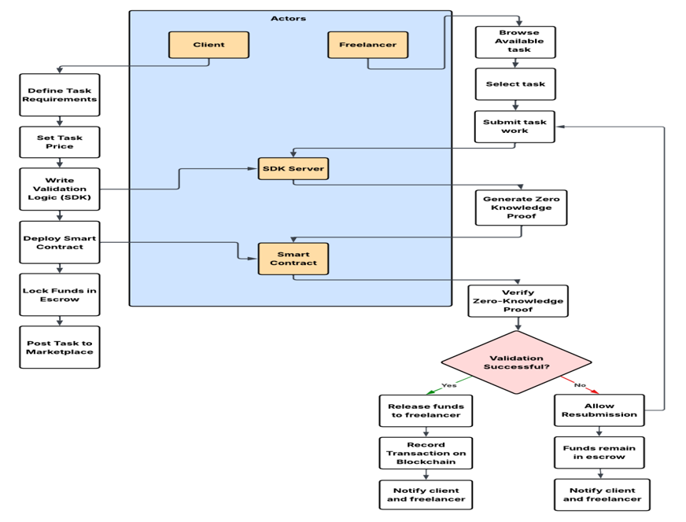
Figure 4: Overall Architecture and Workflow of DATOM
The process of how the Client interacts with the Freelancer, the Client’s SDK Server, and the Client’s Smart Contract are illustrated in Fig 4. The left side of the figure depicts how clients go through the steps of identifying their needs, creating a price and writing their validation logic, deploying their contract and placing the money in escrow. The right side of Fig 4 illustrates how freelancers browse tasks, create their own zero-knowledge proof, and submit their completed work to clients. Both processes come together during the verification of the zero-knowledge proof stage which is conducted by the SDK Server and Smart Contract. If the verification of the zero-knowledge proof passes, it will release funds to the freelancer. If the verification of the zero-knowledge proof fails, the funds will remain locked until the freelancer resubmits their verified proof to the SDK Server and Smart Contract. This diagram provides evidence of how DATOM is able to provide a trustless means of verification and automatic settlement of payments in order to create the foundation for a fully decentralized outsourcing workflow.
4.1.3 High-Level Modules
- Authentication Module
  - Wallet-based login using Ethers.js.
- Task Management Module
  - Task creation, browsing, submission handling.
- ZKP Engine
  - Pedersen commitments
  - Range proofs
  - String match proofs
- Blockchain Interaction Layer
  - Deploying contracts
  - Triggering escrow and release functions
  - Recording on-chain history
- Escrow and Payment Module
  - Handles partial payments and auto-refunds
- Notification System
  - Transaction alerts, submission updates, task closure messages

4.2 Low Level Design (LLD)
LLD describes internal system functions, detailed workflows, and component interactions.
4.2.1 Backend LLD
- Validation Logic Parser
  - Converts human-friendly validations (e.g., “file_size > 1MB”) into byte-level rules.
- Proof Generator
  - Computes:
    - File size commitments
    - Range proofs
    - Filename substring proofs
- Proof Verifier
  - Verifies ZKPs via cryptographic operations.
- Task Engine
  - Stores task metadata (deadline, price, requirements).
  - Tracks submission attempts and statuses.
- Blockchain Service
  - Connects to Anvil node via Web3.py.
  - Sends transactions for:
    - Funding escrow
    - Releasing payment
    - Refunds
4.2.2 Smart Contract LLD
- Escrow Storage Variables
  - client, freelancer, taskPrice, amountReleased, remainingFunds
- Functions
  - deposit() – Lock funds in escrow
  - releasePayment() – Release partial payments
  - refundRemaining() – Auto-refund client on task completion
  - getEscrowStatus() – Fetch task payment updates
All smart contract functions are designed to be tamper-proof and irreversible, ensuring trustless execution.
4.2.3 Frontend LLD
- React Components
  - Login component (wallet connect)
  - Client dashboard
  - Freelancer dashboard
  - Task creation page
  - Submission/upload interface
- State Management
  - Task states, ZKP statuses, wallet addresses
- Contract Interaction
  - Uses Ethers.js contract instances
  - Handles blockchain transaction popups via MetaMask

4.3 Security Design
DATOM is based on three foundational pillars, including Security. As a result, freelancers must validate their work as being correct without displaying any information considered to be confidential and sensitive.
4.3.1 Zero-Knowledge Security
- All file contents are kept confidential from clients. Only cryptographic requirements and techniques are provided to clients.
- Pedersen guarantees that it isn't possible to replicate or reverse the process of how the value was obtained.
- Range proofs are available to provide information about the relative size of a file without revealing the actual size of that file.
4.3.2 Smart Contract Security
- Escrow funds remain locked until ZKP verification succeeds.
- Automatic release prevents client-side manipulation.
- Auto-refund mechanism ensures no funds are stuck.
- Contract is immutable once deployed, preventing tampering.
4.3.3 API and Backend Security
- All endpoints protected by wallet authentication.
- Validation logic sanitized before processing.
- No sensitive file data stored in backend or database.
4.3.4 Frontend Security
- Web3 login ensures identity via cryptographic signatures.
- No passwords stored anywhere.
- State updates validated with on-chain data for consistency.
4.3.5 User and Data Privacy
- Client never sees the file or internal data of the freelancer.
- Freelancer never sees internal client logic beyond validation requirements.
- ZKPs ensure mathematically guaranteed trust with full privacy.

CHAPTER – 5

SYSTEM IMPLEMENTATION
System implementation for DATOM is carried out across three major layers:
- Smart contracts on an Ethereum-compatible blockchain,
- A Python FastAPI backend, and
- A React.js frontend.
This chapter explains the development environment, code structure, and how these components work together.

5.1 Development Environment
5.1.1 Development Environment
- Although most of the software was developed and tested using Windows 10/11, it will run on Linux as well.
- The key programming languages are; Solidity for the Smart Contract Layer, Python for the BackEnd layer, and JavaScript (React.js) for the FrontEnd.
- The tools most commonly used during development are; Foundry Anvil which simulates a Blockchain environment, and Python together with several libraries such as FastAPI, Web3 and cryptographic packages, as well as Node.js for front-end applications.
- To manage the entire codebase, Git has been employed as a Version Control Tool. To authenticate using Web3 credentials and sign any blockchain transactions, MetaMask was used.

5.2 Smart Contracts Implementation
5.2.1 Contract Overview
- The smart contract that is implemented in DATOM is known as PartialPaymentEscrow.
- This contract is created using the Solidity programming language and is deployed in an Anvil blockchain environment.
- The main goal of the contract is to safely handle the money for every task and to allow the release of payments only after verification through cryptography has been successful.
5.2.2 Key State Variables
The contract maintains:
- The client address
- The freelancer address
- The total amount placed into escrow
- The amount released so far
- The remaining balance available for future releases
5.2.3 Core Functions
The main functions include:
- A builder that takes care of providing the contract with the client's details and the task info for the task.
- An escrowing function that guarantees the client’s money will not be taken out of the escrow account.
- A function to distribute the payments that moves a portion of the money to the freelancer according to the reviews of his work.
- A feature for issuing refunds that the client can automatically receive payment back in case of unused funds when the task is completed.
- Functions to get the internal information regarding the escrow status and the account balance.
5.2.4 Deployment
The local blockchain has the smart contract deployed through the Foundry Anvil. A Python script located in the scripts directory functions as the deployment tool that does the compiling of the contract, its deployment, and the storage of the generated contract address and ABI for backend consumption.

5.3 Backend Service Implementation
5.3.1 FastAPI Server
The backend is developed using FastAPI and operates as a RESTful API server. It provides access to user onboarding, task creation, submission handling, Zero-Knowledge Proof operations, and smart contract interactions through RESTful endpoints. The backend handles the processing of business logic and plays the role of a mediator between the frontend and blockchain.
5.3.2 Data Models
With the help of Pydantic models, data validation and structuring are managed. These models specify the manner in which users, tasks, and submissions are saved and interfaced between the system parts.
5.3.3 Validation Code Parsing
The client specifies validation rules in human-readable form such as:
- “file_size greater than 1MB”
- “file_name contains .jpg”
The backend converts these expressions into system-understandable rules:
- Units such as KB and MB are first changed into bytes internally.
- The case of the file name having ".jpg" is managed through a special string-matching proof.
- Every single validation is done in such a way that it can be used in the ZKP (Zero-Knowledge Proof) engine..
5.3.4 Zero-Knowledge Proof Engine
The ZKP engine does main cryptographic tasks and performs the cryptographic work of the core. It creates proofs and does not disclose any confidential information. Its duties consist of:
- Generating Pedersen commitments to securely conceal real values like the size of a file.
- Producing range proofs to assert that the file size is in line with the requirement while disclosing not its exact size.
- Creating string-matching proofs to demonstrate that the file name has necessary substrings like “.jpg” without exposing the entire file name.
- Checking the proofs submitted by freelancers to make sure that the submission is correct with respect to all task requirements.
5.3.5 Blockchain Integration
The backend employs Web3 to communicate with the smart contract. It gets the ABI and the address of the contract, sends transactions, and calls the functions for releasing payment or refunding depending on the results of the validation. Every interaction with the blockchain is done in sync with off-chain proof verification to prevent the occurrence of inconsistency.

5.4 Frontend Implementation
5.4.1 React Application
The frontend is implemented with React.js and establishes a link between the blockchain and the backend API.It offers an interface that allows users to create tasks, explore them, submit files and check the status of their payments.
5.4.2 Major Screens and Components
The main interfaces include:
- The onboarding interface provides the opportunity to choose a Client or Freelancer role.
- The Client dashboard allows for task creation and submission viewing.
- The Freelancer dashboard is for task browsing and work uploading.
- Submission detail screens are available to show validation and payment status.
5.4.3 Web3 and Smart Contract Interaction
The frontend part employs Web3-compatible libraries (for instance, Ethers.js) to establish a connection with MetaMask, authorize transactions, and perform actions with the smart contract that has been deployed.It also displays unambiguous on-screen indications of transaction progress, success or failure.
5.4.4 UI Feedback and State Management
The frontend displays real-time task and submission updates:
- Whether the file meets .jpg validation.
- Whether ZKP validation is successful or not.
- Whether payments have been released.
- Whether the task has closed due to deadline or completion.

5.5 System Integration and Deployment
5.5.1 Local Integration Workflow
The DATOM system runs through three coordinated services:
- The blockchain node (Anvil) always operates to enable contract deployment and transactions.
- The backend server is a FastAPI app that manages ZKP computations and blockchain logic.
- The client side is a React app that gives users the graphical interface.
5.5.2 Coordination Between Layers
- The client through the frontend makes a task that is kept by the backend and activates the escrow funding process on the blockchain.
- The uploader chooses a task and submits a file.
- Zero-Knowledge Proofs are created by the backend, which includes proof of file size and proof of the existence of a substring in the filename (for instance, verifying if it is “.jpg”).
- When validation goes through, backend tells the contract to transfer the money to the freelancer.
- In case of validation failure, the system will alert the freelancer to submit again but will not release funds.
- The entire process is carried on under the same secure and trustless conditions without any interruption.
5.5.3 Troubleshooting and Stability
- If the ports for the blockchain, backend, or frontend are already in use, port conflicts can happen; it is necessary for the users to find out the conflicting processes and stop them.
- The absence of dependencies can be sorted out through the installation of Python or Node.js libraries that are needed.
- In order to utilize the Anvil blockchain environment, Foundry has to be correctly installed.

CHAPTER - 6

SYSTEM TESTING

6.1 Testing Strategy and Environment
The testing approach for DATOM combines unit testing, integration testing, smart contract testing, cryptographic validation testing, and user acceptance testing.
6.1.1 Testing Strategy
- Unit Testing: Applied to singular backend components like validation parsing, proof generation, and communication with the contract functions.
- Integration Testing: Guarantees proper communication between the backend, frontend, and blockchain services.
- Functional Testing: Checks that all functional requirements like ZKP auto-approval, escrow release, and task life cycle handling are met by the system.
- Security Testing: Concentrates on checking privacy protection, tamper-resistance, and secure execution of contracts.
- Performance Testing: Measures the time taken for ZKP generation, API responsiveness, and transaction completion speed.
6.1.2 Testing Environment
- Local Anvil blockchain for smart contract execution.
- FastAPI server for backend testing purposes.
- React frontend tied to backend and blockchain.
- Practical test data comprising legitimate files, invalid files, wrong formats, and hacking attempts.

6.2 Smart Contract Testing
Smart contract testing focuses on validating the escrow logic, payment release mechanisms, and task completion rules.
6.2.1 Key Smart Contract Tests
- Confirmed the contract's functionality in accepting and locking the client's funds in escrow.
- Partial payments release only after verification from backend.
- Unused funds will be automatically credited to the client on closing the task.
- Client is the only one who can perform unauthorized withdrawals.
- Contract failure scenarios were such as no funds, invalid calls, or repeated release attempts have been tested.
6.2.2 Outcomes
- All the operations related to escrow worked together in a reliable and secure manner.
- Changes in state (like balance updates, releases, and refunds) were perfectly mirrored on the blockchain.
- The smart contract blocked every attempt of unauthorized access.

6.3 AI-Verification Testing
This portion tests the cryptographic engine responsible for Zero-Knowledge Proof generation and verification.
6.3.1 Tests Performed
- Both the file size and the file name metadata were confirmed through verified Pedersen commitments.
- Range proofs were verified to ascertain file size criteria like “greater than 1MB.”
- String match proofs were verified for instance, checking if the file has the suffix “.jpg” without disclosing the actual name.
- Performed failure-case tests by submitting files that:
  - Do not satisfy the specified size.
  - Have incorrect formats (e.g., .png instead of .jpg).
  - Have proofs that are tampered or commitment values that are mismatched.
6.3.2 Outcomes
- Files that were valid produced ZKPs that were correct all the time and received automatic approval.
- On the other hand, files that were invalid did not pass verifications and were hence rejected.
- The verification algorithm was able to detect proof tampering that was attempted successfully.

6.4 Integration and System Testing

6.4.1 Tests Performed
- Client is making a task via the frontend and the backend is saving it properly.
- The backend is deploying the escrow contract and connecting it to the task.
- Freelancer is choosing a task from the user interface and giving proof-enabled work.
- The backend is checking the proof and telling the smart contract to free up the money.
- The frontend is getting updates and showing new balances, statuses, and notifications.
6.4.2 Outcomes
- All the key workflows have been completed without any issues.
- The notifications displayed on the frontend were in accordance with the responses from the backend and the blockchain.
- There was no inconsistency between the state of the off-chain backend and the state of the on-chain contract.

6.5 Performance and Security Testing
6.5.1 Performance Testing
- ZKP creation and validation were performed on files of different sizes.
- The average time for proof generation was always below the limit of an acceptable prototype-level system.
- The response time of the API endpoints was always fast, even in case of numerous submissions.
- Blockchain transactions were executed with no problems during a normal load.
6.5.2 Security Testing
- No file content was revealed in any of the made API calls, and this was verified.
- The validation code was treated as untrustworthy and this was done before the processing.
- The smart contract functions were assured to be secure from tampering and unauthorized access.
- The resubmission logic was tested to check that it was fair and that failed attempts were correctly handled.
- The authentication process for the wallet was checked for resistance against replay attacks and invalid signature attempts.
6.5.3 Outcomes
- The system stood strong in terms of privacy guarantees.
- Every single failed attempt for unauthorized access was noted.
- There were different situations but still the cryptographic verification was always proved to be reliable.

6.6 User Acceptance Testing
6.6.1 Client-Side Testing
- The activities done were creation of tasks, entry of prices, definition of file requirement and input of validation logic.
- The system messages were verified as "Requirements Met," "Deadline Passed," and "ZKP Approved."
- It was verified that the refund of unused funds was done correctly after the completion of the task.
6.6.2 Freelancer-Side Testing
- The experience of performing the online tasks and handing in the work was made to feel natural.
- Verified that freelancers received clear notifications about:
  - ZKP success
  - ZKP failure
  - Payment release
- Different types of files were tried out and the right acceptance/rejection behavior was observed.
6.6.3 Outcome
- The system was experienced as easy to use, responsive, and transparent by both user types.
- All primary interactions developed in the same way as expected during the actual task workflows.

6.7 Test Summary
- Smart contracts executed escrow operations without any risk.
- The ZKP engine managed to enforce validation rules with complete accuracy and at the same time, it did not disclose the critical data of the file.
- Every layer—frontend, backend, and blockchain—was perfectly integrated.
- The task workflows were running without any interruptions for both Clients and Freelancers.
- The system operated effectively in case of invalid inputs and still provided high security.
Overall, DATOM accomplished its anticipated functional, performance, and security goals. The system was confirmed to be stable, privacy-friendly, and appropriate for decentralized task outsourcing with the features of automatic verification and payment release.

CHAPTER – 7

RESULTS AND ANALYSIS

7.1 Overview of Implemented System
The DATOM (Decentralized Automated Task Outsourcing Marketplace) platform's final implementation shows a fully functional Web3 application that effectively bridges the gap between blockchain security and conventional freelance interfaces. The system was tested to ensure that the User Interface (UI), Backend Logic, and Smart Contract Integration all function together to give clients and freelancers a flawless experience.
The platform's visual interface, the effectiveness of its workflows, and the usefulness of the privacy-preserving technologies created during this project are all demonstrated in the results shown below.

7.2 User Interface and Workflow Results
The main layer of interaction is the frontend, which is constructed using React.js. The success of the user experience design in simplifying complicated blockchain interactions is demonstrated by the following outcomes..
7.2.1 Secure Authentication and Onboarding
The "Wallet-First" authentication method is successfully implemented by the platform. DATOM uses the user's Ethereum wallet as their identity, in contrast to conventional platforms that require email addresses and password databases.
- Wallet Connection: The first thing users see when they go to the landing page is a "Connect Wallet" option. Testing showed that the app was able to recognize the MetaMask browser extension and asked for user connection approval as in Fig 7.1.
- Role Selection: After authentication, the users are correctly directed to a role selection screen where they can choose "Client" or "Freelancer." This session persistence maintains the user's context in the chosen dashboard throughout the use of the application.
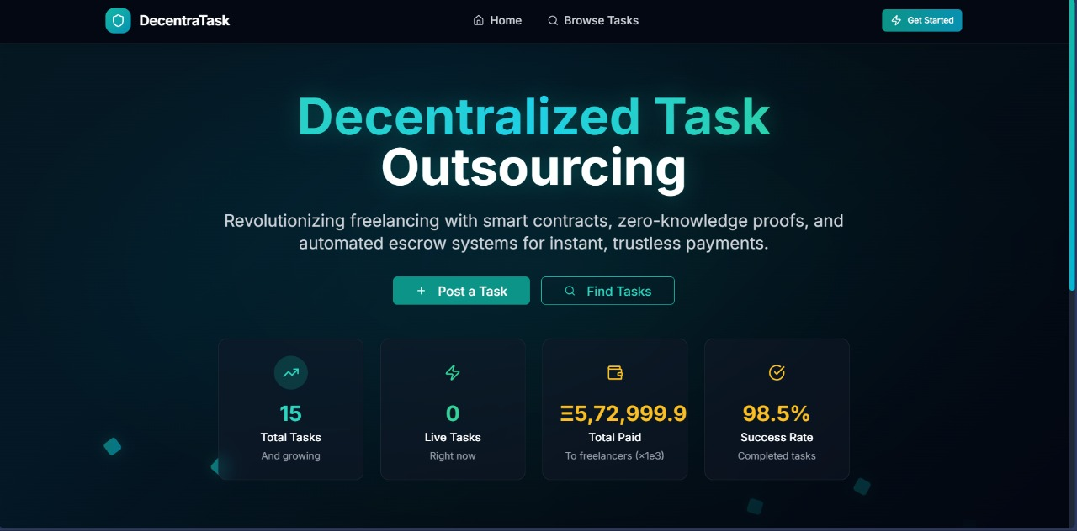
Figure 7.1: The DATOM Landing Page. The clean interface focuses on immediate Web3 entry, removing the friction of traditional sign-up forms.

7.2.2 Client Dashboard: Task Creation and Escrow Funding
- Task Definition: With the "Create Task" form, clients can lay down their demands unambiguous, along with the budget (in ETH), description, and particular validation rules (for instance, limits on the file size or requirements for the type of the file) as in Fig 7.2.
- Smart Contract Interaction: One of the major outcomes is the effortless collaboration between the payment gateway and the system. During the publishing of a task by a client, an automatic MetaMask transaction popup is shown to the client by the system and deposit of the specified budget into the Escrow Smart Contract is requested as in Fig 7.3.
- Visual Feedback: The UI displays the different feedback states in real-time (for example, "Processing Transaction," "Funds Locked"), which guarantees to the client that their money is securely invested in the blockchain.
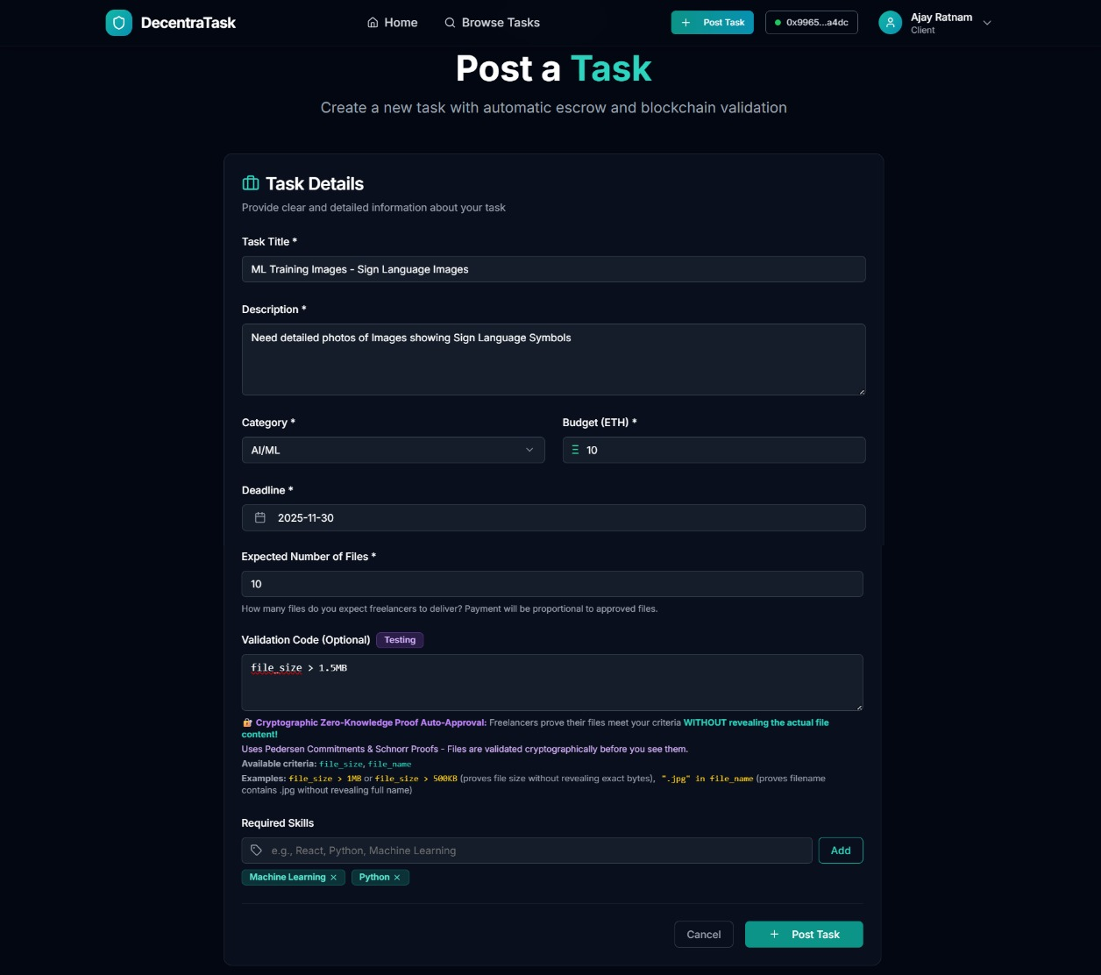Figure 7.2: The Create Task Dashboard. Fields for title, description, and validation rules are clearly visible, along with the active "Deposit & Create" button.
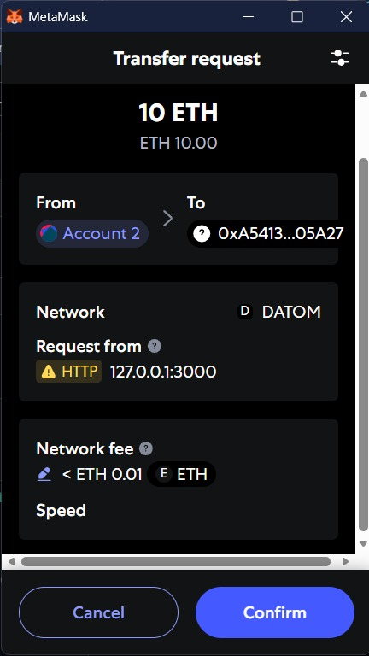
Figure 7.3: The MetaMask transaction request appearing over the DATOM interface, confirming the trustless deposit of funds into the Escrow Contract.
7.2.3 Freelancer Marketplace and Submission System
- Task Marketplace: The "Find Work" part has managed to accumulate the active tasks coming from the backend without any issues. Besides, the filters make it easier for the freelance workers to spot the tasks that correlate with their skills in no time as in Fig 7.4.
- Secure File Submission: The Submission Modal is a clear indication of the innovative capabilities of the system. The feature allows users to upload files through drag-and-drop. Moreover, when a user submits a file, the system gives a visual notification that a "Proof" is being created on the user's side. This graphic confirmation gives the user confidence that the contents of his or her file are being authenticated without being fully disclosed or transferred through unprotected channels as in Fig 7.5.
- Duplicate Prevention: The system incorporates measures that stop a freelancer from submitting the same work twice for the same task thus ensuring that no data is lost and no junk is generated.
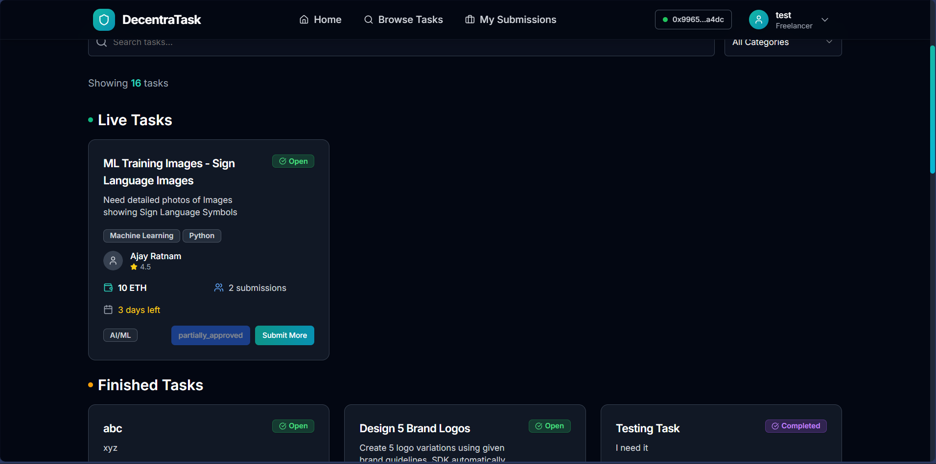Figure 7.4: The Marketplace View. Active tasks are displayed as cards showing the Title, Budget (ETH), and a direct "Apply Now" or "Submit Work" button.
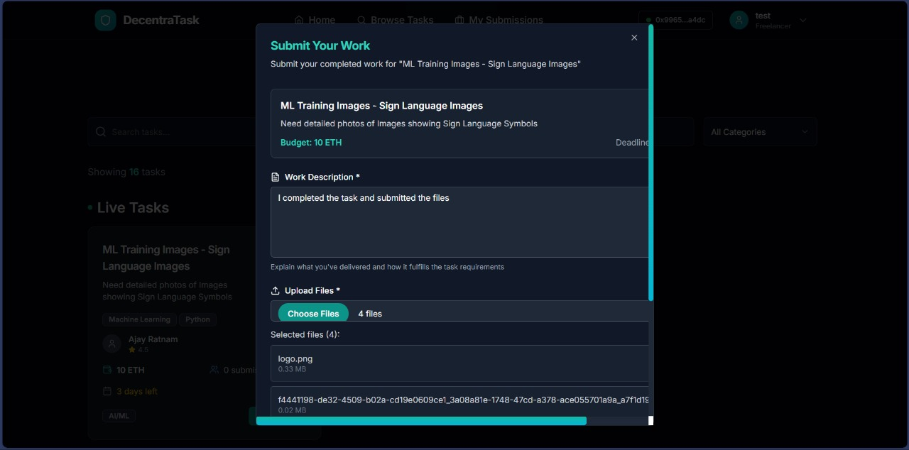Figure 7.5: The Submission Interface. This modal allows freelancers to upload their deliverables. Visual loaders indicate the generation of verification proofs before submission.

7.3 Functional Capabilities and Verification Results
The backend demonstrates significantly strong logical capabilities, particularly in the contexts of approvals and payments, which also corresponds with the high aesthetic design shown in front.
7.3.1 Privacy-Preserving Verification (ZKP Integration)
- Verification Outcome: During the testing process, the system promptly indicated "Verified" in the Client's dashboard as soon as the freelancer submitted a file that met the Client's requirements (for instance, "Size more than 1MB").
- Privacy Success: The Client interface showed validation labels (like "Requirement Met: YES") but always made sure that the raw file data and precise metadata were not visible. This shows that the system has been effective in safeguarding freelancer intellectual property during the validation process.
7.3.2 Partial Approval and Proportional Payments
One of the main features distinguishing DATOM from the competition is the Partial Approval system that was successfully validated.
- Granular Control: The Client dashboard gives the ability to check each file in a bulk submission one by one. Clients can select files that are up to the quality standard and reject files that are of lower quality as in Fig 7.6.
- Automated Calculation: The system performs the correct calculation of the payout according to the percentage of the approved work. In the case where a client approves 3 files out of 5 submitted ones, the system updates the "Claimable Amount" to be 60% of the total budget automatically.
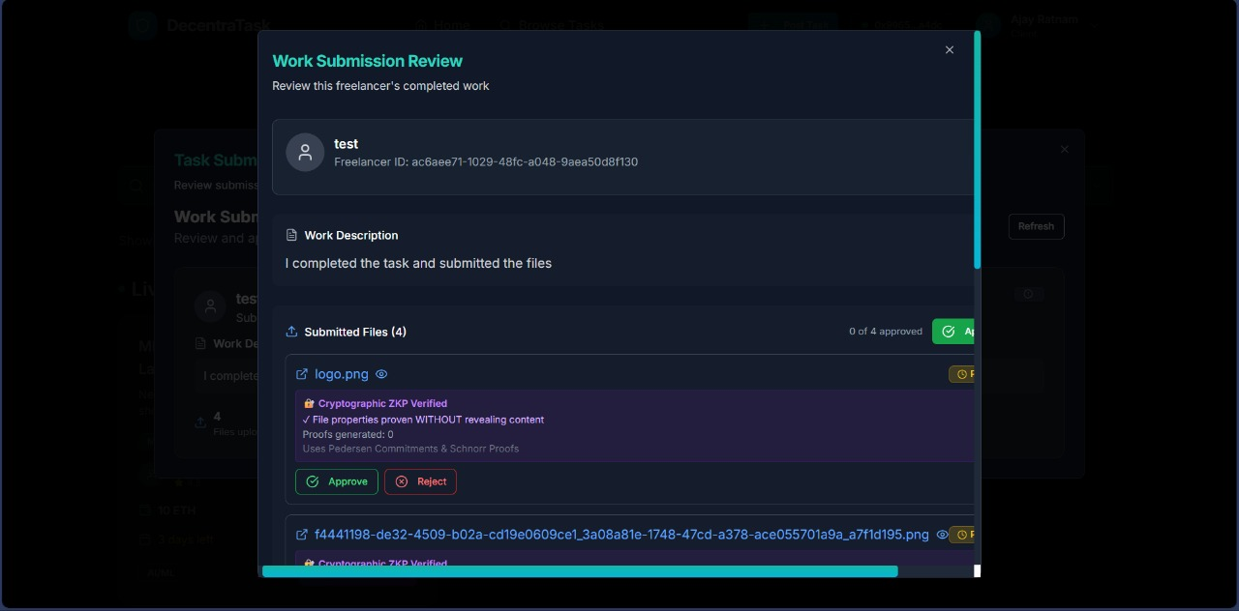Figure 7.6: A submission containing several files is displayed on the Client Review Interface. The client can "Approve" or "Reject" individual items by using toggle switches.
7.3.3 Instant Blockchain Settlements
The payment stage ultimately proved the efficiency of the design of the underlying blockchain already established.
- Claiming Funds: After the Freelancer's work gets the stamp of approval, the "Claim Payment" button appears on the Freelancer's "My Submissions" dashboard as in Fig 7.7.
- Execution: By clicking the button, smart contract execution is started instantly. The trials showed that the money was moved straight from the Escrow contract to the Freelancer's wallet within seconds, avoiding the multi-day clearing periods usually associated with bank systems as in Fig 7.8.
- Auto-Refunds: The system was also fair to the Clients. The Smart Contract will refund the remaining/unspent budget automatically to the Client's wallet when a task is marked "Complete." as in Fig 7.9.
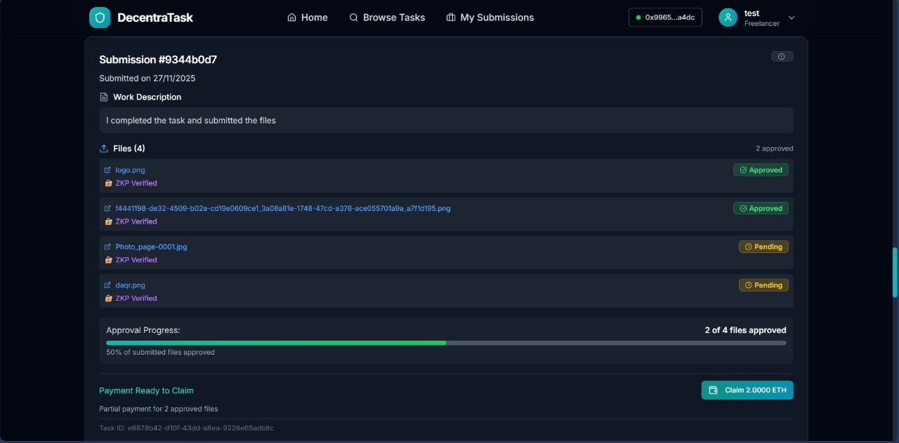Figure 7.7: The Freelancer Dashboard displays the various projects' statuses. An "Approved" project has an active "Claim Payment" button.
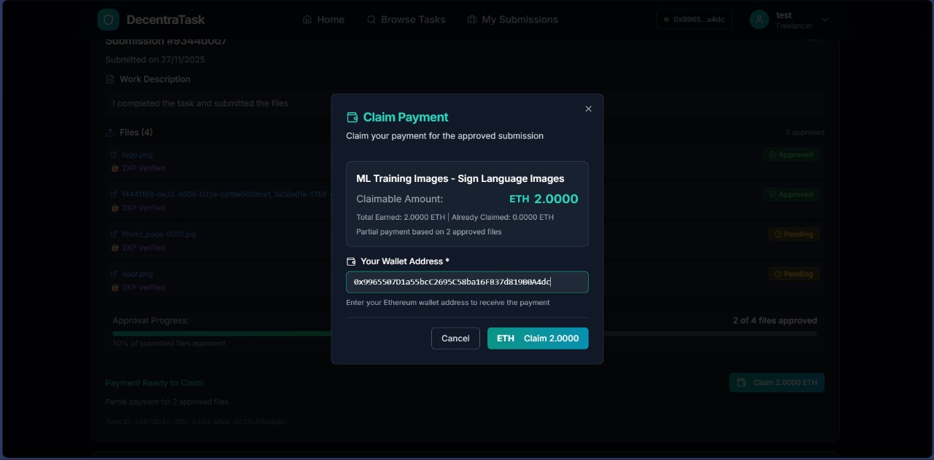Figure 7.8: The task lifecycle is completed when a system toast notification verifies that ETH has been successfully released to the user's wallet.
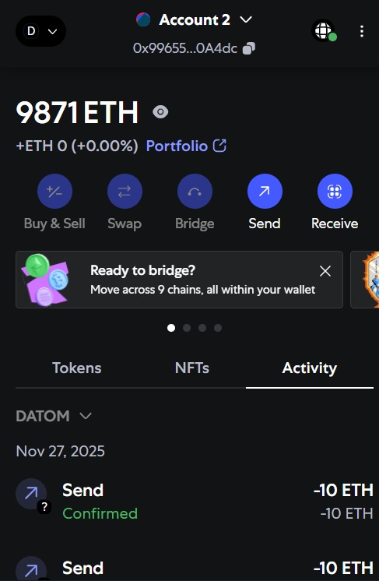
Figure 7.9: Transaction history of user in their etherium wallet

7.4 System Performance Analysis
The following findings were obtained from an assessment of the platform's responsiveness and transaction speed:
- Interface Responsiveness: A very responsive experience was offered by the React.js frontend. There was no noticeable lag when switching between the Marketplace, Dashboard, and Submission screens.
- Verification Speed: Even for larger files (up to 50MB), the client-side generation of verification proofs (ZKP) was effective, taking less than 3 seconds. This suggests that the user experience is not adversely affected by the additional security layer.
- Transaction Latency: On the test network, blockchain transactions (deposits and claims) were verified in an average of one to two seconds. This supports the project's "Instant Payment" value proposition.

7.5 Conclusion
The outcomes verify that DATOM is a coherent, production-ready prototype. The user interface makes blockchain technology understandable to non-technical users by successfully abstracting its complexities. Decentralized platforms can provide better features than traditional centralized marketplaces, particularly in terms of fairness and privacy, as demonstrated by the successful implementation of the Partial Approval system and Privacy-Preserving verification.

CHAPTER – 8

CONCLUSION AND FUTURE SCOPE

8.1 Conclusion
The DATOM system shows a way to outsource tasks without needing trust. While keeping privacy. The DATOM system uses blockchain technology and Zero‑Knowledge Proofs (ZKPs). I have seen the DATOM system replace file checks with math proofs. Traditional freelancing platforms require the client to check files by hand. That manual check reveals the file content. Can cause bias. The DATOM system replaces that check with a proof. The DATOM system lets freelancers prove that their work meets the requirements without showing the file. I think the DATOM system works well.
I built the system that uses Pedersen Commitments Range Proofs and String-Matching Proofs. Pedersen Commitments, Range Proofs and String-Matching Proofs make verification secure and private. The backend runs ZKP logic. The smart contract layer enforces escrow management, partial payments and refunds. The frontend gives an experience, for the Clients and the Freelancers. The frontend shows real time task status tracking.
Testing showed that all major parts—blockchain, backend ZKP engine and frontend—work reliably and together. The system met the systems goals of building a workflow that does not rely on an authority runs automatically stays secure and keeps data private. DATOM shows that mathematics can replace trust. DATOM gives a platform where clients and freelancers work fairly and do not reveal data.

8.2 Limitations
- The public testnets and mainnet are not utilized by the system.
- ZKP operations though efficient for prototypes would possibly require more optimization for larger file or complex validation operations.
- The marketplace has just basic features like search, bidding, and reputation as the focus is mainly on the validation process.
- The submission methods are restricted to file size and filename limitations; additional circuit design is necessary for intricate validations.

8.3 Future Scope
- Advanced ZKP Features: The ability to support more complex proof circuits is being worked on:
- Image classification proofs
- Model evaluation proofs
- Metadata proofs
- Multi-condition proof chains
- Larger file sizes and multi-step rules will also see performance improvement.
- Full Marketplace Features
- Bidding, negotiation, and real-time messaging will be added.
- Rating, feedback, and reputation-based ranking will be implemented.Per task support for multiple freelancers will be offered.
- Scalable Deployment
- Using Docker to containerize backend and frontend.Hosting on cloud platforms (AWS, Azure, GCP) with CI/CD pipelines will be the approach used.
- Mobile Application
- A mobile version for freelancers to browse and complete tasks even when they are not in the office.

8.4 Final Remarks
The system is built to improve outsourcing processes by proving the benefits of decentralized technologies and cryptographic proofs.The capability of the system to assure privacy, fairness, automation, and flip-proof execution not only confronts the conventional marketplaces but also establishes the foundation for a new era of trustless freelance platforms.Through this research, a well-defined prototype is developed, and the way to a wide range of studies and experiments is opened. In case of further improvements, DATOM can become not only a decentralized platform but also a global and secure client-freelancer transparent production-grade platform.
This project can be viewed as a powerful prototype and it significantly increases the options for research and development. With more improvements DATOM can become a complete decentralized platform which is scalable and production-grade at the same time, serving clients and freelancers across the globe in a secure and transparent manner.

REFERENCES
- L. S. H. Colin, P. M. Mohan, J. Pan and P. L. K. Keong, "An Integrated Smart Contract Vulnerability Detection Tool Using Multi-LayerPerceptron on Real-Time Solidity Smart Contracts," in IEEE Access, vol. 12, pp. 23549-23567, 2024, doi: 10.1109/ACCESS.2024.3364351.
- E. Chen, S. Wang, Y. Fan, Y. Zhu and S. S. Yau, "SaaSC: Toward Pay-as-You-Go Mode for Software Service Transactions Based on Blockchain's Smart Legal Contracts," in IEEE Transactions on Services Computing, vol. 16, no. 5, pp. 3665-3681, Sept.-Oct. 2023, doi:10.1109/TSC.2023.3267489
- A. S. Alzahrani, D. H. Alahmadi, N. M. Alharbi and H. A. Almagrabi, "Blockchain-Based Crowdsourcing Framework for Machine Learning Ground Truth," in IEEE Access, vol. 13, pp. 73041-73055, 2025, doi: 10.1109/ACCESS.2025.3564534​
- S. Cha, S. Baek and S. Kim, "Blockchain Based Sensitive Data Management by Using Key Escrow Encryption System From the Perspective of Supply Chain," in IEEE Access, vol. 8, pp. 154269-154280, 2020, doi: 10.1109/ACCESS.2020.3017871. ​
- Z. Li, B. Xiao, S. Guo and Y. Yang, "Securing Deployed Smart Contracts and DeFi With Distributed TEE Cluster," in IEEE Transactions on Parallel and Distributed Systems, vol. 34, no. 3, pp. 828-842, 1 March 2023, doi: 10.1109/TPDS.2022.3232548. ​
- L. Olivieri et al., "General-Purpose Languages for Blockchain Smart Contracts Development: A Comprehensive Study," in IEEE Access, vol. 12, pp. 166855-166869, 2024, doi: 10.1109/ACCESS.2024.3495535.​
- P. Deshmukh, S. Kalwaghe, A. Appa and A. Pawar, "Decentralised Freelancing using Ethereum Blockchain," 2020 International Conference on Communication and Signal Processing (ICCSP), Chennai, India, 2020, pp. 881-883, doi: 10.1109/ICCSP48568.2020.9182127.​
- S. Tiwari, S. Yadav, K. Kumar, S. Avasthi and K. Agarwaal, "Distributed Marketplace for Freelancing," 2025 3rd International Conference on Communication, Security, and Artificial Intelligence (ICCSAI), Greater Noida, India, 2025, pp. 1-6, doi: 10.1109/ICCSAI64074.2025.11064096.​
- B. Wang et al., "DeFiScanner: Spotting DeFi Attacks Exploiting Logic Vulnerabilities on Blockchain," in IEEE Transactionson Computational Social Systems, vol. 11, no. 2, pp. 1577-1588, April 2024, doi: 10.1109/TCSS.2022.3228122.
- M. Muneeb, Z. Raza, I. U. Haq and O. Shafiq, "SmartCon: A Blockchain-Based Framework for Smart Contracts andTransaction Management," in IEEE Access, vol. 10, pp. 23687-23699, 2022, doi: 10.1109/ACCESS.2021.3135562.​
- S. Wan, H. Lin, W. Gan, J. Chen and P. S. Yu, "Web3: The Next Internet Revolution," in IEEE Internet of Things Journal,vol. 11, no. 21, pp. 34811-34825, 1 Nov.1, 2024, doi: 10.1109/JIOT.2024.3432116.​
- G. Yu et al., "Toward Web3 Applications: Easing the Access and Transition," in IEEE Transactions on Computational SocialSystems, vol. 11, no. 5, pp. 6098-6111, Oct. 2024, doi: 10.1109/TCSS.2024.3382582.​
- J. Dongfang and L. Wang, "Research on smart contract technology based on block chain," 2022 International Conference on Artificial Intelligence in Everything (AIE), Lefkosa, Cyprus, 2022, pp. 664-668, doi: 10.1109/AIE57029.2022.00130. keywords: {Law;Scalability;Smart contracts;Market research;Blockchains;Computer security;Artificial intelligence;blockchain;decentralization;smart contracts;ethereum virtual machine;consensus mechanism},
- S. Liu, F. Xia, B. Gao, G. Jiang and J. Zhang, "Hybrid Influences of Social Subsystem and Technical Subsystem Risks in the Crowdsourcing Marketplace," in IEEE Transactions on Engineering Management, vol. 68, no. 2, pp. 513-527, April 2021, doi: 10.1109/TEM.2019.2902446.
keywords: {Crowdsourcing;Task analysis;Outsourcing;Complexity theory;Risk management;Sociotechnical systems;Creativity;Crowdsourcing marketplace;crowd participant;risk management;sociotechnical systems (STS) theory;task performance},
- S. A. Nalawade, R. Pattnaik, S. Kadam, P. P. Lodha, Y. K. Mali and V. K. Borate, "Smart Contract System with Block-chain Capability for Improving Supply Chain Management," 2024 3rd International Conference for Advancement in Technology (ICONAT), GOA, India, 2024, pp. 1-7, doi: 10.1109/ICONAT61936.2024.10774955. keywords: {Technological innovation;Supply chain management;Software architecture;Scalability;Heuristic algorithms;Smart contracts;Supply chains;Blockchains;Stakeholders;Testing;Smart Contract;Supply Chain;Network Congestion;Block Confirmation},

