SECOND THE ITERATION OF DEPLOYMENT

**Table of Contents**

INTRODUCTION 2

CONFIGURATION OF THE MODEL 2

FRAMEWORK / LIBRARY FOR DEPLOYMENT 4

INTEGRATION 1: 5

INTEGRATION 2: 10

CONCLUSION 11

REFERENCES 13

# INTRODUCTION

The task follows the way of the implementation of a model entirely based on machine learning that follows the system of talking heads for preparing it for user consumption. It has become one of the important centers of discussion as it is entitled to boost the various operations carried out by humans. Although it is completely virtual in nature, still it is able to perform several tasks in order to boost the system properly. It establishes a model indicating the concept of virtual humans that are being largely utilized by various end consumers like manufacturers, services that are specifically implemented to assist a huge amount of customers, systems to enhance learning methods, etc. This system is developed with the amalgamation of artificial intelligence and machine learning in this division of technology.

The machine learning model represents the model that is entirely based on the process of training of machine. The primary objective of machine learning is to depict the output generated during the training session of the specific model. It is particularly expressed in the form of mathematical expression. In a way, it can be defined as a particular model that has been trained in such a way that it can find the connections among the new set of data provided and is also able to make predictions. The deployment of the system that incorporates a machine learning model based on the talking head configuration is desired essentially to prepare it for utilization by the end users. Proper deployment of the model in the graphic user interface, often abbreviated as GUI provides a vibrant environment for the users to proceed with specific tasks. Here in this scenario, it enables an individual to access and fulfill the objective through the talking head system properly.

# CONFIGURATION OF THE MODEL

The machine learning model should be trained effectively to make a proper decision to provide specific output for the given set of data input. As per the view of Fried *et al.* (2019), it is a function based on mathematics that follows and synthesizes function over a set of data that is being given as the input. After performing the desired operation, it provides a specific output that has been derived from the prediction made by the model. The prediction is usually made by the model that is entirely based on its training session. As per the view of Guo *et al.* (2021), in order to configure the system properly, an individual should adhere to certain steps and measures that will enhance the model to proceed and fetch a proper result based on the prediction as par with the required execution.

In order to approach to configure a machine-learning model, certain norms are to be followed that will make the model more appropriate and effective. Primarily, the talking head system should be acquired that is required to be undertaken in order to deploy the model based on machine learning properly. Consequently, the dataset that contains the relevant information about the system is explored properly and the algorithm to execute the model successfully is chosen to move a step ahead toward the execution. As per the view of Zakharov *et al.* (2019) After developing the dataset, it is classified into training and testing data and cross-validation should be performed to verify its performance in unforeseen data. The machine is successfully deployed after effective optimization.

In this procedure, the way specified above is followed to configure the model in order to proceed with the result accordingly.

# FRAMEWORK / LIBRARY FOR DEPLOYMENT

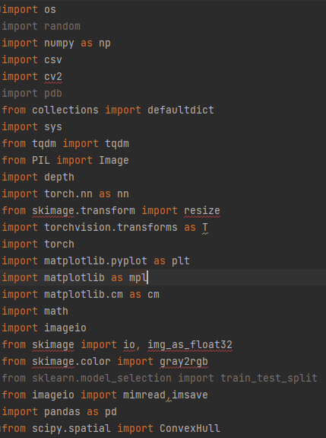

**Figure 1: Importing the library**

(Source: PyCharm)

In the above figure, all the required libraries are imported in the program.

# INTEGRATION 1:

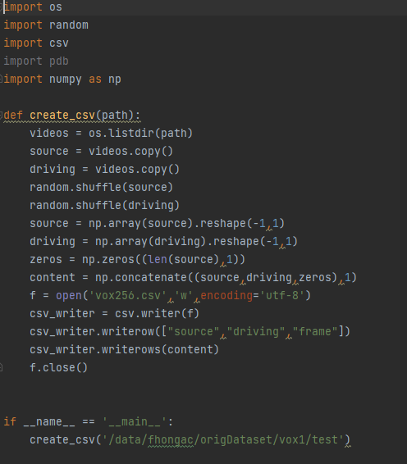

**Figure 2: read the csv files**

(Source: PyCharm)

In the above figure, the imported **“CSV”** is read in this code.

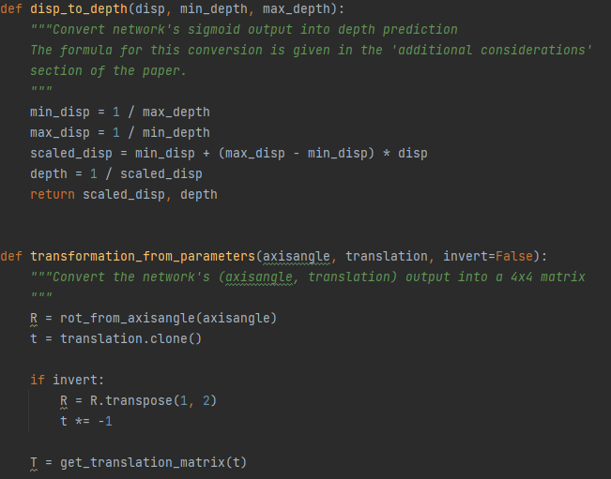

**Figure 3: Defining the different parameter**

(Source: PyCharm)

In the above figure, defining the different parameter in the program.

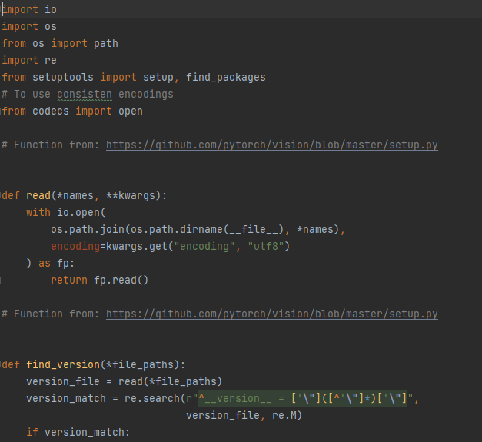

**Figure 4: read different version**

(Source: PyCharm)

In the above figure, read and find the different version in the program.

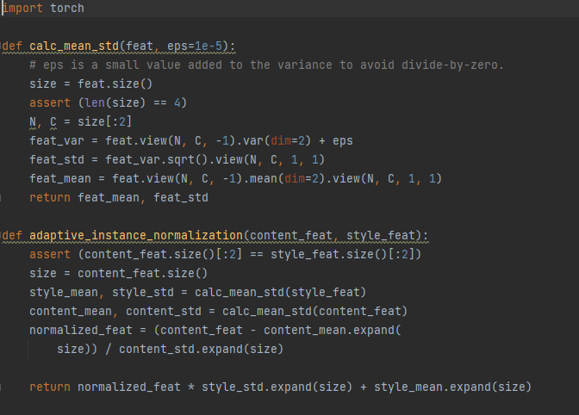

**Figure 4: Various layer**

(Source: PyCharm)

In the above figure, the mean standard and normalization have been done in the program.

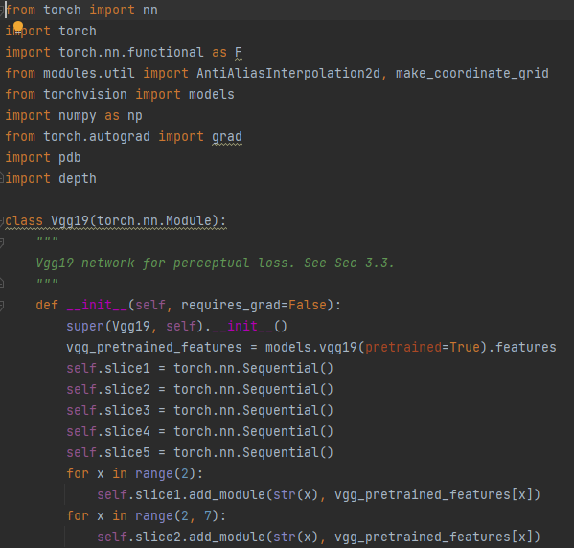

**Figure 5: Run Vgg19 model**

(Source: PyCharm)

In the above figure, the Vgg19 model in the program.

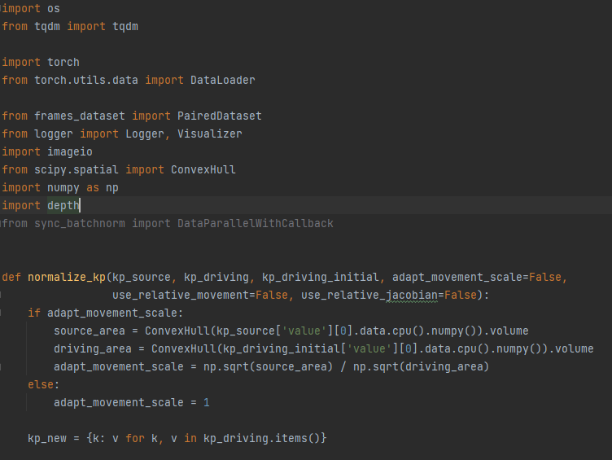

**Figure 6: Create animate file**

(Source: PyCharm)

In the above figure, the animation file has been created in the program.

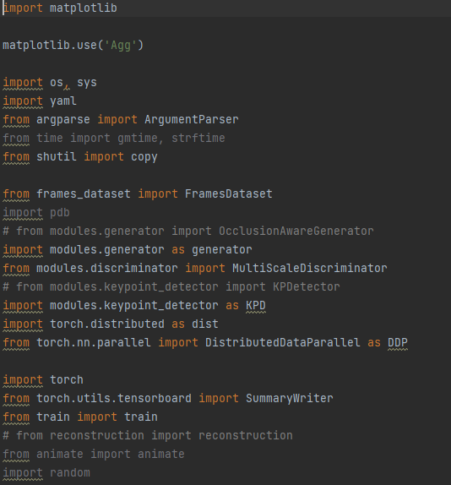

**Figure 7: The run.py file**

(Source: PyCharm)

In the above figure, to run the program this run.py file is created.

# INTEGRATION 2:

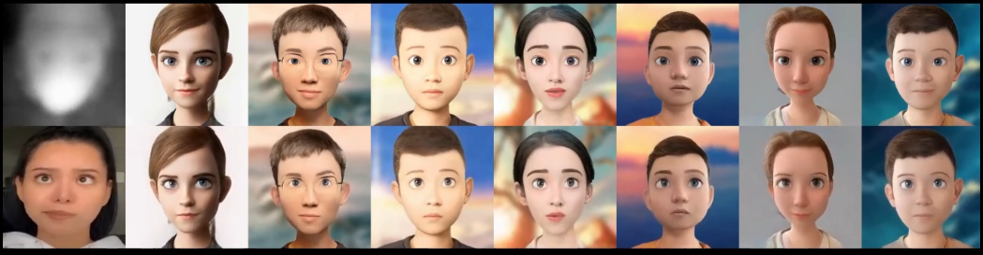

**Figure 8: Animation 1**

(Source: PyCharm)

In the above figure, the first animation is visible.

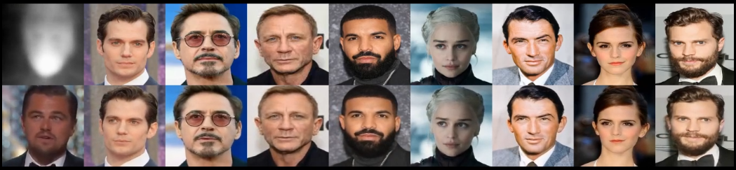

**Figure 9: Animation 2**

(Source: PyCharm)

In the above figure, the second animation is visible.

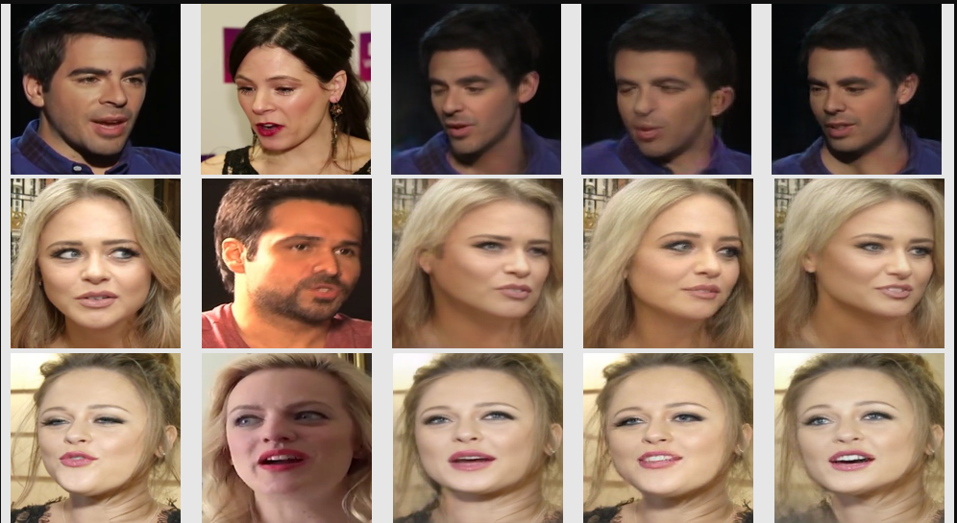

**Figure 10: Image**

(Source: PyCharm)

In the above figure, Image file of the program.

# CONCLUSION

It can be concluded that the venture expected to foster an AI model that predicts the feeling of film surveys utilizing Python. We used different regular language handling methods to remove significant elements from the text information and prepared a strategic relapse model utilizing Scikit-learn library. All through the task, we confronted different difficulties, for example, information cleaning, highlight designing, and model tuning. We defeated these difficulties by using the prescribed procedures and methods accessible in the field of AI.

Generally, the task was effective in accomplishing its objectives and given significant experiences into the field of feeling examination. Later on, we can investigate further developed strategies, for example, profound learning and move figuring out how to additionally work on the model's presentation.

# REFERENCES

Fried, O., Tewari, A., Zollhöfer, M., Finkelstein, A., Shechtman, E., Goldman, D.B., Genova, K., Jin, Z., Theobalt, C. and Agrawala, M., 2019. Text-based editing of talking-head video. ACM Transactions on Graphics (TOG), 38(4), pp.1-14.

Guo, Y., Chen, K., Liang, S., Liu, Y.J., Bao, H. and Zhang, J., 2021. Ad-nerf: Audio driven neural radiance fields for talking head synthesis. In Proceedings of the IEEE/CVF International Conference on Computer Vision (pp. 5784-5794).

Zakharov, E., Shysheya, A., Burkov, E. and Lempitsky, V., 2019. Few-shot adversarial learning of realistic neural talking head models. In *Proceedings of the IEEE/CVF international conference on computer vision* (pp. 9459-9468).