SNS ASSIGNMENT-2 Program instructions

## Srujan R, BT18CSE041

# Z – 2-round Feistel Cipher:

1. First run Alice program with port number as command line input.

Ex: python BT18CSE041_Z_A.py 12345

1. Next run Bob program with the same port number as Alice as command line input.

Ex: python BT18CSE041_Z_B.py 12345

# SE – A Cipher Block Chaining (CBC):

1. First run Alice program with port number as command line input.

Ex: python BT18CSE041_SE_A_A.py 12345

1. Next run Bob program with the same port number as Alice as command line input.

Ex: python BT18CSE041_SE_A_B.py 12345

## AC – A OAEP construction of RSA:

1. First run Alice program with port number as command line input.

Ex: python BT18CSE041_AC_A_A.py 12345

1. Next run Bob program with the same port number as Alice as command line input.

Ex: python BT18CSE041_AC_A_B.py 12345

## EA – A Fiat-Shamir Protocol:

1. First run Alice program with port number as command line input.

Ex: python BT18CSE041_EA_A_A.py 12345

1. Next run Bob program with the same port number as Alice as command line input.

Ex: python BT18CSE041_EA_A_B.py 12345

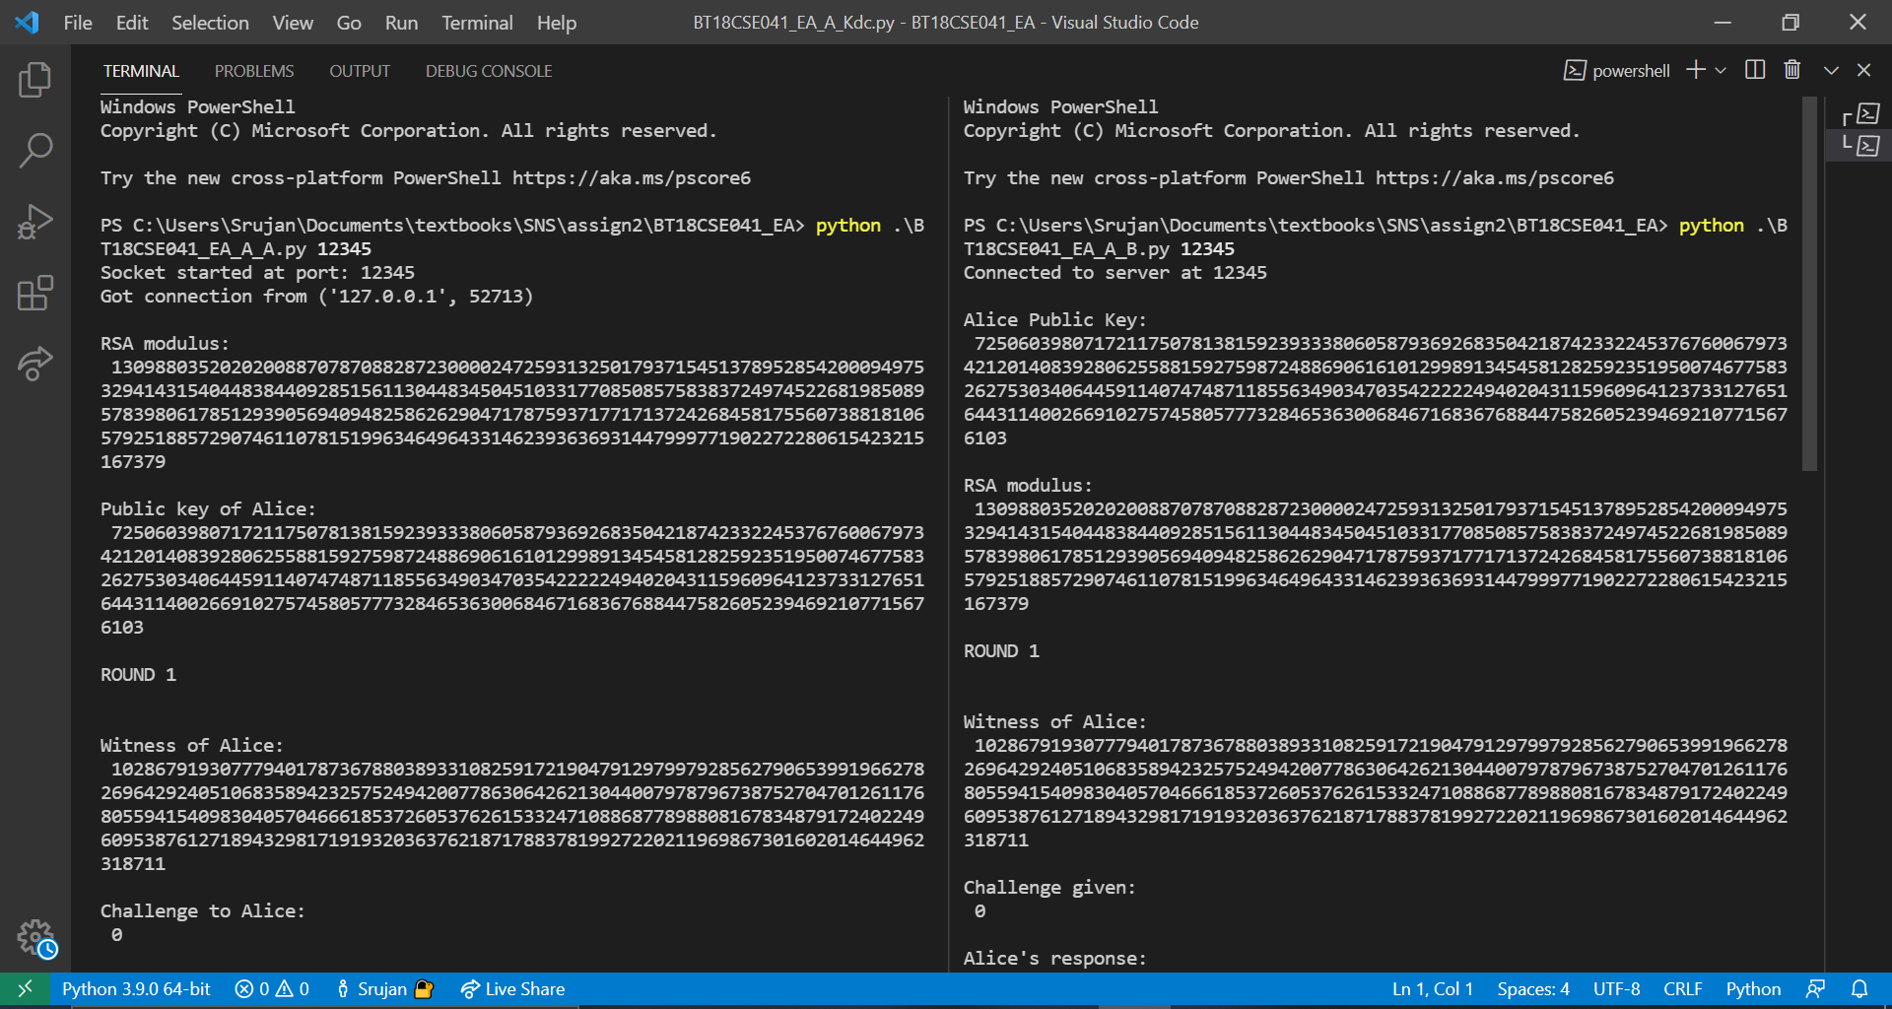

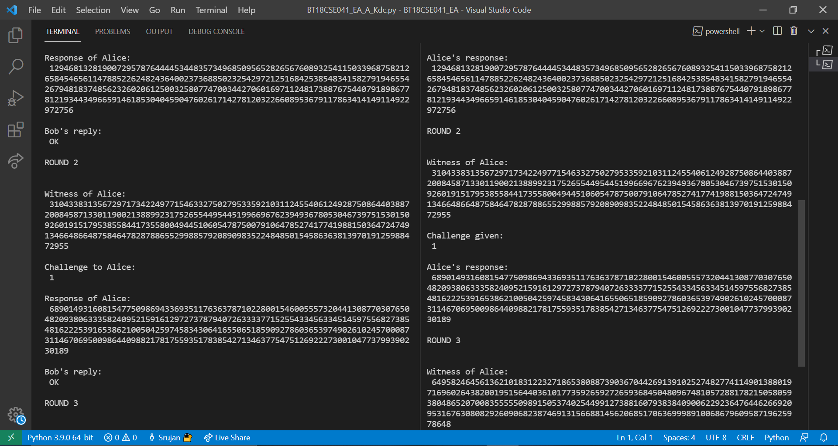

## KM – A Needham - Schroeder Protocol:

1. First check whether the port numbers 12345 (KDC program), 12346 (Alice program) and 12347 (Bob program) are free or not.

Ex: netstat -ano|findstr 12345 , if any process with pid present can stop it using – kill pid

1. Run the KDC program.

Ex: python BT18CSE041_KM_A_Kdc.py

1. Run the Bob program.

Ex: python BT18CSE041_KM_A_B.py

1. Run the Alice program.

Ex: python BT18CSE041_KM_A_A.py

