Assignment 2

# Name: Srujan Patwardhan

# Class: TY-CS-D

# Roll No: 2

# PRN: 12210847

**Setting up small computer networks and Hands on networking commands:**

Set up a small wired and wireless network of 2 to 4 computers using Hub/Switch/Access point. It includes installation of LAN Cards, Preparation of Cables/ Installation and Configuration of Access Point, Assigning unique IP addresses and use of ping utility. Hands on for network commands - ping, pathping, ipconfig/ifconfig, arp, netstat, nbtstat, nslookup, route, traceroute/tracert, nmap.

**Twisted Pair Cable**

Twisted pair cable is a type of electrical cable commonly used for transmitting signals, particularly in telecommunications and computer networking. It consists of pairs of insulated copper wires that are twisted together in a helical pattern.

There are two main types of twisted pair cables:

**Unshielded Twisted Pair (UTP):**

UTP cables are the most common type of twisted pair cables and are widely used in various applications, including Ethernet networking, telephone lines, and more. In UTP cables, the twisted pairs are not surrounded by any additional shielding, which makes them more susceptible to interference from external sources like electronic devices, fluorescent lights, and power cables.

**Shielded Twisted Pair (STP):**

STP cables have an additional layer of shielding around the twisted pairs, providing better protection against external interference. The shielding can be made of metal foil or braided wire mesh. STP cables are commonly used in environments where there's a higher likelihood of interference, such as in industrial settings or areas with high electromagnetic activity.

Twisted pair cables are categorized into different categories based on their performance characteristics.

These categories define the cable's capabilities in terms of data transmission speeds, bandwidth, and the level of interference protection. Some common categories of twisted pair cables include Cat 5e, Cat5, Cat 6, and more.

**UTP categories:**

Category 1 - Voice only (Telephone)

Category 2 - Data to 4 Mbps (Localtalk)

Category 3 - Data to 10Mbps (Ethernet)

Category 4 - Data to 20Mbps (Token ring)

Category 5 - Data to 100Mbps (Fast Ethernet)

Category 5e - Data to 1000Mbps (Gigabit Ethernet)

Category 6 - Data to 2500Mbps (Gigabit Ethernet)

**Color Coding of Twisted Pair cable –**

The color code for twisted pair cables, particularly for Ethernet cables, is used to ensure consistency and proper connections when terminating the cable's connectors (such as RJ-45 connectors) on both ends. In an Ethernet cable, there are four twisted pairs of wires, and each wire within a pair is assigned a specific color.

**The color code is typically as follows:**

Pair 1 - (White with Blue / Blue)

Pair 2 - (White with Orange / Orange)

Pair 3 - (White with Green / Green)

Pair 4 - (White with Brown / Brown)

When crimping connectors onto the ends of twisted pair cables, it's crucial to follow the color code and pinout scheme accurately. Mistakes in wiring can lead to connectivity issues or complete failure of data transmission.

The color code and standards for twisted pair cables are essential for maintaining a structured cabling system, especially in networking and telecommunications environments. Adhering to these standards helps ensure reliable data transmission, reduces the risk of errors, and simplifies troubleshooting and maintenance.

**Networking Commands**

**1. ipconfig**

It is used to manage and troubleshoot network configurations. It provides information on IP addresses, subnet masks, default gateways, DNS settings, and MAC addresses of network interfaces. It provides a quick and convenient way to gather network configuration information.

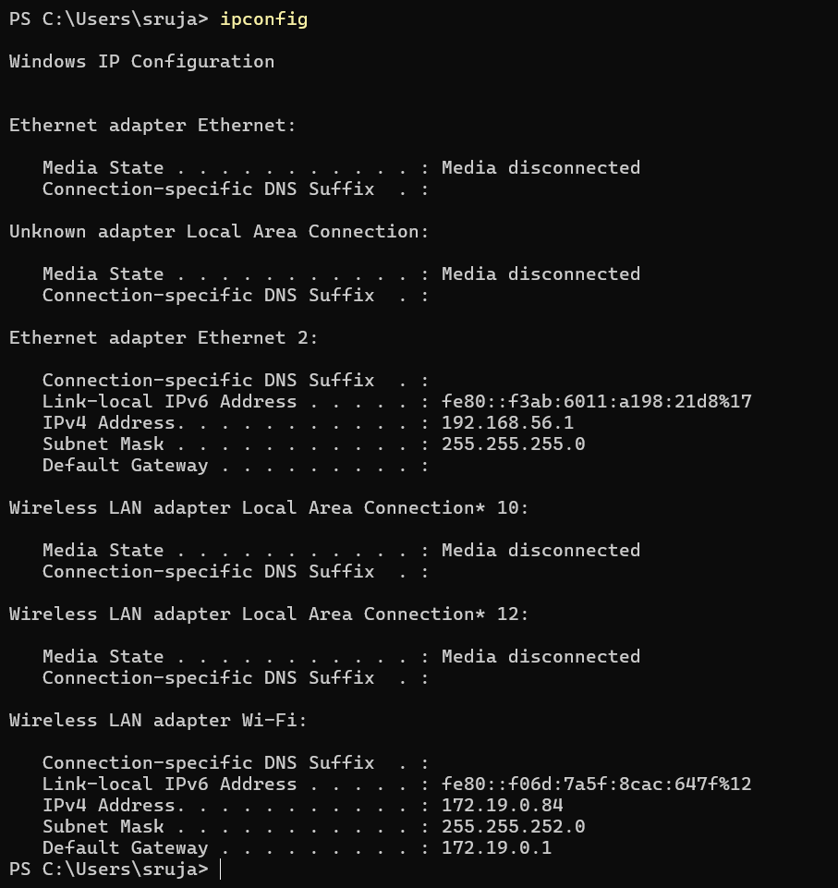

**2. ping**

It is used to test network connectivity, measure response time, determine packet loss. When we specify the IP address or domain name, it sends request to that address and displays all information. There are different options available with ‘ping’ command. When we execute ping command with IP address, information about packets sent and received, round-trip time (in milliseconds) is displayed.

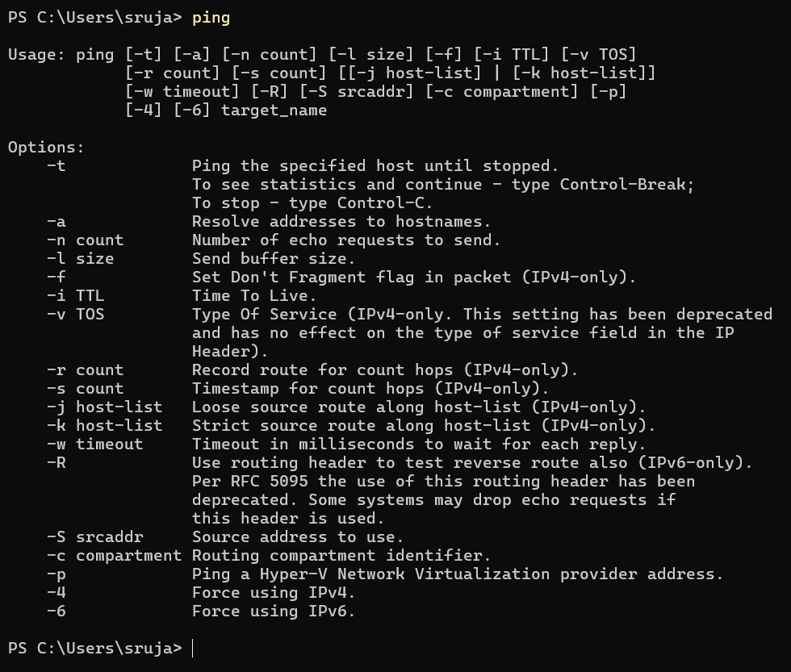

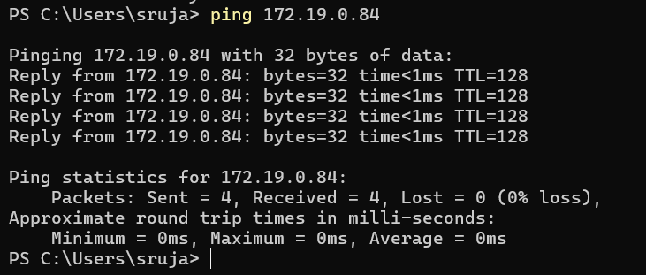

**3. Tracert**

It is used to diagnose connection problem between source and destination. When we enter the IP address or domain name, a list of hops is displayed that the packets traverse along with the round-trip time (in milliseconds) for reaching that hop and IP addresses. Tracert -h can be used to specify the number of hops.

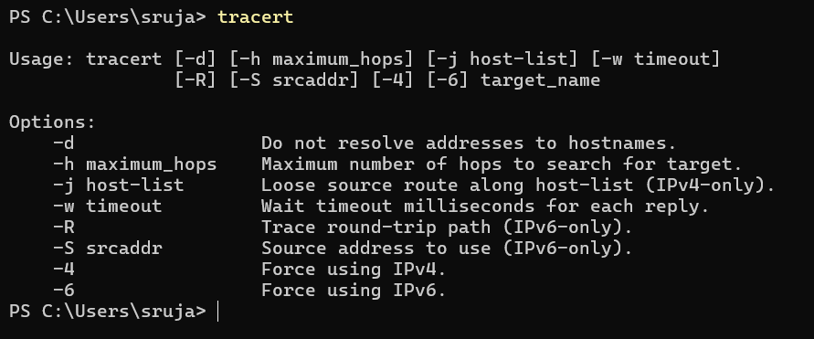

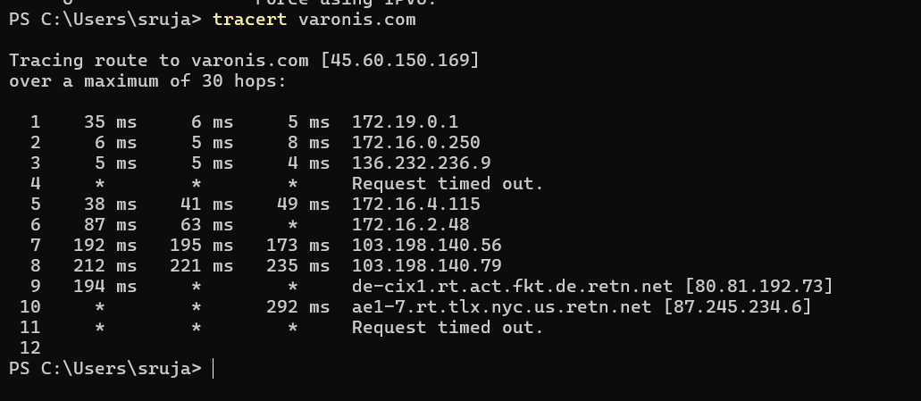

**4. arp**

The arp (Address Resolution Protocol) command is used to map an IP (Internet Protocol) address to a corresponding MAC (Media Access Control) address in a local network. There are different options available in arp command. The arp – a is used to display the ARP table for a particular IP address. The arp command is primarily used for troubleshooting network connectivity issues.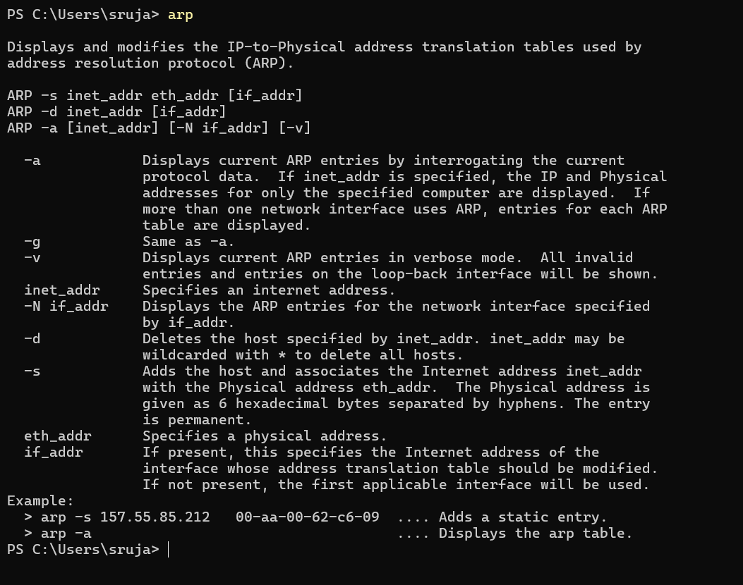

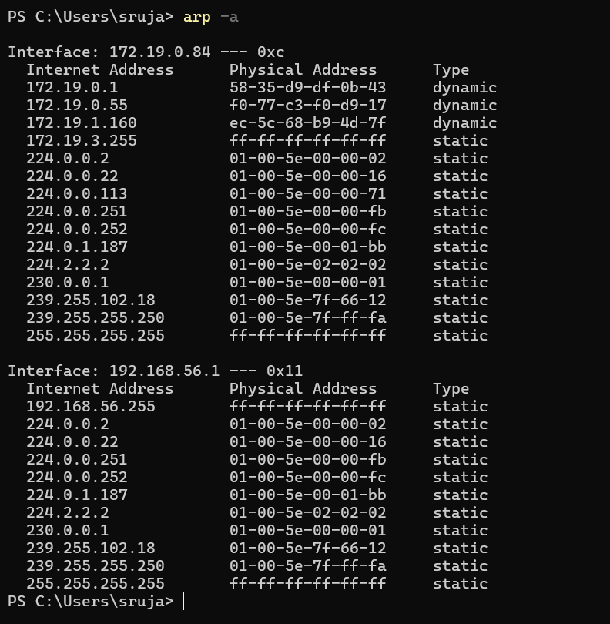

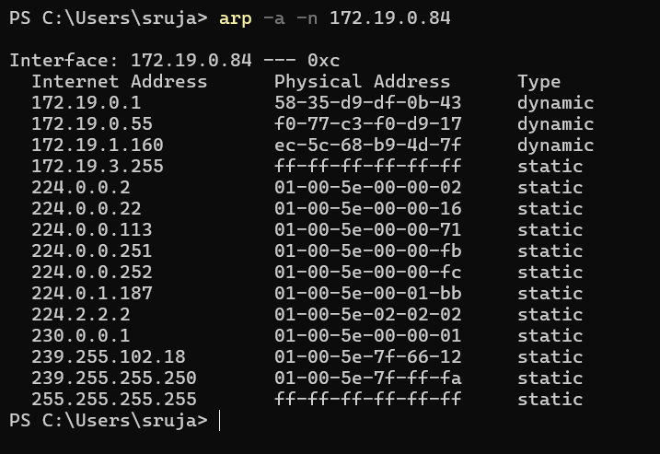

**5. Netstat**

The netstat command is used to display various network-related information. When executed, the netstat command retrieves and displays a list of active network connections, including the protocol used (TCP or UDP), source and destination IP addresses, status of each connection. The netstat -a is used to display the information for our computer system. The netstat -e is used to check the packets sent and received. The netstat -r is used to display network destination, netmask and other information.

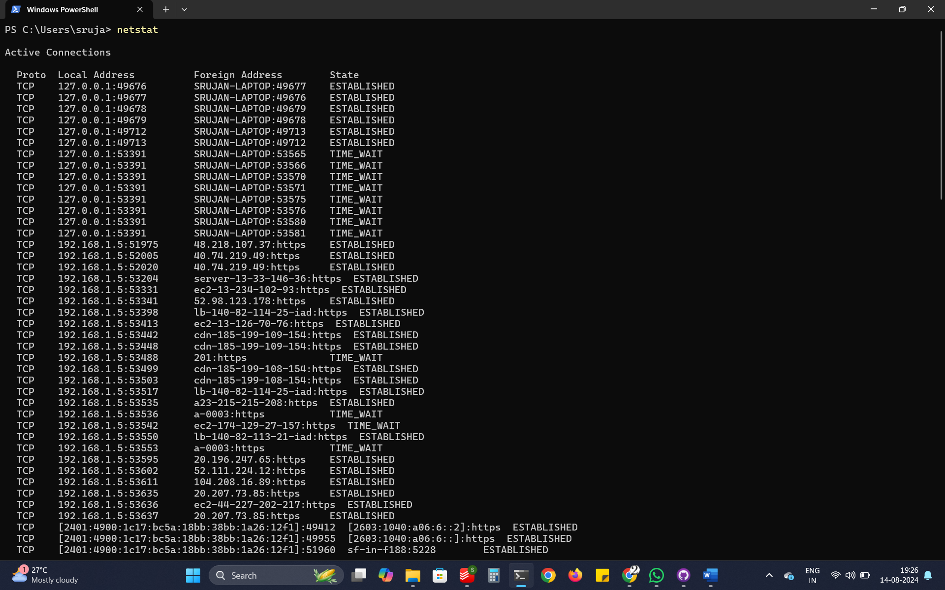 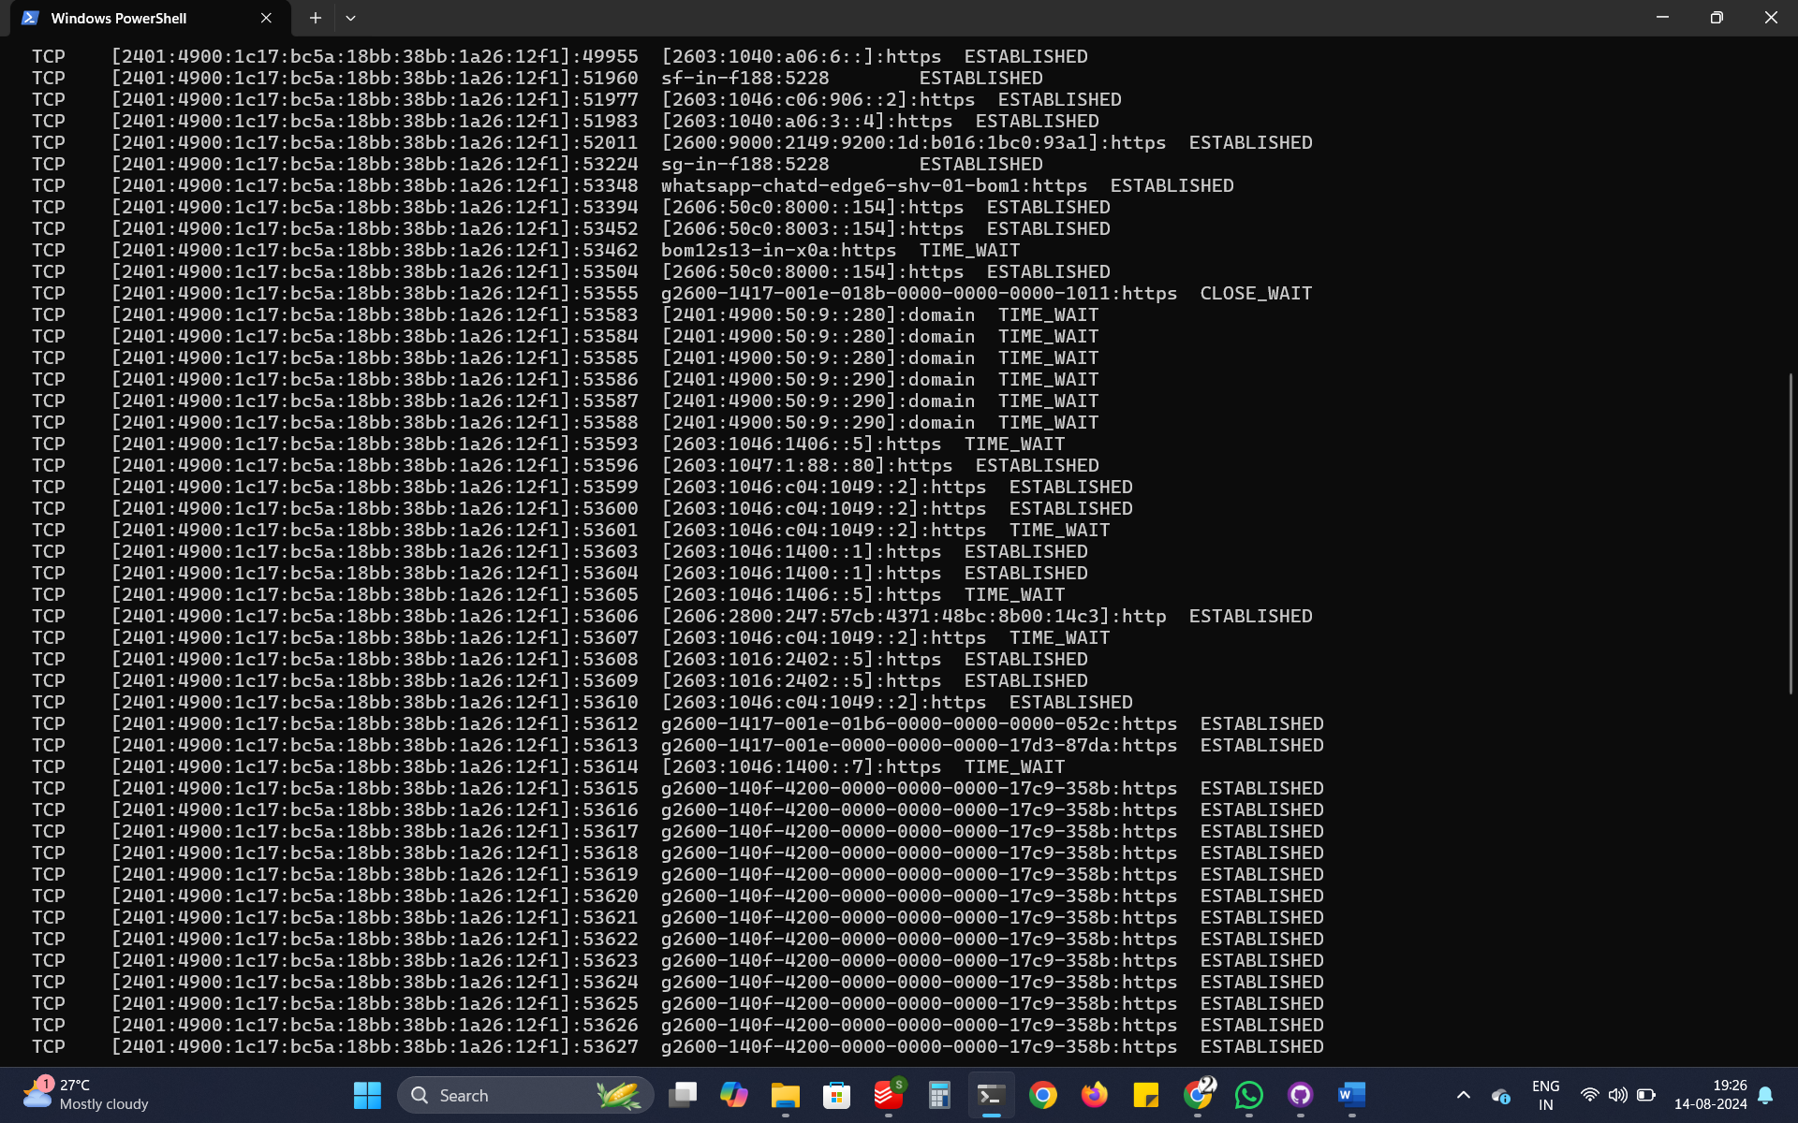

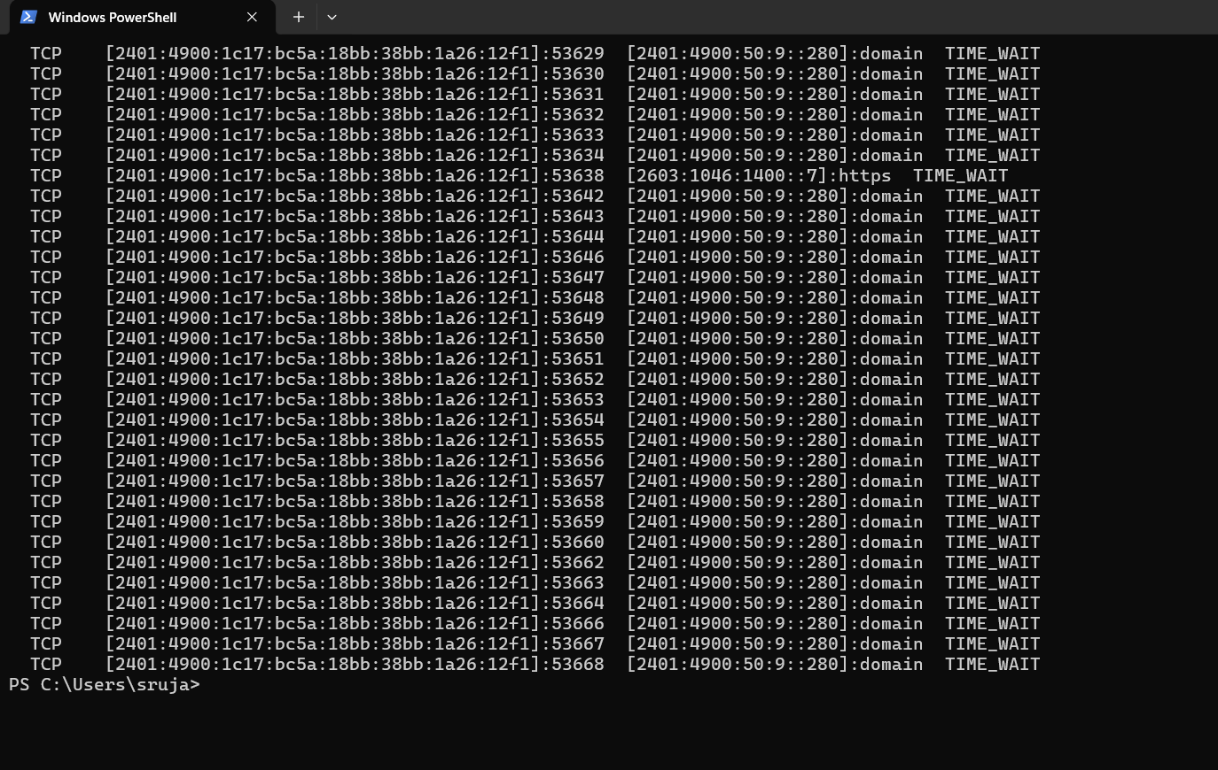

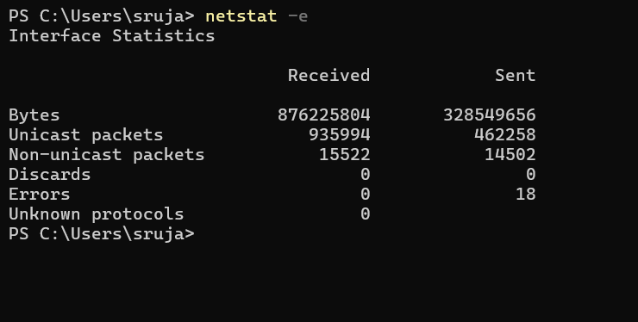

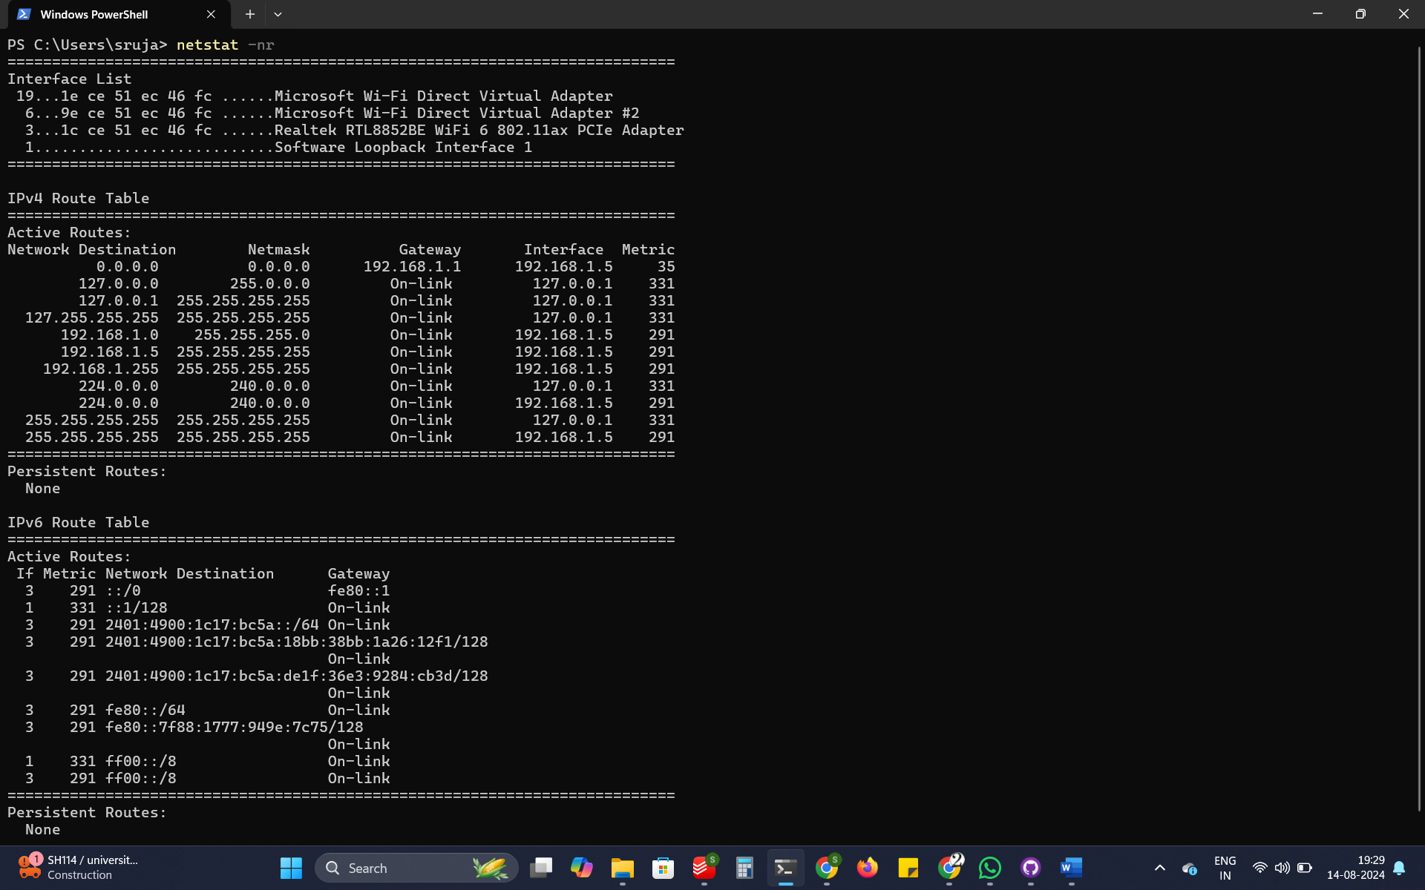

**6. pathping**

The pathping command is used to troubleshoot network issues. It combines features of both tracert and ping commands. When executed, it displays the IP addresses of each hop along with the round-trip time (RTT) for reaching that hop. Pathping provides more detailed information compared to tracert or ping alone. It computes the data for 25 seconds.

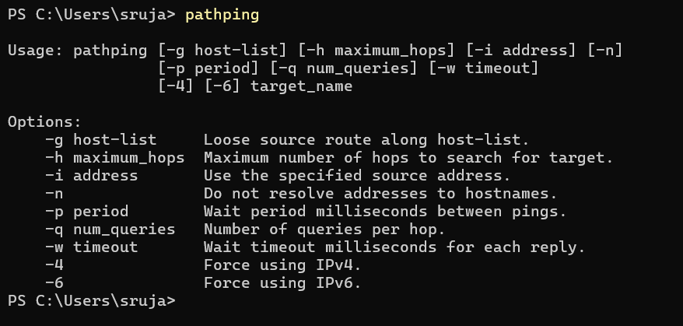

**7. nslookup**

The nslookup command is used to display the IP address if we know the DNS (Domain Name System) information about a given domain name or vice versa. When we enter the domain name, the IP address of that particular domain is displayed. The nslookup command is useful for troubleshooting DNS-related issues.

