**SQL code:**

🡪USING THE CREATE QUERY FORMED A STUDENT TABLE

CREATE TABLE STUDENT

( FNAME VARCHAR(10) NOT NULL,

LNAME VARCHAR(10),

S_USN VARCHAR(10) NOT NULL,

SEM INT(5),

BRANCH VARCHAR(20) ,

EMAIL VARCHAR(30) NOT NULL,

I_GUIDE VARCHAR(20) NOT NULL,

PRIMARY KEY(S_USN)

);

🡪USING INSERT , FILLED THE STUDENT DATA

INSERT INTO `student`(`FNAME`, `LNAME`, `S_USN`, `SEM`, `BRANCH`, `E_MAIL`, `I_GUIDE`) VALUES ('VIDYA','PATIL','17EC07','6','ECE','vidyap@gmail.com','Prof.Ramesh Koti')

🡪 USING THE CREATE QUERY FORMED A COMPANY TABLE

CREATE TABLE COMPANY

( NAME VARCHAR(10) NOT NULL,

S_USN VARCHAR(10) NOT NULL,

C_ID INT(10) NOT NULL,

CONTACT_NO INT(20),

ADDRESS VARCHAR(30) NOT NULL,

E_GUIDE_NAME VARCHAR(20) NOT NULL,

EMAIL VARCHAR(30) NOT NULL,

COURSE VARCHAR(20) NOT NULL,

DURATION_MONTHS INT(10) NOT NULL,

SDT DATE,

EDT DATE,

PRIMARY KEY(C_ID),

FOREIGN KEY(S_USN)

REFERENCES STUDENT(S_USN)

);

🡪USING INSERT , FILLED THE COMPANY DATA

INSERT INTO `company`(`NAME`, `S_USN`, `R0LL_NO`, `CONTACT_NO`, `ADDRESS`,

`E_GUIDE_NAME`, `E_MAIL`, `COURSE`, `DURATION_MONTHS`, `SDT`, `EDT`) VALUES

('TCH-FORTUNE','17EC07','9','221234','ABHISHEK COMPLEX ,ANAGOL, BELAGAVI',

'Mtr.MILIND' ,'milind@gmail.com', 'MACHINE LEARNING','2','2018-06-01','2018-07-31')

🡪USING CREATE , FORMED THE USER TABLE

CREATE TABLE USERS(

FNAME VARCHAR(10) NOT NULL,

LNAME VARCHAR(10),

S_USN VARCHAR(20) NOT NULL,

PASSWORD VARCHAR(20) NOT NULL,

PRIMARY KEY(PASSWORD),

FOREIGN KEY(S_USN)

REFERENCES STUDENT(S_USN)

);

🡪USING INSERT , FILLED THE USER DATA

INSERT INTO `users`(`FNAME`, `LNAME`, `S_USN`, `PASSWORD`) VALUES ('VIDYA','PATIL','17EC07','17EC07')

STUDENT TABLE ,WITH INSERTED DATA:

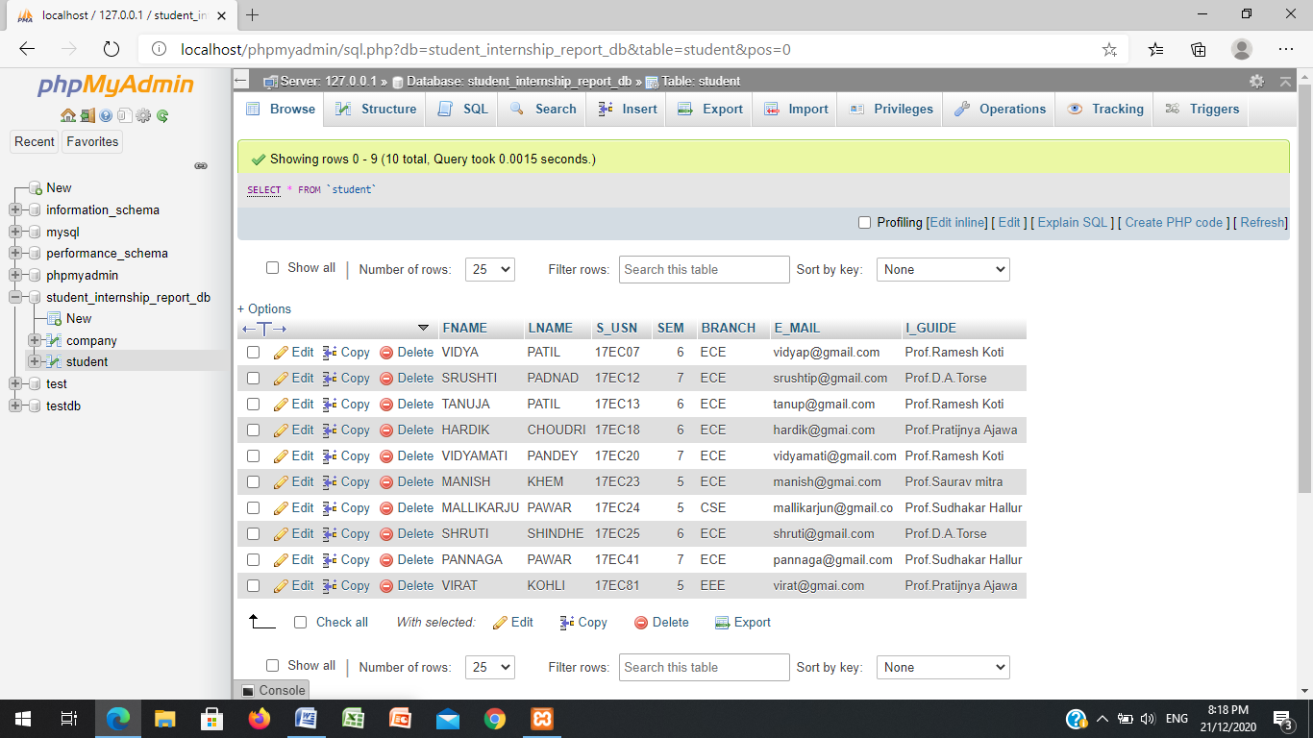

COMPANY TABLE, WITH INSERTED DATA:

