Merge Sort=
#include <stdio.h>
#include <stdlib.h>
#include <time.h>

void merge(int arr[], int l, int m, int r) {
int i, j, k;
int n1 = m - l + 1;
int n2 = r - m;

int L[n1], R[n2];

for(i = 0; i < n1; i++)
L[i] = arr[l + i];
for(j = 0; j < n2; j++)
R[j] = arr[m + 1 + j];

i = 0;
j = 0;
k = l;

while(i < n1 && j < n2) {
if(L[i] <= R[j]) {
arr[k] = L[i];
i++;
} else {
arr[k] = R[j];
j++;
}
k++;
}

while(i < n1) {
arr[k] = L[i];
i++;
k++;
}

while(j < n2) {
arr[k] = R[j];
j++;
k++;
}
}

void mergeSort(int arr[], int l, int r) {
if(l < r) {
int m = (l + r) / 2;

mergeSort(arr, l, m);
mergeSort(arr, m + 1, r);

merge(arr, l, m, r);
}
}

int main() {
int n, i;
clock_t start, end;
double cpu_time;

printf("Enter number of elements: ");
scanf("%d", &n);

int arr[n];

printf("Enter %d elements:\n", n);
for(i = 0; i < n; i++) {
scanf("%d", &arr[i]);
}

start = clock();

mergeSort(arr, 0, n - 1);

end = clock();

cpu_time = ((double)(end - start)) / CLOCKS_PER_SEC;

printf("Sorted array:\n");
for(i = 0; i < n; i++) {
printf("%d ", arr[i]);
}

printf("\nTime taken = %f seconds\n", cpu_time);

return 0;
}
Output=
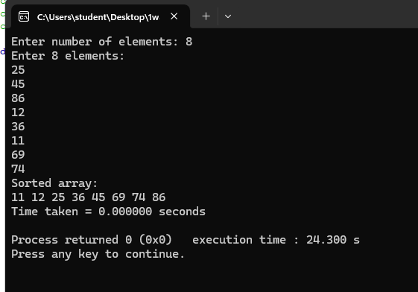

Quick Sort=
#include <stdio.h>
#include <time.h>

void swap(int *a, int *b)
{
int temp;
temp = *a;
*a = *b;
*b = temp;
}

int partition(int arr[], int low, int high)
{
int pivot = arr[low];
int i = low + 1;
int j = high;

while (1)
{
while (i <= high && arr[i] <= pivot)
i++;

while (arr[j] > pivot)
j--;

if (i < j)
swap(&arr[i], &arr[j]);
else
break;
}

swap(&arr[low], &arr[j]);
return j;
}

void quickSort(int arr[], int low, int high)
{
if (low < high)
{
int p = partition(arr, low, high);
quickSort(arr, low, p - 1);
quickSort(arr, p + 1, high);
}
}

int main()
{
int n, i;
int arr[100000];
clock_t start, end;
double time_taken;

printf("Enter number of elements: ");
scanf("%d", &n);

printf("Enter elements:\n");
for (i = 0; i < n; i++)
scanf("%d", &arr[i]);

start = clock();

quickSort(arr, 0, n - 1);

end = clock();

time_taken = ((double)(end - start)) / CLOCKS_PER_SEC;

printf("\nSorted elements are:\n");
for (i = 0; i < n; i++)
printf("%d ", arr[i]);

printf("\n\nTime taken = %f seconds\n", time_taken);

return 0;
}
Output=
