Dining Philosopher Problem =
#include <stdio.h>
#include <pthread.h>
#include <semaphore.h>
#include <unistd.h>
#include <stdlib.h>

int n, times;
sem_t *forks;
pthread_t *philosophers;

void* dine(void* arg)
{
int id = *(int*)arg;

for(int i = 0; i < times; i++)
{
printf("Philosopher %d is thinking\n", id);
sleep(1);

if(id % 2 == 0)
{
sem_wait(&forks[id]);
sem_wait(&forks[(id + 1) % n]);
}
else
{
sem_wait(&forks[(id + 1) % n]);
sem_wait(&forks[id]);
}

printf("Philosopher %d is eating (%d)\n", id, i + 1);
sleep(1);

sem_post(&forks[id]);
sem_post(&forks[(id + 1) % n]);

printf("Philosopher %d finished eating (%d)\n", id, i + 1);
}

return NULL;
}

int main()
{
printf("Enter number of philosophers: ");
scanf("%d", &n);

printf("Enter number of times each philosopher should eat: ");
scanf("%d", &times);

forks = (sem_t*)malloc(n * sizeof(sem_t));
philosophers = (pthread_t*)malloc(n * sizeof(pthread_t));
int ids[n];

for(int i = 0; i < n; i++)
sem_init(&forks[i], 0, 1);

for(int i = 0; i < n; i++)
{
ids[i] = i;
pthread_create(&philosophers[i], NULL, dine, &ids[i]);
}

for(int i = 0; i < n; i++)
pthread_join(philosophers[i], NULL);

return 0;
}
Output=
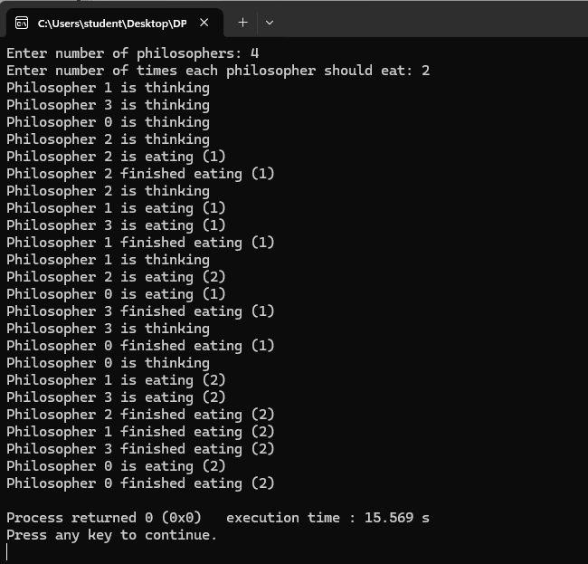
Deadlock Detection Algorithm =
#include <stdio.h>
#include <stdbool.h>

int main()
{
int n, m;
printf("Enter number of processes: ");
scanf("%d", &n);
printf("Enter number of resource types: ");
scanf("%d", &m);

int allocation[n][m], request[n][m], available[m];

printf("Enter allocation matrix:\n");
for(int i = 0; i < n; i++)
for(int j = 0; j < m; j++)
scanf("%d", &allocation[i][j]);

printf("Enter request matrix:\n");
for(int i = 0; i < n; i++)
for(int j = 0; j < m; j++)
scanf("%d", &request[i][j]);

printf("Enter available resources:\n");
for(int i = 0; i < m; i++)
scanf("%d", &available[i]);

bool finish[n];
for(int i = 0; i < n; i++)
{
int sum = 0;
for(int j = 0; j < m; j++)
sum += allocation[i][j];
if(sum == 0)
finish[i] = true;
else
finish[i] = false;
}

int work[m];
for(int i = 0; i < m; i++)
work[i] = available[i];

bool found;
do
{
found = false;
for(int i = 0; i < n; i++)
{
if(!finish[i])
{
int j;
for(j = 0; j < m; j++)
if(request[i][j] > work[j])
break;

if(j == m)
{
for(int k = 0; k < m; k++)
work[k] += allocation[i][k];
finish[i] = true;
found = true;
}
}
}
} while(found);

bool deadlock = false;
printf("Processes in deadlock:\n");
for(int i = 0; i < n; i++)
{
if(!finish[i])
{
printf("P%d ", i);
deadlock = true;
}
}

if(!deadlock)
printf("No deadlock");

printf("\n");
return 0;
}
Output=
