**Event Planner App**

Srushti H S, Kishore M, Chandana R, Hamsini B E, Guruprasad D, Dr Abdul khadar A

UG Student, Dept. of CSE., Presidency University, Bangalore, India

Associate Professor, Dept. of CSE., Presidency University, Bangalore, India

**ABSTRACT:** With a centralised, user-friendly platform that facilitates smooth communication, clear pricing, and effective administration for events of all sizes, the Event Planner App simplifies event planning. Based on availability, price range, and location, users may explore, evaluate, and reserve services; thorough planner profiles and ratings guarantee well-informed choices. The software reduces user stress and gives small businesses the competitive edge by automating procedures and providing secure payments, therefore eliminating inefficiencies such as imprecise pricing and disorganised communication. For improved functionality and security, future upgrades will incorporate chatbot support, blockchain payments, and AI suggestions.

KEYWORDS: **Event planner, application, events, occasions, algorithm, interface.**

1. **Introduction**

Creating immaculate and unforgettable gestures for guests is a continual struggle for event planners in the fast-paced and dynamic world of event planning. Technology has changed the game, and the Event Diary App is a ground-breaking outcome that has the potential to completely transform how events are organised and carried out. This extensive operation is meticulously designed to meet the many needs of event planners, providing a multipronged strategy to optimise all event operations. Fundamentally, the Event Diary App is a comprehensive solution created to handle the challenges involved in organising and carrying out events of all sizes. The software gives organisers access to an unidentified position of complexity and efficacy via the use of slice-edge technology. Its dedication to accessibility is demonstrated by its user-friendly design, which makes it simple for both novices and experts to use the platform for event planning. The app's capacity to facilitate faultless event enrolment and grading is one of its well-known advantages. With only a few clicks, attendees may reserve their spaces, and organisers can easily set up and manage enrolment procedures.

This improves the overall user experience for attendees of the event while also lessening the administrative load on event coordinators. The Event Planner App's real-time attendee interaction features are yet another essential feature. This application asks the user for all the information needed to plan the event. deciding on the venue, the kind of event, and the prerequisites. Additionally, it offers the customer other services based on their needs. In the end, the Android app serves as an organizer's strategic ally, enabling them to skilfully plan and execute events. By utilising its intuitive interface, note-saving capabilities, and expenditure management skills, organisers can optimise their workflow, provide customers with exceptional services, and guarantee that every event is a success.

1. **Related work**

A Survey on event planner apps reveals a growing body of research and publications that explore various aspects of these applications. Researchers and practitioners have delved into topics ranging from the impact of technology on event planning to the user experience of event management apps.

In [1], the development and operation of an Android application designed to simplify event management are examined. It all comes down to overcoming the typical obstacles that event planners encounter in an effort to streamline and improve productivity. The software prioritises security and individualised access, requiring users to create and validate their accounts. [2] This creative program makes use of state-of-the-art technology to provide users a variety of potent features and an intuitive user interface. The software gives event planners a one-stop platform to handle all part of their events, from easy ticketing and registration to real-time capabilities for engaging attendees. [3] The purpose of this article is to create an application for an event management system. Events like weddings and festivals have become an integral part of modern life, which has led to the growth of event management and planning companies. Using a standard system to manage the growing number of clients and events is challenging. A new Smart Event Planner System, which makes use of contemporary technology to manage numerous duties and plan for staff, customers, locations, transportation, and more, may be implemented in order to address the shortcomings of the conventional event managing system. With the aid of this technology, the management team and customers are now closer thanks to mobile and smart web access. [4] Understanding how crucial it is to create a feeling of community among guests, the app offers interactive elements that let users communicate and connect with one another. The app turns events into immersive experiences that go beyond the actual confines of the venue, offering discussion boards, live polls, and networking possibilities. The app's dedication to using strong analytics to support data-driven decision making is one of its most notable features. By learning about the tastes and behaviour of attendees, event planners may make ongoing improvements. By knowing what appeals to their audience, event planners may adjust subsequent events to fit changing demands and provide guests a more unique and fulfilling experience. In the field of event planning, the Event Management App is a shining example of innovation. [5] a complete stack project that establishes the framework for all our objectives, with a primary focus on the suggested recommendation algorithms that allow its users to find events that are likely to catch their attention. Our recommendation algorithms were developed with inspiration from pre-existing implementations, including those at Netflix, YouTube, and Amazon, and the outcome was an innovative fusion.[6] Our project's main goal is to create a mobile application and use contemporary technology to simplify the intricate process of conventional event management techniques, turning them into intelligent event management systems. Our study specifically focusses on events held by several colleges and institutions that adhere to conventional event management techniques.

Every time a college or university hosts an event, there are additional tasks that must be completed, such as organising the event, monitoring the plan, adhering to a strict budget, providing students with clear information about the event, sending out invitations, conducting registration, advertising among other colleges, and occasionally even lacking in-person audience interaction. This specific project is the subject of additional study, which improves the model's properties.

1. **Proposed algorithm**

Frontend: Flutter

In order to ensure smooth interaction for all users, whether they are exploring vendors, making reservations, or handling payments, the Event Planner App's frontend is made to have an aesthetically pleasing, responsive, and user-friendly interface.

Key Features:

* Cross-platform compatability
* User-friendly interface
* Real time update

Backend: Firebase

The backend of the Event Planner App is built on Firebase, offering a robust foundation for managing data processing, business logic, and seamless communication between the frontend and database. It ensures scalability, security, and operational efficiency, aligning with the app's dynamic requirements.

Key features:

* Scalability
* Real-time database management
* Serverless architecture

1. **Pseudo code**

**1. User Authentication**

1. User enters email and password.
2. The app checks if the email exists in the database.
3. If the email exists, the password is verified.
4. On successful verification, the user is logged in, and a session or token is generated.
5. If verification fails, an error message is displayed.

**2. User Registration**

1. User provides their name, email, and password.
2. The app checks if the email is already registered.
3. If not, the user details are saved to the database, and an account is created.
4. A confirmation message is sent to the user.

**3. Vendor Search**

1. User applies filters such as location, service type, price range, or availability.
2. The app queries the database using the provided filters.
3. Matching vendors are displayed in a list with details like ratings, reviews, and availability.

**4. Booking Management**

1. User selects a vendor and specifies event details (date, time, requirements).
2. The app checks the vendor’s availability for the selected date and time.
3. If available, a booking is created and saved in the database.
4. The vendor is notified of the new booking.
5. The user receives a confirmation of the booking

**5. Vendor Profile Management (Admin Dashboard)**

1. Vendors log in to access their dashboard.
2. They can update their profile details, such as services offered, pricing, and availability.
3. Vendors can view all their bookings and manage them (e.g., accept or decline).
4. Vendors can access analytics on their bookings and customer reviews.

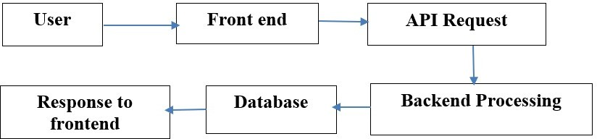.

*fig 1. workflow*

**V. Simulation Results**

It presents the results of the various testing processes conducted for the Event Planner App. These tests aim to ensure that the app performs optimally under different conditions, provides a smooth user experience, and meets user expectations. The testing covered multiple aspects of the app, including load testing for scalability, user acceptance testing (UAT) feedback, and key performance metrics such as average app response time and booking success rates.

1. Load Testing for Scalability Scalability is one of the most important factors for any app, especially one like the Event Planner App that aims to serve a large user base consisting of event planners, service providers, and other stakeholders. Load testing ensures that the app can handle varying levels of traffic and user interactions without compromising performance.
2. User Acceptance Testing (UAT) Feedback User acceptance testing (UAT) is a critical phase where real users interact with the app in a real-world scenario to evaluate its functionality, usability, and overall satisfaction. The feedback gathered from this phase plays a key role in ensuring that the app meets the needs of its target audience and performs as expected.
3. Discussion The results of the testing provide valuable insights into the app’s performance and its ability to meet user expectations. The load testing results confirm that the app is highly scalable and can handle large amounts of traffic, which is essential for its long-term success. The UAT feedback demonstrates that the app is well-received by users, with high satisfaction rates and a seamless experience across the major functions of registration, booking, and payment. Additionally, the performance metrics reflect the app's efficiency in handling operations and its ability to deliver a smooth, uninterrupted experience.

In conclusion, the testing results indicate that the Event Planner App is on track to provide a fast, scalable, and reliable platform for event planning. With the right adjustments and enhancements, it is poised to meet the growing needs of event planners and vendors while offering an excellent user experience.

.

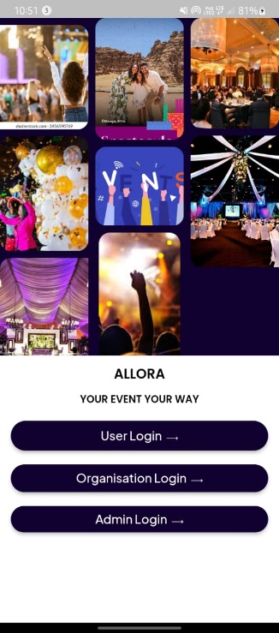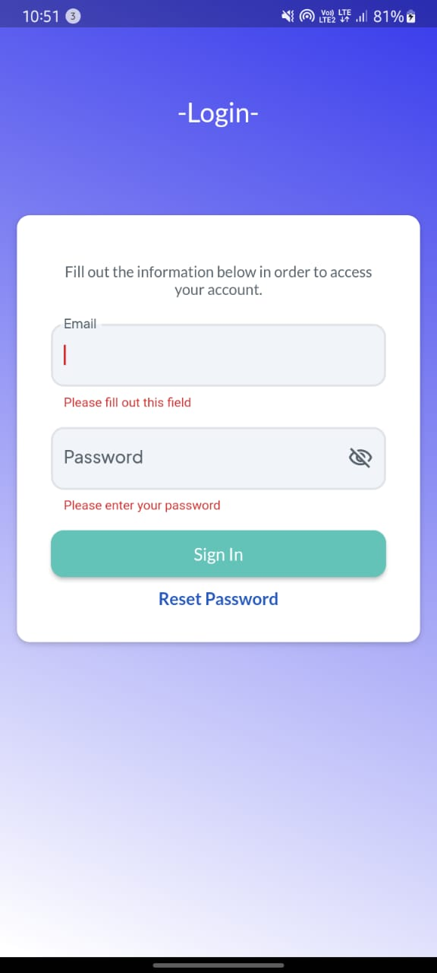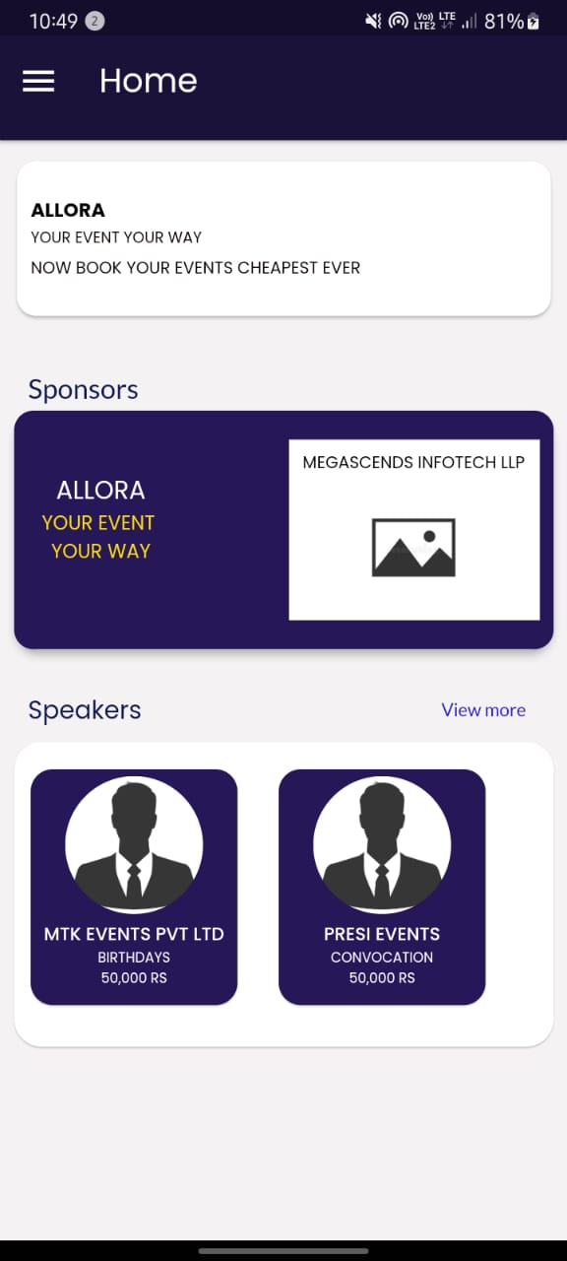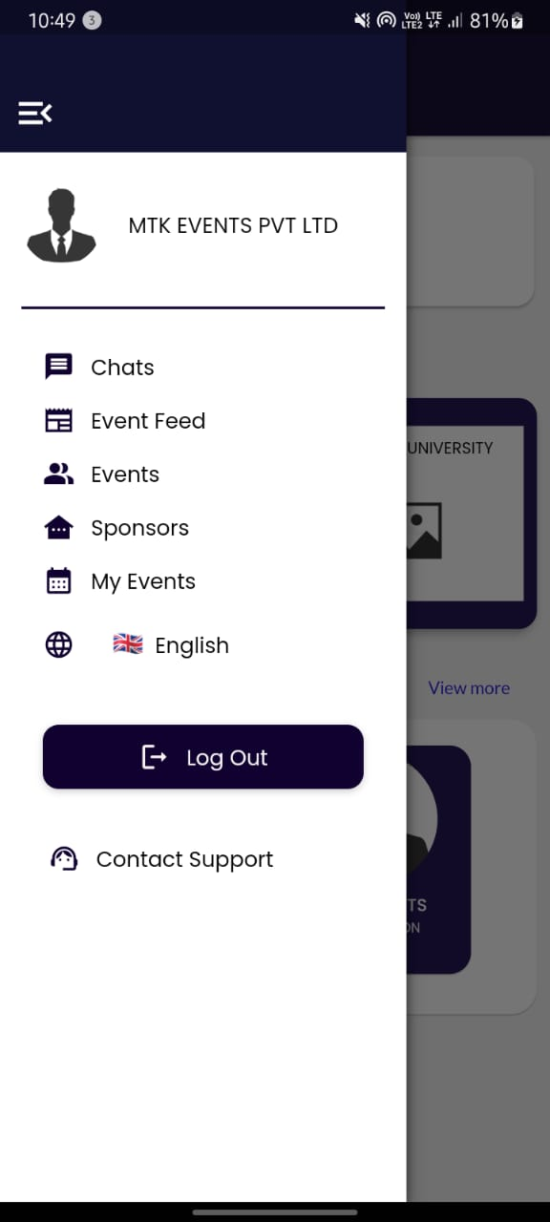

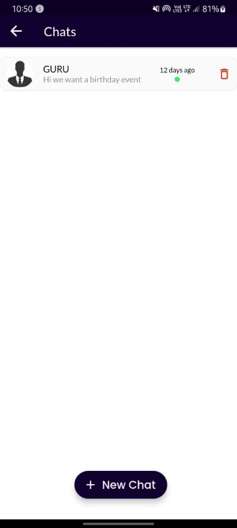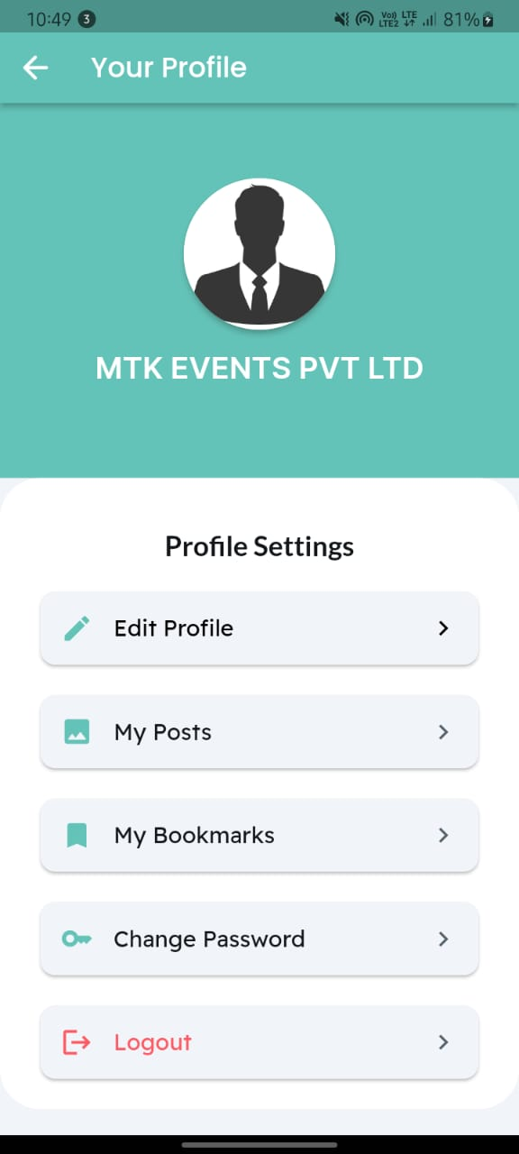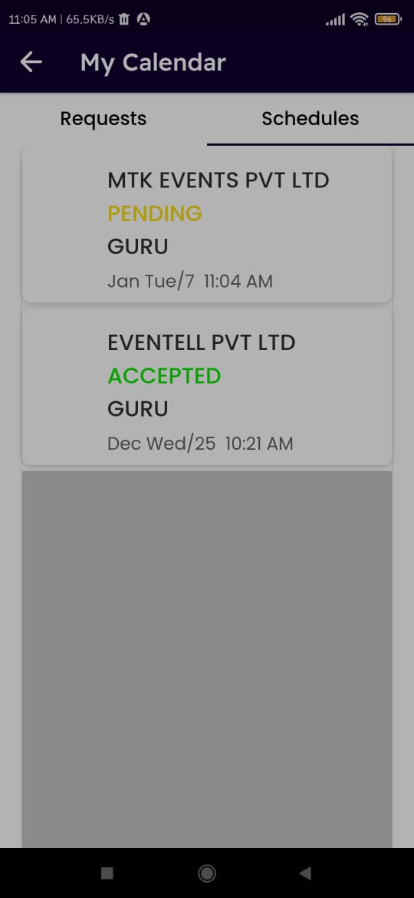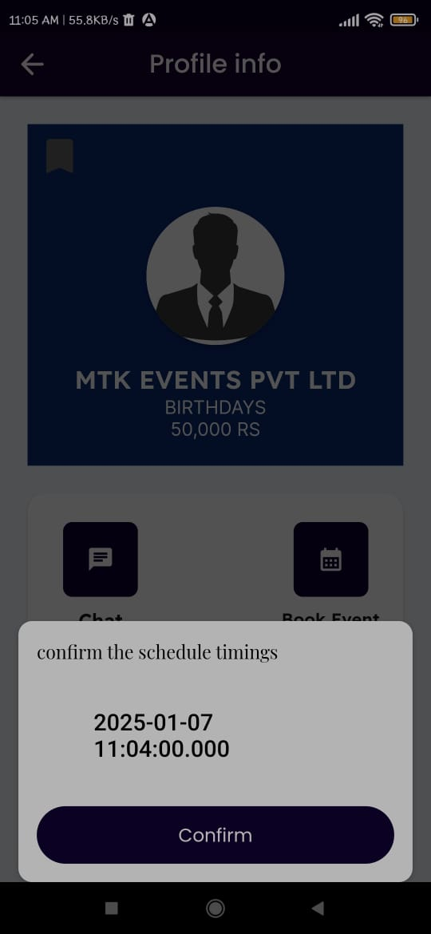 Fig 2 Login page Fig 3 Users Login page Fig 4 Home page Fig 5 Menu page

Fig 6 Schedules page Fig 7 Profile Page Fig 8 Booking page Fig 9 Chat page

1. **Conclusion and Future Work**

By centralising vendor services, facilitating smooth communication, and guaranteeing safe transactions, the Event Planner App has effectively solved the difficulties associated with traditional event planning. For both event hosts and service suppliers, the app promotes efficiency, dependability, and trust by integrating features like user ratings, clear pricing, and real-time availability. By ensuring scalability, data security, and optimal performance via the use of cloud-based technology and rigorous testing methods, the app has established itself as a game-changing tool in the event planning sector. By providing a centralised platform that streamlines the event planning process, the Event Planner App has completely transformed the event planning sector. Future updates will try to improve the app's functionality and user experience even further.

**References**

1. R. L. Johnson and T. J. Smith, *Event Planning and Management: A Guide for Organizers*, New York, NY: Wiley & Sons, 2020.
2. "Application Development for a Project using Flutter," *IEEE Xplore*, 2023. [Online]. Available: <https://ieeexplore.ieee.org/document/9951938/>.
3. *Eventbrite for event organizers*, Eventbrite, 2023. [Online]. Available: <https://www.eventbrite.com/>
4. *WeddingWire for vendors and event planners*, WeddingWire, 2024. [Online]. Available: <https://www.weddingwire.com/>
5. "Flutter Framework Code Portability Measurement on Multiplatform Applications with ISO 9126," *IEEE Xplore*, 2023. [Online]. Available: <https://ieeexplore.ieee.org/document/10030045/>
6. R. Miller, "The future of event planning: AI and the role of data in modern event management," *EventTech Insights*, Dec. 1, 2023. [Online]. Available: [https://www.eventtechinsights.com](https://www.eventtechinsights.com/)
7. *Google Firebase platform documentation*, Google Firebase, 2023. [Online]. Available: https://firebase.google.com/docs
8. *Stripe payments integration for event platforms*, Stripe, 2024. [Online]. Available: <https://stripe.com/docs>