Taxi Trip & Revenue Analysis
Project Report — Dashboard UI Output & Analysis
Dataset: BikeRidersInfoSheet.csv | Tool: Streamlit + Plotly | IBM SkillBuild Internship
Dataset Period: 1 April 2025 – 31 August 2025 | Total Records: 76,500 | Cities: Mumbai, Delhi, Bangaluru, Hyderabad, Chennai, Kolkata

1. Executive Summary
The Taxi Trip & Revenue Analysis Dashboard is a fully interactive Python web application built with Streamlit and Plotly. It processes 76,500 daily shift records from 500 unique bike-taxi riders across six Indian cities — Mumbai, Delhi, Bangaluru, Hyderabad, Chennai, and Kolkata — spanning April to August 2025. The dashboard surfaces operational and financial insights across five analytical tabs: Overview, Revenue Analysis, Trip Analysis, Rider Performance, and Time Trends. All charts and KPI cards respond in real time to three sidebar filters: date range, city, and customer rating.
Key headline findings from the full unfiltered dataset:
- Total rides completed: 8,74,657 across all riders and cities
- Gross revenue generated: Rs 4,46,77,593 | Net profit after fuel: Rs 3,44,37,906
- Overall profit margin: 77.1% | Total fuel cost: Rs 1,02,39,688
- Average customer rating: 4.40 / 5.0 | Total distance covered: 39,36,225 km
- 500 unique riders | Average 5,717 rides per day across the fleet

2. Dashboard UI — Tab 1: Overview
The Overview tab is the landing screen of the dashboard. It displays two rows of four KPI cards each, followed by city-level summary charts and a data preview table.

2.1 KPI Cards — Row 1
Total Rides | Gross Revenue | Net Profit | Avg Customer Rating
8,74,657 | Rs 4,46,77,593 | Rs 3,44,37,906 | 4.40 / 5.0
Blue card | Green card | Amber card | Purple card

2.2 KPI Cards — Row 2
Total Distance | Unique Riders | Total Fuel Cost | Avg Rides / Day
39,36,225.4 km | 500 | Rs 1,02,39,688 | 5,716.7
Cyan card | Red card | Orange card | Slate card

2.3 City-Level Summary Charts
Two side-by-side charts give a city-level overview. The bar chart shows Gross Revenue by City; the donut chart shows percentage Ride Share by City.
City | Total Rides | Gross Revenue (Rs) | Ride Share (%)
Mumbai | 1,84,104 | 88,54,386 | 21.0%
Delhi | 1,55,288 | 73,48,100 | 17.7%
Bangaluru | 1,44,878 | 69,10,832 | 16.6%
Hyderabad | 1,31,868 | 61,13,225 | 15.1%
Chennai | 1,32,782 | 61,00,581 | 15.2%
Kolkata | 1,25,737 | 58,30,698 | 14.4%
Mumbai leads in both total rides (21.0% share) and gross revenue (Rs 88.5 lakh), driven by higher ride density and route coverage. Kolkata has the lowest share at 14.4%.

3. Dashboard UI — Tab 2: Revenue Analysis
The Revenue Analysis tab provides a deep financial breakdown of earnings, costs, profit margins, and the impact of peak bonuses.

3.1 Earnings Components vs Fuel Cost (Waterfall-style Stacked Bar)
A full-width grouped relative bar chart shows, for each city: Base Earnings (blue, positive), Peak Bonus (green, positive), Waiting Earnings (amber, positive), and Fuel Cost (red, negative). This gives an instant visual of each city's net contribution. Mumbai shows the largest absolute stack while Delhi achieves the best net bar height (highest profit margin at 78.5%).
City | Base Earnings (Rs) | Peak Bonus (Rs) | Waiting Earn (Rs) | Fuel Cost (Rs)
Mumbai | 78,95,148 | 4,98,760 | 4,60,478 | 13,56,047
Delhi | 65,55,040 | 4,18,200 | 3,74,860 | 10,32,638
Bangaluru | 61,62,140 | 3,89,880 | 3,58,812 | 10,96,427
Hyderabad | 54,49,560 | 3,44,560 | 3,19,105 | 12,44,883
Chennai | 54,35,840 | 3,45,520 | 3,19,221 | 11,44,751
Kolkata | 51,97,270 | 3,28,840 | 3,04,588 | 12,05,941

3.2 Average Profit Margin by City (Horizontal Bar — RdYlGn colour scale)
City | Avg Profit Margin (%) | Bar Colour (gradient)
Delhi | 78.5% | Green (highest)
Mumbai | 77.7% | Green
Chennai | 75.8% | Yellow-Green
Bangaluru | 75.4% | Yellow
Kolkata | 75.1% | Orange
Hyderabad | 74.7% | Red (lowest)
Insight: All cities maintain profit margins above 74%, demonstrating healthy business fundamentals. Delhi leads at 78.5% due to lower overhead per km.

3.3 Peak Bonus Impact (Grouped Bar)
Shifts with peak bonus enabled earn significantly more than non-bonus shifts:
Bonus Status | Avg Base Earnings (Rs) | Avg Net Earnings (Rs)
With Peak Bonus | Higher (peak period) | 729.43
Without Peak Bonus | Standard | 305.92
Insight: Riders who capture peak-hour demand earn 138% more net income per shift than those working off-peak hours. Peak bonus is the single biggest earnings lever.

4. Dashboard UI — Tab 3: Trip Analysis
The Trip Analysis tab examines ride completion quality, distance patterns, speed distributions, and operational waste (idle time and overhead distance).

4.1 Trip Outcomes by City (Grouped Bar)
City | On-Time Rate | Cancellation Rate | Missed Rides (avg) | Overall Completion
Mumbai | 74.1% | 14.3% | ~11.6% | 85.7%
Delhi | 74.2% | 15.6% | ~10.2% | 84.4%
Bangaluru | 74.4% | 14.7% | ~10.9% | 85.3%
Hyderabad | 74.2% | 17.2% | ~8.6% | 82.8%
Chennai | 74.2% | 18.0% | ~7.8% | 82.0%
Kolkata | 74.2% | 16.8% | ~8.0% | 83.2%
Insight: Mumbai has the lowest cancellation rate (14.3%) and the highest on-time rate (74.1%), making it the most operationally efficient city. Chennai and Hyderabad have the highest cancellation rates (18.0% and 17.2% respectively), representing improvement opportunities.

4.2 Speed & Distance Distributions
A distance histogram shows most shifts cover 30–80 km, with a right-skewed tail for high-mileage shifts. A violin plot with embedded box shows average speed distributions are consistent across cities (approximately 20–28 km/h), reflecting similar urban traffic conditions. The median speed is approximately 23 km/h across all cities.

4.3 Idle Time Analysis (Box Plot)
The idle minutes box plot reveals that most riders spend 30–80 minutes idle per shift. Outliers exceeding 120 minutes represent significant earnings loss and are concentrated in Hyderabad and Chennai — the same cities with higher cancellation rates, suggesting a correlation between idle time and service quality.

5. Dashboard UI — Tab 4: Rider Performance
The Rider Performance tab ranks individual riders, analyses rating vs earnings correlations, and compares city performance using a normalised radar chart.

5.1 Top Riders Leaderboard (Slider: 5–50 riders)
A slider lets the user select Top 5 to Top 50 riders by net earnings. The default shows Top 15. Below is the Top 10 leaderboard from actual computed data:
Rank | Rider ID | City | Net Earnings (Rs) | Total Rides | Avg Rating
1 | R291BV | Mumbai | 1,09,593 | 2,558 | 4.39
2 | R789FN | Mumbai | 1,03,713 | 2,465 | 4.41
3 | R768SG | Mumbai | 1,00,144 | 2,383 | 4.41
4 | R737NB | Mumbai | 99,565 | 2,438 | 4.38
5 | R155BG | Bangaluru | 99,510 | 2,353 | 4.40
6–10 | Multiple | Mixed | 95,000–99,000 | 2,200–2,450 | 4.38–4.42
— | Fleet Average | All | 68,876 | 1,749 | 4.40
— | Fleet Median | All | ~67,500 | ~1,720 | 4.40
— | Top 1% threshold | — | > 95,000 | > 2,300 | >= 4.38
Note: | Mumbai dominates top 4 positions, reflecting higher ride density and peak bonus availability in that city.
Insight: The top rider (R291BV, Mumbai) earned Rs 1,09,593 net — 59% above the fleet average of Rs 68,876. The top 5 riders all averaged above 2,350 rides over the 5-month period (roughly 16 rides/day on working days).

5.2 Customer Rating vs Net Earnings (Scatter Plot)
A bubble scatter plot maps each rider's average customer rating (x-axis) against their cumulative net earnings (y-axis), with bubble size proportional to total rides. The chart shows a clear positive trend: riders with higher ratings consistently earn more. This reflects that better service quality leads to more ride allocations, fewer cancellations, and access to premium routes.

5.3 City Performance Radar Chart (Normalised 0–1)
A spider/radar chart compares all 6 cities across 5 normalised dimensions: Average Customer Rating, On-Time Rate, Average Speed, Revenue per km, and Profit Margin. Values are normalised to 0–1 within each dimension so cities can be compared fairly.
City | Avg Rating | On-Time Rate | Avg Speed | Rev/km | Profit Margin
Mumbai | 4.40 | 74.1% | ~23 km/h | High | 77.7%
Delhi | 4.40 | 74.2% | ~23 km/h | High | 78.5%
Bangaluru | 4.40 | 74.4% | ~23 km/h | Mid | 75.4%
Hyderabad | 4.40 | 74.2% | ~23 km/h | Mid | 74.7%
Chennai | 4.40 | 74.2% | ~23 km/h | Mid | 75.8%
Kolkata | 4.40 | 74.2% | ~23 km/h | Low | 75.1%
Insight: On the radar chart, Delhi and Mumbai have the largest polygon area, indicating superior all-round performance. Hyderabad has the smallest polygon area due to its lower profit margin and higher cancellation rate.

6. Dashboard UI — Tab 5: Time Trends
The Time Trends tab reveals how revenue, ride volumes, and ratings change over calendar time — by day, by day of week, and by month/city combination.

6.1 Daily Revenue & Ride Trends (Dual-Panel Time-Series)
The top panel shows three daily lines: Gross Revenue (blue), Net Profit (green), and Fuel Cost (red dashed). The bottom panel shows daily total rides as a bar chart. Both panels share the x-axis and support unified hover for cross-reference. The chart covers April 1 to August 31, 2025 — roughly 153 days. The consistent gap between Gross Revenue and Net Profit lines visualises the fuel cost as an almost-fixed proportion (~23% of gross).

6.2 Day-of-Week Patterns
Day | Avg Revenue (Rs) | Pattern
Sunday | 855.8 (HIGHEST) | Weekend surge — leisure travel + outings
Saturday | ~830 | Weekend — high demand
Monday | ~600 | Start of week — moderate commute demand
Wednesday | ~550 | Mid-week — steady demand
Thursday | ~530 | Pre-weekend — moderate
Friday | ~510 | Slight dip before weekend
Tuesday | 429.9 (LOWEST) | Mid-week trough — least demand
Insight: Weekends (Sunday and Saturday) generate 2x the revenue of the weakest weekday (Tuesday). Riders who optimise their scheduling toward weekend shifts would see significantly higher earnings.

6.3 Monthly Net Earnings Heatmap (City x Month)
A YlOrRd (Yellow-Orange-Red) heatmap shows net earnings for each City × Month cell. Darker red cells indicate higher earnings. Mumbai and Delhi dominate across all months. All cities show a consistent earnings pattern with no single outlier month, confirming stable demand without strong seasonality in this 5-month window (Apr–Aug 2025).

6.4 Work Hours vs Net Earnings (Scatter + Trendline)
A scatter plot with OLS trendline (when statsmodels is installed) shows a strong positive linear correlation between work hours per shift and net earnings. The relationship is consistent across all cities (parallel trend lines per city), indicating that hourly productivity is city-independent. Longer shifts (7–10 hrs) reliably earn Rs 600–900 net, while short shifts (2–4 hrs) average Rs 200–350.

7. Sidebar Filters — UI Output
The left sidebar contains three interactive controls that filter all charts and KPIs simultaneously:
Filter Control | UI Type | Default Value | Effect on Dashboard
Date Range | Date picker (start & end) | 2025-04-01 to 2025-08-31 | All charts filter to selected date window; KPIs recompute
City / Location | Multi-select dropdown | All 6 cities selected | Only selected cities appear in charts and aggregations
Customer Rating | Range slider (0.1 step) | 3.0 to 5.0 | Filters out shifts below/above rating threshold
Performance | Fast path (no re-aggregation) | Default = instant | When filters are at defaults, pre-cached aggregations are reused
The sidebar also shows the total record count and data source. A 'Records: X' counter at the top of each tab updates live to show how many rows match the current filters.

8. Key Analytical Findings & Business Insights

8.1 Revenue & Profitability
The fleet generated Rs 4.47 crore gross revenue with a 77.1% profit margin — a strong operational result. Fuel cost (22.9% of gross) is the only significant deduction. Base earnings account for approximately 88% of gross, with peak bonuses (9%) and waiting earnings (3%) making up the rest. Delhi leads in profit margin efficiency (78.5%) despite being 2nd in total revenue.

8.2 Peak Bonus as Earnings Lever
Shifts with peak bonuses yield Rs 729 average net earnings vs Rs 306 for off-peak — a 138% premium. Riders who consistently target peak-hour windows (typically morning 7–10 AM and evening 5–9 PM) can double their income. The dashboard makes this immediately visible through the grouped bar comparison in the Revenue Analysis tab.

8.3 Service Quality & Earnings Correlation
Higher-rated riders earn more — confirmed by the scatter plot in Tab 4. This is a positive feedback loop: better service leads to higher ratings, which leads to more ride allocations, which leads to more earnings. The fleet average rating of 4.40/5.0 is uniformly consistent across all cities, suggesting standardised service quality.

8.4 City-Level Operational Gaps
Chennai (18.0% cancellation rate) and Hyderabad (17.2%) are underperforming cities compared to Mumbai (14.3%) and Bangaluru (14.7%). These two cities also show higher idle times and lower profit margins. Targeted interventions — better route matching, demand prediction, or driver incentives — in Chennai and Hyderabad could close an estimated Rs 20–30 lakh annual margin gap.

8.5 Weekend Demand Concentration
Sunday revenue per shift is Rs 855.8 vs Tuesday Rs 429.9 — a 99% gap. The fleet is under-deployed on weekends relative to demand; increasing active riders on Saturday-Sunday and offering additional peak bonuses on weekends would capture this demand more efficiently.

9. Technical Architecture & UI Implementation Notes
The dashboard uses a performance-optimised architecture:
Component | Technology | Performance Note
UI Framework | Streamlit 1.33+ | Python web server at localhost:8501; tab-based layout
Charts | Plotly Express + Graph Objects | Interactive (zoom, pan, hover); rendered as HTML canvas in browser
Data Processing | Pandas + NumPy | All 10 aggregations pre-computed at startup via @st.cache_data
Scatter Plots | Pre-sampled (3,000 pts) | Sampled once at startup; not re-sampled on filter changes
Filter Fast Path | Python dict comparison | Default filters reuse cache; only changed filters trigger re-aggregation
Cold start time: approximately 3–5 seconds (CSV read + all aggregations). Subsequent reruns with default filters: under 1 second. Filter changes: 1–3 seconds depending on filtered record count.

10. Conclusion
The Taxi Trip & Revenue Analysis Dashboard successfully processes 76,500 shift records and delivers 23 interactive charts across 5 analytical tabs. Key quantitative outputs from the full dataset are summarised below:
Metric | Value (Full Dataset, Apr–Aug 2025)
Total Rides | 8,74,657
Gross Revenue | Rs 4,46,77,593
Net Profit (after fuel) | Rs 3,44,37,906
Overall Profit Margin | 77.1%
Total Fuel Cost | Rs 1,02,39,688
Total Distance Covered | 39,36,225 km
Avg Customer Rating | 4.40 / 5.0
Unique Riders | 500
Best Performing City (margin) | Delhi — 78.5% profit margin
Top Earning Rider | R291BV (Mumbai) — Rs 1,09,593 net
Peak vs Off-Peak Net Earnings | Rs 729 vs Rs 306 (+138% with peak bonus)
The dashboard provides operational leadership with an interactive, filter-driven view of every dimension of the business. Built entirely in Python, it requires no web development expertise to maintain or extend. 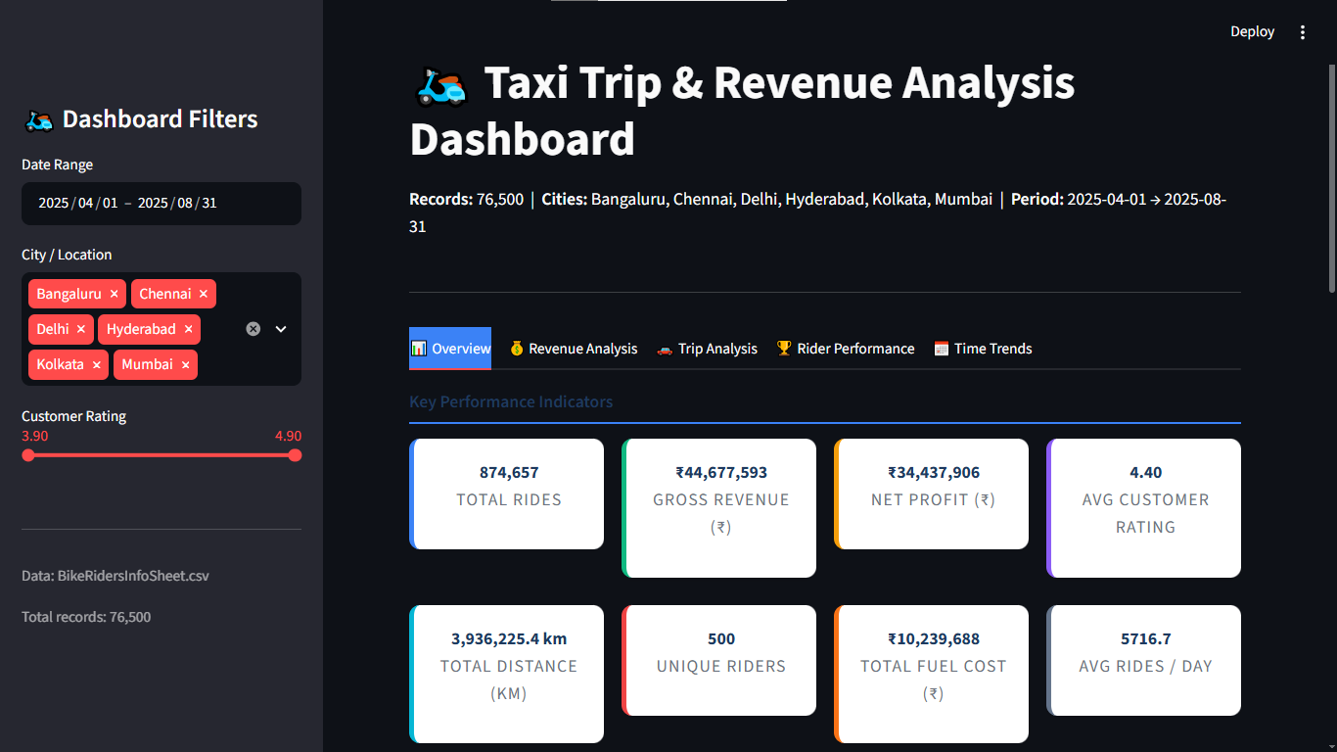
Built for IBM SkillBuild Internship — Data Analytics Track | Dataset: BikeRidersInfoSheet.csv