
K J Somaiya Institute of Technology
An Autonomous Institute Permanently Affiliated to the University of Mumbai

Srushti Milap Patil(BS4 (66))
EXPERIMENT NO. 02
Aim:
Implementation of Queue using Array for real-world application.
Objective:
- To implement a Linear Queue using an array.
- To perform Insert, Delete, and Display operations.
- To understand FIFO (First In First Out) behavior.
- To handle Overflow and Underflow conditions.
Software Used: DOSBox, Turbo C ++
Theory:
A Queue is a linear data structure in which insertion and deletion of elements are performed at specific ends. It follows the FIFO (First In, First Out) principle, which means the element inserted first into the queue is the first element to be removed. A common real-world example of a queue is a line of people waiting at a ticket counter, where the person who arrives first is served first.
A Linear Queue can be implemented using an array. In this implementation, two variables, front and rear, are used to keep track of the elements in the queue. The front points to the first element available for deletion, while the rear points to the last element inserted into the queue.
For the real-world application, the queue is used for heatwave alert prediction based on temperature:
- Temperature >= 45°C: Red Alert (Enqueue Operation)
- Temperature >= 43°C: Orange Alert (Enqueue Operation)
- Temperature >= 40°C: Yellow Alert (Enqueue Operation)
- Temperature < 40°C: All active alerts are removed using Dequeue operations.
The program performs Enqueue, Dequeue, and Display operations using a menu-driven approach. It also handles Overflow when the queue is full and Underflow when the queue is empty.
Program 2.1 :
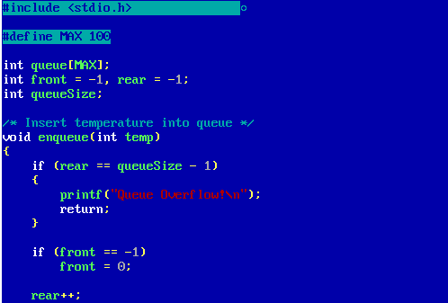
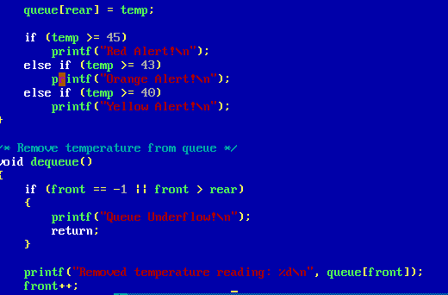
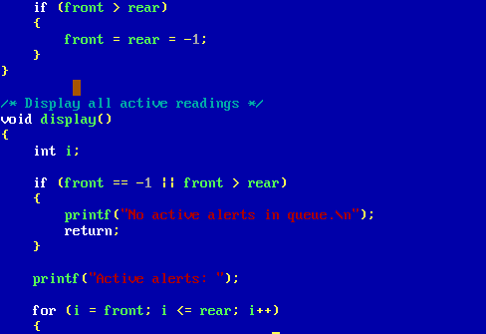
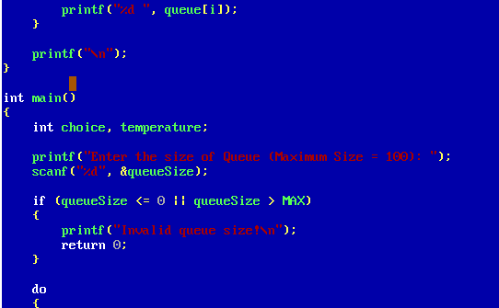
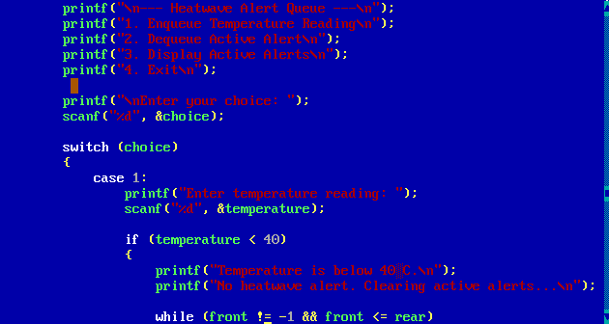
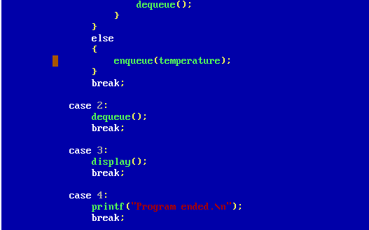

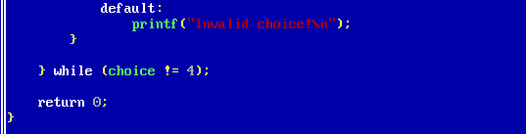
Output:
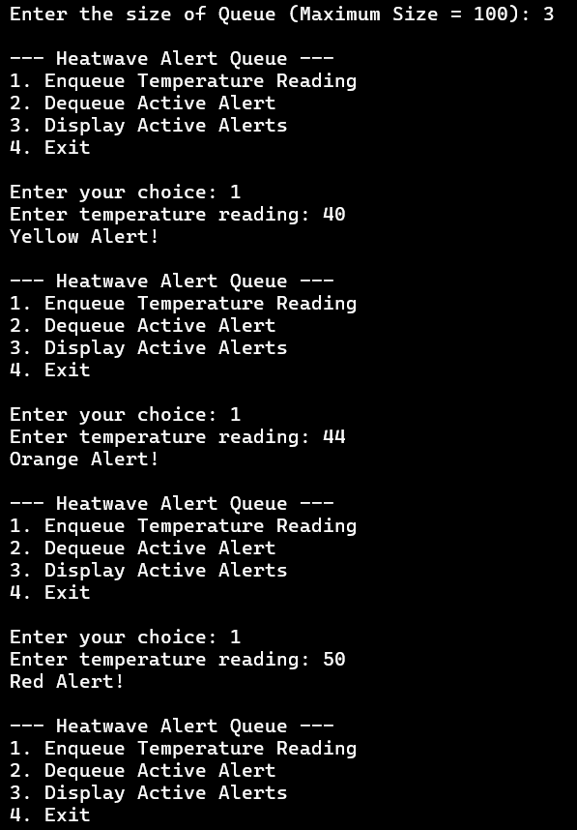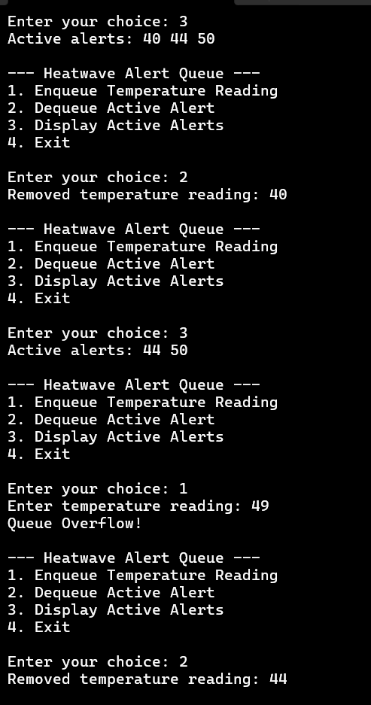

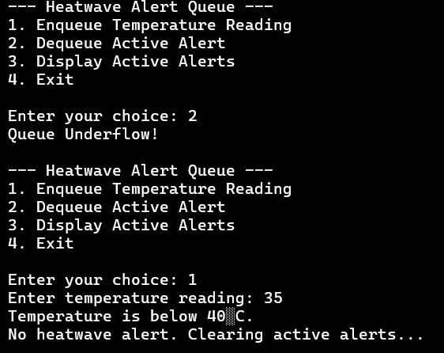

Program 2.2 :
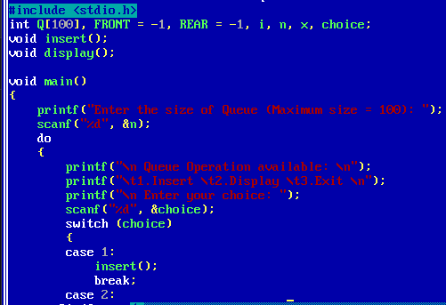
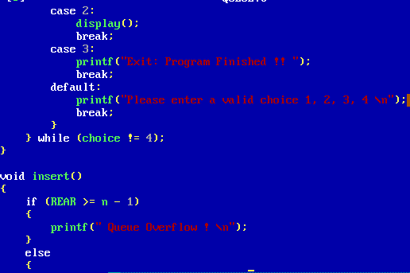
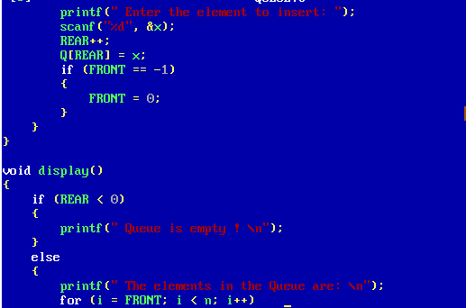
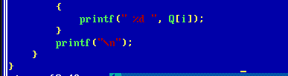
Output :
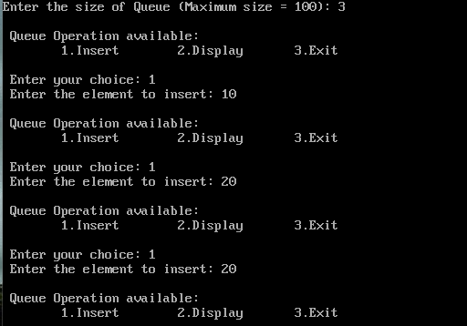
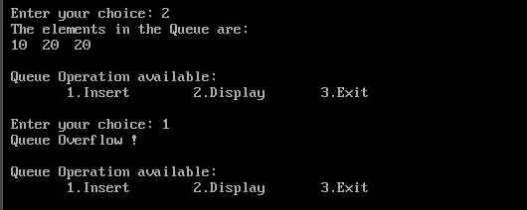

Outcome:
The Linear Queue was successfully implemented using an array. Insert, Delete, and Display operations were performed according to the FIFO principle.
Conclusion:
The program demonstrates the implementation and basic operations of a Linear Queue using an array, including handling of Overflow and Underflow conditions.

