Implement Image Edge Detectin Using Convolutional Neural Network(CNN) Layer With Tensorflow

Introduction
Image processing and feature extraction are essential steps in computer vision. Convolutional Neural Networks (CNNs) are widely used for these tasks, with convolution layers extracting features, activation layers introducing non-linearity, and pooling layers condensing information.
In this project, a grayscale image is processed using a manual CNN-like pipeline in TensorFlow. This demonstrates the fundamental operations of convolution, activation, and pooling used in modern neural networks.
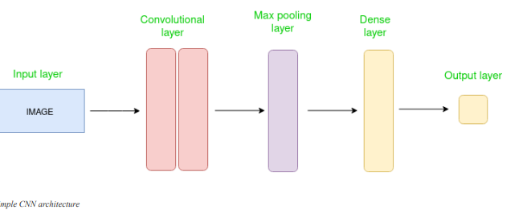

Tools and Technologies Used
- Programming Language: Python
- Libraries:
  - TensorFlow (for image processing and convolution operations)
  - NumPy (for array manipulation)
  - Matplotlib (for visualization)
- Image Format: JPG
- Development Environment: Jupyter Notebook

Theory

4.1 Convolution

Convolution is a mathematical operation used to extract features from images. A convolution kernel (filter) slides over the image, computing weighted sums to highlight specific patterns like edges or textures.
Kernel used in this project:
[
\begin{bmatrix}
-1 & -1 & -1 \
-1 & 8 & -1 \
-1 & -1 & -1
\end{bmatrix}
]
This kernel is a high-pass filter that emphasizes regions with high intensity changes, effectively detecting edges.

4.2 Activation Function (ReLU)

The ReLU (Rectified Linear Unit) function is used to introduce non-linearity by setting all negative values to zero:
[
f(x) = \max(0, x)
]
This allows the network to focus on significant features while ignoring irrelevant negative values.

4.3 Pooling

Pooling reduces the spatial dimensions of the feature map while retaining important information. Max pooling selects the maximum value in a defined window, reducing computational complexity and making feature detection more robust.
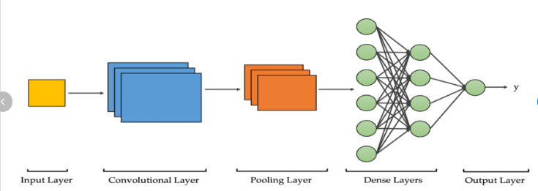

Methodology
The project was implemented using the following steps:
- Image Loading and Preprocessing
  - Load the imageDoremon.jpg using TensorFlow.
  - Convert the image to grayscale and resize it to 300 × 300 pixels.
  - Normalize the image values to [0,1] range.
- Convolution
  - Define a 3×3 edge-detection kernel.
  - Apply convolution to the image using tf.nn.conv2d.
- Activation (ReLU)
  - Apply the ReLU function to the convolution output to highlight positive features.
- Pooling
  - Apply max pooling with a 2×2 window to condense the feature map.
- Visualization
  - Plot the original image, convolution output, activation output, and pooled output using Matplotlib.

Implementation
Step:

import the necessary libraries

set the parameter

define the kernel

Load the image and plot it

Reformat the image

Apply convolution layer operation and plot the output image

. Apply activation layer operation and plot the output image.

Apply pooling layer operation and plot the output image

#implement image edge detectin using convolutional neural network(CNN) layer with tensorflow

import numpy as np

import tensorflow as tf

import matplotlib.pyplot as plt

from itertools import product

#set the param

plt.rc('figure',autolayout=True)

plt.rc('image',cmap='magma')

#define the kernel

kernel=tf.constant([[-1,-1,-1],[-1,8,-1],[-1,-1,-1],])

#load the image

image=tf.io.read_file('Doremon.jpg')

image=tf.io.decode_jpeg(image,channels=1)

image=tf.image.resize(image,size=[300,300])

#plot the image

img=tf.squeeze(image).numpy()

plt.figure(figsize=(5,5))

plt.imshow(img,cmap='pink')

plt.axis('off')

plt.title('original pink Scale image')

plt.show()

#reformate

image=tf.image.convert_image_dtype(image,dtype=tf.float32)

image=tf.expand_dims(image,axis=0)

kernel=tf.reshape(kernel,[*kernel.shape,1,1])

kernel=tf.cast(kernel,dtype=tf.float32)

#convolution layer

conv_fn=tf.nn.conv2d

image_filter=conv_fn(input=image,filters=kernel,

strides=1,padding='SAME',)

plt.figure(figsize=(15,5))

#plot the convolved image

plt.subplot(1,3,1)

plt.imshow(tf.squeeze(image_filter))

plt.axis('off')

plt.title('Convolution')

#activation layer

relu_fn=tf.nn.relu

#image detectin

image_detect=relu_fn(image_filter)

plt.subplot(1,3,2)

plt.imshow(tf.squeeze(image_detect))

plt.axis('off')

plt.title('Activation')

#pooling layer(fixed)

image_condense=tf.nn.pool(

input=image_detect,

window_shape=(2,2),

pooling_type='MAX',

strides=(2,2),

padding='SAME')

#display all results

plt.figure(figsize=(15,5))

plt.subplot(1,3,1)

plt.imshow(tf.squeeze(image_filter),cmap='gray')

plt.title('convolution output')

plt.axis('off')

plt.subplot(1,3,2)

plt.imshow(tf.squeeze(image_detect),cmap='gray')

plt.title('ReLu activation')

plt.axis('off')

plt.subplot(1,3,3)

plt.imshow(tf.squeeze(image_condense),cmap='gray')

plt.title('Max pooling output')

plt.axis('off')

plt.show()

Results
1.Original Grayscale Image:
  - Smooth image with visible intensity variations.

2.Convolution Output:
  - Edges and boundaries in the image are highlighted.
  - Both horizontal and vertical edges are enhanced by the kernel.
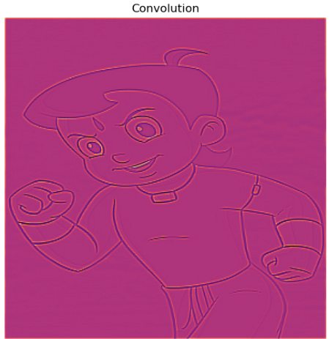

3.ReLU Activation Output:
  - Negative values are removed, focusing on significant features.
  - Edge highlights become more prominent.
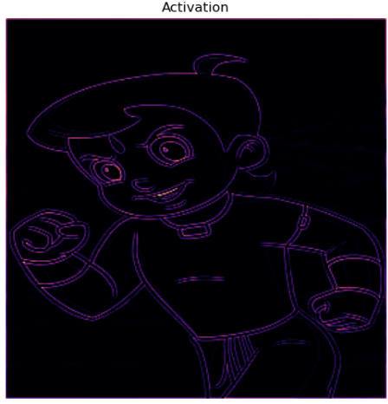

4.Max Pooling Output:
  - Spatial dimensions are reduced.
  - Main features are retained, while fine details and noise are suppressed.
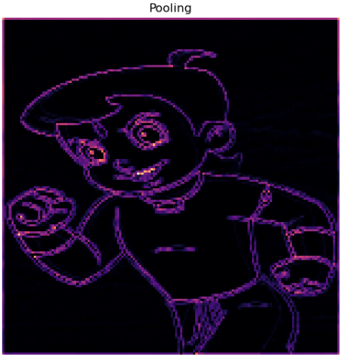

Conclusion
This project demonstrates the fundamental operations of a CNN pipeline:
- Edge detection via convolution.
- Feature enhancement via ReLU activation.
- Dimensionality reduction via max pooling.
The project highlights how TensorFlow can be used for image processing tasks and provides insight into how CNNs process and extract features from images.

