**Project Name: Flipkart**

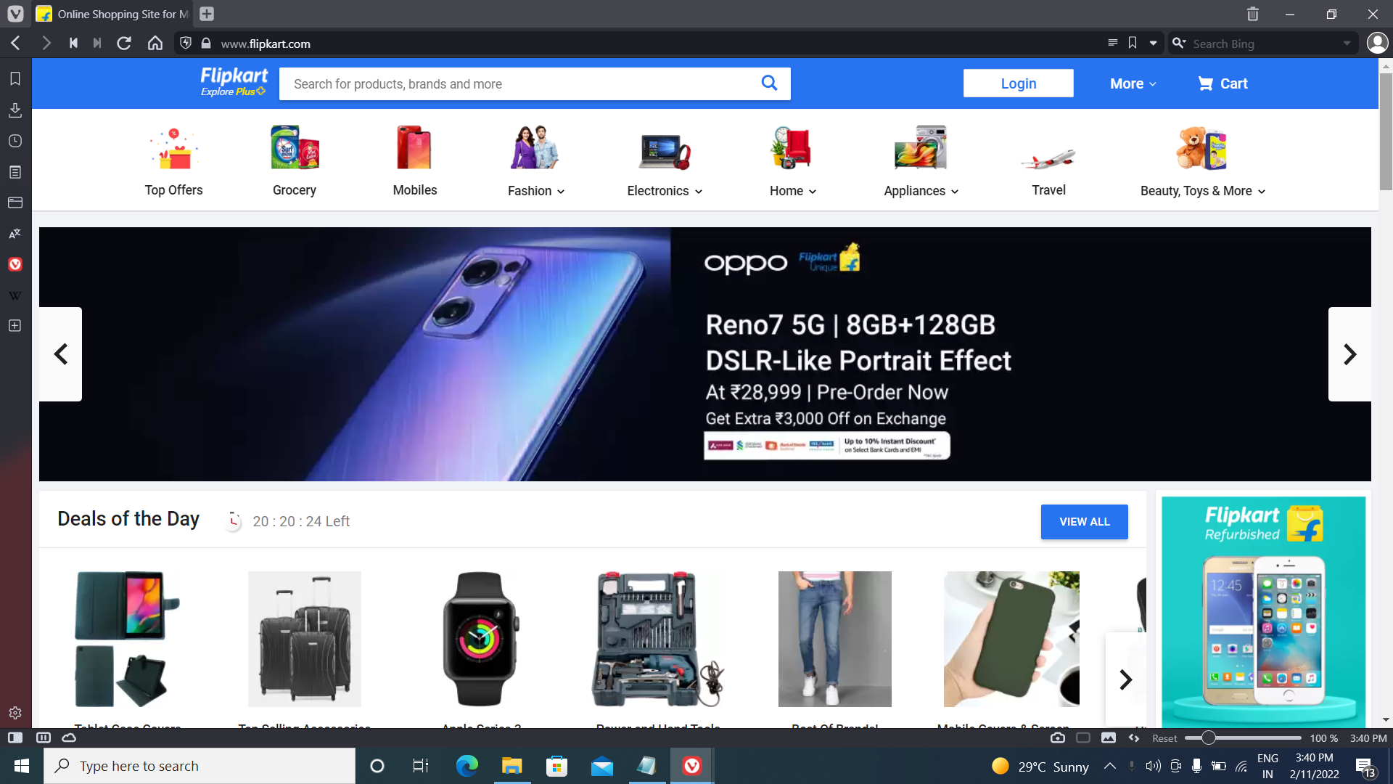

**Overview:**

**Flipkart** is an Indian e-commerce company, headquarter in Bangalore, Karnataka, India, and incorporated in Singapore as a private limited company. The company initially focused on online book sales before expanding into other product categories such as consumer electronics, fashion, home essentials, groceries and lifestyle products.

**Techniques Used:**

Front End:

1. HTML
2. CSS
3. Bootstrap
4. React

Back End:

1. Mongodb
2. Json Data

Code Compiler:

1. Visual Studio Code
2. Git Bash
3. Git hub
4. Node js.