**NAMASTE REACT- AKSHAY SAINI**

**CHAPTER 9 – OPTIMISING OUR APP-THEORY NOTES**

1. When and why do we need lazy()?

Ans:-

Lazy loading is a design pattern. It allows you to load parts of your application on-demand to reduce the initial load time. This is also known as On Demand Loading/Code spilitting/Dynamic Imports.

* Reduces initial loading time by reducing the bundle size.
* Reduces browser workload.
* Improves application performance in low bandwidth situations.
* Improves user experience at initial loading.
* Optimizes resource usage.

React.lazy() takes as its argument a function that must return a promise by calling import() to load the component. The returned promise resolves to a module with a default export containing the React component

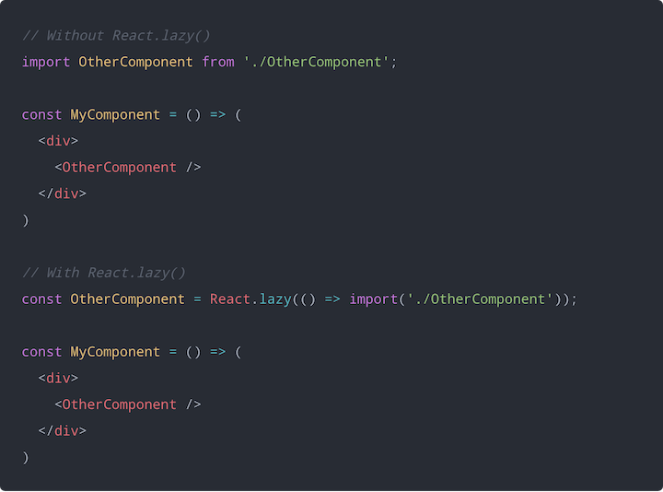

1. What is suspense? When and why do we need Suspense?

Ans:-

A component created using React.lazy() is loaded only when it needs to be rendered. Therefore, you should display some kind of placeholder content while the lazy component is being loaded , such as a loading indicator. This is exactly what React.Suspense is designed for.

The Suspense component takes a fallback prop that accepts the React elements you want rendered as placeholder content while all the lazy components get loaded.

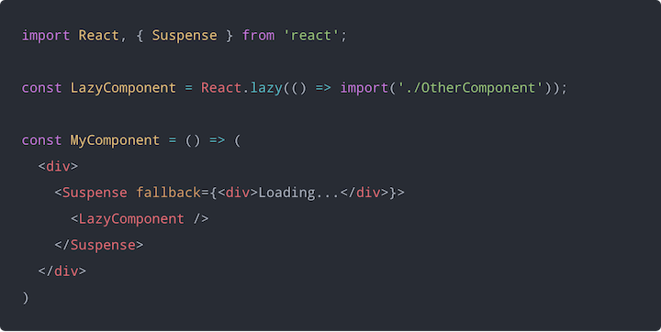

1. Why we got this error : A component suspended while responding to synchronous input. This will cause the UI to be replaced with a loading indicator.

To fix, updates that suspend should be wrapped with startTransition? How does suspense fix this error?

Ans:-

There are sometimes when component under suspense takes sometime to render, but we also don't want to show loader or the fallback component then we can tell react to show the old component only and render the new one when its ready using startTransition method.

Transitions are a new concurrent feature introduced in React 18. They allow you to mark updates as transitions, which tells React that they can be interrupted and avoid going back to Suspense fallbacks for already visible content.

React.startTransition(callback)

### Advantages or disadvantages of code splitting?

### Ans:-

### Advantages of Lazy Loading

* Reduces initial loading time by reducing the bundle size.
* Reduces browser workload.
* Improves application performance in low bandwidth situations.
* Improves user experience at initial loading.
* Optimizes resource usage.

## Disadvantages of Lazy Loading

* Not suitable for small-scale applications.
* Placeholders can slow down quick scrolling.
* Requires additional communication with the server to fetch resources.
* Can affect SEO and ranking.