**Tools Required**

* **Weka (Waikato Environment for Knowledge Analysis)** – Download from: https://www.cs.waikato.ac.nz/ml/weka/
* **Dataset** (e.g., iris.arff, weather.arff, or your custom dataset)

**✅ Steps to Visualize Clustering in Weka**

**1. Launch Weka**

* Open Weka GUI Chooser.
* Select **Explorer**.

**2. Load Dataset**

* Click **Open file** → Choose a dataset like iris.arff.
* This dataset has 4 numeric attributes (sepal and petal dimensions) and a class label.

**3. Remove Class Attribute (Optional for Unsupervised Clustering)**

* Go to the **Preprocess** tab.
* Click on the class attribute (e.g., “class”) and remove it (optional, but useful if you want pure unsupervised clustering).

**4. Apply Clustering Algorithm**

* Go to the **Cluster** tab.
* Choose a clustering algorithm:
  + SimpleKMeans (k-means)
  + EM (Expectation Maximization)
  + Cobweb (incremental clustering)
* Click on the **Choose** button → weka.clusterers.SimpleKMeans.

**5. Configure the Algorithm**

* Click on the algorithm name to set options.
  + For KMeans: Set number of clusters (e.g., 3 for Iris).
* Click **OK** to apply settings.

**6. Start Clustering**

* Click **Start** to run the algorithm.
* Output will show number of clusters, centroids, and distribution.

**7. Visualize the Clusters**

* Click **Visualize cluster assignments** at the bottom.

(Right click on SimpleKMeans🡪visualize cluster assignment)

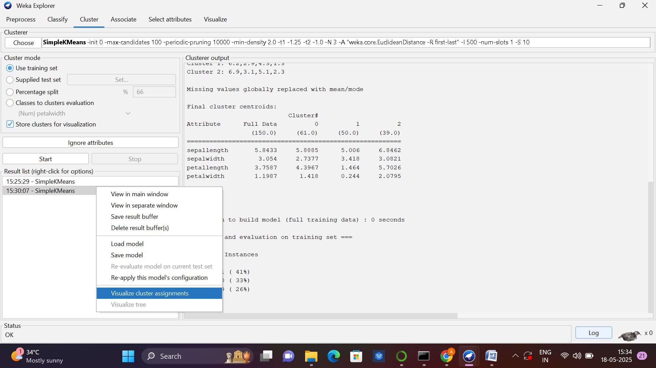

* In the plot window:
  + Select attributes for X and Y axes (e.g., petal length vs. petal width).
  + Clusters will be shown in different colors.
  + You can also explore the clusters interactively.

**Example Output from SimpleKMeans (Iris dataset)**

* 3 Clusters formed
* Cluster 0: mostly Setosa
* Cluster 1: mostly Versicolor
* Cluster 2: mostly Virginica

You will see a **scatter plot** with three colors indicating different clusters.

**Recommended Datasets for Clustering in Weka**

* iris.arff
* weather.nominal.arff
* customer_data.arff (custom)