
K J Somaiya Institute of Technology
An Autonomous Institute Permanently Affiliated to the University of Mumbai DEPARTMENT OF INFORMATION TECHNOLOGY
Name of Student : Srushti Sachin More
Roll No : B - 60
Batch : SB4
EXPERIMENT 1
Aim :- Implementation of Stack using Array for real-world application.
Objectives :-
1. To understand the concepts of data structures and analysis procedures. 2. To understand linear data structures and their implementation for various real-world applications.
Theory :-
A stack is a linear data structure that follows the LIFO (Last In, First Out) principle. It allows insertion and deletion of elements from only one end, called the TOP.
The main operations performed on a stack are:
● Push – Inserts an element at the top of the stack.
● Pop – Removes the topmost element from the stack.
● Peek – Displays the top element without removing it.
● Display – Displays all elements present in the stack.

Stacks can be implemented using arrays or linked lists. They are widely used in applications such as function calls, expression evaluation, recursion, and undo/redo operations.

Operation | Description
Push | Inserts a new element at the top of the stack if the stack is not full.
Pop | Removes the topmost element from the stack if the stack is not empty.
Peek | Displays the top element without removing it from the stack.
Display | Shows all the elements present in the stack from top to bottom.

These operations help in efficiently managing data according to the LIFO principle.

Flowchart:
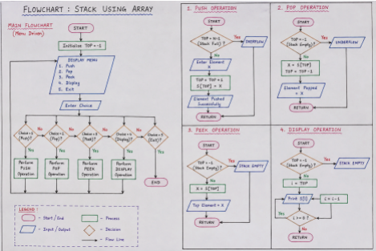
PROGRAM :-
Conditions
Temperature>=40 deg print(Yellow Alert)
Temperature>=43 deg print(Orange Alert)
Temperature>=45 deg print(Red Alert)
Temperature<40 deg: remove all active alerts, Pop.
#include <stdio.h>
int stack[100], top = -1;
void Push(int x)
{
stack[++top] = x;
}
void Pop()
{
if (top == -1)
printf("\nNo active alerts.");
else {
printf("\nPopped: %s",
stack[top] == 1 ? "Yellow Alert" :
stack[top] == 2 ? "Orange Alert" : "Red Alert"); top--; }
}
void Peek()
{
if (top == -1)
printf("\nNo active alerts.");
else
printf("\nTop Alert: %s",
stack[top] == 1 ? "Yellow Alert" :
stack[top] == 2 ? "Orange Alert" : "Red Alert"); } void Display()
{
int i;
if (top == -1)
printf("\nNo active alerts.");
else
for (i = top; i >= 0; i--)
printf("\n%s",
stack[i] == 1 ? "Yellow Alert" :
stack[i] == 2 ? "Orange Alert" : "Red Alert"); } int main()
{
int ch, t;
do {
printf("\n\n--- HEATWAVE ALERT SYSTEM ---"); printf("\n1. Enter Temperature");
printf("\n2. Push Alert");
printf("\n3. Pop Alert");
printf("\n4. Peek Alert");
printf("\n5. Display Alerts");
printf("\n6. Exit");
printf("\nChoice: ");
scanf("%d", &ch);
if (ch == 1) {
printf("Temperature: ");
scanf("%d", &t);
if (t >= 45) {
printf("Red Alert");
Push(3);
}
else if (t >= 43) {
printf("Orange Alert");
Push(2);
}
else if (t >= 40) {
printf("Yellow Alert");
Push(1);
}
else {
printf("Temperature < 40"); while
(top != -1)
Pop();
}
}
else if (ch == 2) {
printf("\nEnter alert (1-Yellow, 2-Orange, 3-Red): "); scanf("%d", &t);
Push(t);
printf("Alert Pushed.");
}
else if (ch == 3)
Pop();
else if (ch == 4)
Peek();
else if (ch == 5)
Display();
else if (ch == 6)
printf("\nProgram Finished.");
else
printf("\nInvalid Choice.");
} while (ch != 6);
return 0;
}
OUTPUT :-
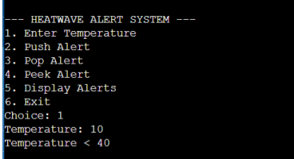
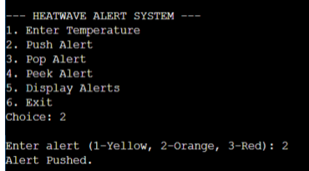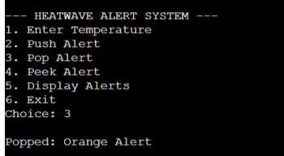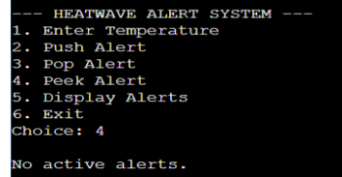
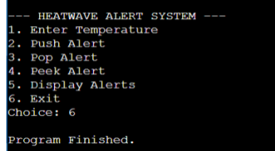
Outcome :-
After completing this experiment, I can implement a stack using an array in C. I am able to perform basic stack operations and understand how the LIFO principle works in practice.
I can also identify stack overflow and underflow conditions while writing programs. I learned how stacks are used in real-world applications such as expression evaluation, recursion, and undo/redo features.
Conclusion :-
Through this experiment, I understood the concept and working of the stack data structure using an array. I learned how Push, Pop, Peek, and Display operations are implemented and how they follow the LIFO principle.
I also understood the conditions of stack overflow and stack underflow. Overall, the experiment gave me a clear understanding of stack implementation and its importance in real-world applications.

Algorithms :-
1. Stack Push
Step 1: Check Overflow
If TOP = N, then write "Overflow" and return.
Step 2: Increment TOP
TOP ← TOP + 1

Step 3: Insert Element
S[TOP] ← Y
Step 4: Return
2. Stack Pop
Step 1: Check Underflow
If TOP = 0, then write "Underflow" and return.
Step 2: Delete Element
Y ← S[TOP]
Step 3: Decrement TOP
TOP ← TOP - 1
Step 4: Return Element
Return(Y)

3. Stack Peep
Step 1: Check Valid Position
If TOP - POS + 1 ≤ 0, then write "Invalid Position" and return 0. Step 2: Find Element
Y ← S[TOP - POS + 1]
Step 3: Return Element
Return(Y)
4. Stack Display
Step 1: Check Underflow
If TOP = 0, then write "STACK EMPTY" and return. Step 2: Display Elements
For i ← TOP down to 1:
Write(S[i])
Step 3: Return

