
DEPARTMENT OF INFORMATION TECHNOLOGY
Name: Srushti Sachin More
Roll Number: B - 60
Batch: SB4
Course Name and Code: Data Structures Lab (ITL302)
Semester: III (SYIT)
Academic Year: 2026-27 (Odd Semester)

EXPERIMENT 7

Code

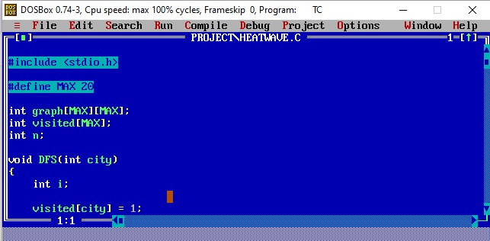

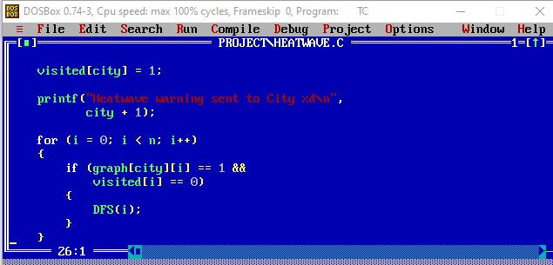

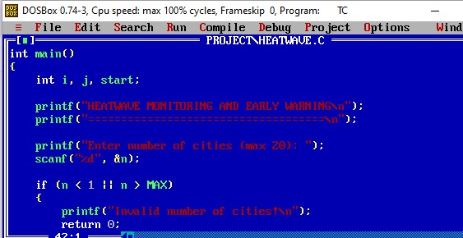
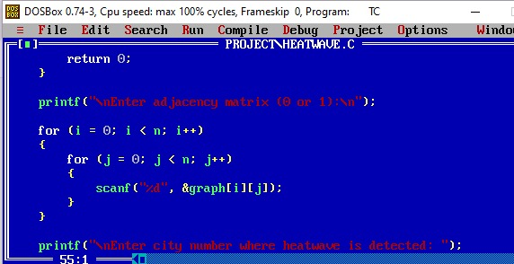
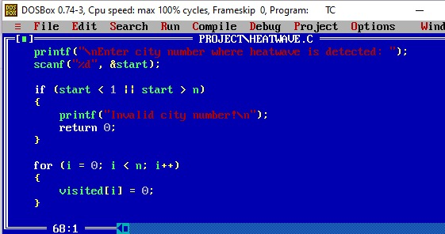

output
