UX CASE STUDY
Zomato
User Journey Analysis, Heuristic Evaluation & Redesign Proposals — June 2026

1. Introduction
Zomato is one of India's largest food-discovery and delivery platforms, serving tens of millions of monthly transacting customers. The app's core job: help a hungry person decide what to eat and get it delivered with minimal friction, while surfacing offers, discovery, and account management within the same experience.
This report analyzes the Zomato app end-to-end — from opening the app to checkout — using a user journey map and a heuristic evaluation grounded in Jakob Nielsen's 10 usability heuristics. Based on that analysis, three scoped improvements are proposed, each shown as a before/after mockup.
Platform analyzed | Zomato — Android / iOS consumer app (food delivery flow)
Methodology | Heuristic evaluation, user journey mapping, comparative review of published UX critiques

2. User Journey Map
The journey below follows a representative persona — “Priya, 27, software engineer” — ordering dinner on a weeknight, from app open to post-delivery feedback.
Stage | What the user does / sees | Friction
Discovery | Opens app; home screen stacks several promotional banners before any personalized content. | Mild friction
Search | Taps search; results screen shows a deep breadcrumb and a search icon rather than an editable field. | Friction
Evaluation | Browses restaurant cards; uses ratings, delivery time, and cuisine tags to shortlist. | Smooth
Menu & Customization | Opens restaurant page; scrolls a well-organized menu with photos and reviews. | Smooth
Cart & Checkout | Reviews cart; bill shows multiple stacked fee lines and a pre-checked donation add-on. | Friction
Payment | Selects saved UPI method; pays in one tap. | Smooth
Tracking & Feedback | Watches live rider location; receives a rating prompt ~30 min after delivery. | Smooth
Table 1. Journey stages from app open to post-delivery feedback.
The two stages with the most friction — discovery (clutter) and checkout (pricing transparency) — plus a related navigation problem inside search, form the basis of the improvements in Section 4.

3. Heuristic Evaluation: Strengths & Weaknesses

3.1 Strengths
Heuristic | Evidence in the app | Effect on user
Visibility of system status | Order tracking shows live rider location, ETA, and status labels at every stage. | Builds trust while waiting
Match with real world | Familiar food icons and “Delivery / Dining” tabs mirror how users already think. | Low learning curve
Recognition over recall | Order history and reorder shortcuts mean users rarely need to remember names. | Speeds repeat orders
Informative restaurant pages | Pages separate overview, menu, photos, and reviews into clear sections. | Reduces cognitive load
Table 2. Heuristics the current design satisfies well.

3.2 Weaknesses
Heuristic | Evidence in the app | Effect on user
Aesthetic & minimalist design | Home screen stacks a Gold strip, banner ads, tabs, and an offer banner before any restaurant content. | Cognitive overload
User control & freedom | Search results show only a search icon and a breadcrumb instead of an editable field / back action. | Hard to revise a search
Honesty in pricing | Checkout splits charges into five lines, several collapsed behind a disclosure arrow. | Perceived hidden costs
User consent | A donation is added by default via a pre-checked toggle rather than opt-in. | Functions as a dark pattern
Table 3. Heuristics with clear violations, used to scope the improvements below.

4. Proposed Improvements
Mockups show the current screen beside the proposed redesign; red outlines mark problems, green outlines mark the fix.

4.1 Declutter the Home Screen & Establish Clear Hierarchy
Problem:
The home screen stacks a Gold promo strip, three banner ads, a tab bar, search, filter chips, and a dashed offer banner — six elements — before any restaurant content. This violates aesthetic-and-minimalist-design and delays the primary task.
Solution:
Promote search to the hero position, consolidate promotions into one offer strip, and surface a personalized “Order Again” card right below it — a low-effort default nudging users toward a fast reorder while halving the competing elements.
BEFORE  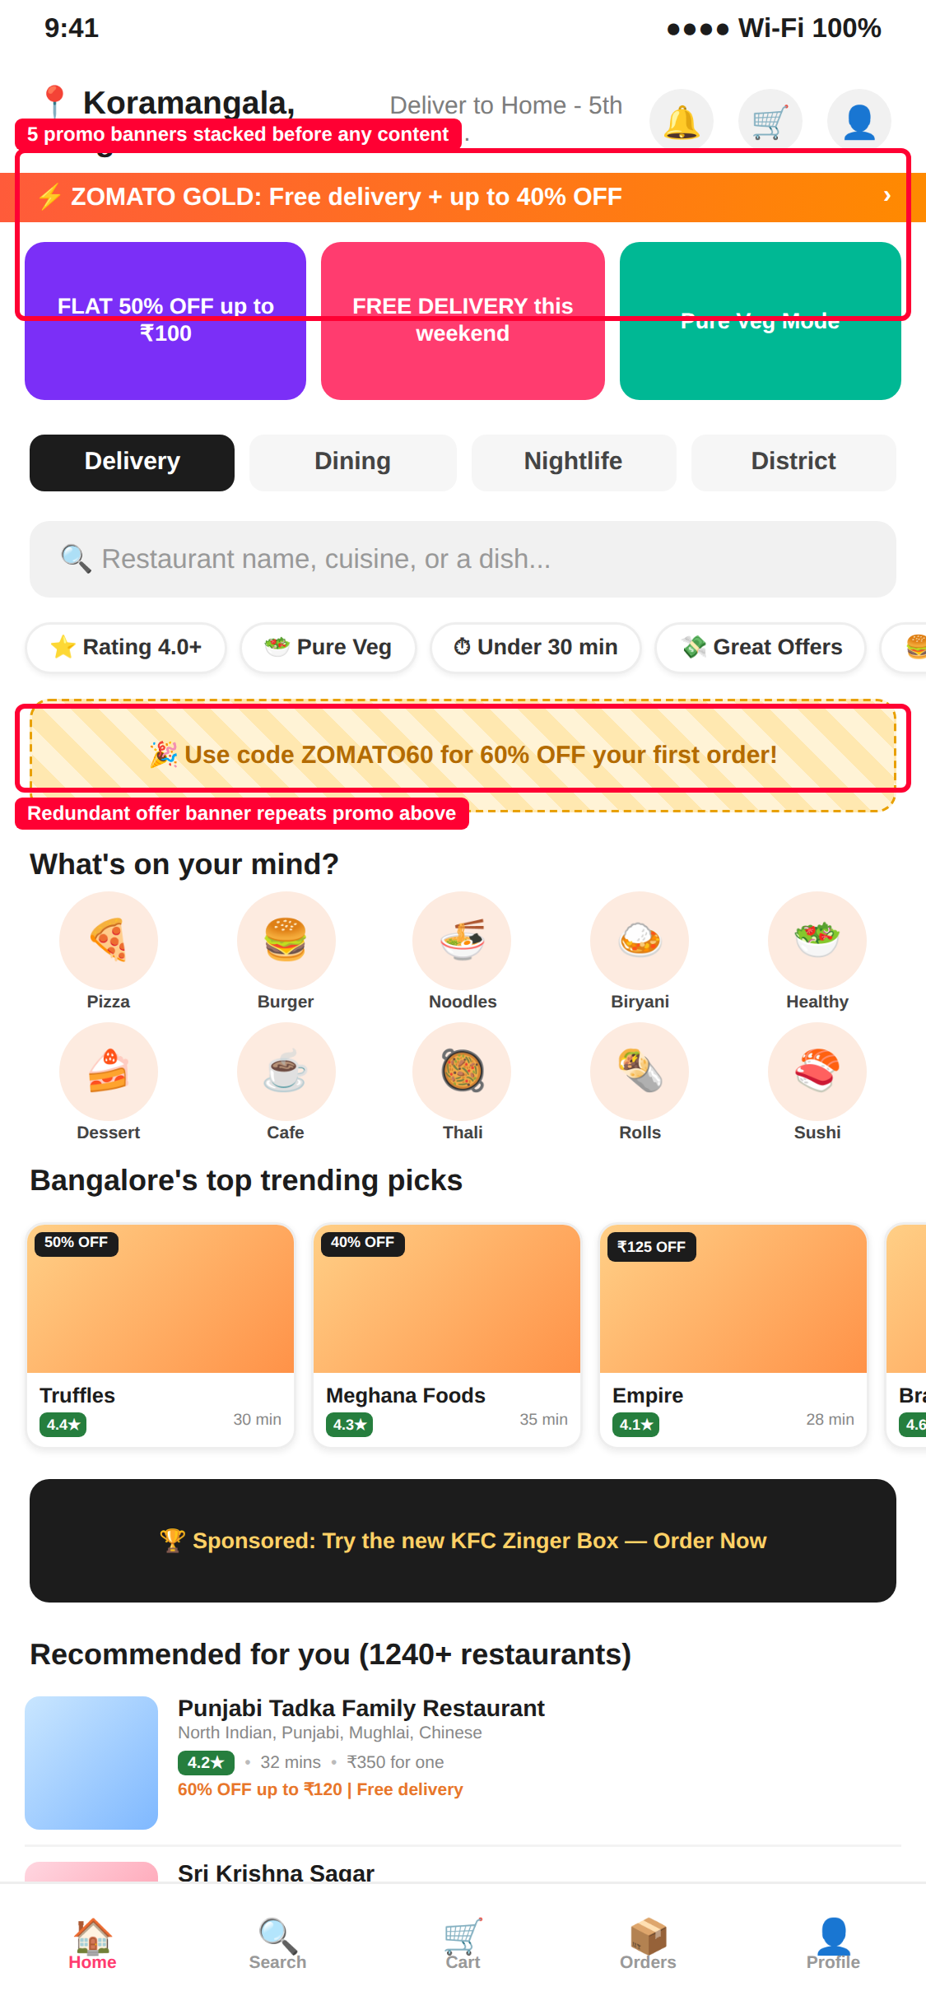 | AFTER  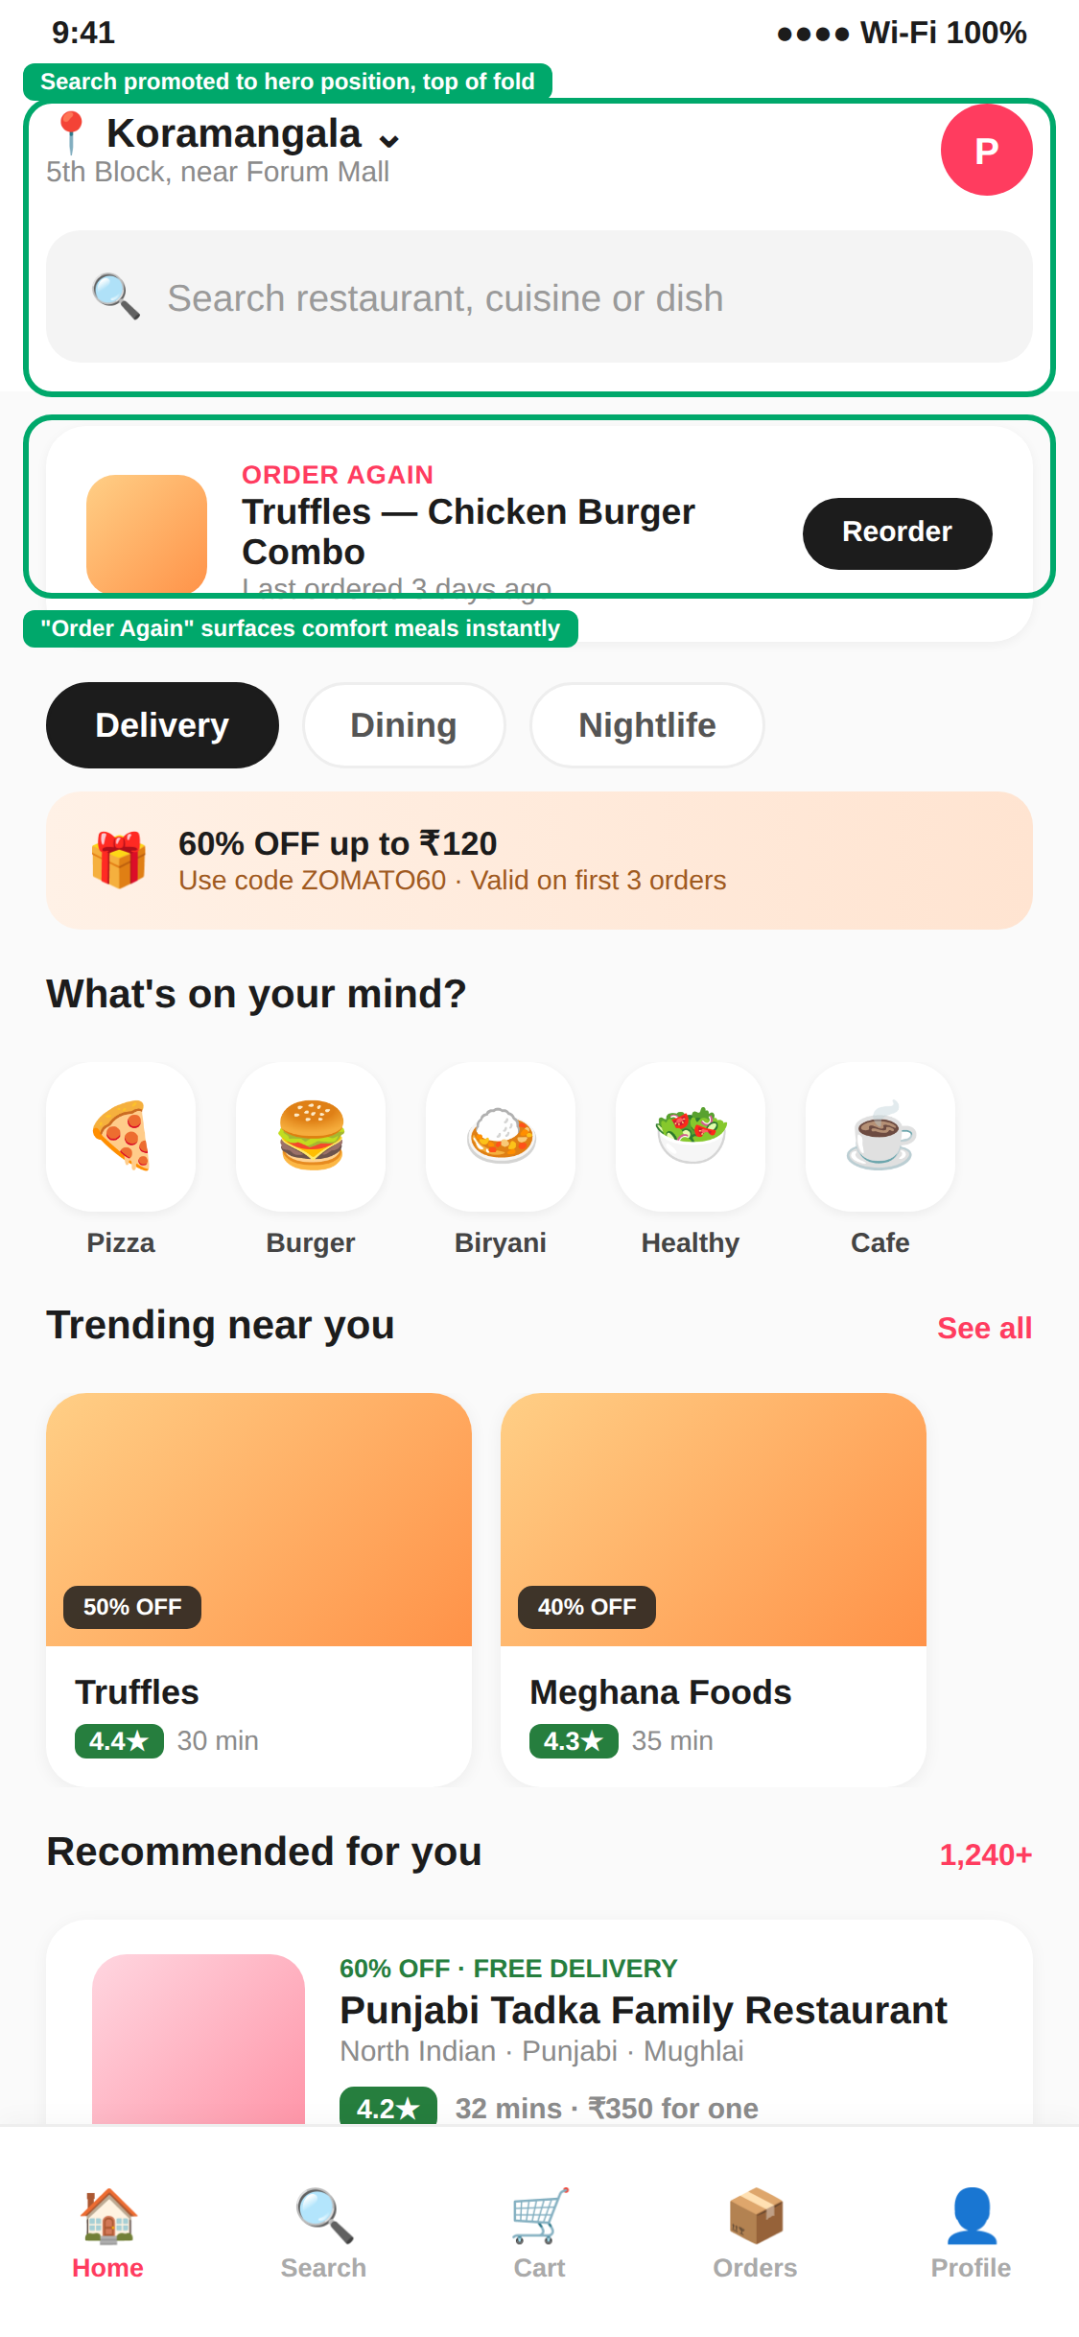
Figure 1. Home screen — stacked promotions (left) vs. hero search + “Order Again” (right).

4.2 Persistent, Editable Search Bar & Clear Back Navigation
Problem:
On results, search collapses to an icon rather than an editable field, and the only wayfinding cue is a long breadcrumb with no obvious back action — violating user-control-and-freedom.
Solution:
Keep the query visible and editable in a persistent top bar with a clear back button, and replace the breadcrumb with removable filter chips (each with an ×), making refinement a one-tap action.
BEFORE  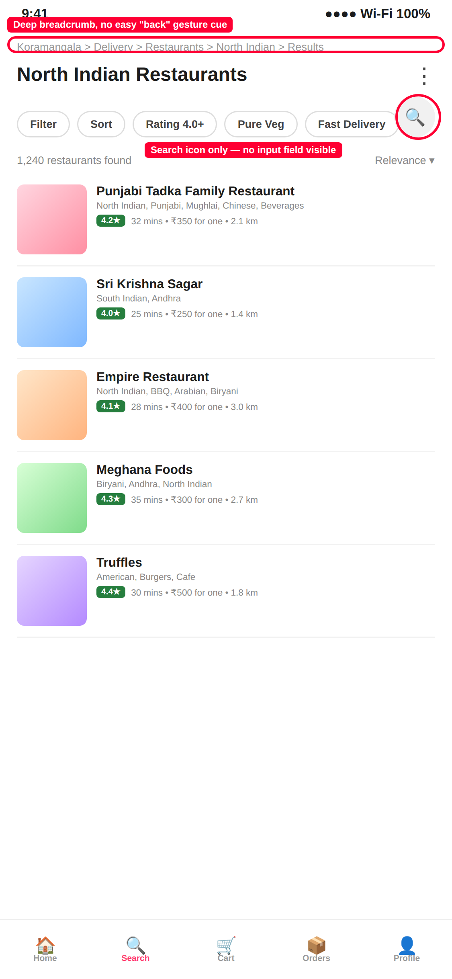 | AFTER  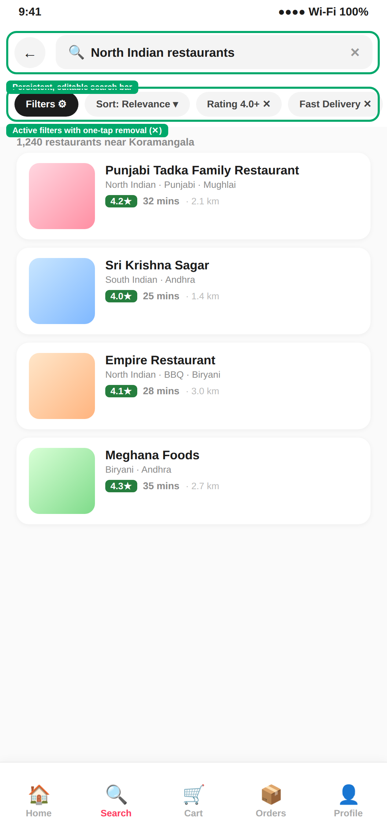
Figure 2. Search results — buried icon + breadcrumb (left) vs. persistent search bar + removable filters (right).

4.3 Transparent, Consolidated Pricing & Opt-In Donations
Problem:
Checkout splits charges into five lines, some collapsed, and adds a donation by default via a pre-checked toggle — making the final price feel opaque and shifting the opt-out burden to the user.
Solution:
Consolidate fees into three fully expanded lines labeled “All charges shown upfront,” and change the donation to an explicit opt-in toggle defaulting to off — directly addressing the pricing-honesty and consent issues from Section 3.2.
BEFORE  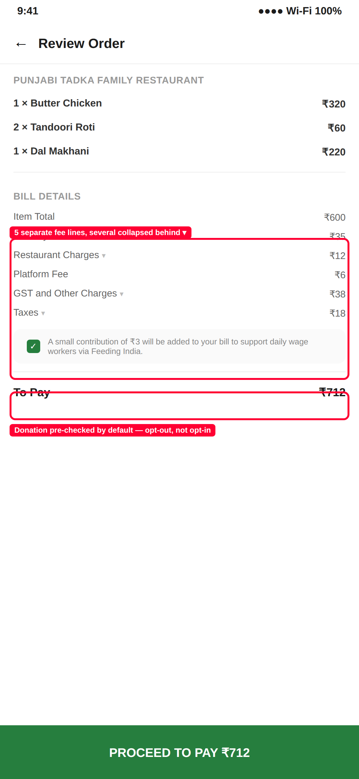 | AFTER  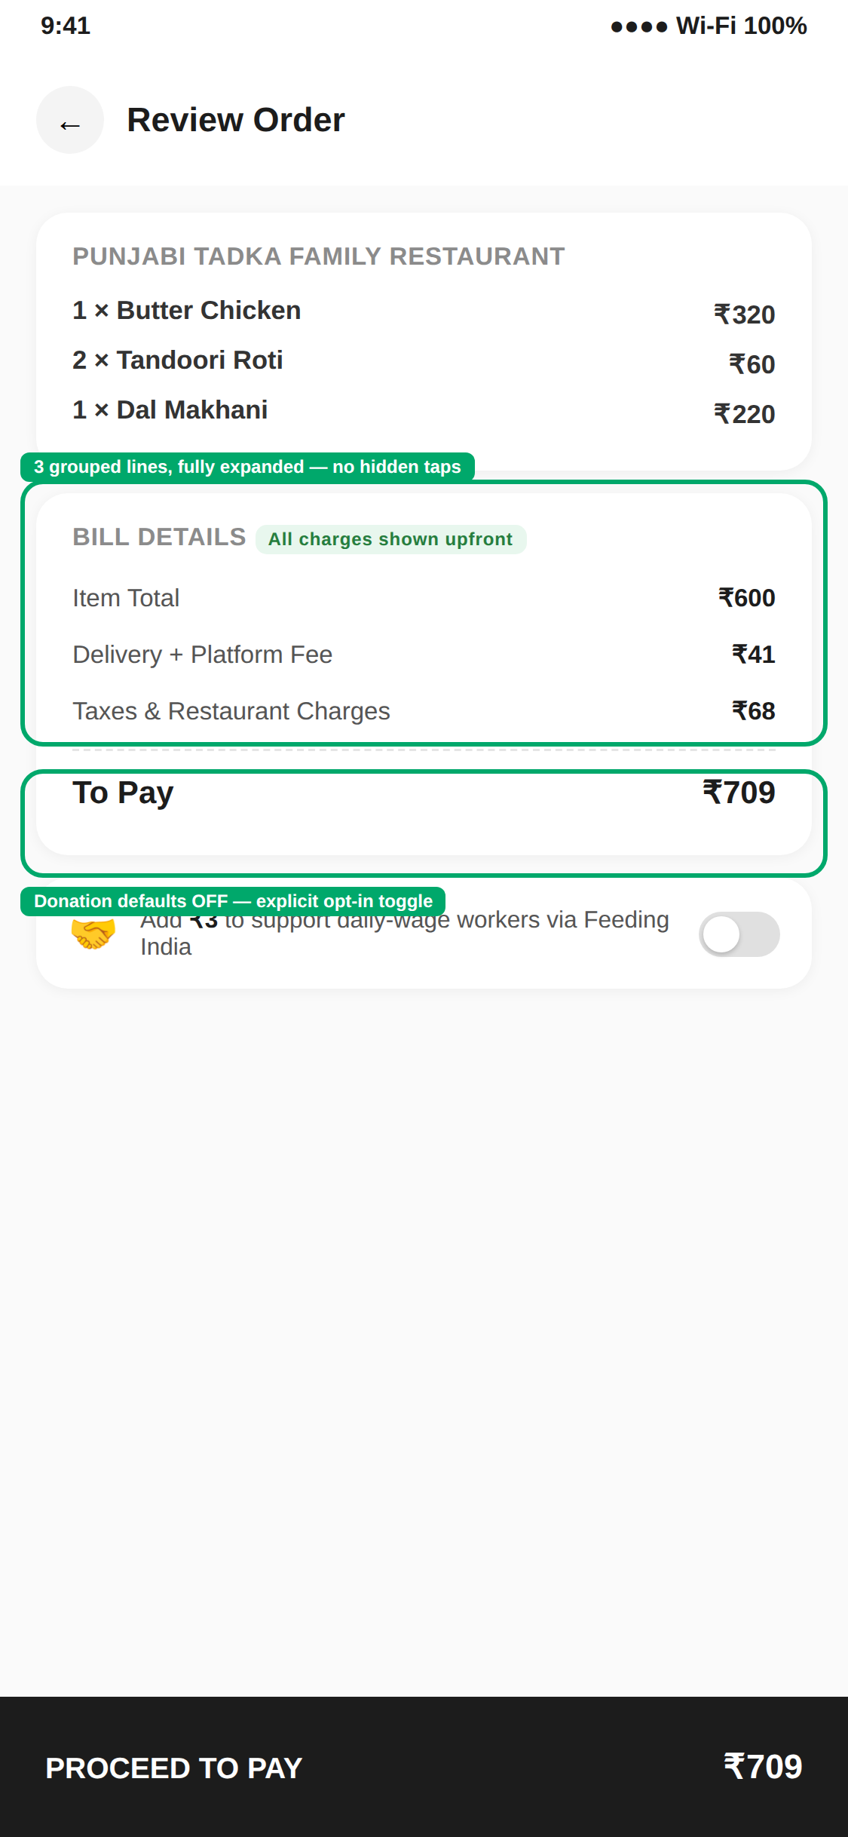
Figure 3. Checkout — five stacked fees + pre-checked donation (left) vs. upfront pricing + opt-in toggle (right).

5. Expected Impact & Conclusion
Declutter home screen | Faster time-to-decision; higher engagement with the reorder shortcut
Persistent search bar | Fewer abandoned searches; less back-and-forth between search and results
Transparent pricing | Lower cart abandonment; fewer complaints about “hidden” fees; better-consented donations
These changes are deliberately incremental rather than a full overhaul: each targets one evidenced friction point from the journey map and heuristic evaluation, and each could be validated independently via A/B testing.
Zomato already succeeds at the heuristics that matter once a user has committed to ordering: status visibility during tracking, real-world metaphors, and well-organized restaurant pages. Its weaknesses cluster at the edges of the journey — the first screen, search refinement, and the final screen before payment — which is exactly where these three proposals are aimed, without disturbing what already works.

