WIREFRAMING & LOW-FIDELITY DESIGN
E-Commerce Mobile App
Wireframe Specification — Home to Order Confirmation Flow

1. Project Overview
This document specifies the low-fidelity wireframes for the core shopping flow of an e-commerce mobile app, from product discovery through checkout and order confirmation. Wireframes are intentionally grayscale and free of color, imagery, and brand styling — the goal at this stage is to validate layout, information hierarchy, and navigation flow before any visual design work begins.
Platform | Mobile app (iOS / Android), 375 × 812pt reference frame
Flow covered | Home → Search/Category → Product Detail → Cart → Checkout → Order Confirmation
Fidelity | Low-fidelity (grayscale, placeholder content, no final copy or imagery)
Tool equivalent | Structured as a Figma/Adobe XD frame set — one artboard per screen, annotated
Each screen below is shown with a numbered annotation legend explaining the purpose of key elements, matching how these would be documented as sticky-note or comment annotations on a Figma board.

2. Screen 1 — Home / Discovery
Purpose:
Entry point of the app. Surfaces a search affordance, promotional banner, browsable categories, and a product grid so users can either search directly or browse into discovery.
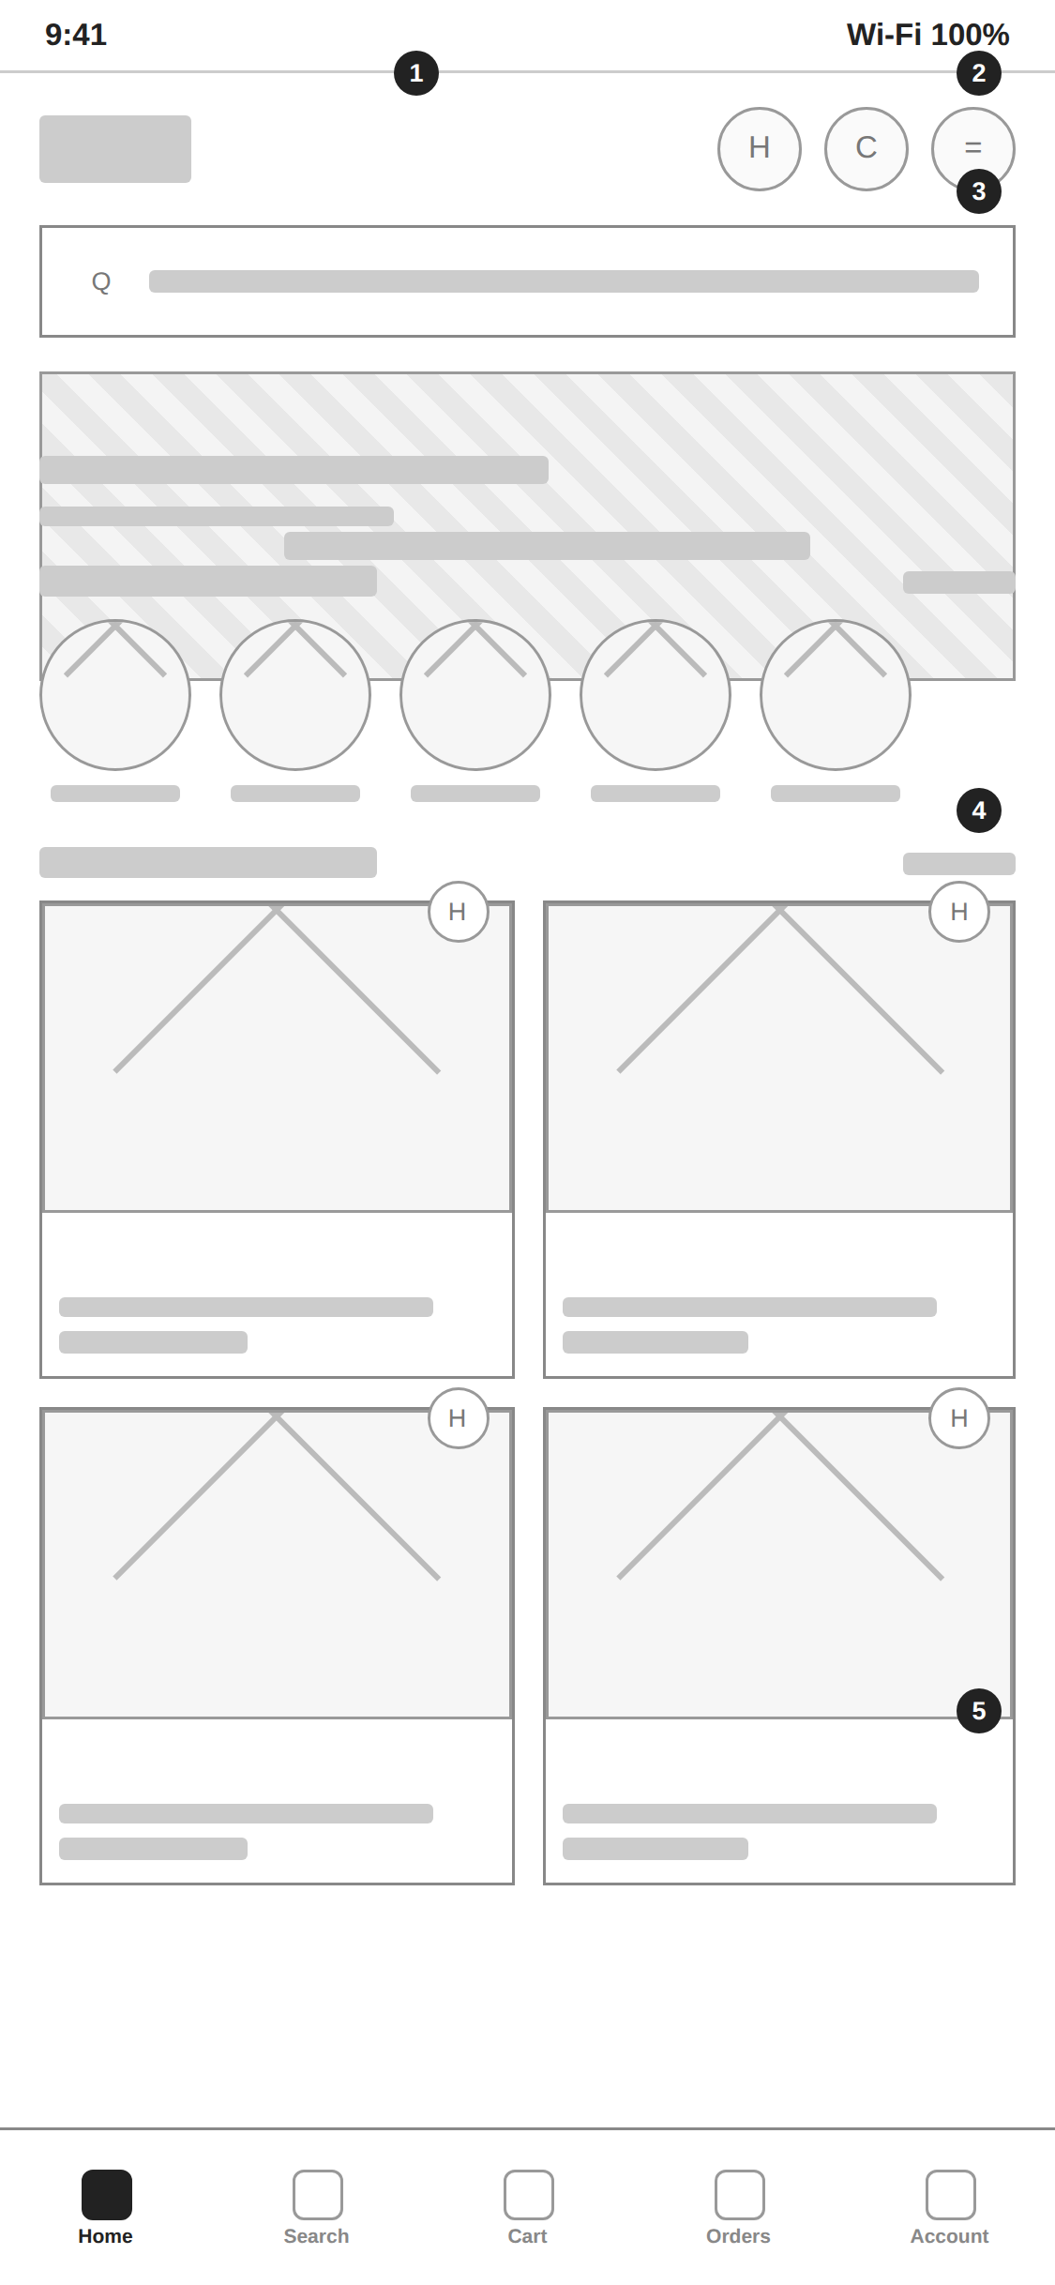 | 1 Logo / Status bar App logo top-left; wishlist, cart, and menu icons top-right for quick access to account-related actions.  2 Cart icon Persistent cart shortcut, present on every primary screen so users always know how to reach their cart.  3 Promotional banner Full-width hero banner slot for seasonal campaigns or top offers; placeholder pattern indicates image content.  4 Category strip Horizontally scrollable category shortcuts (circular icons) for fast browsing by department.  5 Product grid Two-column grid of product cards, each with image, name, price, and a wishlist toggle — the primary discovery surface.
Figure 1. Home screen wireframe with annotated regions.

3. Screen 2 — Search / Category Results
Purpose:
Reached from the home search bar or a category tap. Lets users filter and sort a result set, then scan products in a grid.
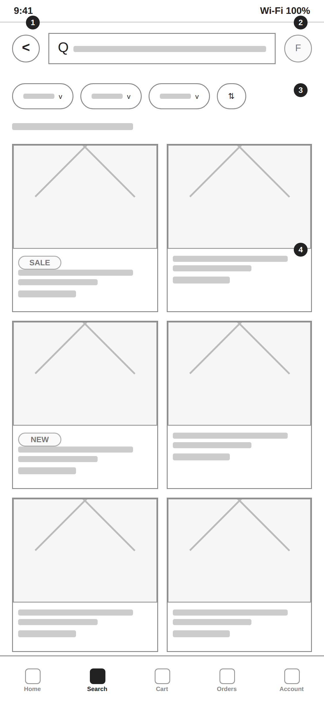 | 1 Back + search field Editable search field stays visible and editable here (not collapsed to an icon), with a clear back action.  2 Filter icon Opens a full filter panel (price, size, brand, rating) as a modal or side-sheet.  3 Filter chips + sort Quick-access filter pills plus a sort toggle, so common filters don't require opening the full panel.  4 Result cards Two-column grid; tags such as SALE / NEW are shown as a badge in the top-left corner of relevant cards.
Figure 2. Search/category results wireframe with annotated regions.

4. Screen 3 — Product Detail
Purpose:
Gives the user everything needed to decide to buy: imagery, price, variant selection, and supporting details, ending in a persistent add-to-cart action.
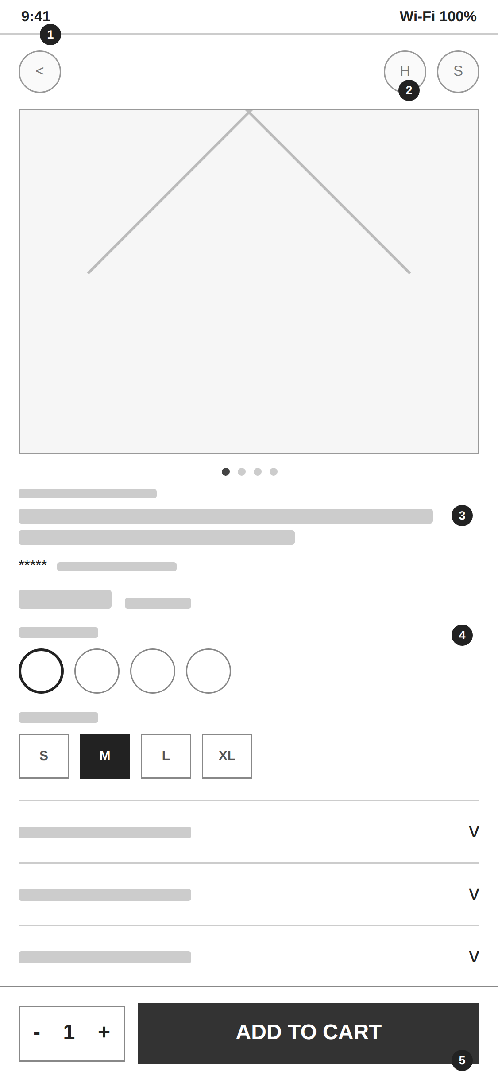 | 1 Back + actions Back navigation plus wishlist and share icons, kept out of the way of the hero image.  2 Image carousel Swipeable product image gallery with dot indicators; first image is the default/active state.  3 Title, rating & price Brand, product title, star rating with review count, and current price with a struck-through original price for discounts.  4 Variant selectors Color swatches and size selector; selected state is clearly distinguished (filled / outlined) from unselected options.  5 Sticky add-to-cart bar Quantity stepper plus a full-width Add to Cart button, pinned to the bottom so it's reachable regardless of scroll position.
Figure 3. Product detail wireframe with annotated regions.

5. Screen 4 — Cart
Purpose:
Lets the user review, adjust, or remove items before proceeding, see an order summary, and apply a promo code.
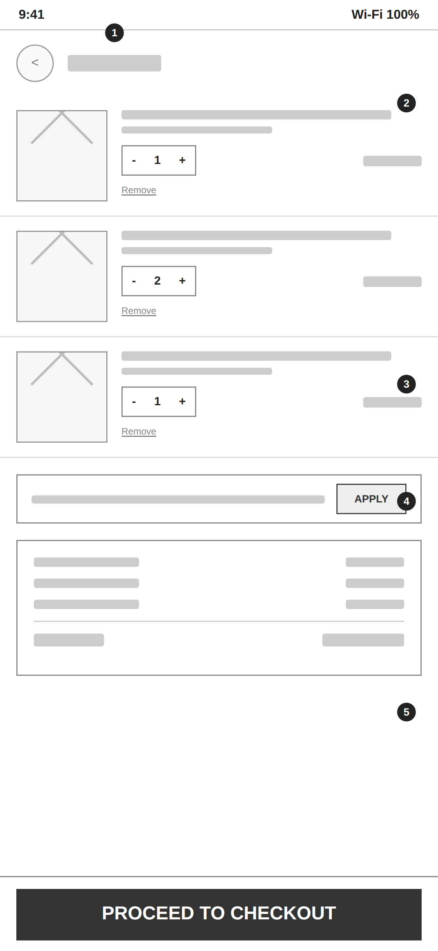 | 1 Header Back action and “Cart” title; itemized list begins directly below with no extra chrome.  2 Line item Thumbnail, name, variant, quantity stepper, price, and a text-link “Remove” action per item — repeated for each cart item.  3 Promo code field Inline text field with an Apply button so users can test discount codes without leaving the cart.  4 Order summary Subtotal, shipping, and tax broken out individually, with a clearly separated total at the bottom.  5 Sticky checkout bar Full-width “Proceed to Checkout” button pinned to the bottom, always reachable.
Figure 4. Cart wireframe with annotated regions.

6. Screen 5 — Checkout
Purpose:
Collects shipping and payment information and gives a final order summary before purchase, structured as a short multi-step flow.
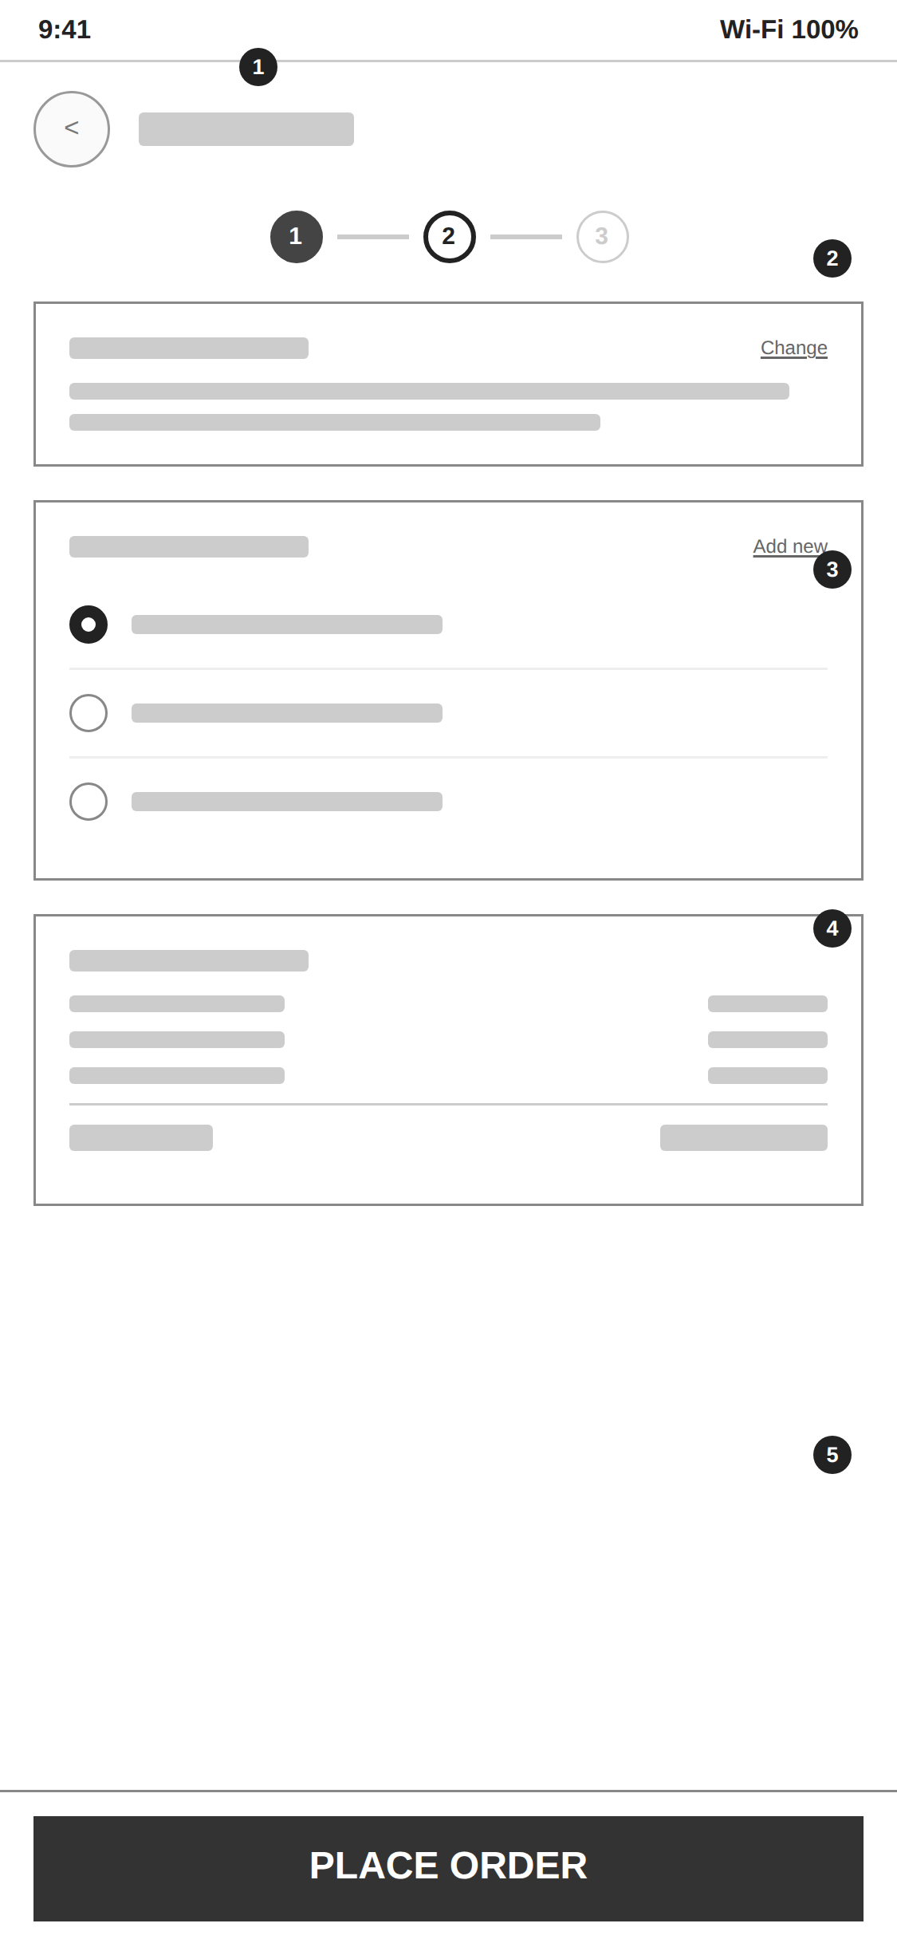 | 1 Header + step indicator A 3-step progress indicator (Cart → Checkout → Confirmation) tells the user exactly where they are in the flow.  2 Shipping address card Selected address summary with an inline “Change” action rather than navigating to a separate screen.  3 Payment method Radio-button list of saved payment methods, plus an “Add new” action for entering a new card or method.  4 Order summary Final cost breakdown mirrored from the cart screen for consistency, ending in the grand total.  5 Sticky place-order bar Full-width “Place Order” button as the single, unambiguous final action of the flow.
Figure 5. Checkout wireframe with annotated regions.

7. Screen 6 — Order Confirmation
Purpose:
Confirms the order succeeded, summarizes key order details, and offers clear next actions so the user isn't left at a dead end.
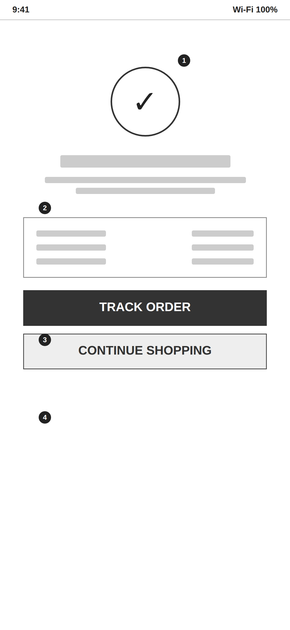 | 1 Success indicator Large checkmark icon as the immediate, unambiguous visual confirmation that the order was placed.  2 Order summary card Order number, estimated delivery date, and payment method shown as quick-reference facts.  3 Primary action “Track Order” as the filled, primary button — the most likely next thing a user wants to do.  4 Secondary action “Continue Shopping” as an outlined secondary button, returning the user to the home/discovery screen.
Figure 6. Order confirmation wireframe with annotated regions.

8. Wireframing Notes & Next Steps
These six screens form a complete, navigable low-fidelity flow: a user can move from discovery through to a confirmed order without any missing steps. Deliberate choices at this stage include a persistent cart icon across browsing screens, a sticky primary action on every screen with a checkout-adjacent task, and a visible step indicator during the multi-step checkout to reduce drop-off.
Recommended next steps: validate this flow with quick usability testing or stakeholder review at the wireframe stage (cheap to change here), then proceed to high-fidelity UI design — applying a color palette, typography system, real photography, and final copy — once the layout and flow are confirmed.

