NovaPay Financial Performance Analysis Report

Prepared by: Srushti Mahant Pawar
Project: AI-Enabled FP&A Command Center
Tools Used: Excel, SQL, Python, Power BI
Date: May 28, 2026

- Executive Summary
This project focuses on building an AI-enabled Financial Planning and Analysis command center for NovaPay, a fintech-style business. The main objective was to organize financial and customer data, analyze business performance, create forecasts, and build an interactive Power BI dashboard for decision-making.
The project covers the complete analytics workflow, starting from raw data preparation, Excel financial modeling, SQL-based analysis, Python forecasting, and Power BI dashboard development. The final dashboard allows users to filter performance by month and review important business metrics such as total revenue, gross margin, EBITDA, active customers, churn rate, customer-level revenue, expenses, and CAC trends.
Overall, the dashboard helps identify revenue growth patterns, cost pressure, margin behavior, customer concentration, and areas where NovaPay can improve profitability.

- Project Objective
The objective of this project was to create a complete FP&A reporting system that can help NovaPay track financial performance and make better business decisions.
- The main goals were:
- Build a clean financial model in Excel.
- Use SQL queries to analyze revenue, expenses, customer performance, and KPIs.
- Use Python to support forecasting and trend analysis.
- Build an interactive Power BI dashboard.
- Create a final business report with insights and recommendations.

- Data Used
The project uses multiple business datasets related to NovaPay’s financial and operating performance. The main tables used in the analysis include.
Revenue data: Monthly revenue by customer, including subscription revenue, transaction fee revenue, setup fee revenue, premium analytics revenue, transaction volume, and total revenue.
Expense data: Expense category-level data such as payroll, marketing spend, cloud hosting, rent, software, and customer support.
Budget data: Monthly budgeted revenue and budgeted EBITDA used for comparing actual performance against planned performance.
KPI data: Business performance metrics such as gross margin, churn rate, CAC, active customers, lost customers, new customers, average revenue, and net revenue.
Customer data: Customer names and customer-related revenue contribution.
Scenario inputs: Supporting assumptions for analysis and forecasting

- Work Completed
The project was completed in multiple stages.
First, the Excel financial model was created and cleaned. The model includes separate sheets for revenue, expenses, budget, KPI metrics, customers, and scenario inputs.
Second, SQL queries were developed to analyze business performance. These queries helped summarize revenue, compare actuals against budget, review expenses, and identify key customer-level insights.
Third, Python was used for forecasting and analysis. The notebook supports trend-based analysis and helps understand future performance direction based on available data.
Fourth, Power BI was used to build the final interactive dashboard. The dashboard includes KPI cards, revenue trends, budget comparison, expense breakdown, customer revenue analysis, gross margin trend, CAC trend, and a month slicer for interactivity.

- Power BI Dashboard Overview
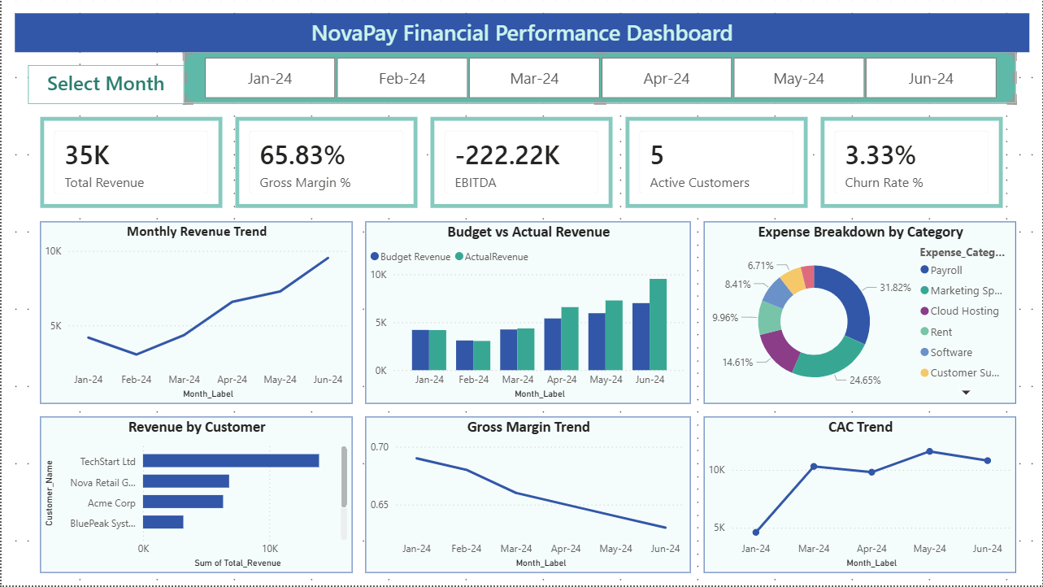

The Power BI dashboard provides a complete executive-level view of NovaPay’s financial performance. It includes key performance indicators at the top and detailed visual analysis below.
The top KPI cards show total revenue, gross margin percentage, EBITDA, active customers, and churn rate. These metrics give a quick summary of business health.
The trend charts show how revenue, gross margin, and CAC changed across the months. The dashboard also includes budget versus actual revenue comparison, customer-wise revenue contribution, and expense category breakdown.
The month slicer allows the user to filter the dashboard by specific months such as Jan-24, Feb-24, Mar-24, Apr-24, May-24, and Jun-24.

- Key Insights
- Revenue shows an increasing trend from Jan-24 to Jun-24, which indicates positive business growth.
- Budget vs actual revenue comparison shows whether NovaPay is meeting or missing its planned revenue targets.
- Gross margin remains an important profitability metric because it shows how efficiently NovaPay converts revenue into profit after direct costs.
- EBITDA is negative, which means the company still has pressure from operating expenses and needs to improve profitability.
- Expense breakdown shows that payroll and marketing spend are major cost categories.
- Revenue by customer shows that a few customers contribute a large portion of total revenue. This means customer concentration should be monitored carefully.
- CAC trend helps understand whether customer acquisition cost is increasing or becoming more efficient over time.
- The interactive month slicer allows users to review monthly performance and compare how KPIs change across different months.

- Business Recommendations
Based on the analysis, NovaPay should focus on improving profitability while continuing revenue growth.
First, the company should review major expense categories such as payroll, marketing, and cloud hosting to identify areas where costs can be optimized.
Second, NovaPay should monitor customer concentration risk. If only a few customers contribute most of the revenue, losing one major customer could affect overall performance.
Third, the company should improve EBITDA by controlling operating expenses and increasing higher-margin revenue streams.
Fourth, CAC should be monitored closely. If customer acquisition cost increases faster than revenue, the company may need to improve marketing efficiency.
Fifth, NovaPay should continue using the Power BI dashboard for monthly performance review, budget tracking, and management reporting.

- Tools Used
The following tools were used in this project:
Excel: Used for financial modeling, organizing revenue and expense data, and preparing structured business tables.
SQL: Used for querying, summarizing, and analyzing financial and customer data.
Python: Used for forecasting, trend analysis, and supporting financial analysis.
Power BI: Used to create the final interactive dashboard with KPIs, charts, slicers, and executive-level visuals.
GitHub: Used to organize and share the complete project files.

- Final Conclusion
The NovaPay FP&A Command Center successfully combines financial modeling, SQL analysis, Python forecasting, and Power BI dashboarding into one complete analytics project.
The final dashboard helps users understand business performance through revenue trends, budget comparisons, expense analysis, customer revenue contribution, profitability metrics, and acquisition cost trends.
This project demonstrates how financial data can be converted into useful business insights through a structured analytics workflow.



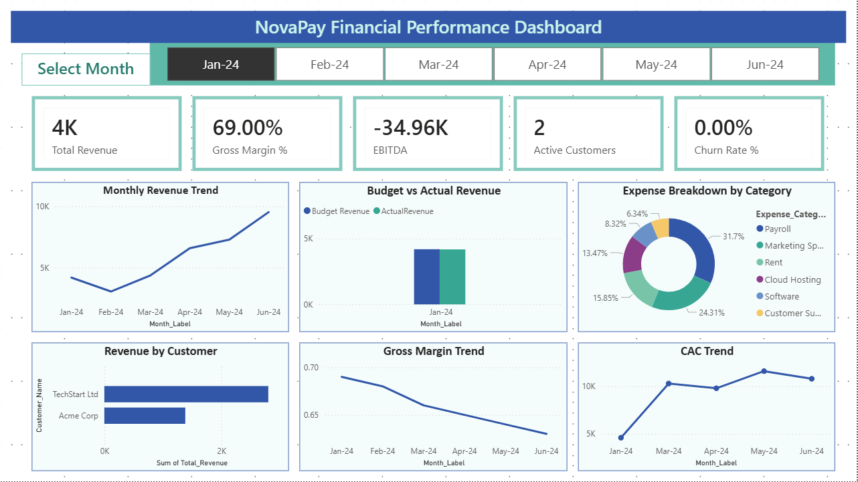

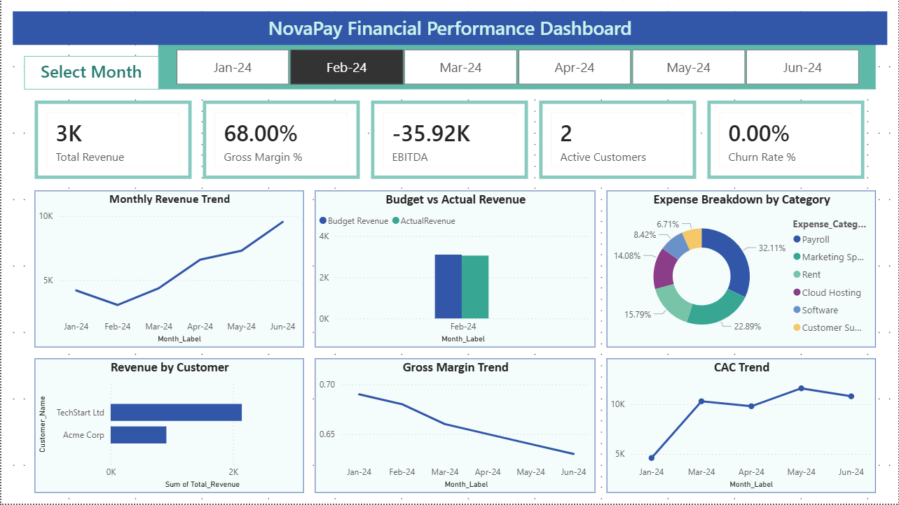

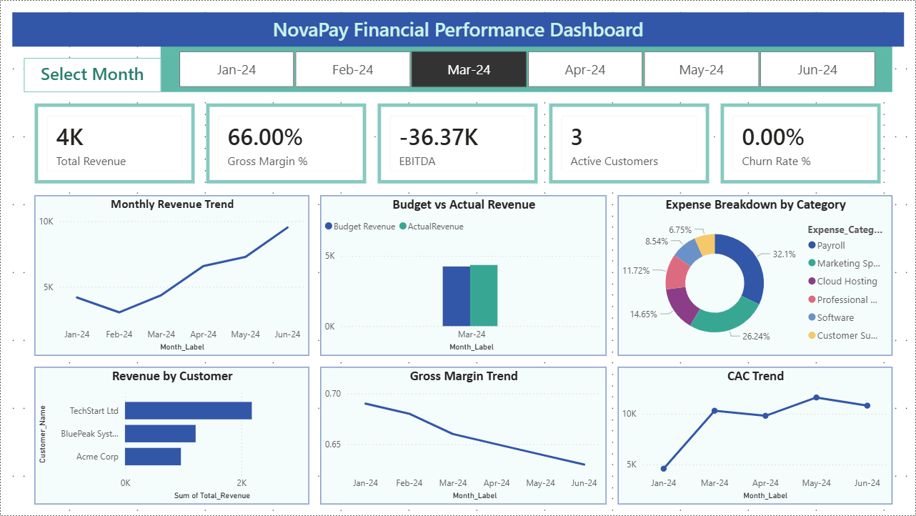

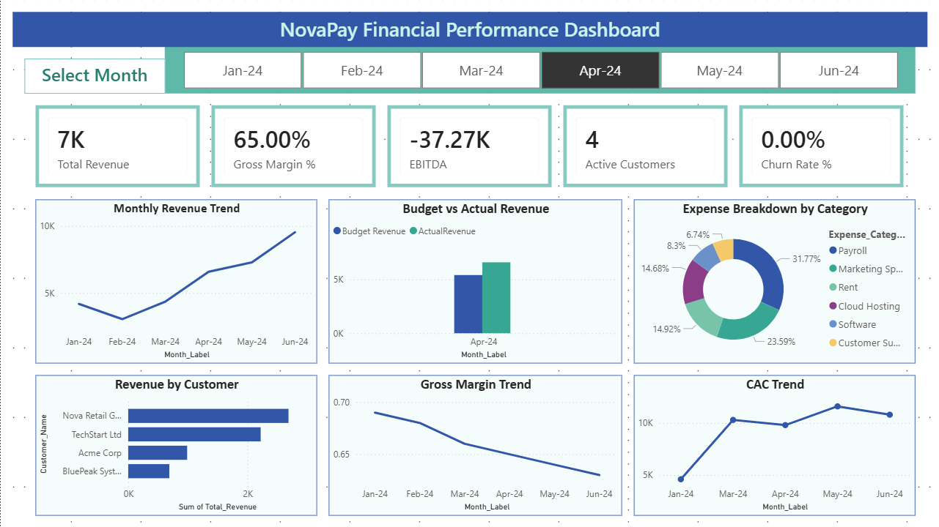

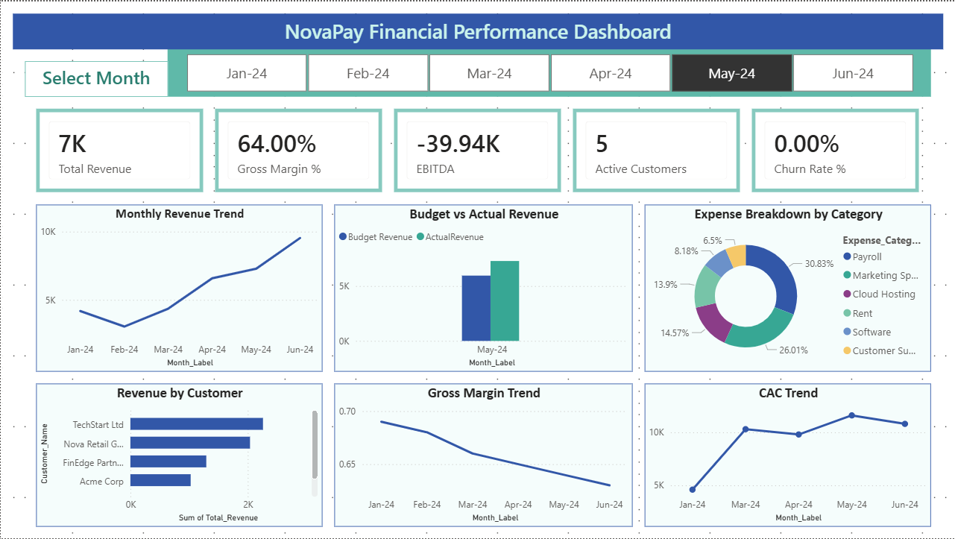

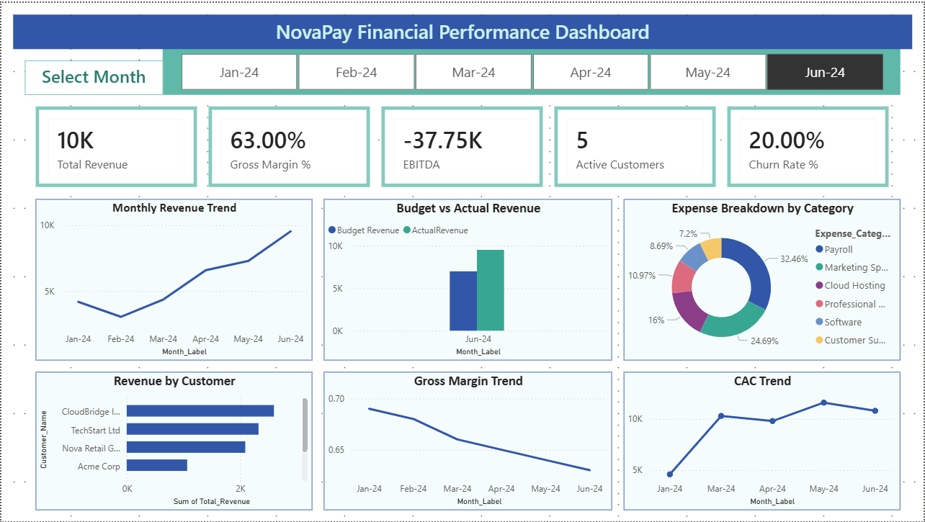

The screenshots above show that the dashboard can be filtered by month using the slicer. This makes the dashboard interactive and allows users to review monthly performance separately.

