[1]

**Grocery Management System**

Prof. Deepali Joshi, Dijasmit Patil, Hiranmayee Sant, Vyankatesh Pareek, Srushti Shingade, Devendra Kanade

Vishwakarma Institute of Technology, Pune-411037, Maharashtra, India

*Abstract — The Grocery Store is a web application which totally runs in online mode and enables the user to order the grocery in just few clicks. Food Retail Industry has undergone many changes due to Information technology and of course the Covid crises which has paved way for them. This has led to creation of website/webpage by many developers that provide competitive rates and offers to customers directly. We provide plenty of products under one store dealing with new business opportunities in e-commerce or e-tail marketing with spot payment. Earlier Web services were used for information gathering, but now it is used for direct purchase of various services or things from suppliers without middlemen. Under these circumstances this paper is a case study on the Grocery Store about its acceptance and impact of being a good platform for online marketing.*

***Keywords -----*** ***registration, order, billing, products, admin, users.***

# Introduction

Grocery Store is an online grocery delivery application which runs in online mode on different web browsers like Mozilla, Google Chrome, OPERA and IE8. It basically includes two modules. First module is the Admin Module which can only be handled by the grocery store manager in which the I have included the dashboard which displays the number of the users who have registered to this store. The next menu

displays all the detailed information of the users including their name, mobile number and email. Next also the store manager can categorize the products under various headings. Also the admin can see the order details and accordingly he or she can proceed for the delivery of the selected products. The admin or the store manager can also edit his profile, change the password and also can recover the password. The next module is the user module in which there is a home page in which total products under their respective headings is listed with their respective prices with add to cart option. On the menu bar there are sign in, sign up options and also there is logout option to jump out of the user module. On the menu bar cart option is available in which the products added by the user are listed along with the total of all the products ordered by the user. Also there is option to proceed in which we accept the address of the user for the home delivery purpose.

# Literature Review

[1] This paper seeks to understand the triggers which influence the adoption (and the discontinuation) of online grocery shopping.

[2] This survey was administered to explore consumers’ perceptions of Online Grocery Shopping in Coimbatore.

[3] This study tell us about the traditional methods of inventory and logistics management call for intense cash-burning - a business condition most of the bootstrapped Indian start-ups fail to meet. [4] The aim of this research is to investigate if positive attitudes influence the intentions to purchase groceries online.

# Methodology/Experimental

PHP language is being used as a tool. Visual Studio (VS) Editor being used as means of Technology for process. MySQL database is used to store all the data we enter into the website while browsing through our Grocery Store. For the frontend or we can say designing the user interface of the website HTML, AJAX, JQUERY, CSS and JAVASCRIPT are used. The website can be opened on browsers like Mozilla, Google Chrome, IE8 and OPERA. The website is ran on the XAMPP server.

Steps involved to run the Grocery Store application :

1] Code all the things in a folder placed at C:\xampp\htdocs\GroceryStore.

2] Open PHPMyAdmin

3] Create a database with name bgs.

4] Import bgs.sql file from the GroceryStore file.

5] Run the script <https://localhost/GroceryStore> (for frontend).

6] For the admin panel run the <https://localhost/GroceryStore/admin> (for admin panel).

# Results and Discussions

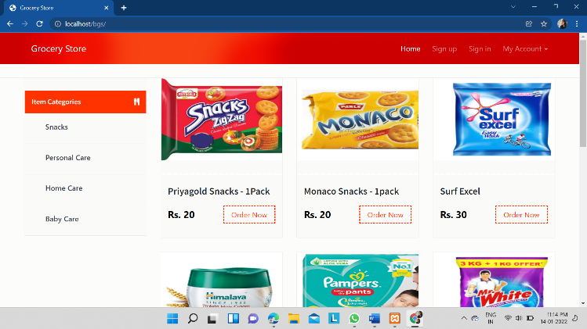

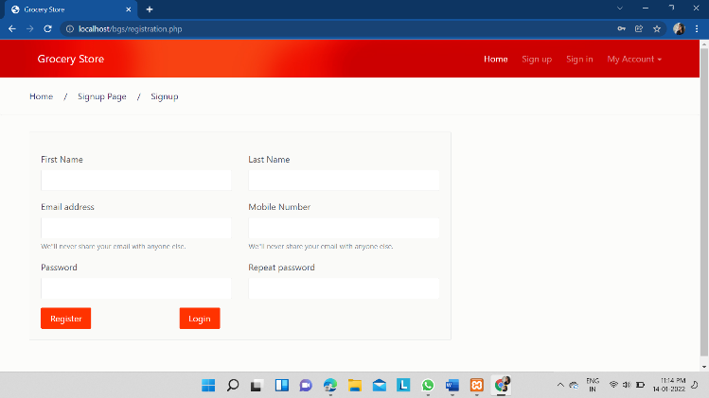

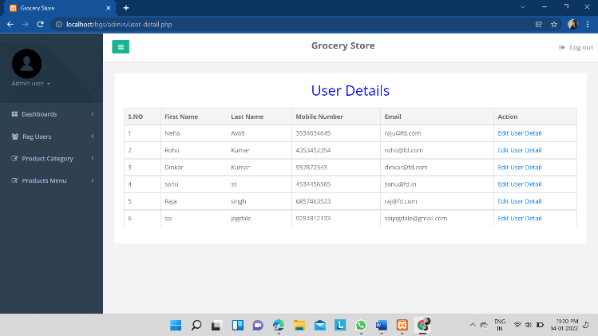

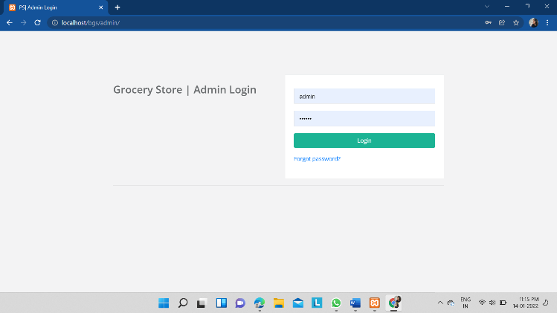

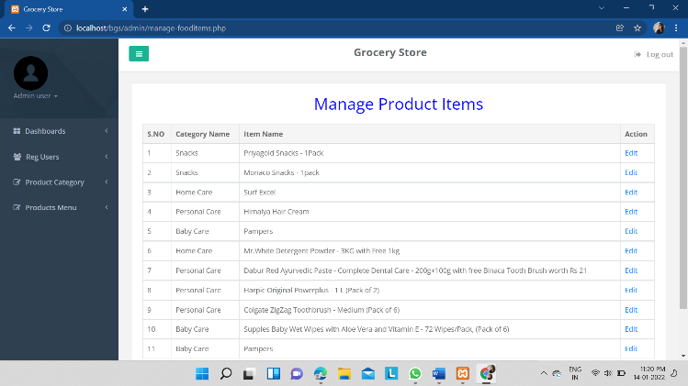

# Limitations

1. Only few products are being listed for now and of a specific quantity.

2. Can’t receive acknowledgement from the customer.

3. Only saves the order details and then on submitting again refreshes the same page.

4. Not yet joined hands with the delivering companies.

5. Delivery only available on the addresses of major cities.

# Future Scope

1] Using GPS technology and mathematical modeling software to track the location of the customer to deliver their products on correct location.

2] Adding each and every product in different quantities so it can be profitable and also handy to order less or more amount of grocery accordingly.

# Conclusion

There are many different activities occurring in retail sector. The Grocery Store application helps the user to order the grocery in online mode. This application provides such user friendly interface that allows the customers to control and handle the grocery related activities effectively and efficiently.

ACKNOWLEDGEMENT

Foremost, I strengthen my sincere feelings to our project guide Prof. Preeti A. Bailke for her continuous support to our project and this report. Also I would like to mention that she is much creative person who inspired us alot in our work.

REFERENCES

1. <https://www.researchgate.net/publication/38178214_Online_grocery_shopping_The_influence_of_situational_factors>
2. <https://www.researchgate.net/publication/324806028_A_Study_on_Consumers_acuity_towards_online_grocery_shopping>
3. <https://iosrjournals.org/iosr-jbm/papers/Conf.15010/Volume%202/25.%2048-53.pdf>
4. [Microsoft Word - Consumer Attitudes Towards Online Grocery Shopping.docx (diva-portal.org)](https://www.diva-portal.org/smash/get/diva2:812884/FULLTEXT01.pdf)

1.