**St. Francis Institute of Technology, Mumbai-400 103.**

**Department of Information Technology**

**A.Y. 2020-2021**

**Class: SE-ITA/B, Semester: IV**

**Subject: UNIX LAB**

**Experiment – 9 B: grep/ egrep script programming.**

**1. Aim**: To study and implement grep/ egrep script programming.

**2. Objectives:**

• To understand grep and egrep scripting.

• To understand the use of grep filter.

**3. Outcomes**: After study of this experiment, the student will be able to

• Develop shell scripts using grep and egrep filter.

• Perform pattern matching using grep scripts.

**4. Prerequisite**: Filters, shell scripts.

**5. Requirements**: Personal Computer, Ubuntu OS, Text Editor, LibreOffice.

**6. Pre-Experiment Exercise:**

**Brief Theory:**

Grep comand

The grep command is a pattern matching tool. The grep filter scans its input

for a particular pattern of characters, and displays all lines or the filenames that

contain that pattern. The pattern that is searched is referred to as the regular

expression. grep stands for globally search for regular expression and print out.

Grep is also a filter, so its output can be redirected to a file or to another command.

Syntax:

grep [options] pattern [files]

Grep options description

1. -c: This prints only a count of the lines that match a pattern.

2. -h: Display the matched lines, but do not display the filenames.

3. -i: Ignores, case for matching.

4. -l: Displays list of a filenames only.

5. -n: Display the matched lines and their line numbers.

6. –r: Searches the pattern recursively.

7. -v: This prints out all the lines that do not matches the pattern.

8. -e exp: Specifies expression with this option. Can use multiple times.

9. -f file: Takes patterns from file, one per line.

10. -E: Treats pattern as an extended regular expression (ERE).

11. –F: Treats pattern as a set of multiple fixed strings.

12. -w: Match whole word

13. -o: Print only the matched parts of a matching line, with each such part on a

separate output line.

Egrep

On Unix-like operating systems, the egrep command searches for a text

pattern, using extended regular expressions to perform the match. Running egrep is equivalent to running grep with the -E option.

Syntax:

grep [options] pattern [files].

**7. Laboratory Exercise**

**A. Procedure**

1. Write a grep script to find the number of matched characters, words and lines

in a file.

2. Write a grep script to find the number of characters, words and lines in a file.

3. Write an egrep script to display list of files starting with particular letter in the directory.

**B. Result/Program code Screenshots**

**8. Post-Experiments Exercise**

**A. Extended Theory:**

Nil

**B. Questions:**

1. Write a shell program using grep to count the number of files in a Directory.

**C. Conclusion:**

1. Write what was performed in the experiment.

2. Mention few applications of what was studied.

3. Write the significance of the topic studied in the experiment.

**D. References:**

1. Yashwant Kanetkar, UNIX Shell Programming, BPB Publications.

2. Sumitabha Das, UNIX Concepts and Applications, 3rd Ed., Tata McGraw

Hill.

3. <https://www.geeksforgeeks.org/grep-command-in-unixlinux/>.

**7. Laboratory Exercise**

**A. Procedure**

1. Write a grep script to find the number of matched characters, words and lines

in a file.

**Code:**

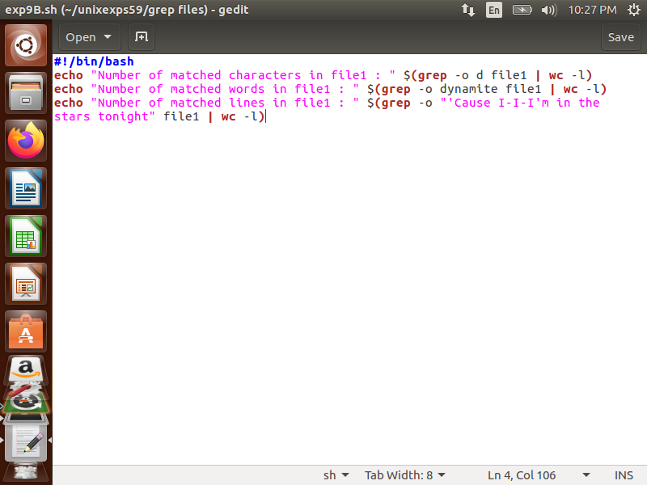

2. Write a grep script to find the number of characters, words and lines in a file.

**Code:**

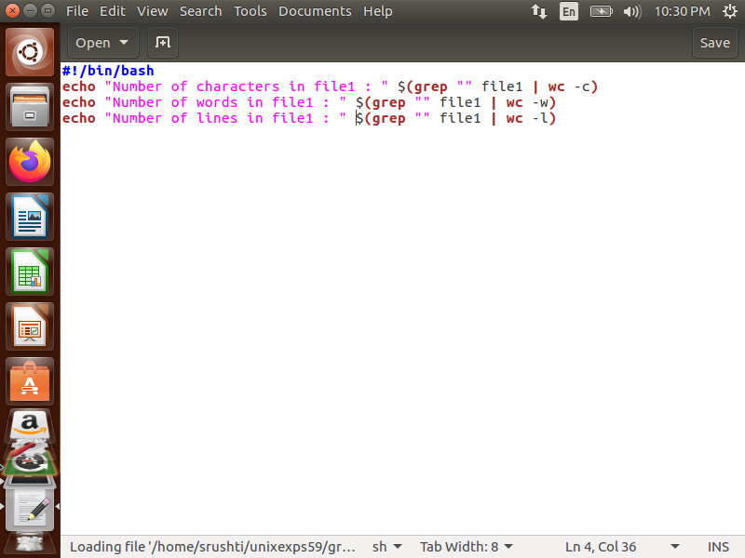

3. Write an egrep script to display list of files starting with particular letter in the directory.

**Code:**

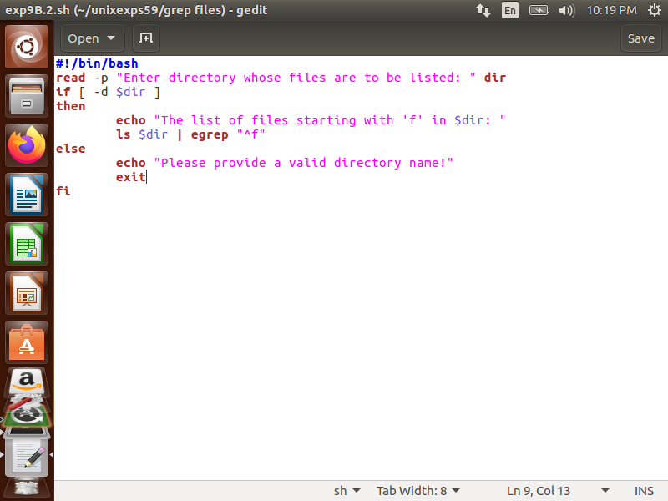

**B. Result/Program code Screenshots**

1. Write a grep script to find the number of matched characters, words and lines

in a file.

**Output:**

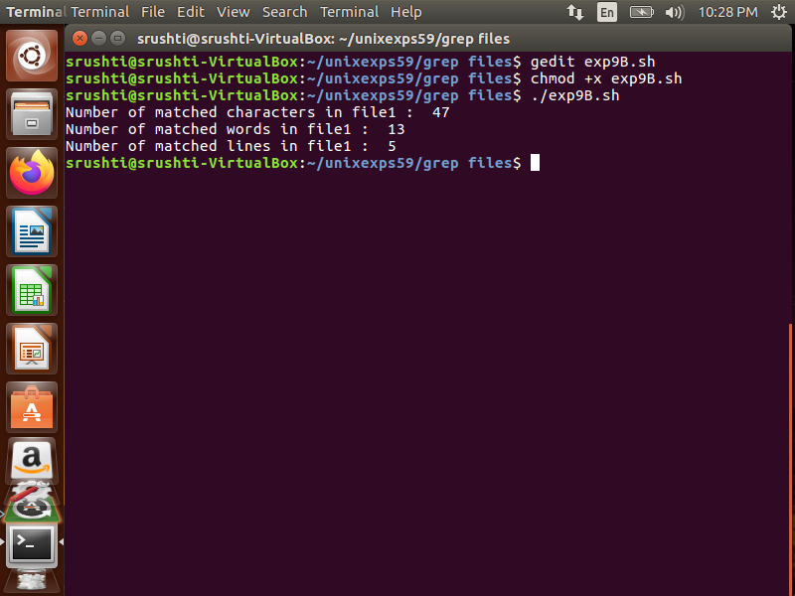

2. Write a grep script to find the number of characters, words and lines in a file.

**Output:**

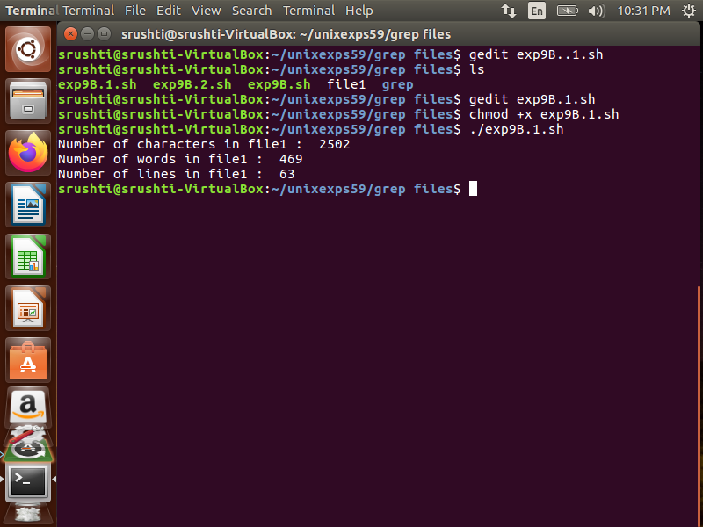

3. Write an egrep script to display list of files starting with particular letter in the directory.

**Output:**

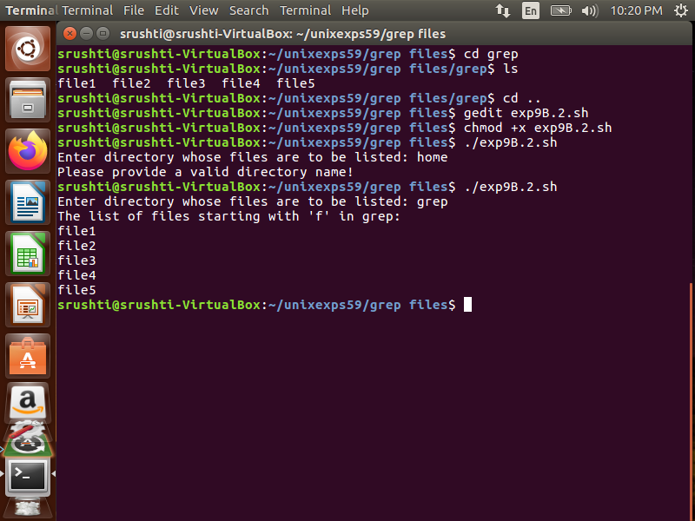

**8. Post-Experiments Exercise**

**A. Extended Theory:**

Nil

**B. Questions:**

1. Write a shell program using grep to count the number of files in a Directory.

**Code:**

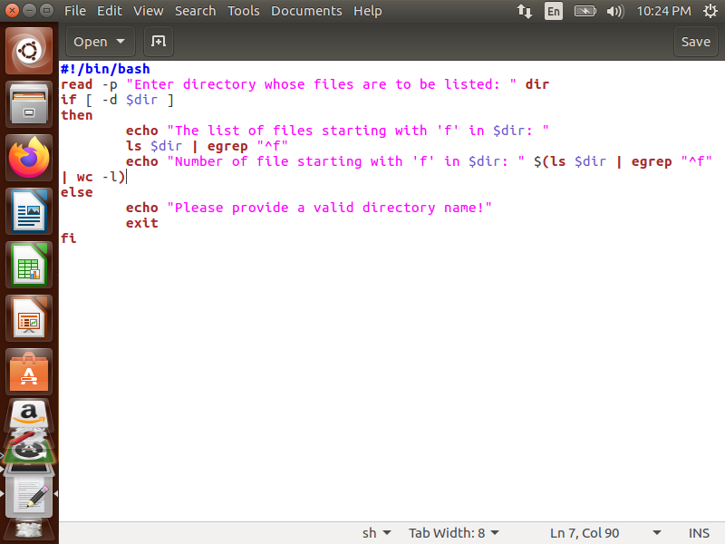

**Output:**

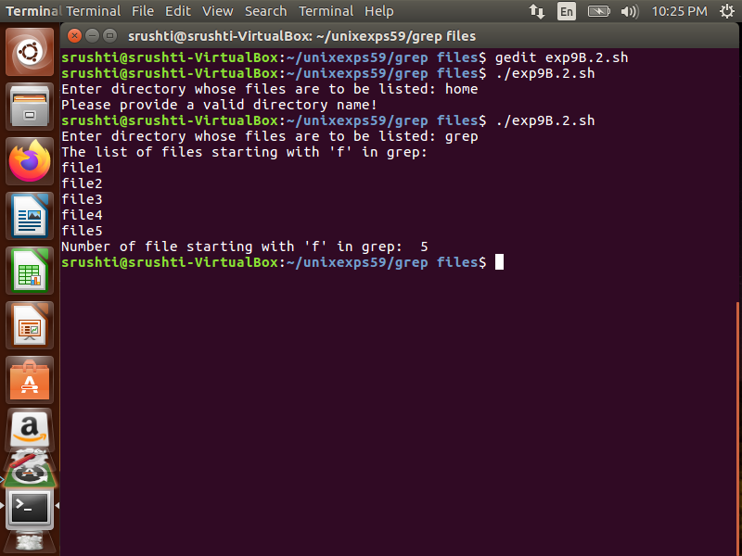

**C. Conclusion:**

1. Write what was performed in the experiment.

2. Mention few applications of what was studied.

3. Write the significance of the topic studied in the experiment.

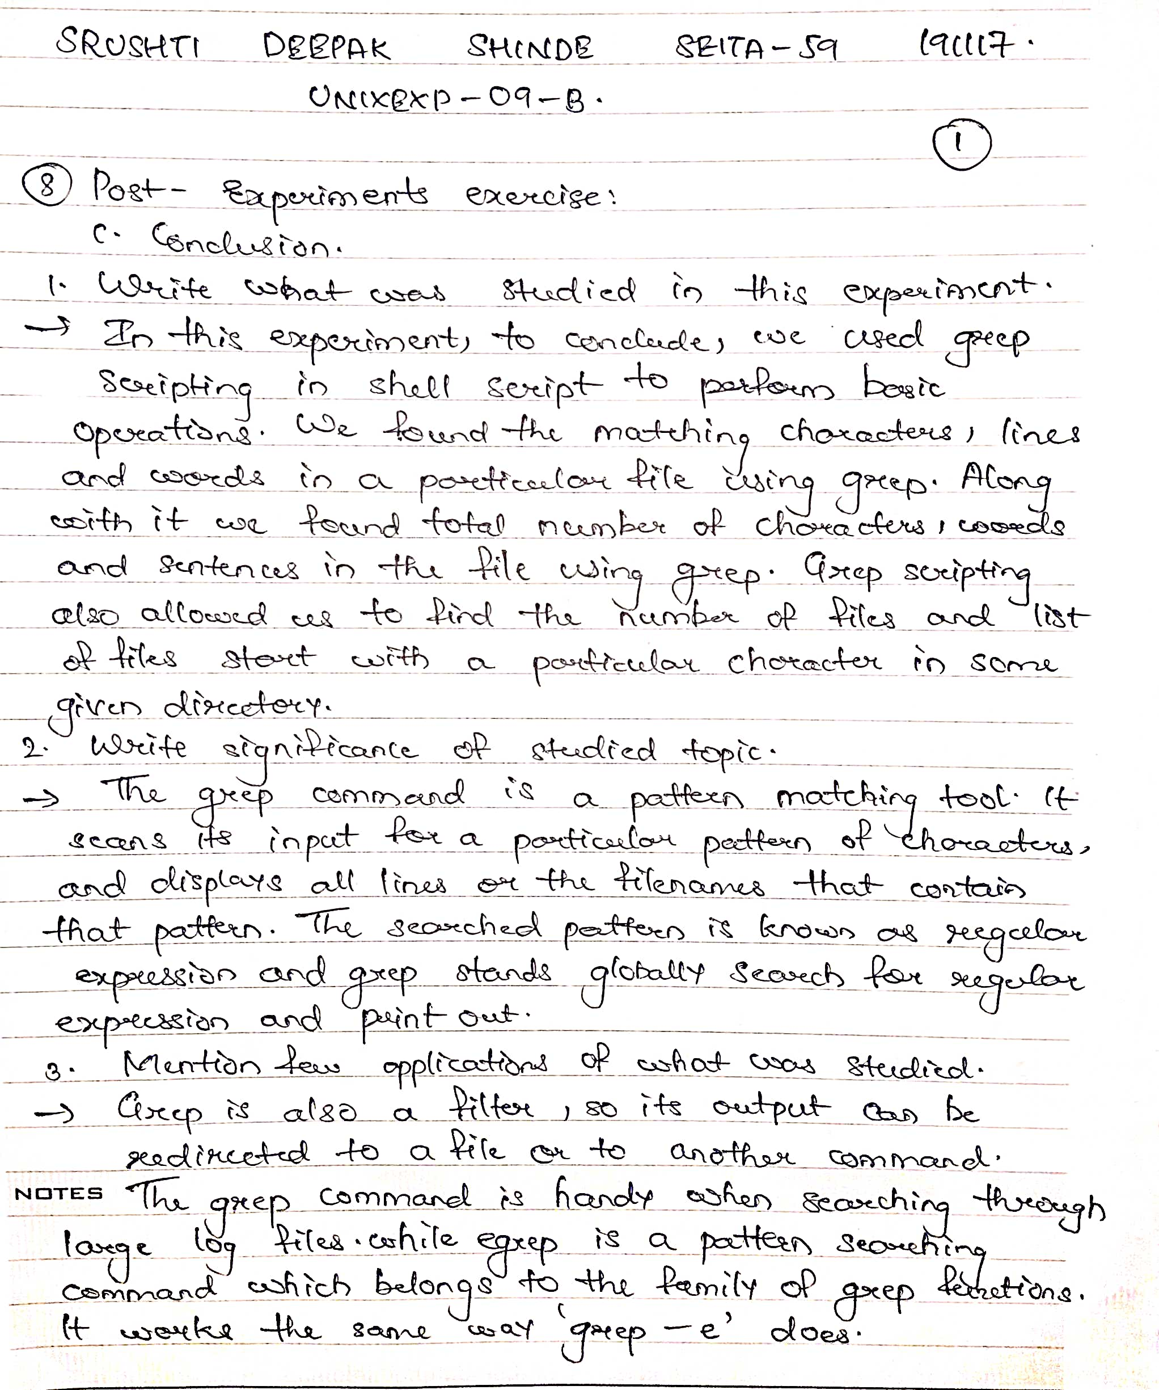

**D. References:**

1. Yashwant Kanetkar, UNIX Shell Programming, BPB Publications.

2. Sumitabha Das, UNIX Concepts and Applications, 3rd Ed., Tata McGraw

Hill.

3. <https://www.geeksforgeeks.org/grep-command-in-unixlinux/>.