**St. Francis Institute of Technology, Mumbai-400 103.**

**Department of Information Technology**

**A.Y. 2020-2021**

**Class: SE-ITA/B, Semester: IV**

**Subject: UNIX LAB**

**Experiment – 10 A: Advanced filtering with AWK script programming.**

**1. Aim:** To study and implement AWK script programming.

**2. Objectives:**

• To understand and implement AWK scripts.

• To understand the use of AWK scripts.

**3. Outcomes:** After study of this experiment, the student will be able to

• Understand and implement AWK scripts.

• Use AWK filter as a report formatting tool.

**4. Prerequisite**: Filters, shell scripts.

**5. Requirements**: Personal Computer, Ubuntu OS, Text Editor, LibreOffice.

**6. Pre-Experiment Exercise:**

**Brief Theory:**

**AWK:**

Awk is a scripting language used for manipulating data and generating

reports. The awk command programming language requires no compiling, and

allows the user to use variables, numeric functions, string functions, and logical

operators.

Awk is a utility that enables a programmer to write tiny but effective programs

in the form of statements that define text patterns that are to be searched for in each line of a document and the action that is to be taken when a match is found within a line. Unlike other filters, it operates at the field level and can easily access, transform and format individual fields in a line. Awk is mostly used for pattern scanning and processing. It searches one or more files to see if they contain lines that matches with the specified patterns and then performs the associated actions.

Awk is named after its authors – Aho, Weinberger, and Kernighan.

Syntax: awk options 'selection _criteria {action }' input-file(s)

**AWK workflow**

AWK follows a simple workflow − Read, Execute, and Repeat. Figure1.

depicts the workflow of AWK.

**Read**

AWK reads a line from the input stream (file, pipe, or stdin) and stores it in memory.

**Execute**

All AWK commands are applied sequentially on the input. By default, AWK execute commands on every line. We can restrict this by providing patterns.

**Repeat**

This process repeats until the file reaches its end.

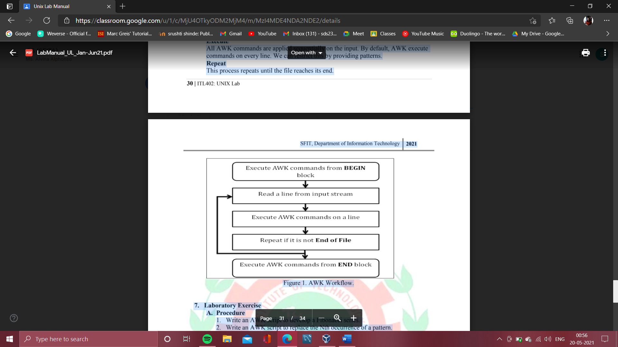

Figure 1. AWK Workflow.

**7. Laboratory Exercise**

**A. Procedure**

1. Write an AWK script to develop a Fibonacci series.

2. Write an AWK script to replace the Nth occurrence of a pattern.

3. Write an AWK script to display the pattern from a file.

**B. Result/Program code Screenshots**

**8. Post-Experiments Exercise**

**A. Extended Theory:**

Nil

**B. Questions:**

1. Write an AWK script to print only certain columns from the input field.

**C. Conclusion:**

1. Write what was performed in the experiment.

2. Mention few applications of what was studied.

3. Write the significance of the topic studied in the experiment.

**D. References:**

1. Yashwant Kanetkar, UNIX Shell Programming, BPB Publications.

2. Sumitabha Das, UNIX Concepts and Applications, 3rd Ed., Tata McGraw Hill.

3. <https://www.geeksforgeeks.org/awk-command-unixlinux-examples/>.

**7. Laboratory Exercise**

**A. Procedure**

1. Write an AWK script to develop a Fibonacci series.

**Code:**

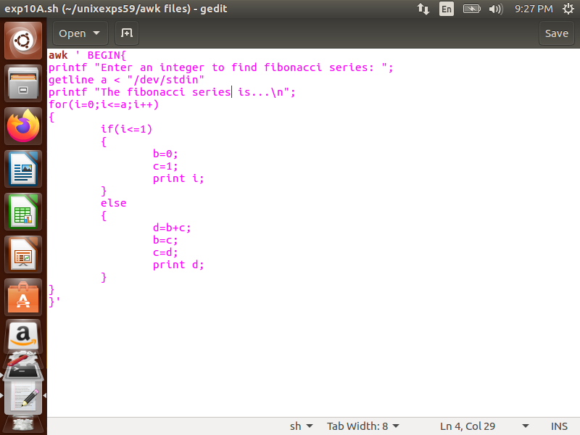

2. Write an AWK script to replace the Nth occurrence of a pattern.

**Code:**

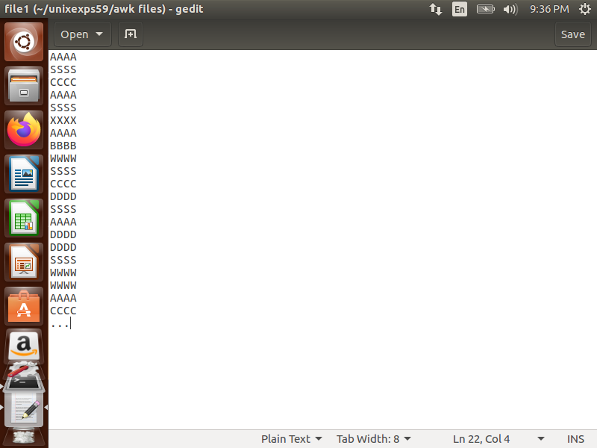

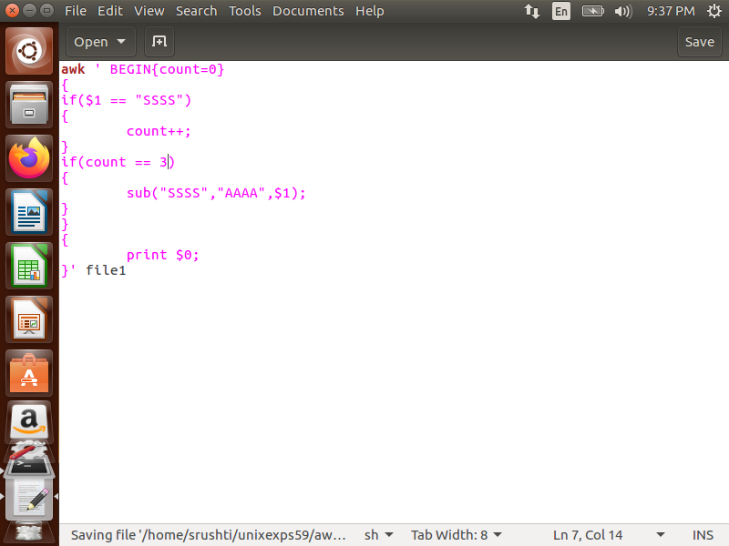

3. Write an AWK script to display the pattern from a file.

**Code:**

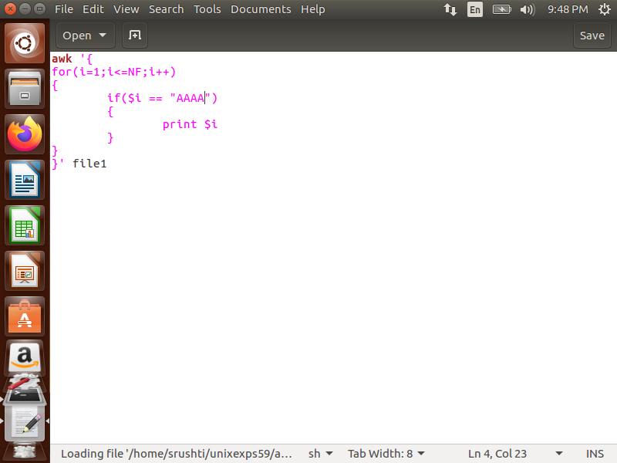

**B. Result/Program code Screenshots**

1. Write an AWK script to develop a Fibonacci series.

**Output:**

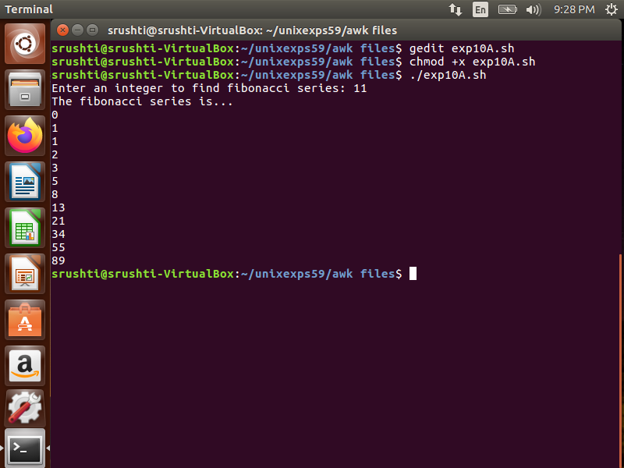

2. Write an AWK script to replace the Nth occurrence of a pattern.

**Output:**

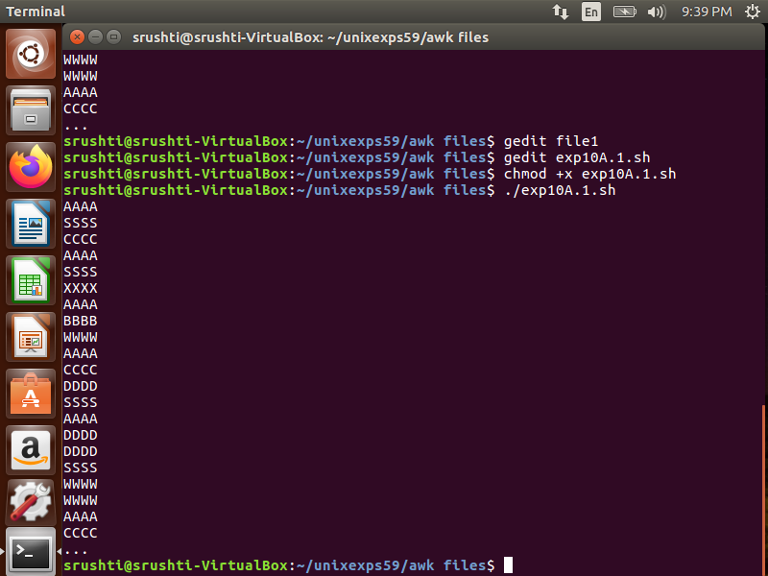

3. Write an AWK script to display the pattern from a file.

**Output:**

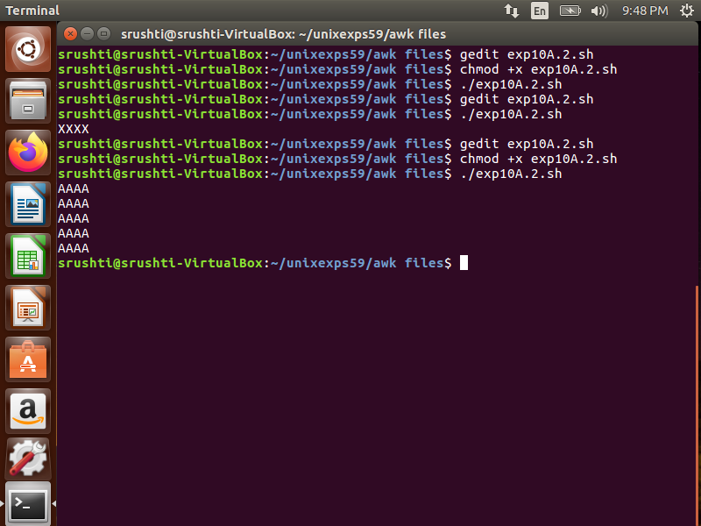

**8. Post-Experiments Exercise**

**A. Extended Theory:**

Nil

**B. Questions:**

1. Write an AWK script to print only certain columns from the input field.

**Code:**

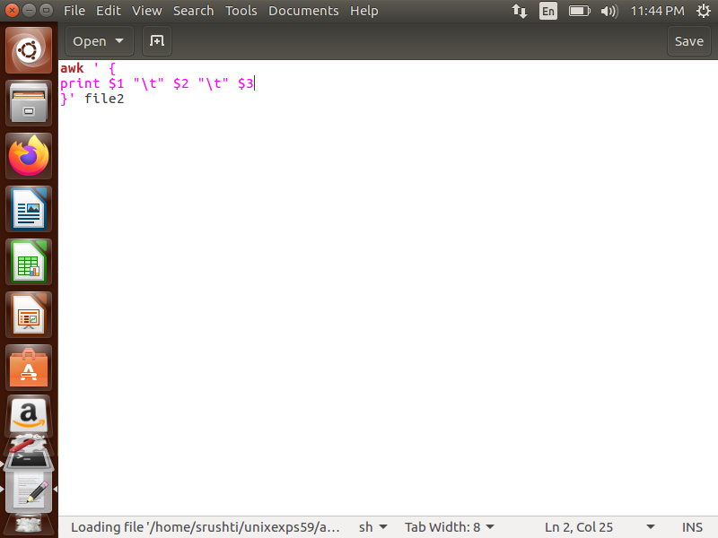

**Output:**

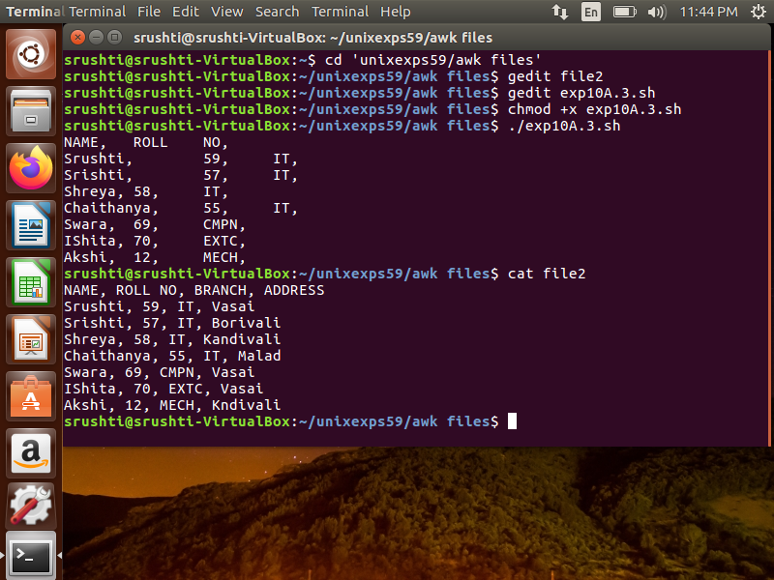

**C. Conclusion:**

1. Write what was performed in the experiment.

2. Mention few applications of what was studied.

3. Write the significance of the topic studied in the experiment.

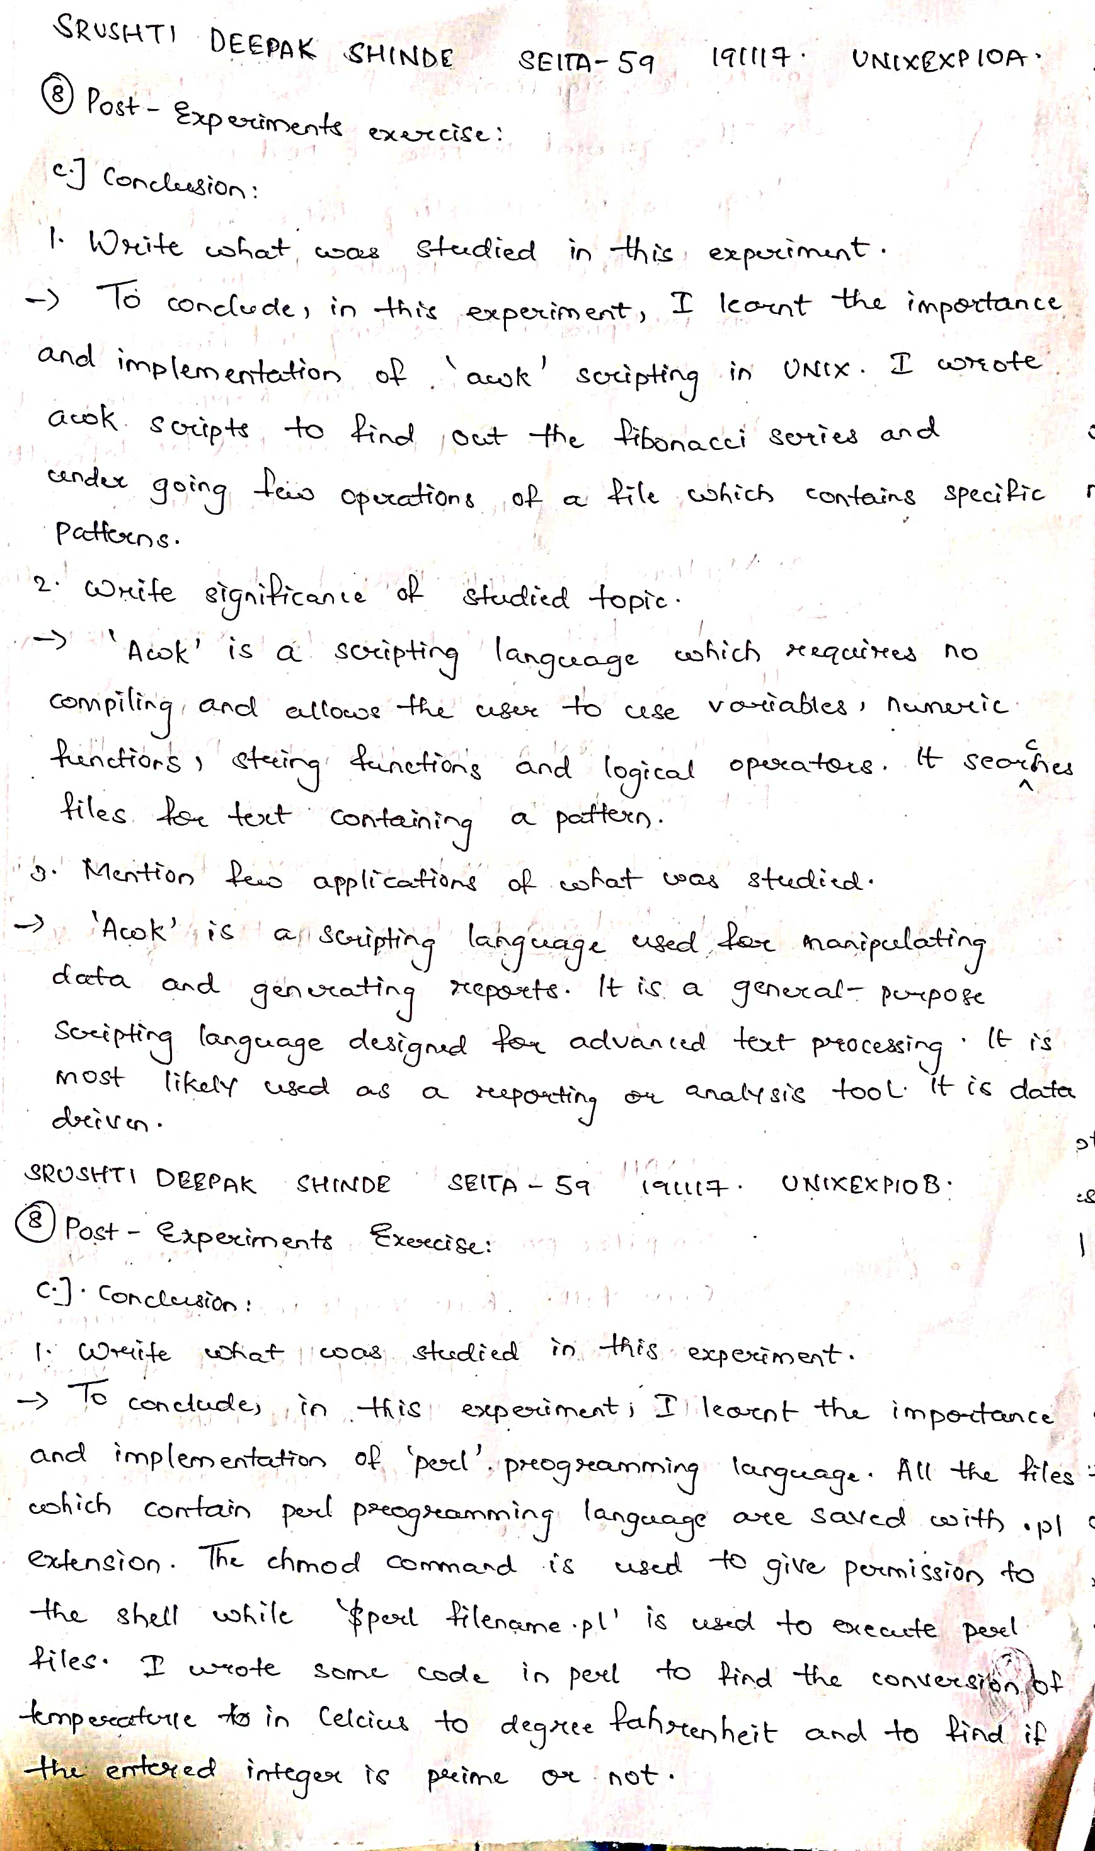

**D. References:**

1. Yashwant Kanetkar, UNIX Shell Programming, BPB Publications.

2. Sumitabha Das, UNIX Concepts and Applications, 3rd Ed., Tata McGraw Hill.

3. <https://www.geeksforgeeks.org/awk-command-unixlinux-examples/>.