**St. Francis Institute of Technology, Mumbai-400 103.**

**Department of Information Technology**

**A.Y. 2020-2021**

**Class: SE-ITA/B, Semester: IV**

**Subject: UNIX LAB**

**Experiment – 10 B: Text processing using perl script programming.**

**1. Aim:** To study and implement perl script programming.

**2. Objectives:**

• To understand and implement perl script programming.

• To use perl for text manipulation.

**3. Outcomes**: After study of this experiment, the student will be able to

• Understand perl script programming.

• Use perl for text manipulation.

**4. Prerequisite:** Shell scripts.

**5. Requirements**: Personal Computer, Ubuntu OS, Text Editor, LibreOffice.

**6. Pre-Experiment Exercise:**

**Brief Theory:**

**Perl:**

Perl is a programming language developed by Larry Wall, especially designed

for text processing. It stands for Practical Extraction and Report Language. It runs on a variety of platforms, such as Windows, Mac OS, and the various versions of UNIX.

It is free and executables are available for all Unix flavors.

Perl combines the power of shell, tr, grep, sed and awk. It is faster than the

shell and awk. Perl is a programming language specially designed for text

manipulation. It is now widely used for a variety of purposes including Unix and Linux system administration, network programming, web development, etc.

**Steps to create and execute perl script in Unix**

1. To find out if you already have Perl installed, go into the command line and type:

perl -v.

2. If you need to update the Perl version then just enter one single line of command

sudo apt-get install perl

3. Create a file using a vi editor (or any other editor).

4. Name the script file with extension .pl

5. Start the script with #! /bin/perl

6. Write some code.

7. Save the script file as filename.pl

8. Give the shell permission to execute it.

9. For executing the script type perl filename.pl

**7. Laboratory Exercise**

**A. Procedure**

1. Write an interactive perl script to convert temperature from Centigrade to

Fahrenheit.

2. Write a perl script to check whether the entered number is prime or not.

**B. Result/Program code Screenshots**

**8. Post-Experiments Exercise**

**A. Extended Theory:**

Nil

**B. Questions:**

1. Write a perl script to check whether the year is leap year or not.

**C. Conclusion:**

1. Write what was performed in the experiment.

2. Mention few applications of what was studied.

3. Write the significance of the topic studied in the experiment.

**D. References:**

1. Yashwant Kanetkar, UNIX Shell Programming, BPB Publications.

2. Sumitabha Das, UNIX Concepts and Applications, 3rd Ed., Tata McGraw

Hill.

**7. Laboratory Exercise**

**A. Procedure**

1. Write an interactive perl script to convert temperature from Centigrade to

Fahrenheit.

**Code:**

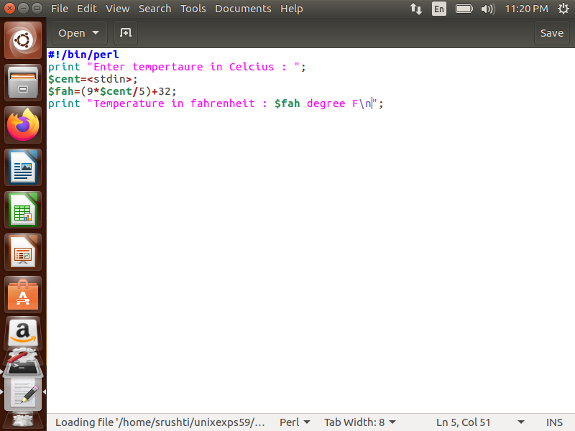

2. Write a perl script to check whether the entered number is prime or not.

**Code:**

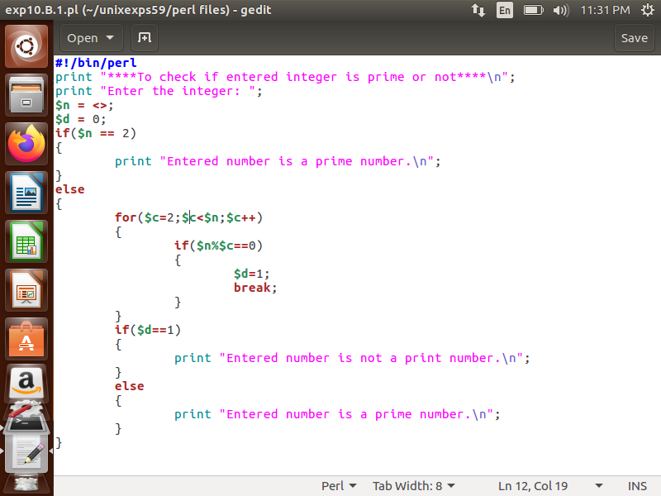

**B. Result/Program code Screenshots**

1. Write an interactive perl script to convert temperature from Centigrade to

Fahrenheit.

**Output:**

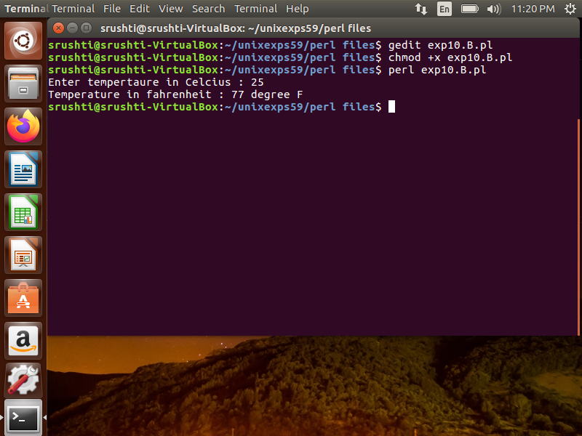

2. Write a perl script to check whether the entered number is prime or not.

**Output:**

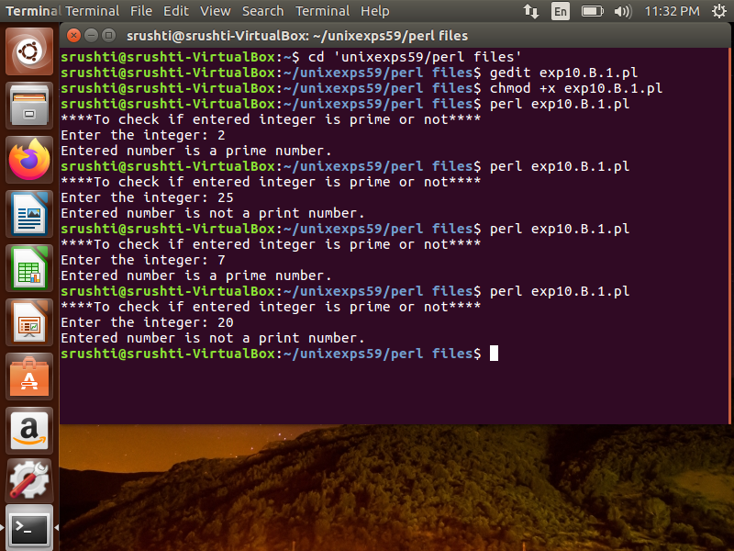

**8. Post-Experiments Exercise**

**A. Extended Theory:**

Nil

**B. Questions:**

1. Write a perl script to check whether the year is leap year or not.

**Code:**

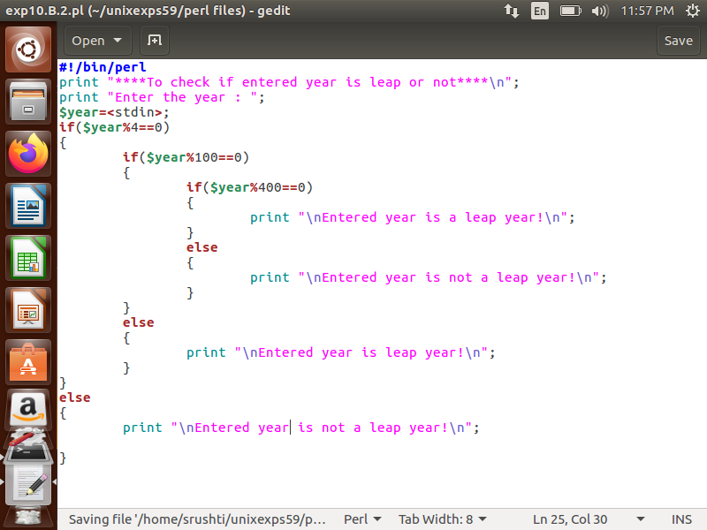

**Output:**

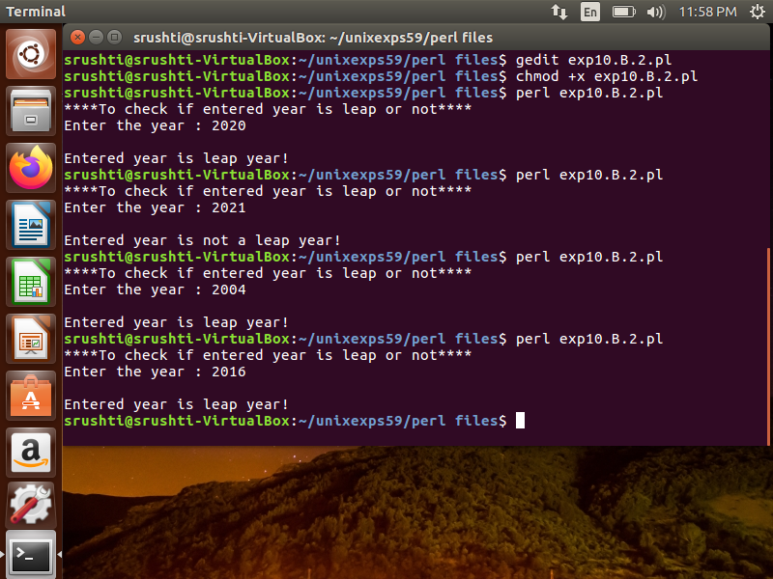

**C. Conclusion:**

1. Write what was performed in the experiment.

2. Mention few applications of what was studied.

3. Write the significance of the topic studied in the experiment.

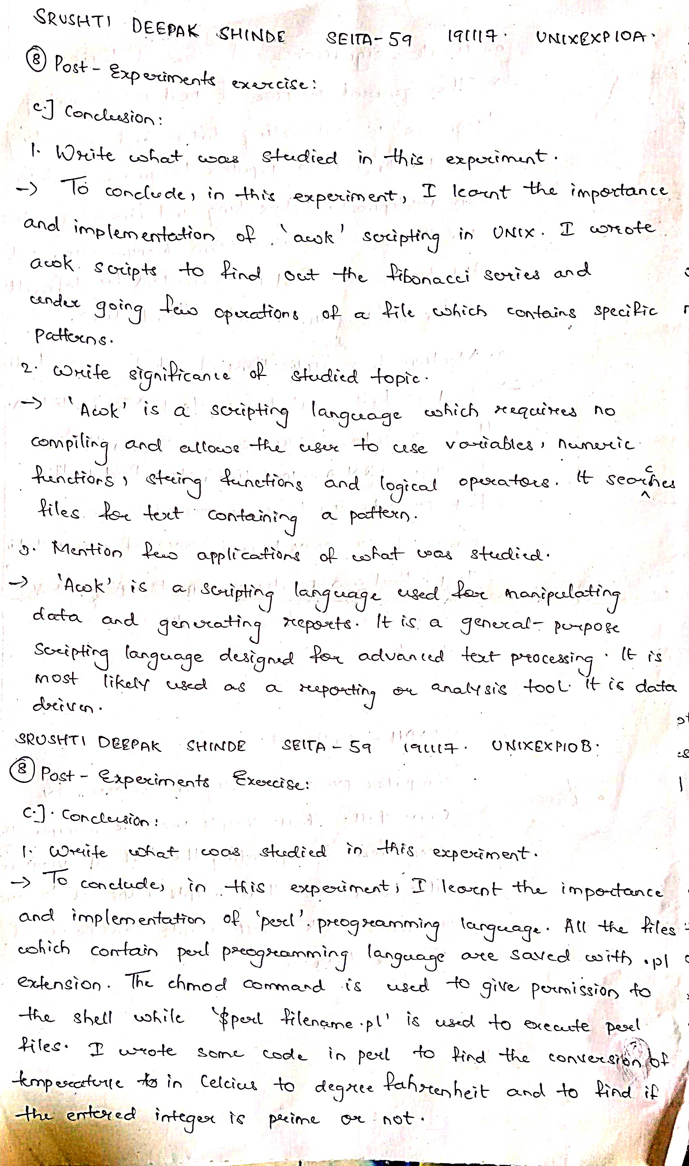

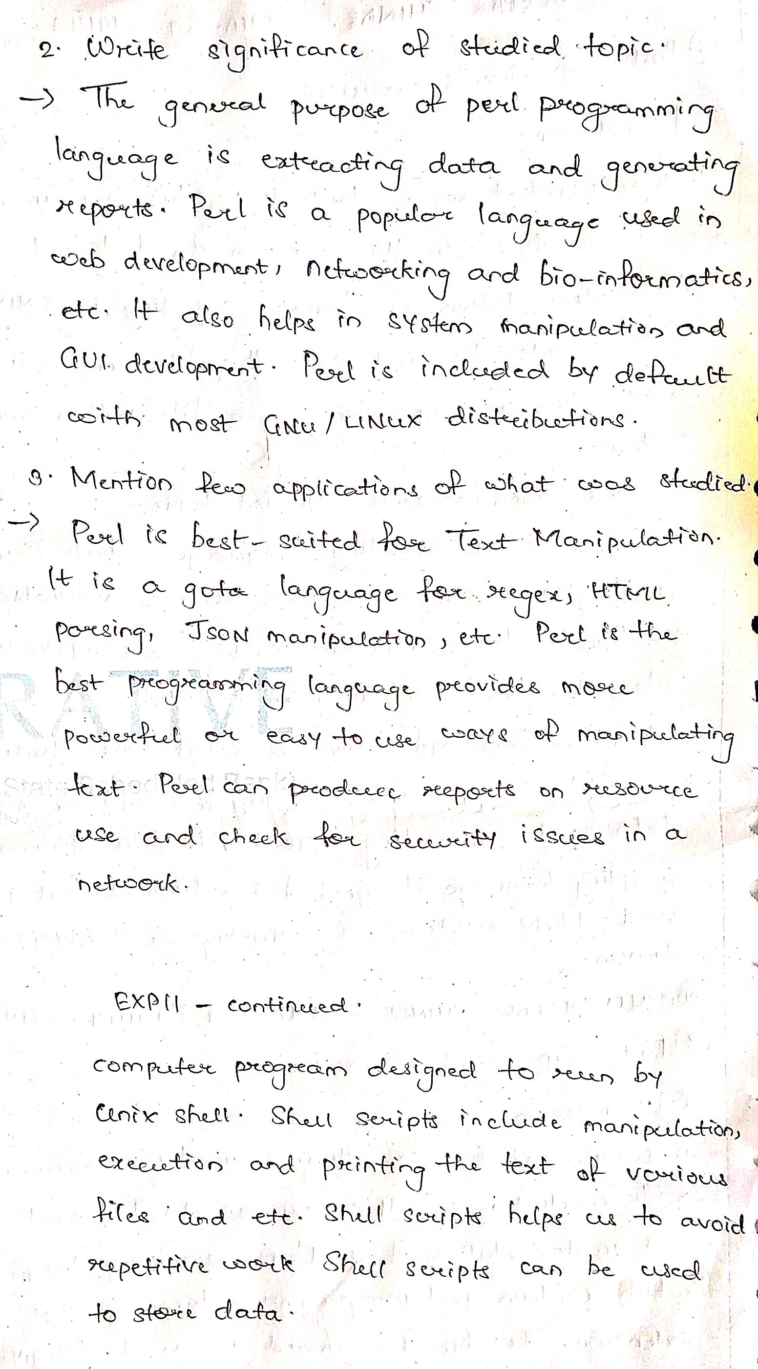



**D. References:**

1. Yashwant Kanetkar, UNIX Shell Programming, BPB Publications.

2. Sumitabha Das, UNIX Concepts and Applications, 3rd Ed., Tata McGraw

Hill.