WEEK 3 REPORT
Python-Based Machine Learning Model Development and Evaluation Plan
Project: E-Commerce Customer Churn Prediction
Virtual Data Science Explorer Internship
Planning document — no model was trained or evaluated for this assignment.

1. Introduction
Week 3 focuses on planning the machine learning stage of the same hypothetical E-Commerce Customer Churn Prediction project used in Weeks 1 and 2. The aim is to turn the earlier project plan and EDA framework into a practical model-development workflow. The planned system will use customer behaviour and transaction-related features to estimate whether a customer is likely to churn.
This is a planning assignment, not an implementation. No actual dataset is supplied and the task states that code execution is not required. Therefore, examples, feature values, model comparisons, and expected outcomes in this report are illustrative and do not claim actual model performance.

2. Problem Definition

2.1 Hypothetical problem
An e-commerce company wants to identify customers who may stop purchasing from the platform. A binary classification model can be planned to predict whether a customer is likely to churn using information available before the prediction date.

2.2 Target variable
Variable | Type | Planned meaning
Churn | Binary categorical | 1/Yes if the customer meets the defined churn condition; otherwise 0/No.
Example churn rule | Business rule | A customer may be treated as churned if there is no purchase for a predefined period such as 90 days. The exact threshold would be confirmed with the business.

2.3 Example input features
Feature | Type | Example | Why it may help
Customer tenure | Numeric | 18 months | Shows how long the customer has been active.
Order count | Numeric | 12 orders | Represents purchase frequency.
Average order value | Numeric | ₹850 | Represents typical spending level.
Days since last purchase | Numeric | 74 days | Captures recent engagement.
Support interactions | Numeric | 4 | May indicate service friction or unresolved issues.
Preferred device | Categorical | Mobile | Can capture differences in user behaviour.
Membership type | Categorical | Standard | May reflect differences in benefits and engagement.

2.4 Why machine learning is relevant
This is a supervised classification problem because historical customers can be associated with known churn outcomes. A trained model could learn patterns from past examples and assign a churn probability to newer customers. For example, a customer with low order frequency, a long purchase gap, and several support interactions could receive a higher predicted churn probability. This is an illustrative example, not an actual model result.

3. Data Preprocessing Plan

3.1 Initial checks
1. Load the approved customer dataset using Pandas.
2. Check rows, columns, data types, duplicates, missing values, and summary statistics.
3. Review unique values in categorical columns.
4. Check whether any feature contains information that would only be known after the prediction date.

3.2 Missing values
Missing values will first be measured rather than automatically replaced. Numeric features can use median imputation when appropriate, while categorical features can use the most frequent category or an 'Unknown' category depending on the reason for missingness. Features with excessive missingness may be removed if they have weak business value.

3.3 Duplicates and inconsistent records
• Identify duplicate customer records and investigate their cause.
• Standardize inconsistent category labels such as Premium, premium, and PREMIUM.
• Standardize dates and numeric formats.
• Do not remove unusual observations without checking whether they are genuine business records.

3.4 Outliers
Potential outliers can be screened using box plots and the IQR rule. Values below Q1 − 1.5×IQR or above Q3 + 1.5×IQR can be flagged. Flagging does not automatically mean deletion; a very high order value may be a valid purchase.

3.5 Encoding and scaling
Step | Planned approach | Reason
Categorical encoding | One-hot encoding for nominal variables; ordinal encoding only when order is meaningful. | Converts categories into model-ready values without inventing an order.
Scaling | Standardization for scale-sensitive models such as Logistic Regression. | Places numeric features on comparable scales.
Tree models | Scaling is generally not required for Decision Tree or Random Forest. | Tree splits are based on thresholds rather than feature distance.

3.6 Leakage prevention
Learned preprocessing steps such as imputation and scaling should be fitted using training data only. In cross-validation, they should be placed inside a pipeline so validation information does not leak into training. Features that reveal future behaviour after the prediction point must also be excluded.

4. Feature Engineering and Feature Selection
Week 2 EDA findings would guide feature engineering. The aim is to create useful variables without making the model unnecessarily complicated.
Planned feature | Possible calculation | Expected use
Purchase recency | Days between reference date and latest purchase | Measures recent engagement.
Purchase frequency | Orders / observation period | Represents buying frequency.
Average order value | Total spend / number of orders | Captures typical transaction value.
Support-contact rate | Support contacts / observation period | Normalizes support activity.
Customer value group | Rule-based or quantile grouping | Allows subgroup analysis when justified.

Feature selection will consider business relevance, missingness, redundancy, leakage risk, and model behaviour. Correlation can help identify related numeric features, but correlation alone will not decide whether a feature is removed.

5. Train, Validation and Test Strategy
Because churn is a binary classification problem, a stratified split is planned so class proportions are reasonably represented. A possible starting plan is 70% training and 30% test data, with stratified cross-validation inside the training portion for model selection and tuning. The exact split can be adjusted after the real dataset is inspected.
Portion | Role | Important rule
Training set | Fit preprocessing and candidate models. | Used for learning model parameters.
Cross-validation | Compare models and tune hyperparameters. | Validation information must not leak into model fitting.
Test set | Final estimate of selected model performance. | Used only after model and major settings are finalized.

If the real data represents customer activity over time, a time-aware split may be more appropriate than a random split so that training does not use information from a later period.

6. Candidate Model Selection
Three candidate classifiers are planned. A simple baseline is included so more complex models can be compared against a clear reference.
Model | Role | Strengths | Points to check
Logistic Regression | Baseline | Simple, fast, interpretable, useful probability output. | May miss complex non-linear relationships.
Decision Tree | Interpretable non-linear model | Can model interactions and is easy to explain. | Can overfit without complexity controls.
Random Forest | Ensemble candidate | Handles non-linear patterns and interactions and is often useful for tabular data. | More complex and less directly interpretable than one tree.

The final model will not be selected in advance. Candidate models will use the same preprocessing and validation procedure. Selection will consider performance, stability, interpretability, and practical complexity.

7. Model Training Plan
1. Prepare the training features and target.
2. Build a preprocessing pipeline for numeric and categorical features.
3. Train Logistic Regression as the baseline.
4. Train a controlled Decision Tree.
5. Train a Random Forest with reasonable initial parameters.
6. Use stratified cross-validation for comparison and tuning.
7. Record metrics and settings for each candidate.
8. Select the model using predefined evaluation criteria.
9. Retrain the selected pipeline on the complete training portion.
10. Evaluate the finalized model once on the held-out test set.

7.1 Illustrative Python structure
This short outline shows how the plan could be implemented later. It is not executed for this assignment.
from sklearn.model_selection import train_test_split
from sklearn.compose import ColumnTransformer
from sklearn.pipeline import Pipeline
from sklearn.preprocessing import OneHotEncoder, StandardScaler
from sklearn.linear_model import LogisticRegression
X_train, X_test, y_train, y_test = train_test_split(
X, y, test_size=0.30, stratify=y, random_state=42
)
preprocess = ColumnTransformer([
("num", StandardScaler(), numeric_features),
("cat", OneHotEncoder(handle_unknown="ignore"), categorical_features)
])
model = Pipeline([
("preprocess", preprocess),
("classifier", LogisticRegression(max_iter=1000))
])

8. Hyperparameter Tuning Strategy
Tuning will be performed after establishing a sensible baseline. Grid Search or Randomized Search with stratified cross-validation can be used depending on the number of parameters and available resources.
Model | Example hyperparameters | Purpose
Logistic Regression | C, class_weight | Controls regularization and can help with class imbalance.
Decision Tree | max_depth, min_samples_split, min_samples_leaf | Controls model complexity and overfitting.
Random Forest | n_estimators, max_depth, min_samples_leaf, max_features | Balances ensemble size, tree complexity, and diversity.

The tuning metric should match the business objective. For churn, F1-score or recall may be more informative than accuracy alone when missing a true churner has a meaningful business cost.

9. Evaluation Metrics and Validation

9.1 Confusion matrix
The confusion matrix will show true positives, true negatives, false positives, and false negatives. A false negative is a customer who actually churns but is predicted as non-churned. A false positive is a customer predicted as churned who does not actually churn.
Metric | What it measures | Planned interpretation
Accuracy | Overall proportion of correct predictions. | Useful generally, but can mislead when classes are imbalanced.
Precision | Of predicted churners, how many actually churned. | Important when retention actions are costly.
Recall | Of actual churners, how many were identified. | Important when the goal is to catch as many churners as possible.
F1-score | Balance of precision and recall. | Useful when both error types matter.
ROC-AUC | Ability to rank positive and negative cases across thresholds. | Useful for comparing discrimination across thresholds.

9.2 Cross-validation
Stratified K-fold cross-validation is planned for model comparison. With 5 folds, the training data is divided into five parts; the model trains on four and validates on the remaining part, repeating until each part has been used for validation. Mean and spread of the metrics can then be reviewed to assess consistency.

9.3 Final model selection
No single metric will automatically decide the model. The decision will consider the business goal, precision-recall trade-off, F1-score, ROC-AUC, cross-validation stability, interpretability, and complexity. If finding potential churners is the priority, recall may receive more attention; if retention actions are expensive, precision may matter more.

10. Planned Evaluation Workflow
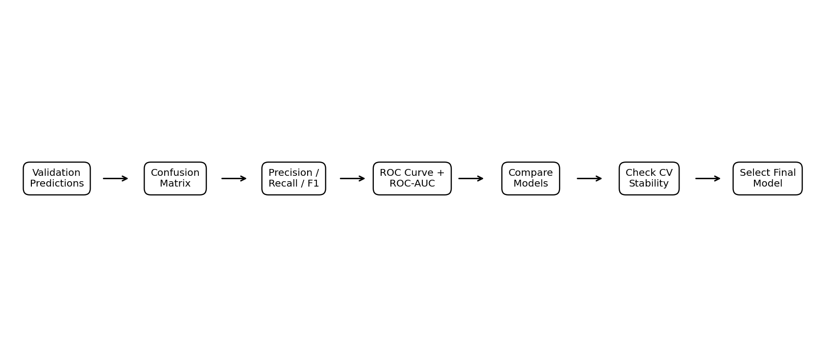
Figure 1. Planned model evaluation and validation flow

11. Overall Machine Learning Workflow
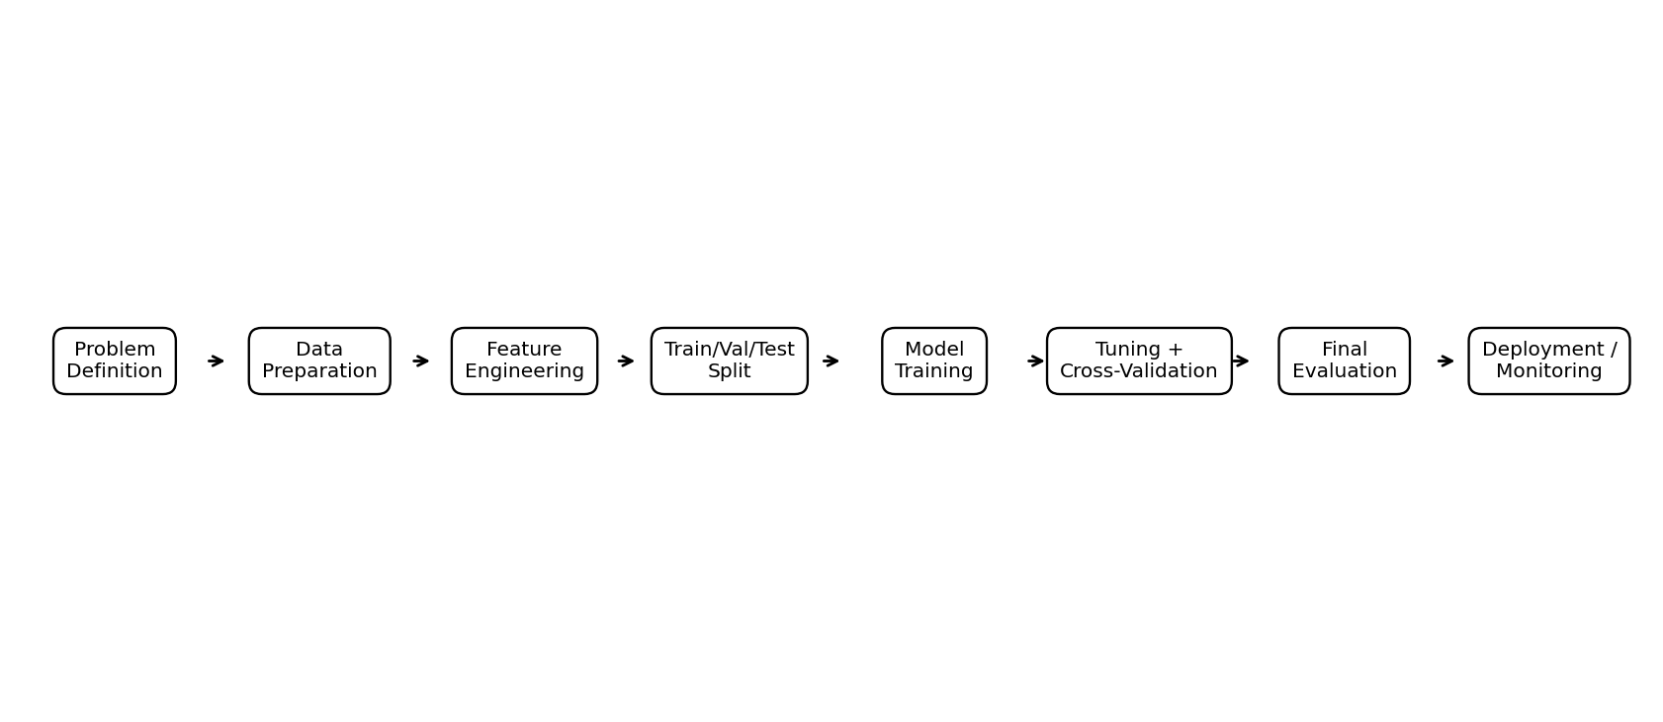
Figure 2. Planned end-to-end machine learning workflow

11.1 Component interaction
Component | Input | Action | Output
Problem definition | Business question | Define target, prediction point, and success criteria. | Classification objective.
Preprocessing | Raw customer data | Clean, encode, scale where required, prevent leakage. | Model-ready features.
Feature engineering | Cleaned features | Create meaningful behaviour-based variables. | Candidate feature set.
Training | Features + labels | Fit candidate classifiers. | Candidate models.
Tuning + validation | Training data + candidates | Compare stability and tune settings. | Selected model settings.
Final evaluation | Held-out test set | Measure performance and inspect errors. | Final evaluation.
Deployment plan | Final model + requirements | Plan serving, monitoring, and updates. | Maintainable ML workflow.

12. Concrete Illustrative Example
The following small table is only an illustrative example to explain the planned reasoning. It is not an actual dataset or result.
Customer | Tenure | Orders | Avg. order value | Days since purchase | Support | Churn
C001 | 18 months | 12 | ₹850 | 18 | 1 | No
C002 | 7 months | 3 | ₹620 | 74 | 4 | Yes
C003 | 30 months | 20 | ₹910 | 12 | 0 | No
C004 | 10 months | 5 | ₹540 | 61 | 3 | Yes
C005 | 24 months | 9 | ₹760 | 29 | 1 | No

C002 and C004 have longer purchase gaps and more support contacts than several other illustrative customers. A real model would learn from many labelled examples; this table only shows why recency and support activity could be considered candidate predictors.

13. Class Imbalance Plan
The churn versus non-churn distribution will be checked before training. If churn is uncommon, accuracy alone will not be sufficient. Stratified splitting will preserve class proportions, and class weights can be tested. Oversampling would only be considered on training folds and never on the held-out test data.

14. Error Analysis Plan
• Review false negatives because these are missed churners.
• Review false positives because they may cause unnecessary retention actions.
• Compare errors across meaningful customer groups when enough data exists.
• Check whether errors cluster around recency, tenure, or spending ranges.
• Use findings to decide whether features, thresholds, or additional data need revision.

15. Optional Deployment and Maintenance Plan
If the final model performs adequately, it could be exposed through a simple API or internal dashboard that accepts customer features and returns a churn probability. A production system would also need input validation, access control, logging, monitoring, and model versioning.
• Monitor feature distributions and prediction behaviour.
• Track model performance when reliable outcome labels become available.
• Retrain periodically or when drift or performance degradation is detected.
• Keep model and preprocessing versions for reproducibility.
• Review whether the model continues to support the business objective.

16. Challenges and Mitigation
Challenge | Possible impact | Mitigation
Class imbalance | Model may favour non-churn. | Stratification, relevant metrics, class weights, and training-only resampling if justified.
Data leakage | Overly optimistic validation. | Define prediction point and use pipelines.
Overfitting | Weak unseen performance. | Cross-validation, regularization, and tree-complexity controls.
Too many features | Noise and complexity. | Business relevance and redundancy checks.
Changing behaviour | Performance can fall over time. | Monitor drift and plan retraining.
Unclear churn definition | Labels may not match business needs. | Agree on a measurable churn rule first.

17. Planned Timeline – Approximately 32 Hours
Activity | Hours | Output
Problem and target definition | 2 | Churn definition and success criteria.
Dataset understanding and preprocessing design | 4 | Cleaning, leakage, encoding, scaling plan.
Feature engineering and selection | 4 | Candidate feature set and rationale.
Train/validation/test strategy | 2 | Split and cross-validation plan.
Candidate model design | 4 | Logistic Regression, Decision Tree, Random Forest plan.
Training and hyperparameter tuning | 5 | Parameter-search strategy.
Evaluation and error analysis | 5 | Metric and error-analysis framework.
Deployment/maintenance planning | 2 | Conceptual maintenance plan.
Documentation and final review | 4 | Final report and consistency checks.

Total planned effort: 32 hours.

18. Expected Outcomes
• Clear ML problem and target definition.
• Reproducible preprocessing and feature-engineering plan.
• Fair comparison framework for three candidate classifiers.
• Validation strategy that reduces leakage and overfitting.
• Metric framework that considers false-positive and false-negative costs.
• Documented path from model selection to possible deployment and monitoring.

19. Limitations and Assumptions
• No real dataset was supplied, so no actual training or performance results are reported.
• Feature names and churn rule are illustrative and would need confirmation with real data.
• The 70/30 split is an example; the final strategy depends on dataset size and time structure.
• Model selection is intentionally left open until the defined procedure is executed.

20. Conclusion
This Week 3 plan connects the earlier EDA work with the machine learning stage of the e-commerce customer churn project. It covers problem definition, preprocessing, feature engineering, data splitting, candidate models, tuning, evaluation metrics, cross-validation, error analysis, and an optional deployment path. The plan is designed so a real dataset can be inserted later without changing the overall structure. The focus is on avoiding leakage, selecting suitable metrics, checking stability, and keeping the model useful for the business problem.

