WEEK 2 TASK
Exploratory Data Analysis (EDA)
and Visualization Framework Design
Hypothetical Framework for an E-Commerce Customer Churn Dataset
Item | Details
Task Type | Data Science planning and analysis framework
Project Context | E-Commerce Customer Churn Prediction
Focus | EDA, data quality, visualization, and reporting
Planned Environment | Python and Jupyter Notebook
Main Libraries | Pandas, NumPy, Matplotlib, Seaborn, Plotly
Planned Effort | Approximately 32 hours

Prepared as a Week 2 planning deliverable

1. Introduction to Exploratory Data Analysis
Exploratory Data Analysis (EDA) is the stage where a dataset is examined before building a final model or drawing conclusions. The main purpose is to understand what the data contains, check its quality, find useful patterns, and identify problems that could affect later analysis. EDA is not limited to making charts. It combines summary statistics, data-quality checks, visual exploration, and interpretation.
For this Week 2 framework, the hypothetical project is an e-commerce customer churn prediction problem. The dataset is assumed to contain customer information such as customer tenure, order frequency, average order value, number of support interactions, and a churn indicator. No actual dataset is used in this task; the report describes how the analysis would be carried out when a suitable dataset becomes available.
A structured EDA process helps prevent decisions based on incorrect or incomplete data. For example, a missing value in customer tenure should be handled before calculating averages, while an unusually high order value should be checked before deciding whether it is a genuine customer purchase or a data-entry problem.

2. Potential Data Types and Dataset Structure
The first step after receiving a dataset would be to identify the data types and understand what each column represents. The exact columns would depend on the dataset, but the following structure is suitable for planning.
Variable Type | Possible Examples | EDA Purpose
Numerical – continuous | Average order value, spending amount | Distribution, spread, outlier checks
Numerical – discrete | Number of orders, support tickets | Counts and frequency patterns
Categorical – nominal | Payment method, city, device type | Group comparisons
Categorical – ordinal | Customer satisfaction level | Ordered comparisons
Boolean / binary | Churned: Yes/No | Target distribution and group analysis
Date / time | Signup date, last purchase date | Trends and recency analysis

Before analysis, the column names, data types, units, and meaning of important variables would be documented. This prevents confusion later, especially when the same concept can be represented in different ways.

3. Initial Data Inspection and Quality Checks
The analysis would begin with a basic inspection rather than immediately creating charts. Pandas would be used to load the dataset and understand its structure.
• Check the number of rows and columns.
• Display the first and last few records.
• Review column names and data types.
• Check missing values and duplicate records.
• Generate descriptive statistics for numerical variables.
• Review unique values and category frequencies.
• Check date columns for invalid or inconsistent values.
• Check whether the target variable, churn, is reasonably represented.
Typical Pandas functions for this stage would include head(), tail(), shape, info(), describe(), isna().sum(), duplicated().sum(), and value_counts(). These checks provide a quick picture of the dataset before deeper exploration.

4. Data Cleaning Plan
Cleaning decisions would be made based on the meaning and quality of the data rather than applying the same rule to every column.
• Missing values: measure the amount and pattern of missingness first. Numerical values may be imputed with a suitable statistic when justified, while categorical values may use a meaningful category or another appropriate method.
• Duplicates: identify exact duplicates and investigate repeated customer records before removing them.
• Invalid values: check for impossible values such as negative order amounts or invalid dates.
• Outliers: identify unusual observations using plots and statistical methods, then determine whether they are valid observations or errors.
• Inconsistent categories: standardize spelling, capitalization, or category labels where appropriate.
The cleaned data would be kept separately from the raw input so that the original information is not overwritten. Important cleaning decisions would also be recorded in the project notes.

5. Data Exploration Techniques

5.1 Univariate Analysis
Univariate analysis studies one variable at a time. For numerical variables, the analysis would include measures such as mean, median, minimum, maximum, standard deviation, and quartiles. Histograms and box plots would be used to understand distribution and spread. For categorical variables, frequency tables and bar charts would show the most common categories.

5.2 Bivariate Analysis
Bivariate analysis examines the relationship between two variables. For example, average order value could be compared between churned and retained customers. A scatter plot could be used to examine the relationship between order frequency and spending, while grouped bar plots could compare churn rates across customer categories.

5.3 Multivariate Analysis
Multivariate analysis considers several variables together. A correlation matrix can show relationships among numerical variables, while grouped or faceted visualizations can help compare several customer characteristics at the same time. The aim is to identify patterns that may not be visible when variables are studied separately.

6. Handling Missing Data and Outliers
Missing data would first be quantified rather than automatically deleted. If only a small number of values are missing and the variable is suitable for imputation, an appropriate method can be considered. If a column has extensive missingness or has an important business meaning, the decision would be documented and reviewed.
Outliers would be investigated using box plots, the interquartile range (IQR), and domain knowledge. An extreme value is not automatically an error. For example, a high-value order may be a genuine purchase. Removing valid observations simply because they are unusual could distort the analysis.
Lower limit = Q1 − 1.5 × IQR Upper limit = Q3 + 1.5 × IQR

7. Proposed EDA Workflow
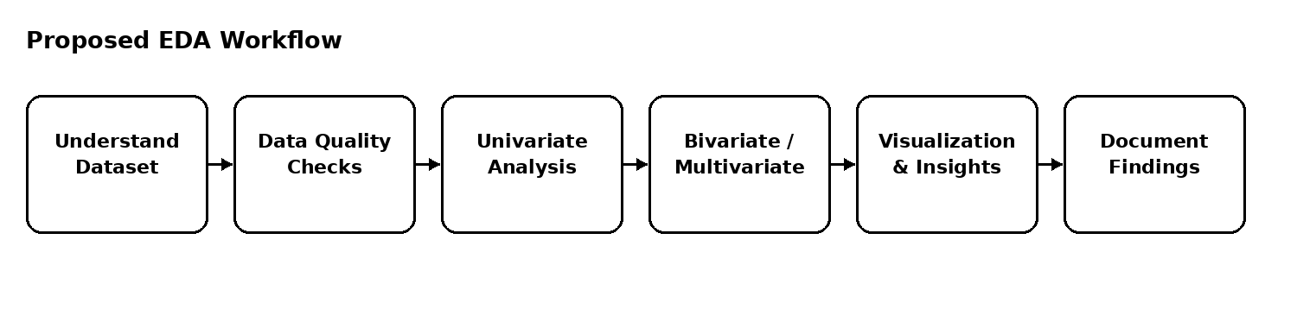
Figure 1. Planned workflow from dataset understanding to documented findings.

8. Visualization Strategy
Visualizations would be selected according to the question being investigated. The goal is not to create a large number of charts, but to choose charts that make the relevant pattern easier to understand.
Question / Purpose | Recommended Visualization | What It Can Show
How is a numerical variable distributed? | Histogram | Shape, concentration, skewness
Are there extreme numerical values? | Box plot | Median, spread, potential outliers
How do categories compare? | Bar chart | Counts or aggregated values
How are two numerical variables related? | Scatter plot | Trend, clusters, unusual observations
How do groups differ? | Box plot / grouped bar chart | Differences between customer groups
Which numerical variables move together? | Correlation heatmap | Strength and direction of pairwise correlation
How does a value change over time? | Line chart | Trend and possible seasonality

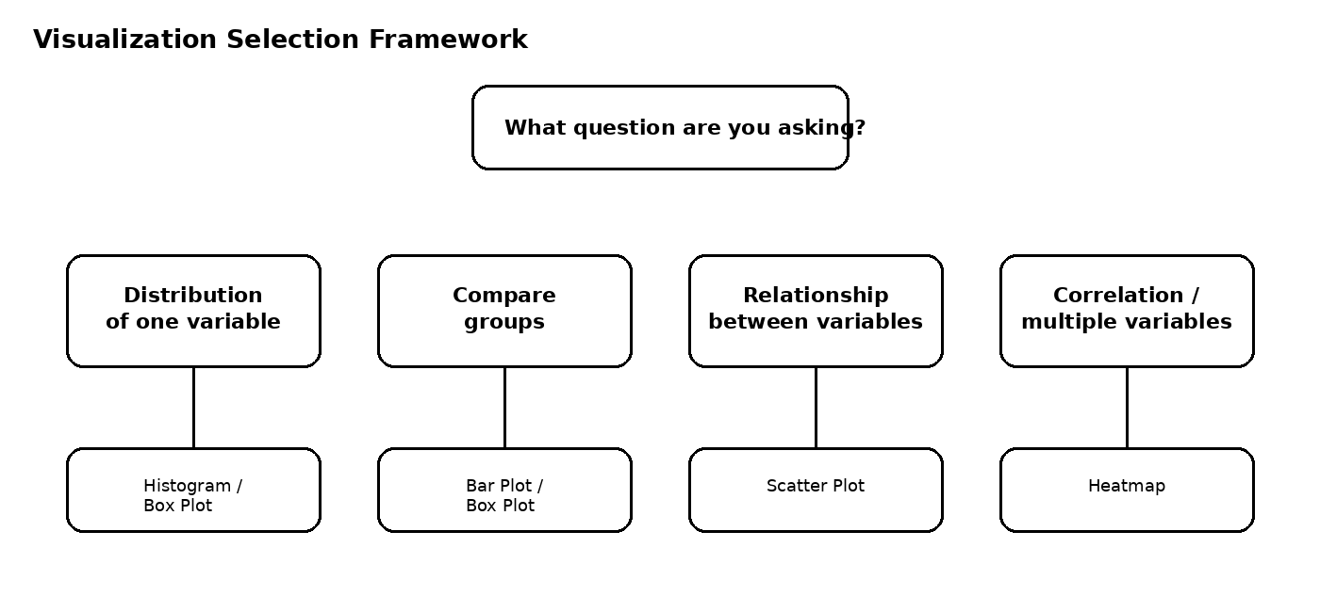
Figure 2. Example decision framework for choosing a visualization.

9. Python Tools and Libraries
Tool / Library | Planned Use
Python | Main programming language for the analysis.
Jupyter Notebook | Interactive environment for documenting code, observations, and results.
Pandas | Data loading, inspection, cleaning, grouping, and tabular analysis.
NumPy | Numerical operations and array-based calculations.
Matplotlib | Basic and customizable charts.
Seaborn | Statistical visualizations with clear plotting structures.
Plotly | Interactive charts when interactive exploration is useful.

Scikit-learn may be introduced later if the project proceeds from EDA into predictive modeling. It is not required for the core EDA framework itself.
9.1 Illustrative Python Snippets
The following short snippets show how the planned EDA steps could be implemented when a real dataset is available. They are examples only and were not executed for this planning task because no dataset was supplied.
Load and inspect the dataset
import pandas as pd
df = pd.read_csv("customer_data.csv")
print(df.shape)
print(df.info())
print(df.head())
print(df.isna().sum())
Summarize numerical variables
summary = df.describe()
print(summary)
Check churn distribution
print(df["churn"].value_counts(dropna=False))
df["churn"].value_counts().plot(kind="bar")
plt.xlabel("Churn")
plt.ylabel("Number of customers")
plt.title("Customer Churn Distribution")
Inspect a relationship with a scatter plot
import seaborn as sns
import matplotlib.pyplot as plt
sns.scatterplot(
data=df,
x="orders",
y="average_order_value",
hue="churn"
)
plt.title("Orders vs Average Order Value")

10. Reporting and Documentation Plan
Each major finding would be recorded along with the chart or statistic that supports it. The report would distinguish between an observation and a conclusion. Instead of simply stating that a variable is important, the analysis would describe the observed relationship and explain why it may matter for the project.
• Project background and analysis objective
• Dataset description and data dictionary
• Data quality findings
• Cleaning decisions
• Univariate analysis
• Bivariate and multivariate analysis
• Key visualizations and observations
• Limitations and assumptions
• Summary of findings and next steps

11. Planned Timeline – Approximately 32 Hours
Stage | Planned Work | Hours
1 | Understand dataset structure and define analysis questions | 3
2 | Initial inspection and data-quality checks | 4
3 | Missing-value, duplicate, and consistency review | 4
4 | Univariate exploration | 5
5 | Bivariate and multivariate exploration | 5
6 | Visualization development and refinement | 4
7 | Interpretation and documentation of findings | 4
8 | Final review and report preparation | 3
Total |  | 32

12. Expected Outcomes and Possible Challenges
The main expected outcome is a reusable EDA framework that can be applied to a new dataset with only minor changes. The analysis should make the dataset easier to understand, reveal data-quality issues, identify useful patterns, and provide a clear foundation for later modeling.
Potential Challenge | Possible Mitigation
Large number of missing values | Measure missingness by column and investigate the reason before choosing a treatment.
Strongly imbalanced churn classes | Report the imbalance clearly and consider suitable evaluation methods in the later modeling stage.
Extreme observations | Use visual and statistical checks and confirm whether extreme values are genuine.
Many categorical variables | Group rare categories where appropriate and use clear frequency-based visualizations.
Too many charts | Select visuals based on specific analysis questions rather than producing charts without a purpose.
Misleading interpretation | Record the evidence behind each finding and avoid treating correlation as proof of causation.

13. Limitations and Assumptions
This assignment is a planning exercise and does not use an actual dataset. Therefore, the report does not claim any real customer behavior or actual churn patterns. The examples of variables and visualizations are proposed only to demonstrate how the analysis would be organized. When a real dataset is provided, the exact cleaning rules, plots, and interpretations would be adjusted to match its contents and business context.

14. Conclusion
This Week 2 framework provides a practical plan for performing EDA on a hypothetical e-commerce customer churn dataset. Unlike the Week 1 project-planning task, this report focuses specifically on how the data would be inspected, cleaned, explored, visualized, and documented before any predictive model is built.
The final purpose of EDA is to turn a raw dataset into a clearer understanding of its structure and possible patterns. A well-documented EDA stage can also reduce problems in later modeling because data-quality issues and assumptions are identified early.

15. Concrete Illustrative EDA Example
Because the internship task does not provide a real dataset, the following values are only a small illustrative example created to show how the planned EDA would work. They are not actual customer results and should not be interpreted as findings.
Customer ID | Tenure (months) | Orders | Avg. Order Value (₹) | Days Since Last Purchase | Support Contacts | Churn
C001 | 18 | 12 | 850 | 18 | 1 | No
C002 | 7 | 3 | 620 | 74 | 4 | Yes
C003 | 30 | 20 | 910 | 12 | 0 | No
C004 | 10 | 5 | 540 | 61 | 3 | Yes
C005 | 24 | 9 | 760 | 29 | 1 | No

For example, in this small illustration, C002 and C004 have longer gaps since their last purchase and more support contacts than several retained customers. In a real dataset, I would not call this a confirmed churn pattern from only five records. I would test the pattern using the full dataset, compare distributions between churn groups, and check whether the difference remains after considering other variables.

15.1 Example Questions and Expected EDA Checks
Question | Planned Check | Possible Interpretation
Do churned customers have longer purchase gaps? | Compare days_since_last_purchase using box plots and group medians. | A higher median among churned customers would make recency a variable worth investigating further.
Are high support contacts associated with churn? | Compare support_contacts by churn status and inspect a grouped chart. | A visible difference would justify deeper investigation, but would not by itself prove that support contacts cause churn.
Does order frequency differ between groups? | Compare purchase_frequency distributions for churned and retained customers. | A lower distribution for churned customers could indicate reduced engagement.
Are spending variables strongly related? | Use a correlation heatmap for numerical features. | High correlation can reveal redundancy and may affect later feature selection.

16. Component Interaction and Analysis Flow
The EDA framework is designed as a sequence of connected components. Each component produces information that is used by the next one. The workflow is not simply a list of unrelated charts.
Component | Input | Action | Output Used By Next Stage
1. Data loading | Raw CSV/Excel/database export | Load data with Pandas and preserve the raw copy. | DataFrame used for profiling.
2. Data profiling | DataFrame | Check shape, types, missing values, duplicates, unique values, and basic statistics. | Data-quality issue list.
3. Cleaning | Issue list + raw data | Handle missing, invalid, duplicate, and inconsistent records using documented rules. | Clean analysis dataset.
4. Univariate analysis | Clean analysis dataset | Study one variable at a time using statistics and distribution plots. | Distribution and quality observations.
5. Bivariate analysis | Clean data + selected variables | Compare groups and examine relationships between pairs of variables. | Candidate relationships for deeper analysis.
6. Multivariate analysis | Clean data + important variables | Examine several variables together using correlation and grouped visualizations. | More complete pattern view.
7. Interpretation | All EDA outputs | Compare evidence, check assumptions, and separate observations from conclusions. | Validated findings and limitations.
8. Reporting | Validated findings + charts | Document the question, method, result, and limitation for each major finding. | Final EDA report and next-step recommendations.

16.1 Example of Component Interaction
Suppose the initial profiling shows that days_since_last_purchase contains missing values. That issue is handled before the recency distribution is plotted. After cleaning, the variable can be compared across the churn groups. If the comparison shows a noticeable difference, a follow-up analysis can examine whether the same pattern remains across customer-tenure groups. The final report would then describe the evidence, the limitations of the comparison, and whether the variable should be considered in later modeling.

17. What Would Count as a Useful EDA Finding?
A useful EDA finding should connect a question, evidence, and interpretation. For example: “The churn group shows a wider distribution of days since the last purchase in the analyzed dataset.” This is different from claiming “long purchase gaps cause churn,” because EDA can reveal association but does not establish causation. This distinction would be maintained throughout the report.

18. Diagram Reference
Figure 1 is embedded in this DOCX and shows the planned EDA workflow: understand the dataset → check data quality → perform univariate analysis → perform bivariate and multivariate analysis → create visualizations and interpret insights → document findings.
Figure 2 is embedded in this DOCX and shows how the visualization is selected according to the question: distribution → histogram or box plot; group comparison → bar plot or box plot; relationship between two numerical variables → scatter plot; multiple numerical variables → correlation heatmap.

Appendix A – EDA Checklist
• Understand the dataset and define analysis questions.
• Inspect dimensions, column names, and data types.
• Check missing values and duplicates.
• Check invalid and inconsistent values.
• Summarize numerical and categorical variables.
• Perform univariate analysis.
• Perform bivariate analysis.
• Perform multivariate analysis where useful.
• Investigate outliers.
• Create question-driven visualizations.
• Record observations and limitations.
• Prepare a structured final report.

Appendix B – Submission Description
This Week 2 report presents a planned framework for Exploratory Data Analysis and data visualization using Python. The task is based on a hypothetical e-commerce customer churn dataset, so no real dataset or final analysis results are claimed in the report. The main purpose was to design a practical process that could be followed when a dataset is provided. The framework begins with understanding the dataset structure, identifying numerical, categorical, binary, and date-related variables, and performing initial data-quality checks. It then covers missing values, duplicate records, inconsistent entries, and possible outliers. The report explains univariate, bivariate, and multivariate analysis and describes how each can help reveal useful patterns. A visualization strategy is also included, with examples such as histograms, box plots, bar charts, scatter plots, line charts, and correlation heatmaps. The choice of a chart is linked to the type of question being investigated instead of creating charts without a clear purpose. The report also lists the planned Python tools, including Pandas, NumPy, Matplotlib, Seaborn, Plotly, and Jupyter Notebook, and explains the role of each tool in the analysis. A 32-hour work plan is provided to organize the different stages from initial inspection to documentation. Possible challenges such as missing data, outliers, class imbalance, and misleading interpretations are discussed along with practical mitigation steps. Overall, the deliverable focuses on building a clear and reusable EDA process that can be adapted to different datasets and can provide a strong foundation for later data science and machine learning work.

