COMPREHENSIVE DATA SCIENCE REPORT
AND INSIGHTS PRESENTATION PLAN
E-Commerce Customer Churn Prediction
Week 4 Internship Assignment
Note: The numbers and charts used in this report are sample values for demonstrating the reporting approach. No real dataset was supplied for this assignment.

1. Executive Summary
This report explains how I would present the results of the E-Commerce Customer Churn Prediction project to a business audience. The main idea is simple: use customer data to find behaviour patterns that may help the company identify customers who are likely to leave, and then turn those findings into practical retention actions.
For the project, I have considered customer details such as how long a customer has been with the company, number of orders, average order value, days since the last purchase, and support interactions. The planned analysis includes checking the data, exploring the main variables, preparing features, building classification models, comparing their performance, and explaining the results using simple charts and tables.
Since the internship task does not provide a real dataset, the charts and numerical examples in this report are only sample values. They show how the final findings could be written once the actual analysis is completed. I have also included a presentation plan so that the technical work can be explained to someone who may not have a data science background.

2. Project Purpose and Business Question
The business problem is to understand customer churn and identify useful warning signs before a customer leaves. A churn model should not be treated as the final answer by itself. The useful part is being able to use its output to decide which customers need attention and what kind of action should be tested.

Main questions
• Which customer behaviours are related to churn?
• Are newer customers more likely to leave?
• Does a longer gap since the last purchase indicate higher churn risk?
• Is frequent customer support contact a useful warning sign?
• How can the model output be used to plan customer retention activities?

3. Data Used for the Planned Analysis
No real dataset was supplied with the assignment, so the project uses a hypothetical customer dataset. I have assumed that each row represents one customer and that the target column records whether the customer churned.
Field | Type | Example | Use in analysis
Customer_ID | ID | C001 | Identifies a customer; not used as a model feature.
Tenure_Months | Numeric | 18 | Shows how long the customer has been active.
Order_Count | Numeric | 12 | Shows purchase frequency.
Average_Order_Value | Numeric | ₹850 | Shows the usual order value.
Days_Since_Last_Purchase | Numeric | 18 | Shows how recently the customer purchased.
Support_Interactions | Numeric | 1 | Shows the amount of support activity.
Churn | Binary | Yes / No | Target variable for the classification problem.

These fields are examples of what could be used. If an actual dataset is provided later, the column names, data types and available variables would first be checked before making any conclusions.

4. Methodology Overview
The analysis would be carried out in stages. I would first make sure the problem and churn definition are clear, then check the quality of the data. After that, I would explore the variables and look for useful patterns. The selected features would be prepared for modelling, and different classification models would be compared using the same validation approach. The final step would be to explain what the results mean for the business.
Stage | What I would do | Expected output
Problem definition | Define churn and the business decision the model should support. | Clear target and project goal.
Data checking | Check missing values, duplicates, invalid values and unusual ranges. | Cleaner and more reliable data.
Exploratory analysis | Compare customer groups and study important relationships. | Possible churn patterns.
Feature preparation | Encode categories and create useful behaviour features where required. | Model-ready data.
Model development | Compare Logistic Regression, Decision Tree and Random Forest. | Candidate models.
Validation | Use stratified cross-validation and a separate test set. | More reliable performance estimate.
Interpretation | Review metrics, errors and important variables. | Useful model and business insights.
Reporting | Present the main findings with simple visuals and recommendations. | Business-ready report.

5. Illustrative Findings and Analysis
The next three sections show the type of findings I would report after analysing a real dataset. The values below are sample values only. They are included to demonstrate the presentation style and are not being claimed as actual project results.

5.1 Customer tenure
In the sample scenario, customers with 0–6 months of tenure have a churn rate of 34%, while customers with more than 25 months have a churn rate of 9%. If a real analysis showed a similar pattern, I would look more closely at the first few months of the customer journey. It could point to a need for better onboarding or earlier engagement.
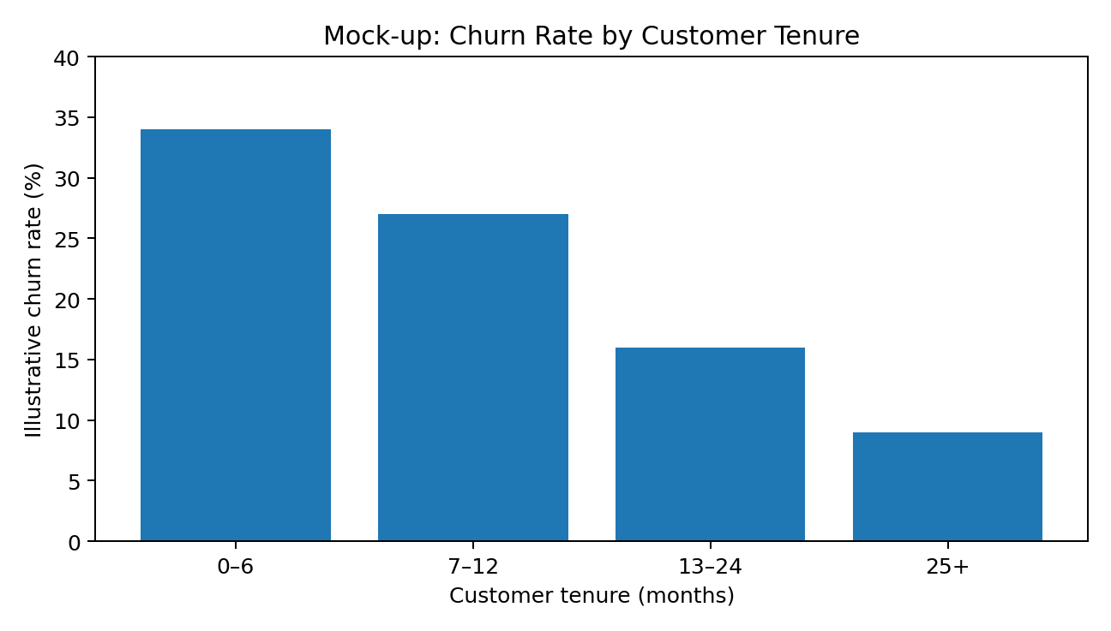
Figure 1. Sample chart showing how churn could be compared across tenure groups. Values are illustrative.
I would avoid saying that shorter tenure causes churn. The chart only shows a difference between groups. Other factors would need to be checked before making a stronger conclusion.

5.2 Purchase recency
In the sample comparison, retained customers have an average of 21 days since their last purchase, while churned customers have an average of 67 days. If the actual data showed this type of difference, purchase recency could be monitored as an early warning signal.
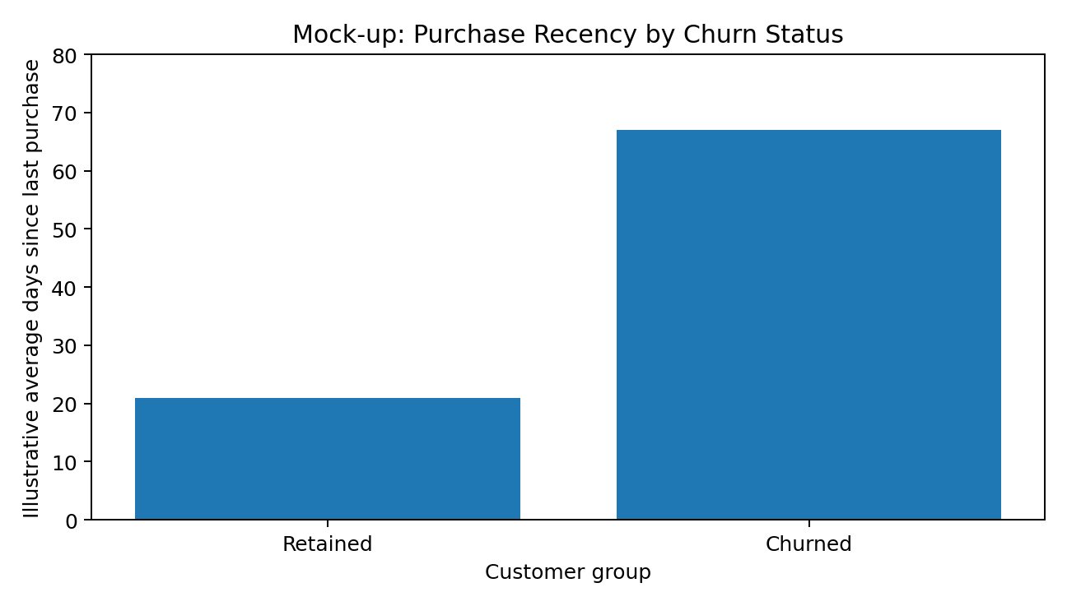
Figure 2. Sample chart comparing purchase recency for retained and churned customers. Values are illustrative.
A possible business action would be to contact customers whose activity has dropped, using an appropriate reminder or recommendation. The threshold should be decided from the actual data rather than chosen only because it looks good in a chart.

5.3 Support interactions
The sample data shows 1.1 average support interactions for retained customers and 3.6 for churned customers. This could be a useful signal, but it does not mean that support contact itself causes churn. A customer may contact support more often because they are already facing a problem.
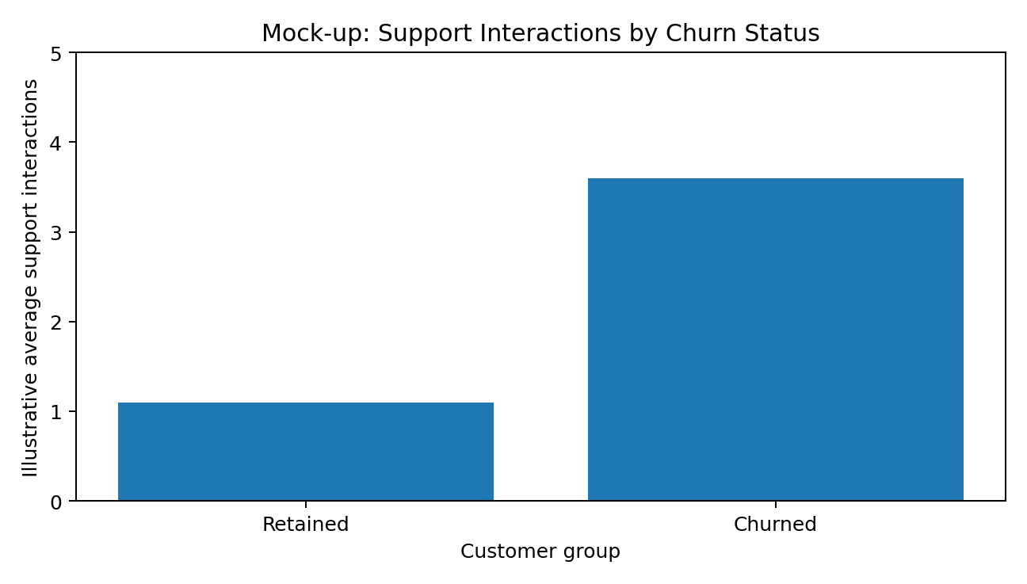
Figure 3. Sample chart comparing support interactions by churn status. Values are illustrative.
If this pattern appeared in the real data, I would check the type of issue, resolution time and customer satisfaction before suggesting a business action.

6. How the Findings Would Be Interpreted
I would not treat a chart or model score as a conclusion on its own. Before making a recommendation, I would check the size of each group, missing values, possible outliers and whether the same pattern is visible across different customer segments.
Pattern to investigate | Checks needed | Possible meaning | Possible response
Higher churn among newer customers | Compare group sizes and other customer characteristics. | New customers may not be fully engaged. | Improve onboarding and early follow-up.
Longer gaps between purchases | Check the full recency distribution and related behaviour. | Reduced activity may be a warning sign. | Test targeted re-engagement.
More support interactions | Check issue type, resolution time and satisfaction. | Repeated problems may be linked with churn. | Prioritize unresolved customer issues.
Many false positive predictions | Check precision and confusion matrix. | Too many customers may be flagged. | Review the prediction threshold.
Many false negative predictions | Check recall and missed churners. | Some at-risk customers may be missed. | Review features and threshold.

7. Mock-up of an Executive Dashboard
For a manager or business stakeholder, I would keep the first page simple. The dashboard should show only the numbers and visuals needed to understand the problem and decide what to do next.
Dashboard item | Sample value | What it would tell the reader
Customers analysed | 10,000 | Size of the customer group being studied.
Churn rate | 18% | Share of customers who churned in the sample scenario.
Higher-risk segment | 0–6 months | Group that may need closer attention.
Behaviour to monitor | Purchase recency | Long inactivity may be a useful warning signal.
Model metric | ROC-AUC | One measure of how well the model separates the two classes.
Suggested action | Early retention outreach | A possible action to test after validating the findings.

All values in this dashboard are placeholders for demonstrating the report layout.

8. Visualization Plan
Question | Visual | Why I would use it
How is churn distributed? | Bar chart | Easy way to compare retained and churned customers.
Does churn change with tenure? | Bar chart | Makes differences between tenure groups easy to see.
Does purchase recency differ? | Box plot or bar chart | Shows the typical value and, where needed, the spread.
How are two numeric variables related? | Scatter plot | Useful for seeing relationships and unusual observations.
Which numeric variables are related? | Correlation heatmap | Gives a quick view of relationships across several variables.
How is the model performing? | Confusion matrix and ROC curve | Shows classification errors and overall separation ability.

9. Presentation Strategy for a Non-Technical Audience
I would present the results as a short story instead of starting with technical terms. The order would be: what the business problem is, what the data shows, why the pattern matters, and what the company could do about it. Technical metrics would still be included, but they would be explained in simple language.
1. Start with the business problem and explain why customer churn matters.
2. Show one or two important findings with clear visuals.
3. Explain what the patterns could mean and mention any important limitations.
4. Explain model performance using the most useful metrics rather than showing every technical output.
5. Connect the findings to a specific action that the business could test.
6. Finish with the next steps and the measures that should be tracked.

Suggested presentation flow
Slide | Main point | Visual
1 | Why churn matters | One KPI and a short problem statement
2 | Which customers look more at risk? | Tenure/churn chart
3 | What behaviour may indicate risk? | Recency and support charts
4 | How reliable is the model? | Confusion matrix and ROC curve
5 | What should we do? | Recommendation/action table
6 | How will we know if it worked? | Simple monitoring KPIs

10. Recommendations and Next Steps
• Pay closer attention to customers during their early months and test whether better onboarding improves retention.
• Monitor purchase recency and test whether an appropriate inactivity threshold helps identify customers who need attention.
• Study repeated support issues together with resolution time and satisfaction instead of using support count alone.
• Use model risk scores to prioritize customers rather than treating every customer as equally likely to churn.
• Choose the prediction threshold by considering the cost of missing a churner and the cost of contacting a customer who would not have churned.
• Test retention actions through controlled experiments and measure whether customers actually return or remain active.
• Review model performance over time because customer behaviour and business conditions can change.

11. Limitations and Possible Problems
Issue | Why it can cause a problem | How I would handle it
No real dataset | Real findings cannot be claimed yet. | Keep all sample values clearly labelled and replace them after analysis.
Class imbalance | Accuracy may look good even when churners are missed. | Use precision, recall, F1-score and ROC-AUC along with the confusion matrix.
Correlation vs. causation | A relationship does not prove that one variable causes another. | Use careful wording and test business actions separately.
Data leakage | Using future information can make the model look better than it really is. | Keep preprocessing inside the validation process and exclude future information.
Changing behaviour | A model can become less useful when customer behaviour changes. | Monitor performance and review/retrain the model when necessary.
Too much technical detail | The main business message can get lost. | Keep the presentation focused on the decision and use simple visuals.

12. Planned Work Timeline – 32 Hours
Work | Hours | Output
Review the project goal and business questions | 3 | Final reporting scope
Review the analysis method and assumptions | 4 | Methodology section
Prepare sample findings and interpretations | 5 | Findings section
Prepare charts, tables and dashboard mock-up | 6 | Visual aids
Plan the presentation story | 4 | Presentation structure
Prepare recommendations | 3 | Action plan
Check consistency and limitations | 2 | Quality check
Format and proofread the report | 3 | Final document
Final assignment/rubric check | 2 | Submission-ready report
Total | 32 | Complete Week 4 report

13. From Model Output to Business Action
The model should not be treated as the end of the project. Once a model is validated, its predictions can be used to create customer risk groups. The business can then decide which group should receive an intervention and measure whether that intervention actually improves retention.
Step | Question | Measure
Risk scoring | Which customers have higher predicted risk? | Number/share of high-risk customers.
Business rule | Who should receive an intervention? | Eligible customers and campaign cost.
Intervention | What action should be tested? | Offer, reminder, recommendation or service follow-up.
Experiment | Did the action change behaviour? | Reactivation or retention rate.
Business result | Was the action useful compared with its cost? | Retained revenue and cost per retained customer.
Model review | Is the model still working well? | Performance and data/model drift.

14. Conclusion
This report gives a practical structure for presenting the customer churn project to a business audience. It brings together the project purpose, methodology, sample findings, visualizations, presentation plan and recommendations in one place. The main focus is on explaining what the analysis could mean for the business and how the results could be used.
Because no real dataset was provided, the charts and numbers in this report are only examples. Once real data is available, the same structure can be used with actual statistics and validated model results. This keeps the report clear and useful without presenting sample information as if it were measured evidence.

