WEEK 1 TASK
Data Science Project Planning
and Strategy Design
Hypothetical Project: E-Commerce Customer Churn Prediction
A structured plan for applying Python-based data science to understand
customer churn and identify factors associated with customer retention.

Project Type | Hypothetical Data Science Project
Project Domain | E-Commerce Customer Analytics
Planned Effort | 32 hours
Main Tools | Python, Jupyter Notebook, Pandas, NumPy, Matplotlib, Seaborn, Scikit-learn

Prepared for the Week 1 assignment

1. Project Background and Introduction
For this project, I have considered an e-commerce company that wants to understand why some customers stop purchasing. The company may already have information such as purchase frequency, average order value, last purchase date and customer-support interactions. Looking at these details can help us find patterns related to customers leaving.
The project is intentionally planned before working with a real dataset. This allows the data science process, assumptions, success criteria, analysis strategy, and technical architecture to be defined first. Once data becomes available, the plan can be implemented and adjusted based on data quality and observed patterns.

1.1 Problem Statement
The company has customer and transaction records, but it does not have a simple way to identify customers who may leave. I would use the available customer information to study their behaviour and build a model that predicts whether a customer is likely to churn during a selected future period.

1.2 Motivation
• Convert historical customer data into actionable analytical insights.
• Identify behavioral and service-related factors associated with churn.
• Create a reproducible Python workflow from raw data to model evaluation.
• Provide a transparent basis for future customer-retention strategies.
• Practice the complete data science lifecycle before implementation.

2. Project Objectives and Scope

2.1 Objectives
- Define a measurable churn prediction problem and target variable.
- Plan the collection and validation of customer, transaction, engagement, and service-related data.
- Clean and preprocess the planned dataset, including missing values, duplicates, inconsistent formats, and outliers.
- Perform exploratory data analysis to discover churn-related patterns and relationships.
- Engineer useful numerical, categorical, and behavioral features.
- Develop and compare suitable classification models using Scikit-learn.
- Evaluate models using appropriate classification metrics rather than relying only on accuracy.
- Document findings, limitations, and recommendations for future implementation.

2.2 In Scope
• Customer-level churn prediction.
• Data quality assessment and preprocessing.
• Exploratory analysis and visualization.
• Feature engineering and feature importance analysis.
• Baseline and machine learning classification models.
• Model evaluation, comparison, and documentation.
• A conceptual deployment and reporting plan.

2.3 Out of Scope
• Live production deployment.
• Real-time recommendation or automated customer communication.
• Collection of personally identifiable information.
• Building a complete CRM system.
• Guaranteed business revenue improvement.
• Use of real customer data during the planning stage.

3. Methodology and Strategy
I would follow the normal data science process instead of directly training a model. First I would understand the problem and the data, then clean it, explore it, prepare the features, train a few models and finally evaluate them. If something looks wrong during evaluation, I would go back and improve the earlier steps.
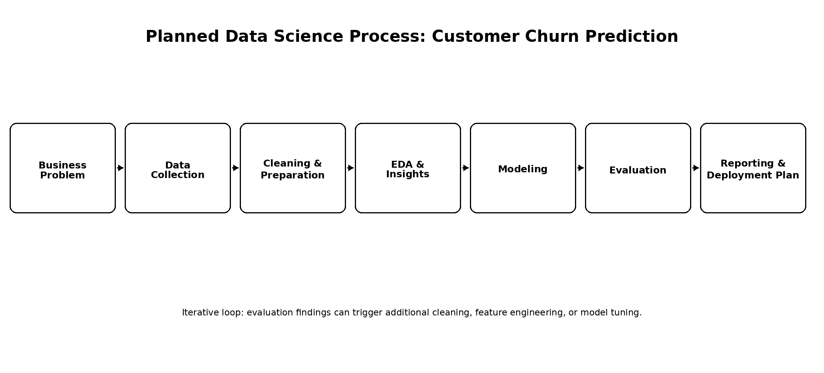
Figure 1. Planned end-to-end data science workflow.

3.1 Data Collection Plan
The planned dataset should contain one row per customer or a well-defined customer-period structure. Candidate fields include customer tenure, purchase frequency, average order value, recency of last purchase, number of support contacts, delivery-related indicators, discount usage, engagement measures, and a binary churn label.
• Define the observation period and prediction window before modeling.
• Document the source, meaning, unit, and expected data type of every field.
• Check whether the target variable is available without information leakage.
• Separate training and testing data before fitting preprocessing steps that learn from data.

3.2 Data Cleaning & Preparation
• Inspect dimensions, data types, duplicate records, missing values, and invalid entries.
• Standardize categorical labels and date formats.
• Treat missing values using rules appropriate to each variable.
• Investigate outliers and determine whether they are genuine observations or data errors.
• Encode categorical variables and scale numerical variables when required by the chosen model.
• Check class balance because churn datasets may contain fewer churned customers than retained customers.

3.3 Exploratory Data Analysis
• Univariate analysis of customer and transaction variables.
• Churn-rate comparison across customer segments.
• Distribution and relationship analysis for numerical variables.
• Correlation analysis where appropriate.
• Visualizations such as histograms, box plots, bar charts, and heatmaps.
• Identification of suspicious patterns, leakage, and potentially useful predictors.

3.4 Modeling Strategy
A simple baseline will be established first. Candidate models may include Logistic Regression, Decision Tree, Random Forest, and Gradient Boosting. The final model will be selected based on the evaluation requirements and interpretability needs rather than model complexity alone.

3.5 Evaluation Strategy
• Use a training and testing split or cross-validation as appropriate.
• Measure precision, recall, F1-score, confusion matrix, and ROC-AUC.
• Pay particular attention to recall and false-negative cases because missed churners may be important.
• Compare the baseline with candidate models using the same evaluation framework.
• Check whether model performance is stable and whether the model has signs of overfitting.

4. Python Libraries and Tools
Tool or Library | Planned Use | Project Stage
Python | Core programming and workflow implementation | All stages
Jupyter Notebook | Interactive analysis, notes, experiments, and reproducibility | All stages
Pandas | Data loading, cleaning, transformation, and analysis | Data Preparation and EDA
NumPy | Numerical operations and array-based computation | Data Preparation and Modeling
Matplotlib | Basic charts and visualizations | EDA and Reporting
Seaborn | Statistical and relationship visualizations | EDA
Scikit-learn | Preprocessing, model training, validation, and metrics | Modeling and Evaluation
Git and GitHub | Version control and project documentation | Project management
The tools are selected to keep the project reproducible, lightweight, and suitable for a Python-based data science workflow.

5. Timeline and Work Allocation
I have planned 32 hours for the work, which is within the required 30–35 hour range. I have kept enough time for cleaning and EDA because understanding the data properly is important before building the model.
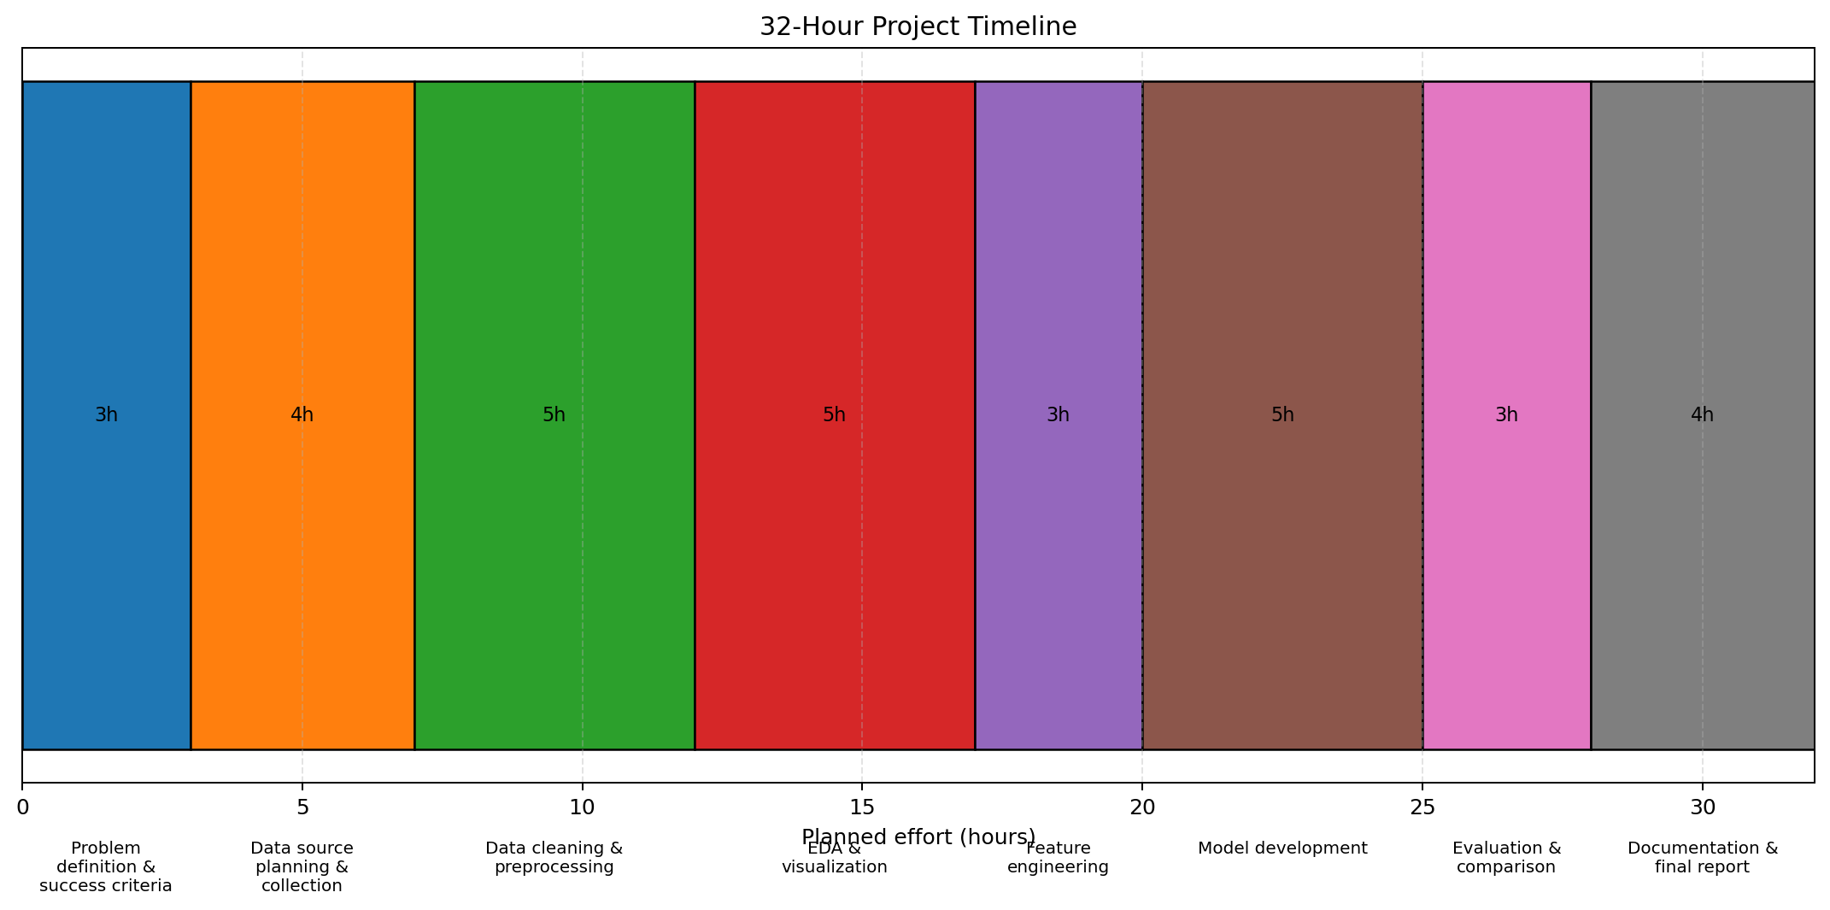
Figure 2. Planned 32-hour effort allocation.
Activity | Hours | Main Deliverable
Problem definition & success criteria | 3 | Problem statement and success metrics
Data source planning & collection | 4 | Data dictionary and acquisition plan
Data cleaning & preprocessing | 5 | Clean modeling-ready dataset plan
EDA & visualization | 5 | Charts and analytical observations
Feature engineering | 3 | Final feature set
Model development | 5 | Baseline and candidate models
Evaluation & comparison | 3 | Metrics and model comparison
Documentation & final report | 4 | Final report and recommendations

6. Expected Outcomes and Benefits
• A clearly defined and reproducible customer-churn data science workflow.
• A documented data dictionary and data-quality checklist.
• EDA findings showing which customer behaviors are associated with churn in the hypothetical dataset.
• A cleaned and transformed feature set suitable for machine learning.
• A baseline classification model and multiple candidate models.
• A model evaluation report using appropriate classification metrics.
• A clear explanation of model limitations and future improvements.
• A structured project report that can be converted into a future implementation plan.

6.1 Anticipated Challenges and Mitigation
Potential Challenge | Impact | Mitigation Strategy
Missing or inconsistent values | Can reduce data quality and model reliability | Profile data early; use variable-specific imputation and validation rules.
Class imbalance | Accuracy may look high while churn detection is poor | Use precision, recall and F1-score, stratified splitting, and suitable resampling only when justified.
Data leakage | Can produce unrealistically strong results | Define prediction timing and fit learned transformations only on training data.
Overfitting | Poor performance on unseen customers | Use cross-validation, simpler baselines, and regularization or pruning where appropriate.
Unclear business definition of churn | Target label may be inconsistent | Agree on a precise churn definition and prediction window before modeling.
Limited interpretability | Stakeholders may not trust complex predictions | Use interpretable baselines and feature importance or explanation methods.

7. Planned Project Architecture
The conceptual architecture separates data handling, analysis, modeling, evaluation, and reporting. This structure makes it easier to reproduce the project and replace individual components later.
Layer | Planned Component
Input | Customer, transaction, engagement, and service data
Preparation | Validation → cleaning → encoding → feature engineering
Analysis | EDA → segmentation → relationship analysis
Modeling | Baseline → candidate classifiers → tuning
Evaluation | Confusion matrix → precision, recall, F1-score → ROC-AUC
Output | Churn predictions → key factors → analytical report

8. Success Criteria
• The project plan covers the full data science lifecycle from problem definition through evaluation.
• The churn target and prediction window are explicitly defined before modeling.
• The workflow includes data-quality checks and leakage prevention.
• At least one baseline and multiple candidate classification approaches are planned.
• Evaluation uses metrics suitable for classification and potential class imbalance.
• The final documentation clearly communicates assumptions, limitations, expected outcomes, and next steps.
• The complete planned effort remains within approximately 30–35 hours.

9. Conclusion
This Week 1 plan gives me a clear starting point for a customer churn prediction project. I have focused on planning the work before jumping into coding or model training. The main steps are to understand the problem, decide what data is needed, clean and explore it, create useful features, try a few classification models and evaluate their results. The 32-hour schedule keeps the work realistic. Once an actual dataset is available, some parts of the plan may need to change depending on the data. The main goal is to follow the data science process in a simple and logical way.

Appendix A – Proposed Data Dictionary (Planning Stage)
Field | Type | Description | Role
customer_id | Categorical | Unique customer identifier | Identifier
tenure_months | Numeric | Months since customer registration | Feature
purchase_frequency | Numeric | Number of purchases in observation period | Feature
avg_order_value | Numeric | Average value per order | Feature
days_since_last_purchase | Numeric | Recency of latest purchase | Feature
support_contacts | Numeric | Number of customer-support interactions | Feature
discount_usage | Numeric | Number or proportion of orders using discounts | Feature
engagement_score | Numeric | Planned composite engagement measure | Feature
churn | Binary | Whether the customer churned within prediction window | Target

Appendix B – Submission Description
This report is my Week 1 plan for a hypothetical e-commerce customer churn prediction project. The idea is to use Python and machine learning to understand customer behaviour and identify customers who may stop purchasing. Since this is only the planning stage, I have not used a real dataset. Instead, I have planned what information would be needed and how I would work with it. The report covers the problem statement, motivation, objectives, scope and the main steps of the data science process. I have included data collection, cleaning, exploratory data analysis, feature engineering, model building and evaluation. For the machine learning part, I would start with Logistic Regression and then compare it with models such as Decision Tree, Random Forest and Gradient Boosting. I would use precision, recall, F1-score, confusion matrix and ROC-AUC along with accuracy so that the model is not judged using only one number. The main Python tools planned for the project are Pandas, NumPy, Matplotlib, Seaborn, Scikit-learn and Jupyter Notebook. I have also divided the work into a 32-hour timeline, with more time given to data cleaning and EDA. Possible problems such as missing values, class imbalance, data leakage and overfitting are discussed, along with simple ways to handle them. The diagrams in the report show the overall workflow and the planned time allocation. Overall, this assignment helped me think through the project before starting the actual technical implementation.

