ROYAL COLLEGE OF ENGINEERING & TECHNOLOGY
Department of Computer Science and Engineering
An Internship Report on
HOUSE PRICE PREDICTION USING LINEAR REGRESSION
(Undertaken at Star Innovations, Thrissur)
Submitted in partial fulfillment of the requirements for the award of the degree of
BACHELOR OF TECHNOLOGY
in COMPUTER SCIENCE AND ENGINEERING
Submitted by
SRUTHI E S
RCE24CS069
Internship Duration: 15 Days, June 2026
Host Organization: Star Innovations
Star Chambers, Shornur Road, Thrissur, Kerala – 680001, India
JUNE 2026

Internship Certificate
This section summarises the internship completion certificate issued by the host organisation. The original signed certificate, issued by Star Innovations on letterhead, is held on file and can be attached separately as a scanned copy if required for submission.
star innovations
INTERNSHIP CERTIFICATE
This is to certify that Sruthi E S (RCE24CS069), student of Royal College of Engineering & Technology, has successfully completed 15 days internship at our concern during the period June 2026.
During this period the intern has completed 60 hours of training in the domain of Python with Machine Learning and AI. The intern demonstrated dedication, enthusiasm and a willingness to learn and contribute to assigned tasks and responsibilities.
Date: 26-06-2026
Authorized Signatory — Star Innovations, Thrissur
Figure 1: Summary of the Internship Certificate issued by Star Innovations to Sruthi E S

Declaration
I, Sruthi E S, hereby declare that this internship report titled “House Price Prediction using Linear Regression” is a bona fide record of the internship training undertaken by me at Star Innovations, Thrissur, during June 2026, in partial fulfillment of the requirements for the award of the degree of Bachelor of Technology in Computer Science and Engineering from Royal College of Engineering & Technology.
I further declare that this report is an original account of the work carried out by me and has not been submitted, in full or in part, to any other university or institution for the award of any degree or diploma.

Place: Thrissur
Date: 26 June 2026

____________________________
Sruthi E S

Acknowledgement
I would like to express my sincere gratitude to Star Innovations for providing me the opportunity to undertake my internship in Python with Machine Learning and AI. This training exposed me to practical, industry-relevant data science practices that greatly complemented my academic learning.
I am deeply thankful to the mentors and staff at Star Innovations for creating a learning environment that encouraged curiosity and hands-on experimentation, and for their constant guidance throughout the training, which helped me progress from foundational Python concepts and core machine learning theory to building a complete, multi-feature machine learning project.
I also extend my heartfelt gratitude to my Internal Guide and the Head of the Department of Computer Science and Engineering, Royal College of Engineering & Technology, for their academic support and encouragement. Finally, I thank my family and friends for their constant motivation throughout the internship period.

Abstract
This report presents an account of the 15-day internship undertaken at Star Innovations, Thrissur, in the domain of Python with Machine Learning and AI, carried out during June 2026. Star Innovations is a Thrissur-based technology company offering mobile, web, startup, technology consulting, enterprise solutions, and training services under the tagline “your digital horizon”.
The internship comprised 60 hours of structured training, beginning with Python and pandas fundamentals and progressing through the core paradigms of machine learning — supervised, unsupervised, semi-supervised, and reinforcement learning — along with an overview of widely used algorithms including Linear Regression, Logistic Regression, Decision Tree, Random Forest, Support Vector Machine (SVM), K-Nearest Neighbours (KNN), and K-Means Clustering. This theoretical grounding culminated in a hands-on data science project: House Price Prediction using Linear Regression.
The project uses a Multiple Linear Regression model, built with pandas, NumPy, matplotlib, seaborn, and scikit-learn, to predict residential house prices from five physical attributes of a property — area, number of bedrooms, bathrooms, stories, and parking spaces. The report documents the internship timeline, the organisational profile of Star Innovations, the technical architecture and implementation of the house price prediction project, the technical and professional skills developed, the challenges encountered and the solutions adopted, and concludes with an assessment of the overall learning outcomes and directions for future enhancement of the project.

Table of Contents
Chapter 1: Introduction 1
1.1 About the Internship Programme 1
1.2 Objectives of the Internship 1
1.3 Scope of the Internship 2
1.4 Structure of the Report 2
Chapter 2: Company Profile 3
2.1 About Star Innovations 3
2.2 Focus Areas 3
2.3 Organisational Snapshot 4
2.4 Relevance to the Internship 4
Chapter 3: Internship Activities 5
3.1 Duration and Attendance Summary 5
3.2 Weekly Work Log 6
3.3 Mentor Verification 8
Chapter 4: Technical Learning and Project Work 9
4.1 Project Overview 9
4.2 Problem Statement 9
4.3 Dataset and Tools 10
4.4 Project Workflow 11
4.5 Why Multiple Linear Regression? 12
4.6 Implementation 12
4.7 Model Evaluation 14
4.8 Results and Sample Prediction 15
4.9 Suggested Enhancements 16
Chapter 5: Skills Developed 17
5.1 Technical Skills 17
5.2 Soft Skills 17
5.3 Industry Exposure 18
Chapter 6: Challenges and Solutions 19
Chapter 7: Conclusion 21
7.1 Conclusion 21
7.2 Future Scope 21
References 22
Appendix A: Attendance Certification 23
Appendix B: Extended Implementation (Future Scope Code) 24
Appendix C: Sample Dataset 25
Appendix D: Glossary of Terms 26

List of Figures
Figure 1: Summary of the Internship Certificate issued by Star Innovations to Sruthi E S .......... i
Figure 2: Dataset preview and structure via pandas (head, info, missing values) .......... 7
Figure 3: Correlation heatmap of housing features .......... 13
Figure 4: House price distribution .......... 13
Figure 5: Actual vs Predicted house price scatter plot .......... 15

List of Tables
Table 1: Week-wise summary of the internship schedule .......... 6
Table 2: Day-wise internship activity log (June 2026) .......... 6
Table 3: Technology stack used in the project .......... 10
Table 4: Attendance certification summary .......... 23

Chapter 1: Introduction

1.1 About the Internship Programme
As part of the curriculum requirements for the Bachelor of Technology programme in Computer Science and Engineering at Royal College of Engineering & Technology, students are required to undertake an industry internship to gain first-hand exposure to real-world software and data science practices. This report documents the internship undertaken at Star Innovations, a technology company based in Thrissur, Kerala, in the domain of Python with Machine Learning and Artificial Intelligence, over a period of 15 days in June 2026.
The internship was structured as a short, intensive training programme combining foundational instruction in Python and pandas, a broad theoretical grounding in the major paradigms and algorithms of machine learning, and a self-contained project, House Price Prediction using Linear Regression, that consolidated the concepts learned into a single working, multi-feature model.

1.2 Objectives of the Internship
- To gain practical, hands-on experience in Python programming and pandas for data analysis and machine learning.
- To understand the major paradigms of machine learning — supervised, unsupervised, semi-supervised, and reinforcement learning.
- To study the working principles of key classification, regression, and clustering algorithms, including Linear Regression, Logistic Regression, Decision Tree, Random Forest, Support Vector Machine (SVM), K-Nearest Neighbours (KNN), and K-Means Clustering.
- To understand the workflow of a supervised learning project, from raw data to a trained, evaluated model.
- To design and build a functional predictive model (a house price prediction tool) using Multiple Linear Regression, demonstrating the practical use of regression analysis on several property features.
- To develop professional and workplace skills, including self-management, debugging discipline, and technical communication.

1.3 Scope of the Internship
The scope of the internship covered a broad theoretical introduction to machine learning — spanning supervised, unsupervised, semi-supervised, and reinforcement learning, and algorithms such as linear regression, logistic regression, decision tree, random forest, SVM, KNN, and K-Means — followed by the design and development of a single machine learning demonstration project built using Python, pandas, NumPy, matplotlib, seaborn, and scikit-learn. The project stage covered the core stages of a small-scale data science workflow: data collection and inspection, data preprocessing, model selection, training, evaluation, and visualization of results. Advanced concerns such as large-scale deployment, hyperparameter tuning, and production-grade MLOps practices were outside the scope of this 15-day internship.

1.4 Structure of the Report
The remainder of this report is organised as follows. Chapter 2 presents the profile of the host organisation, Star Innovations. Chapter 3 details the internship timeline and attendance record. Chapter 4 describes the technical learning and the House Price Prediction project in depth, including its architecture, implementation, and results. Chapter 5 discusses the technical and soft skills developed during the internship. Chapter 6 outlines the challenges encountered and the solutions adopted. Chapter 7 concludes the report with a summary of outcomes and directions for future work.

Chapter 2: Company Profile

2.1 About Star Innovations
Star Innovations is a technology company headquartered at Star Chambers, Shornur Road, Thrissur, Kerala – 680001, India, operating under the tagline “your digital horizon”. The company positions itself as a broad-based digital solutions provider, offering services that span mobile and web application development, startup enablement, technology consulting, enterprise solutions, and professional training.
The organisation can be reached at info@starinnovations.in or +91-8301813673, and maintains an online presence at www.starinnovations.in. Its combination of client-facing technology services and a structured training/internship offering reflects a business model that pairs commercial software delivery with skill development for early-career technologists.

2.2 Focus Areas
Star Innovations' work is organised around six broad service lines, summarised in the table below.
Service Line | Description
Mobile | Design and development of mobile applications for client businesses.
Web | Web application and website development services.
Startup Services | Support offerings tailored to early-stage companies and founders.
Technology Consulting | Advisory services on technology strategy and adoption.
Enterprise Solutions | Software solutions designed for larger organisational clients.
Training | Structured technical training programmes, including internships such as this one.

2.3 Organisational Snapshot
Particular | Detail
Company Name | Star Innovations
Tagline | “Your Digital Horizon”
Location | Star Chambers, Shornur Road, Thrissur, Kerala – 680001, India
Email | info@starinnovations.in
Phone | +91-8301813673
Website | www.starinnovations.in

2.4 Relevance to the Internship
Star Innovations' Training service line is the direct context for this internship. The company's Python with Machine Learning and AI track is designed to take an early-career learner from core programming and machine learning theory through to a complete, demonstrable data science project within a short, intensive schedule — a structure that shaped the pacing and milestones of the 15-day internship described in this report.
The pairing of client-facing technology delivery (mobile, web, and enterprise solutions) with an in-house training track also meant that the internship's project-based approach mirrored, at a smaller scale, the kind of applied, outcome-oriented work the company undertakes for its own clients.

Chapter 3: Internship Activities

3.1 Duration and Attendance Summary
The internship was carried out over a period of 15 working days spread across three weeks in June 2026. Training sessions were held for four hours per day, amounting to a total of 60 hours of structured training and project work, as certified by Star Innovations. Attendance across the internship period was complete, with no absences recorded, and was formally verified on the internship completion certificate dated 26 June 2026.
Week | Dates | Working Days | Focus Area
Week 1 | 08 – 12 June 2026 | 5 | Python programming refresher; NumPy and pandas fundamentals, including dataset loading practice
Week 2 | 15 – 20 June 2026 | 6 | Core machine learning paradigms and algorithms: supervised, unsupervised, semi-supervised, and reinforcement learning; classification and regression algorithms
Week 3 | 22 – 25 June 2026 | 4 | House Price Prediction project: data preprocessing, model building, evaluation, and demonstration
Table 1: Week-wise summary of the internship schedule

3.2 Weekly Work Log
The table below presents a day-by-day record of activities performed during the internship.
Date | Activities Performed (4 Hours)
08-Jun-2026 | Set up the Python development environment; covered variables, data types, and basic input/output operations.
09-Jun-2026 | Studied conditional statements and looping constructs; practiced problem-solving exercises in Python.
10-Jun-2026 | Learned functions, modules, and core data structures — lists, tuples, and dictionaries.
11-Jun-2026 | Introduced to NumPy for numerical computing and array-based operations.
12-Jun-2026 | Covered pandas fundamentals: Series, DataFrames, and reading CSV files. Practiced loading a real dataset (Housing.csv) and exploring it with head(), info(), and isnull().sum() (see Figure 2).
15-Jun-2026 | Introduced to Machine Learning paradigms: supervised, unsupervised, semi-supervised, and reinforcement learning, with real-world examples of each.
16-Jun-2026 | Studied classification vs. regression problems; explored the Linear Regression and Logistic Regression algorithms.
17-Jun-2026 | Studied the Decision Tree and Random Forest algorithms for classification and regression tasks.
18-Jun-2026 | Studied the Support Vector Machine (SVM) and K-Nearest Neighbours (KNN) algorithms.
19-Jun-2026 | Studied K-Means Clustering as an unsupervised learning algorithm; compared supervised and unsupervised approaches.
20-Jun-2026 | Reviewed all machine learning algorithms studied during the week; practiced identifying suitable algorithms for different problem types.
22-Jun-2026 | Began the House Price Prediction project: loaded the housing dataset (545 rows, 13 columns) and performed initial inspection with pandas.
23-Jun-2026 | Performed exploratory data analysis (EDA): checked for missing values, generated a statistical summary, and plotted a correlation heatmap and price distribution.
24-Jun-2026 | Selected and trained a Multiple Linear Regression model using scikit-learn on five features — area, bedrooms, bathrooms, stories, and parking — and generated predictions on test data.
25-Jun-2026 | Evaluated model performance using R², MAE, and RMSE; visualized actual vs. predicted prices; completed the final project demonstration.
Table 2: Day-wise internship activity log (June 2026)
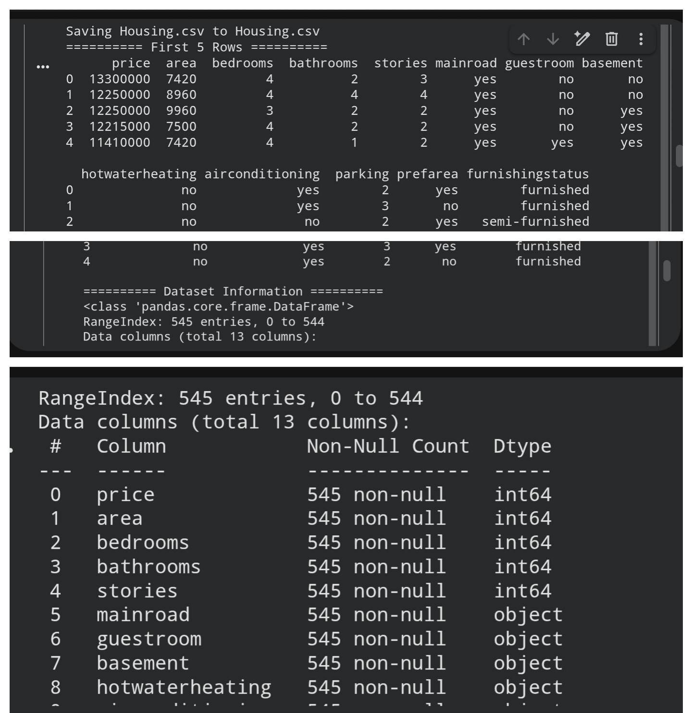
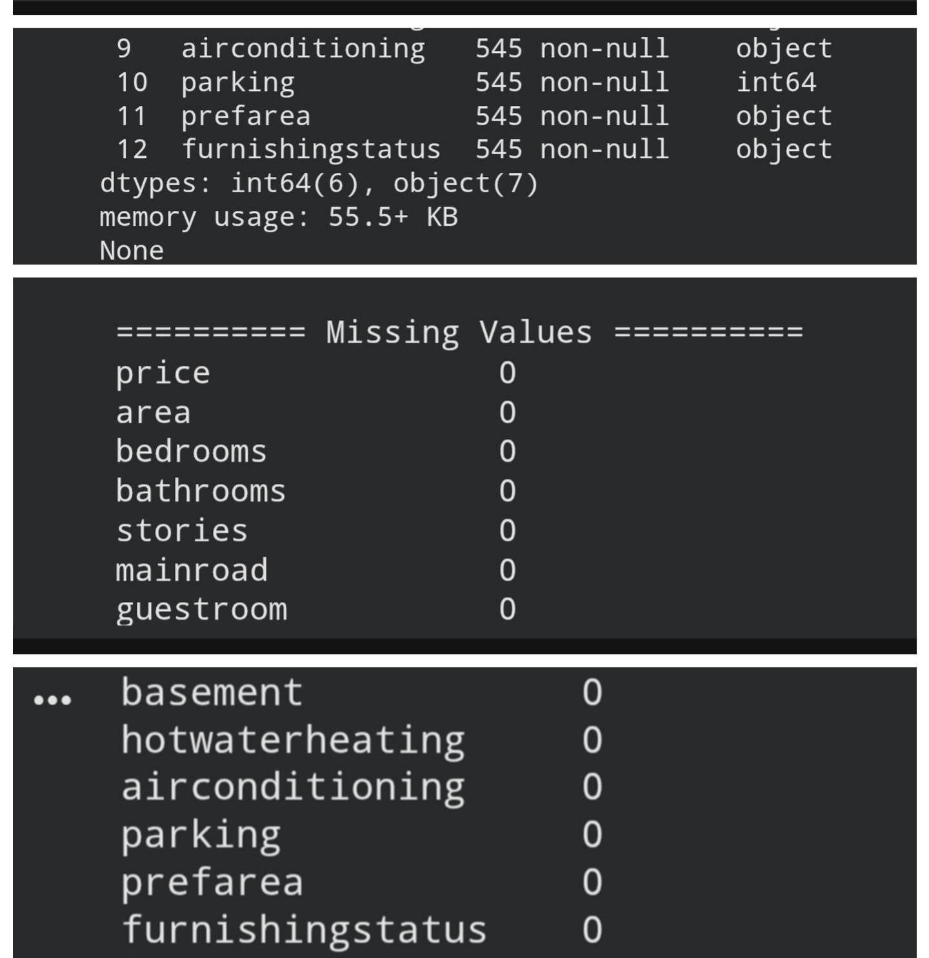
Figure 2: Dataset preview and structure via pandas — head(), info(), and missing-value check performed while learning pandas on 12 June 2026

3.3 Mentor Verification
The attendance and activity record summarised above is consistent with the training period and domain (Python with Machine Learning and AI) certified by Star Innovations, confirming that the intern maintained full attendance and satisfactorily completed the assigned project during the internship period.

Chapter 4: Technical Learning and Project Work

4.1 Project Overview
The centrepiece of the internship was House Price Prediction using Linear Regression, a complete data science project that predicts residential house prices from five physical attributes of a property: area, number of bedrooms, bathrooms, stories, and parking spaces. The project was implemented in Python using pandas and NumPy for data handling, matplotlib and seaborn for visualization, and scikit-learn for modelling, on Google Colab.

4.2 Problem Statement
The goal of the project is to build a predictive model that estimates the market price of a residential property based on its physical attributes — area, bedrooms, bathrooms, stories, and parking availability. This helps both buyers and sellers make data-driven decisions instead of relying on guesswork or asking prices alone.
The model takes these five property attributes (continuous and discrete numeric features) as input and produces predicted price (the estimated market value) as output.

4.3 Dataset and Tools
The dataset used is a housing dataset containing 545 records and 13 columns, including price, area, bedrooms, bathrooms, stories, mainroad, guestroom, basement, hotwaterheating, airconditioning, parking, prefarea, and furnishingstatus. The dataset was confirmed to have zero missing values across all columns. The following tools and libraries were used in the implementation:
Category | Tools / Libraries
Programming Language | Python 3
Data Handling | pandas, NumPy
Visualization | matplotlib, seaborn
Machine Learning | scikit-learn (LinearRegression, train_test_split, metrics)
Development Environment | Google Colab
Table 3: Technology stack used in the project

4.4 Project Workflow
The project followed a four-step workflow:
- Data Collection & Inspection — Load the housing dataset (545 rows, 13 columns) with pandas and inspect its structure, data types, and summary statistics.
- Data Preprocessing — Check for missing values across all columns (none were found) and review the statistical distribution of each feature.
- Model Selection — Choose Multiple Linear Regression to model the relationship between five property features (input) and price (output).
- Evaluation — Use R-squared (R²), Mean Absolute Error (MAE), and Root Mean Squared Error (RMSE) to quantify how well the model explains and predicts house prices.

4.5 Why Multiple Linear Regression?
Area, bedrooms, bathrooms, stories, and parking each show a roughly linear relationship with price — as these values increase, price tends to increase proportionally. Multiple Linear Regression is a natural first model for this pattern, since it combines several predictors into one linear equation, remains highly interpretable, and is fast to train and evaluate. The model takes the form:
f(x) = β0 + β1x1 + β2x2 + β3x3 + β4x4 + β5x5
where β0 is the intercept (base price), and β1 through β5 are the coefficients corresponding to area, bedrooms, bathrooms, stories, and parking respectively. The model is fitted by minimizing the sum of squared residuals between predicted and actual prices across all five features simultaneously.

4.6 Implementation
The core implementation, using pandas for data loading, seaborn and matplotlib for visualization, and scikit-learn for modelling, is shown below.
import pandas as pd
import numpy as np
import matplotlib.pyplot as plt
import seaborn as sns
from sklearn.model_selection import train_test_split
from sklearn.linear_model import LinearRegression
from sklearn.metrics import mean_absolute_error, mean_squared_error, r2_score

df = pd.read_csv("Housing.csv")
print(df.head())
print(df.info())
print(df.isnull().sum())

X = df[['area', 'bedrooms', 'bathrooms', 'stories', 'parking']]
y = df['price']

X_train, X_test, y_train, y_test = train_test_split(
X, y, test_size=0.2, random_state=42)

model = LinearRegression()
model.fit(X_train, y_train)
y_pred = model.predict(X_test)

r2 = r2_score(y_test, y_pred)
mae = mean_absolute_error(y_test, y_pred)
mse = mean_squared_error(y_test, y_pred)
print('R2 Score:', r2, ' MAE:', mae, ' MSE:', mse)

new_house = pd.DataFrame({'area':[1000], 'bedrooms':[1],
'bathrooms':[2], 'stories':[1], 'parking':[1]})
print('Predicted Price:', model.predict(new_house)[0])

4.7 Model Evaluation
R-squared (R²) tells us what proportion of the variance in house prices is explained by the five selected features together — the higher the value, the better the features predict price. An R² close to 1 indicates that the features explain most of the price variation, while an R² close to 0 indicates that they explain very little of it. Mean Absolute Error (MAE) and Root Mean Squared Error (RMSE) express the average prediction error in the same units as price (INR), giving an intuitive sense of how far off a typical prediction is.
Metric | Value
R² Score | 0.546
Accuracy (R² as %) | 54.64%
MAE | ₹ 11.27 Lakh
RMSE | ₹ 15.14 Lakh
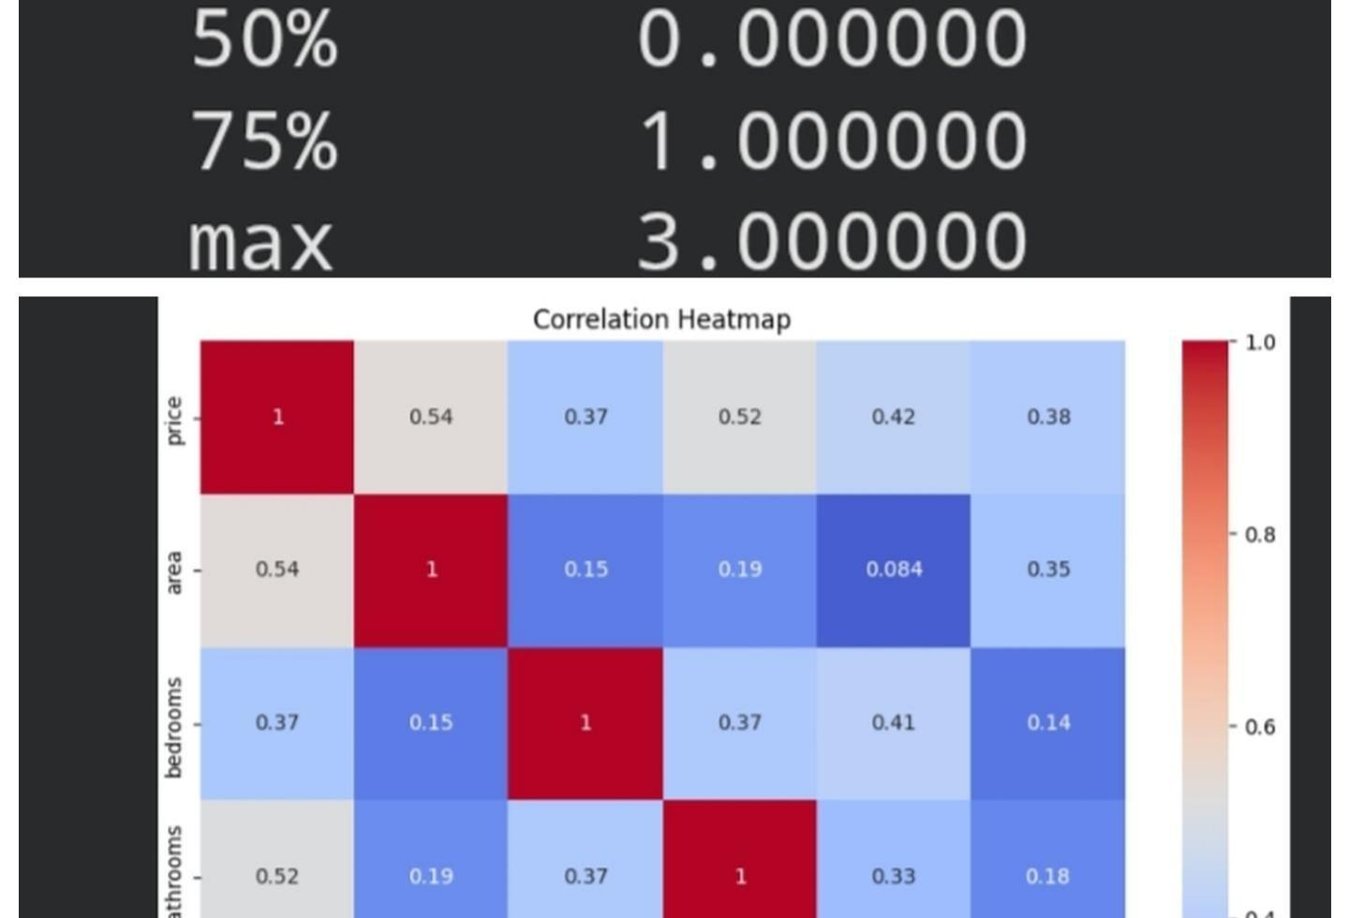
Figure 3: Correlation heatmap of housing features
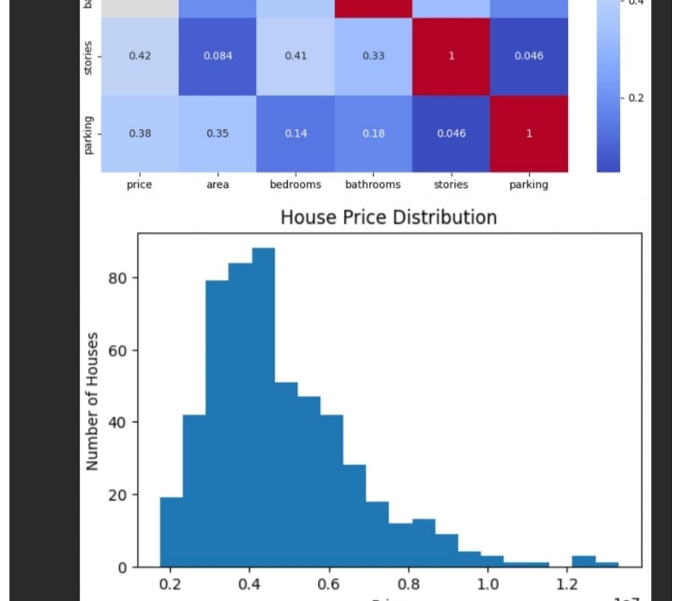
Figure 4: House price distribution

4.8 Results and Sample Prediction
The trained model was used to visualize predicted prices against actual prices on the held-out test set, confirming a positive linear trend broadly aligned with the ideal 45° reference line. As a concrete demonstration, the model was used to predict the price of a hypothetical property with area 1000 sq ft, 1 bedroom, 2 bathrooms, 1 story, and 1 parking space, producing an estimated price of ₹ 37,16,338 — illustrating how the trained model can be used for real-world estimation across several property attributes at once.
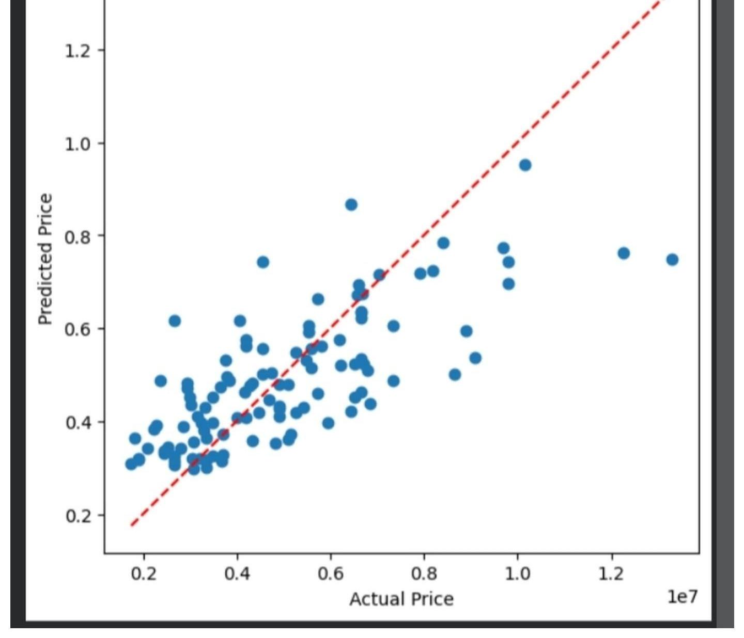
Figure 5: Actual vs Predicted house price scatter plot

4.9 Suggested Enhancements
Three upgrades were identified that would turn this into a more industry-grade project:
- Additional Features — Incorporate qualitative attributes already present in the dataset (furnishing status, preferred area, air conditioning) or external factors such as location, to capture more of the price variation currently left unexplained.
- Algorithm Comparison — Compare Multiple Linear Regression against other algorithms studied during the internship, such as Random Forest Regressor or Decision Tree Regressor, to see whether a non-linear model improves accuracy.
- Residual Analysis — Add a residual plot alongside the actual-vs-predicted scatter plot to more rigorously diagnose the quality and limitations of the fitted model.

Chapter 5: Skills Developed

5.1 Technical Skills
- Core Python programming, including control structures, functions, and data structures.
- Data handling and exploratory data analysis using pandas and NumPy.
- Data visualization using matplotlib and seaborn, including heatmaps, histograms, and scatter plots.
- Conceptual understanding of supervised, unsupervised, semi-supervised, and reinforcement learning paradigms.
- Working knowledge of classification, regression, and clustering algorithms: Linear Regression, Logistic Regression, Decision Tree, Random Forest, SVM, KNN, and K-Means.
- Building, training, and evaluating a Multiple Linear Regression model using scikit-learn.
- Interpreting model coefficients and evaluation metrics such as R², MAE, and RMSE.
- Applying a structured, staged workflow to a small machine learning project.

5.2 Soft Skills
- Self-directed learning and time management within a short, intensive training schedule.
- Analytical and logical problem-solving while working through a complete modelling workflow.
- Technical communication, including explaining and justifying modelling decisions.
- Attention to detail while cleaning data and validating model outputs.

5.3 Industry Exposure
Beyond specific technical competencies, the internship provided exposure to how a small technology company structures a short, outcome-focused training programme, and to the discipline of carrying a data science idea from raw data through to a working, interpretable model within a fixed and limited timeframe.

Chapter 6: Challenges and Solutions

6.1 Challenge 1
Challenge: Covering a broad range of machine learning paradigms and algorithms — supervised, unsupervised, semi-supervised, and reinforcement learning, along with seven distinct algorithms — within a single week made it difficult to retain the details of each.
Solution: Each algorithm was studied with a focused real-world example and compared directly against the previous one, reinforcing differences (e.g. classification vs. regression, or Decision Tree vs. Random Forest) rather than treating them as an isolated list.

6.2 Challenge 2
Challenge: Working with five features instead of one meant the model's coefficients were harder to interpret individually than a simple one-feature slope.
Solution: Each coefficient was related back to its real-world unit (price per sq ft of area, price per additional bedroom, and so on), and the correlation heatmap was used to sanity-check which features had the strongest individual relationship with price before interpreting the combined model.

6.3 Challenge 3
Challenge: The compressed 15-day timeframe made it difficult to consolidate each new Python and machine learning concept before moving on to the next.
Solution: Concepts were reinforced through small, hands-on exercises at each stage (as reflected in the weekly work log), and official pandas, scikit-learn, and seaborn documentation was used as a continual reference.

6.4 Challenge 4
Challenge: Selecting the right subset of columns from a 13-column dataset for the model, and keeping the feature order consistent between training and prediction, initially caused a mismatch error when predicting on a new sample.
Solution: The issue was resolved by consistently selecting features as a named DataFrame (df[['area','bedrooms','bathrooms','stories','parking']]) and by constructing the new-sample DataFrame with the exact same column names and order before calling predict().

6.5 Challenge 5
Challenge: Producing a clear, presentation-ready set of visualizations (heatmap, distribution, and actual-vs-predicted plot) with proper labelling took several iterations.
Solution: The plotting code was refined incrementally — adding titles, axis labels, and a shared colour scheme — until the three figures together gave an immediately readable picture of the data and the model's fit.

Chapter 7: Conclusion

7.1 Conclusion
The 15-day internship at Star Innovations in Python with Machine Learning and AI provided a focused, hands-on introduction to applied data science. Beginning with core Python and pandas fundamentals, progressing through the major paradigms and algorithms of machine learning, and culminating in a complete Multiple Linear Regression project, the internship followed a coherent, milestone-based learning path that ended in the successful development of the House Price Prediction using Linear Regression model.
Beyond the technical deliverable, the internship offered practical exposure to the discipline of carrying a data science idea from raw data through to a working, multi-feature, interpretable model, and reinforced the value of clear visualization and honest evaluation when communicating a model's results.

7.2 Future Scope
- Comparing the Multiple Linear Regression model against other algorithms studied during the internship, such as Random Forest Regressor or Decision Tree Regressor.
- Incorporating additional features already present in the dataset, such as furnishing status and preferred area, to improve predictive accuracy.
- Adding a residual plot and cross-validation to more rigorously diagnose the quality and stability of the fitted model.
- Deploying the trained model behind a simple web interface so that users can obtain price estimates interactively.

References
Star Innovations. (2026). Company profile. Retrieved from https://www.starinnovations.in
pandas development team. (2026). pandas documentation. Retrieved from https://pandas.pydata.org/docs
Matplotlib development team. (2026). Matplotlib documentation. Retrieved from https://matplotlib.org/stable/contents.html
Waskom, M. (2026). seaborn: statistical data visualization. Retrieved from https://seaborn.pydata.org
scikit-learn developers. (2026). scikit-learn user guide: Linear Models. Retrieved from https://scikit-learn.org/stable/modules/linear_model.html
Python Software Foundation. (2026). The Python tutorial. Retrieved from https://docs.python.org/3/tutorial

Appendix A: Attendance Certification
This appendix summarises the attendance verification for the internship period, as reflected on the internship certificate issued by Star Innovations.
Particular | Detail
Intern Name | Sruthi E S
Register Number | RCE24CS069
College | Royal College of Engineering and Technology
Department | Computer Science and Engineering
Internship Domain | Python with Machine Learning and AI
Internship Period | June 2026 (15 days)
Total Hours | 60 hours
Host Organization | Star Innovations, Thrissur
Certificate Date | 26 June 2026
Table 4: Attendance certification summary

Appendix B: Extended Implementation (Future Scope Code)
The following sample code illustrates how the enhancement suggested in Section 4.9 — comparing the Linear Regression model against a Random Forest Regressor — could be added to the project. It is provided for reference and was not part of the core internship deliverable.
from sklearn.ensemble import RandomForestRegressor
from sklearn.metrics import r2_score

rf_model = RandomForestRegressor(n_estimators=200, random_state=42)
rf_model.fit(X_train, y_train)
rf_pred = rf_model.predict(X_test)

print('Linear Regression R2:', r2_score(y_test, y_pred))
print('Random Forest R2:', r2_score(y_test, rf_pred))
Running this extended script would report whether a non-linear ensemble model like Random Forest offers a meaningful improvement in R² over the simpler, more interpretable Linear Regression baseline used in the core project.

Appendix C: Sample Dataset
The table below lists a sample of rows from the housing dataset used in the project (from the first few rows returned by df.head()), illustrating the structure referenced in Section 4.3.
price | area | bedrooms | bathrooms | stories | parking
1,33,00,000 | 7420 | 4 | 2 | 3 | 2
1,22,50,000 | 8960 | 4 | 4 | 4 | 3
1,22,50,000 | 9960 | 3 | 2 | 2 | 2
1,22,15,000 | 7500 | 4 | 2 | 2 | 3
1,14,10,000 | 7420 | 4 | 1 | 2 | 2

Appendix D: Glossary of Terms
Term | Meaning
Feature | An input variable used by a model to make predictions — here, a property's area, bedrooms, bathrooms, stories, or parking.
Target / Response | The output variable a model is trained to predict — here, the property's price.
Supervised Learning | A learning paradigm where the model is trained on labelled input-output pairs.
Unsupervised Learning | A learning paradigm where the model finds patterns in unlabelled data, e.g. clustering.
Semi-Supervised Learning | A paradigm that trains on a mix of labelled and unlabelled data.
Reinforcement Learning | A paradigm where an agent learns by taking actions and receiving rewards or penalties.
Classification | A supervised learning task that predicts a discrete category or class label.
Regression | A supervised learning task that predicts a continuous numeric value.
Linear Regression | A method that models the relationship between one feature and a target as a straight line.
Multiple Linear Regression | A method that models the relationship between several features and a target as a linear combination.
Logistic Regression | A classification algorithm that models the probability of a discrete outcome.
Decision Tree | A model that splits data using a tree of feature-based decisions for classification or regression.
Random Forest | An ensemble of decision trees whose predictions are combined for improved accuracy.
Support Vector Machine (SVM) | An algorithm that finds the optimal boundary separating classes in feature space.
K-Nearest Neighbours (KNN) | An algorithm that predicts based on the majority class or average of the nearest data points.
K-Means Clustering | An unsupervised algorithm that groups data into K clusters based on similarity.
Intercept (β0) | The predicted value of the target when all features are zero; the base price in this project.
Coefficient (β1–β5) | The change in predicted price for a one-unit increase in a given feature, holding others constant.
Residual | The difference between an actual observed value and the value predicted by the model.
R-squared (R²) | A metric between 0 and 1 describing the proportion of variance in the target explained by the model.
MAE / RMSE | Mean Absolute Error and Root Mean Squared Error — metrics expressing average prediction error in the target's units.
Train/Test Split | Dividing a dataset into a portion used to fit the model and a separate portion used to evaluate it.
EDA | Exploratory Data Analysis — the initial process of examining a dataset to understand its structure and patterns.

