Documented by Sruthi.R:

Title: Innovation in Data Warehousing with IBM Cloud Db2 Warehouse

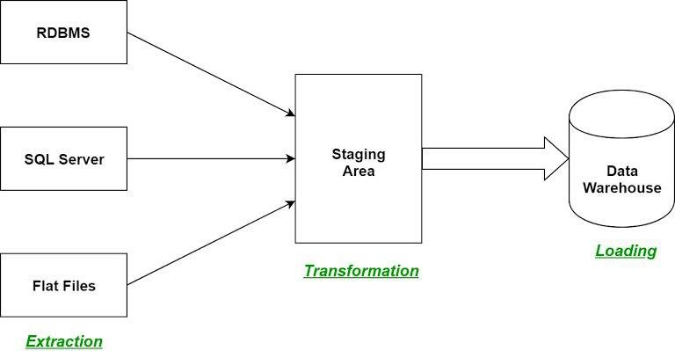

Building a data warehouse and implementing ETL processes typically involves multiple steps. Here's a high-level overview of the process:

1. Define Requirements: Clearly define the goals and requirements of your data warehouse. Understand what data you need to collect and how it will be used.

2. Select ETL Tools: Choose the right ETL (Extract, Transform, Load) tools and technologies for your needs. Popular choices include Apache NiFi, Talend, and Apache Spark.

3. Data Extraction (E): Extract data from various source systems, which could include databases, files, APIs, and more. Ensure data quality and consistency.

4. Data Transformation (T): Clean, transform, and enrich the extracted data. This step involves data validation, cleaning, aggregations, and other operations to prepare the data for analytics.

5. Data Loading (L): Load the transformed data into your data warehouse. This might involve batch or real-time data loading, depending on your requirements.

6. Data Modeling: Design and create the data warehouse schema (e.g., star schema or snowflake schema) to optimize querying and reporting.

7. Data Exploration: Implement tools and processes for data exploration. This can involve data visualization tools like Tableau, Power BI, or custom dashboards.

8. Data Security and Governance: Ensure data security and governance practices are in place to protect sensitive information and maintain data quality.

9. Monitoring and Maintenance: Continuously monitor the ETL processes and the data warehouse's performance. Set up alerts for data quality issues or performance problems.10. Documentation: Document the ETL processes, data models, and data dictionaries for future reference.

11. User Training: Train users who will be exploring and analyzing the data in your data warehouse.

12. Scaling and Optimization: As your data needs grow, consider scaling and optimizing your data warehouse architecture.

Implementing ETL (Extract, Transform, Load) processes to populate a data warehouse involves several steps. Here's a general outline of the process:

1. Extract Data:

- Identify the data sources from which you want to extract data. These sources could be databases, flat files, APIs, or other systems.

- Use ETL tools or scripts to extract data from these sources. Ensure data quality and consistency during extraction.

2. Transform Data:

- Clean and preprocess the extracted data. This may involve handling missing values, data type conversions, and standardizing data formats.

- Perform data transformations, such as aggregations, calculations, and data enrichment.

- Apply business rules and logic to align the data with your data warehouse schema.

3. Load Data:

- Determine the load strategy (batch or real-time) based on your data warehouse requirements.

- Load the transformed data into the data warehouse tables. Ensure that data integrity and referential constraints are maintained.

4. Data Quality and Validation:

- Implement data validation checks to ensure data quality. This includes checks for duplicates, data integrity, and consistency.

- Handle data quality issues, such as data anomalies or errors, during the ETL process.

5. Error Handling:

- Create mechanisms to capture and log errors during the ETL process. This will help in diagnosing and resolving issues.

6. Schedule and Automation:- Set up a schedule for ETL processes to run at appropriate intervals (e.g., daily, hourly) or in response to data changes.

- Automate the ETL process as much as possible to minimize manual intervention.

7. Monitoring and Logging:

- Implement monitoring and logging to track the performance and status of ETL jobs. Set up alerts for failures or performance bottlenecks.

8. Version Control and Documentation:

- Use version control to manage ETL code and configurations.

- Maintain comprehensive documentation of ETL processes, including data lineage, transformations, and dependencies.

9. Testing:

- Perform thorough testing of the ETL processes to ensure data accuracy and reliability.

- Test data migration and rollback procedures.

10. Deployment:

- Deploy ETL processes into the production environment, considering security and access controls.

11. Optimization and Scaling:

- Continuously optimize ETL processes for performance and efficiency.

- Plan for scalability as data volumes grow.

12. Data Security:

- Implement data security measures to protect sensitive information during the ETL process.

13. User Access and Reporting:

- Allow users to access and query the data in the data warehouse for reporting and analysis. Enabling data architects to explore and analyze data within Db2 Warehouse using SQL queries and analysis techniques involves several steps:

1. Access to Db2 Warehouse:

- Ensure that data architects have the necessary access permissions and credentials to connect to Db2 Warehouse.

2. SQL Query Tools:

- Provide data architects with SQL query tools. Db2 Warehouse typically supports standard SQL, so common tools like IBM Data Studio, DataGrip, or even command-line SQL clients can be used.

3. Data Exploration:- Encourage data architects to explore the data using SQL queries. They can start with basic queries to understand the structure of the data, including table names, column names, and data types.

4. Advanced SQL Techniques:

- Train data architects in advanced SQL techniques, such as joins, subqueries, window functions, and aggregate functions. These techniques are essential for complex data analysis.

5. Data Analysis:

- Guide data architects in performing data analysis using SQL. This can involve filtering data, calculating aggregates, and creating derived columns.

6. Optimization:

- Teach data architects about query optimization. Explain the importance of indexes, query execution plans, and ways to improve query performance.

7. Data Visualization:

- Suggest data visualization tools like Tableau, Power BI, or IBM Cognos for creating visualizations based on the SQL query results.

8. Database Documentation:

- Ensure that there is comprehensive documentation of the database schema, including table relationships, constraints, and metadata. This will help data architects understand the data model.

9. Collaboration and Sharing:

- Promote collaboration among data architects. They can share SQL scripts, findings, and best practices within the team.

10. Security and Compliance:

- Emphasize data security and compliance. Make sure that data architects follow security protocols and respect data privacy regulations when accessing and analyzing data.

11. Data Governance:

- Implement data governance practices to maintain data quality and consistency. Define data standards and enforce them during data analysis.

12. Version Control:

- Use version control for SQL scripts and queries to track changes and maintain a history of analysis efforts.

13. Performance Monitoring:

- Set up performance monitoring and alerting to identify and address any performance issues in Db2 Warehouse.

14. Scalability:- Plan for scalability as the data volume and complexity grow. This might involve optimizing the database schema and ETL processes.

15. Continuous Learning:

- Encourage data architects to stay up-to-date with the latest SQL features and analysis techniques through training and self-learning.

Step 1: Set Up IBM Cloud Db2 Warehouse

Sign up for IBM Cloud if you haven't already.

Access the IBM Cloud Console and create a Db2 Warehouse instance.

Configure security settings, such as authentication and access controls.

Load your data into Db2 Warehouse, either manually or through data integration tools.

Step 2: Data Integration and Transformation

To perform data integration and transformation effortlessly, you can use SQL or ETL tools like IBM DataStage.

Write SQL queries to join, filter, and aggregate data from various sources within Db2 Warehouse.

Utilize Db2 Warehouse's in-database processing capabilities for data transformation.

Step 3: Feature Engineering

Feature engineering is essential for building effective machine learning models. You can create new features from your data. Here's a Python example for feature engineering using Pandas:

python code :

import pandas as pd

# Assuming you have a DataFrame 'df' with your data

df['new_feature'] = df['feature1'] * df['feature2']

Step 4: Model Training

You can use various libraries like scikit-learn or IBM Watson AutoAI for model training. Here's a simple scikit-learn example:

Python code :

from sklearn.model_selection import train_test_split

from sklearn.ensemble import RandomForestClassifier

# Split data into training and testing sets

X_train, X_test, y_train, y_test = train_test_split(features, target, test_size=0.2)

# Create and train a model

model = RandomForestClassifier()

model.fit(X_train, y_train)

Step 5: Model Evaluation

Evaluate your model's performance using appropriate metrics. Here's an example:

python code :

from sklearn.metrics import accuracy_score, classification_report

# Make predictions

y_pred = model.predict(X_test)

# Calculate accuracy

accuracy = accuracy_score(y_test, y_pred)

# Generate a classification report

report = classification_report(y_test, y_pred)