**---------------------------------------------------**

**-:Project Documentation & Report:-**

**PROJECT TITLE: -**

**Todo App**

**Team: -**

**TEAM ID : LTVIP2023TMID06375**

**TEAM SIZE : 5**

**TEAM LEADER : C SRUTHI**

**TEAM MEMBER : G SARANYA**

**TEAM MEMBER : C CHAITRA**

**TEAM MEMBER : CHAKALA MALLIKA**

**TEAM MEMBER : G H DEEPIKA**

**FACULTY MENTOR : V.SHEKAR**

**1.INTRODUCTION:**

**1.1 Overview :**

This is a Simple todo list application Which contains list of tasks to do. User can add a new task and its details. User can complete a task and can invoke its actions like delete.

### Salient Features:-

* Add New Item to list
* Delete existing item from list
* Complete a task from lists

Most typically, they’re organised in order of priority. Traditionally, they’re written on a piece of paper or post it notes and act as a memory aid. As technology has evolved we have been able to create a todo lists with excel spreadsheets, word documents, [email](https://en.wikipedia.org/wiki/Email" \t "https://checkify.com/blog/what-is-a-todo-list/_blank) lists, todo list apps, Microsoft to do and google to do list to name a few. You can[use a to do list](https://checkify.com/blog/how-to-use-a-to-do-list/) in your home and personal life, or in the workplace.

Having a list of everything you need to do written down in one place means you shouldn’t forget anything important. By prioritising the tasks in the list you plan the order in which you’re going to do them and can quickly see what needs your immediate attention and what tasks you can leave until a little later.

## The Benefits of Using a To Do List:-

One of the most important reasons you should use a to do list is that it will help you stay organised. When you write all your tasks in a list, they seem more manageable. When you’ve got a clear outline of the tasks you’ve got to do and those you’ve completed, it helps you stay focused. While freeing up space in your mind for other more creative tasks.

When you complete a task, you can cross it off your list. This gives you a sense of progress and achievement, something you’ll lack if you’re always rushing from one task to the next. If you feel a sense of achievement, it spurs you on and motivates you to keep moving forward.

But that’s not the only benefit of a to do list. Here are a few more:

****Improves your memory****: A to do list acts as an external memory aid. It’s only possible to hold a few pieces of information at one time. Keep a to do list and you’ll be able to keep track of everything, rather than just a few of the tasks you need to do. Your to do list will also reinforce the information, which makes it less likely you’re going to forget something.

****Increases productivity****: A to do list allows you to prioritize the tasks that are more important. This means you don’t waste time on tasks that don’t require your immediate attention. Your list will help you stay focused on the tasks that are the most important.

****Helps with motivation****: To do lists are a great motivational tool because you can use them to clarify your goals. You can divide your long-term goal into smaller, more achievable short-term goals and as you tick each one off your list, your confidence will increase.

A "to-do app" or "task management app" is a software application designed to help individuals or teams organize, prioritize, and track their tasks and responsibilities. These apps are popular for personal and professional use, as they provide a convenient way to manage one's tasks, goals, and deadlines. Here are some key features and components typically found in a to-do app:

**Task Lists**: Users can create multiple lists or categories to organize their tasks. For example, you might have lists for work, home, groceries, and more.

**Task Creation**: Users can add new tasks to their lists, typically with a title, description, due date, and sometimes additional information like priority or labels.

## **Task Prioritization**: Many to-do apps allow users to assign priorities or tags to tasks, helping them focus on what's most important.

## **Due Dates and Reminders**: Users can set due dates for tasks and receive reminders or notifications when deadlines are approaching.

## **Task Completion:** Users can mark tasks as completed when they are finished. Some apps also allow for task archiving or moving completed tasks to a separate section.

## **Subtasks:** To break down complex tasks, to-do apps often support the creation of subtasks or checklists within a task.

## **Sorting and Filtering**: Users can often sort and filter tasks by due date, priority, or other criteria to better manage their workload

## **Collaboration**: Some to-do apps offer collaboration features, allowing users to share task lists with others and work together on projects or tasks.

## **Notes and Attachments**: Users may be able to add notes or attachments to tasks to provide additional context or details.

## **Sync Across Devices:** To-do apps often sync tasks and lists across various devices (smartphones, tablets, computers) to ensure users have access to their tasks wherever they are.

## **Integration**: Many to-do apps integrate with other productivity tools and services like calendars, email, and project management platforms.

## **Customization**: Users may have options to customize the app's appearance, notifications, and settings to suit their preferences.

## Popular to-do apps include Todoist, Microsoft To Do, Apple's Reminders, Google Tasks, Trello, Asana, Wunderlist (though it has been discontinued), and many others. The choice of a to-do app often depends on individual preferences and the specific needs of the user, such as personal task management, project management, or team collaboration.

## What is a ToDo List in business and why is it important:-

It seems such a simple solution by putting pen to paper and taking time out of your day to create a to do list, a plan for your day helps define your challenges and goals. Preventing time from being wasted trying to identify what is the next most important task to tackle next and even more important makes sure you don’t forget to do something important.

To-do lists offer a way to increase productivity, stopping you from forgetting things, helps prioritise tasks, manage tasks effectively, use time wisely and improve time management as well as workflow.

## What Makes a Great To Do List App:-

To do lists come in all shapes and sizes. It always used to be something that you would write using pen and paper, but thanks to technology there’s an app that can come to the rescue. What makes a good to do list app?

* Tasks should be fast to add and organise
* There should be a variety of ways to organise the tasks
* Ability to plan your workflow
* Setting priorities
* Reminders for any self-imposed deadlines.
* Allocation of tasks if using it for task management with a team. Team to-do list allows you to assign to the best person for the job.
* Able to synch between different platforms

All it takes is just a few minutes every day to keep a to do list up to date. With a to do list, you can complete goals without wasting time trying to figure out priorities. Your productivity will increase, you won’t forget things, your time management will improve and you’ll be able to manage your tasks more effectively.

Importance:-

One of the most significant benefits of why to do list is important that it will help you stay organized. It will also help those tasks appear more manageable.

You’ll be able to stay more focused because you’ve got an outline of what you’ve got to do and things you’ve already completed. Having tasks written in a list frees up space in your mind and allows you to be more creative.

**Key Elements of a To-Do List:**

**Task Items**: These are the individual items or activities that you need to accomplish. Each task is typically described in a brief and actionable manner.

**Priority:** To-do lists often include a way to prioritize tasks. Common methods include marking tasks as high, medium, or low priority, or using numbers (e.g., 1, 2, 3) to indicate importance.

**Due Dates:** Many to-do lists allow you to assign due dates or deadlines to tasks. This helps you manage time-sensitive activities effectively.

**Status or Completion Indicator**: You can track the status of tasks, such as marking them as "complete," "in progress," or "not started."

**Notes or Descriptions:** Some to-do lists provide space for additional information or notes related to a task, offering context or instructions.

**Benefits of Using a To-Do List:**

**Organization**: To-do lists help you organize your tasks, ensuring that nothing is forgotten or overlooked.

**Prioritization:** You can prioritize tasks based on their importance and urgency, helping you focus on what matters most.

**Productivity**: To-do lists promote productivity by providing a clear plan of action. They help you avoid procrastination and distractions.

**Reduced Stress:** By breaking down tasks into manageable items and setting clear priorities, to-do lists can reduce stress and anxiety.

**Goal Achievement**: To-do lists are effective tools for achieving both short-term and long-term goals, as they provide a structured way to work toward objectives.

**Time Management**: With due dates and deadlines, to-do lists aid in effective time management, helping you allocate your time wisely.

**Tips for Creating an Effective To-Do List:**

**Keep It Simple:** Make your to-do list easy to read and understand. Use concise language and avoid overly complex formats.

**Use Categories or Sections**: Group similar tasks together by category or project to maintain clarity.

**Prioritize:** Identify the most critical tasks and tackle them first. Use prioritization methods that work best for you.

**Set Realistic Goals:** Be realistic about what you can accomplish in a day. Avoid overloading your list with too many tasks.

**Regular Updates:** Review and update your to-do list regularly to reflect changes in priorities or new tasks that arise.

**Cross Off Completed Tasks:** Physically or digitally marking tasks as complete can provide a sense of accomplishment.

**Avoid Overthinking:** Don't spend too much time on creating the perfect list. The goal is to be productive, not perfect.

**Use Technology:** Consider using digital tools and apps for managing your to-do lists, as they often offer features like reminders and synchronization across devices.

**Flexibility:** Be flexible and adapt your to-do list as circumstances change. Sometimes, unexpected events can affect your plans.

To-do lists are versatile and can be used by individuals in their personal lives, by professionals at work, or by teams collaborating on projects. They are a fundamental tool for staying organized, managing time effectively, and achieving both short-term and long-term goals.

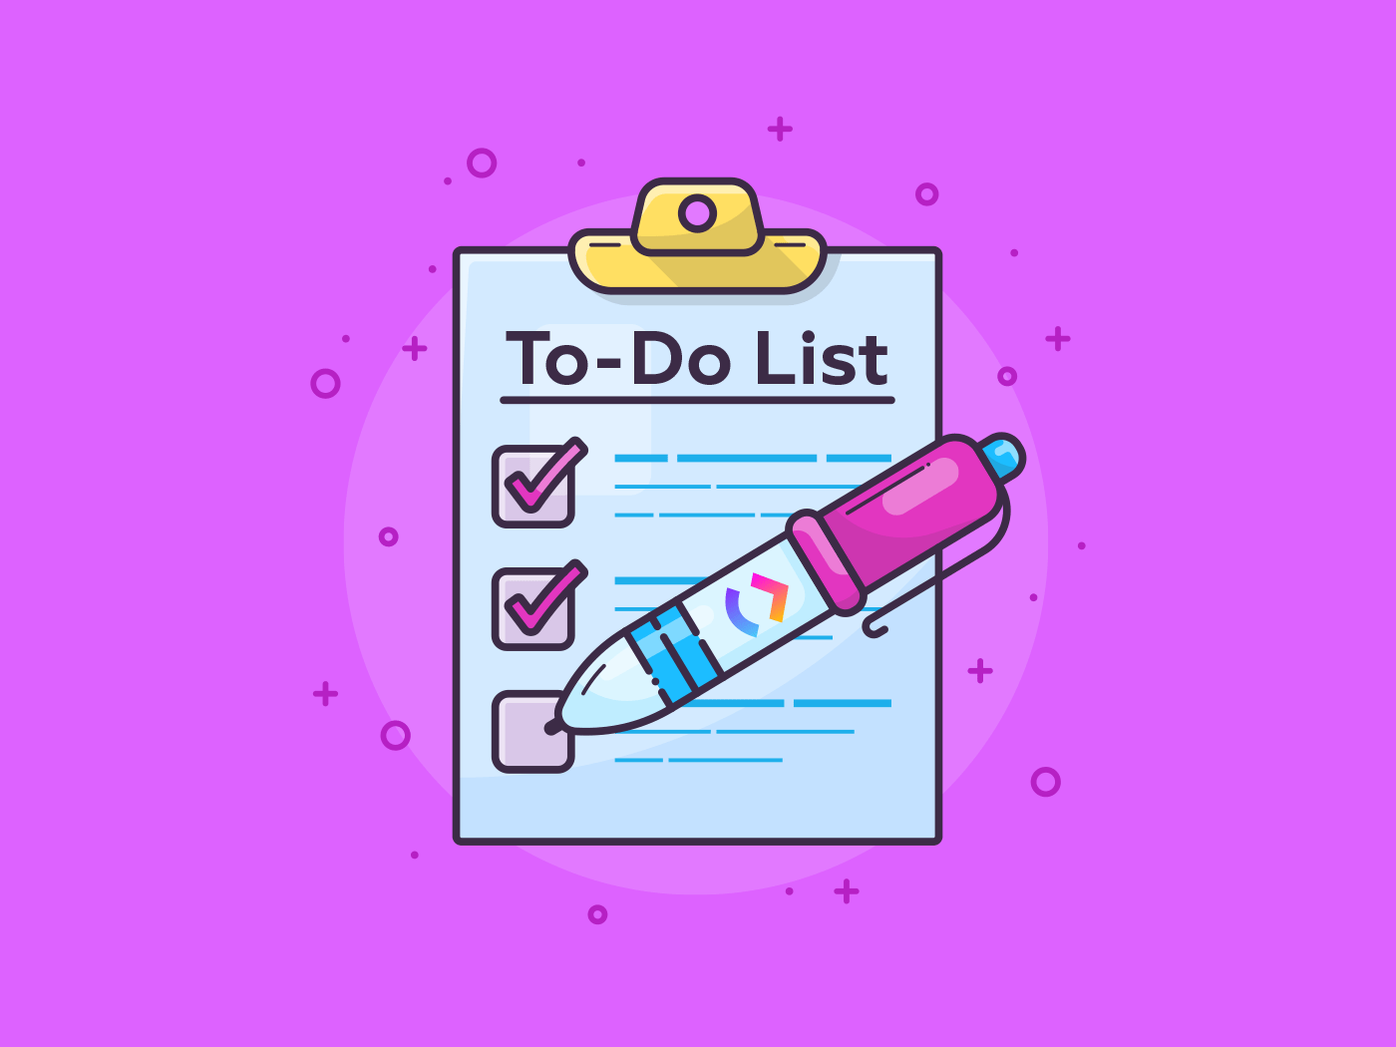

In this documentation we have created three files one for html,css, and javascript.

**Index.html**:

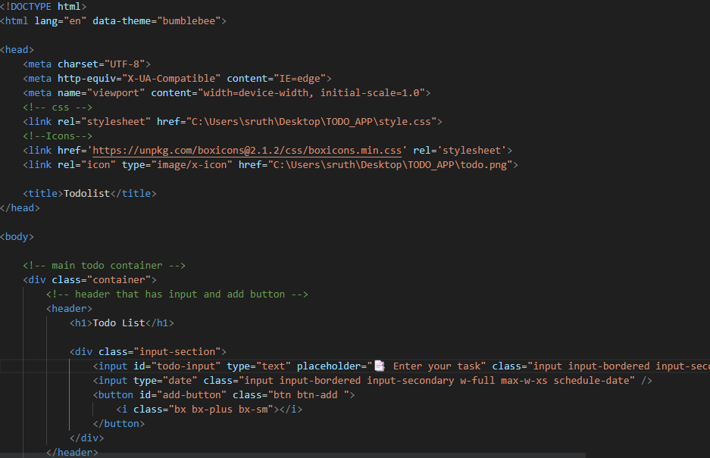

**Style.css:-**

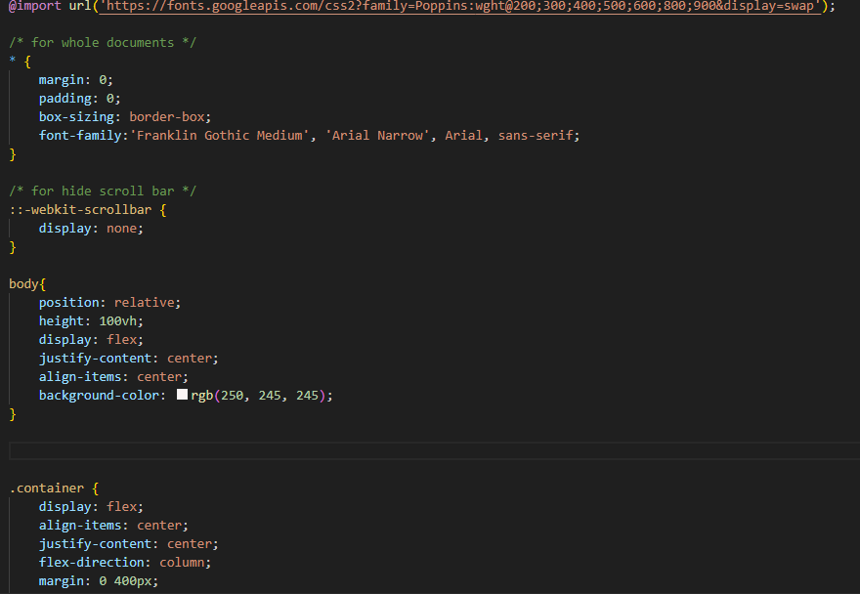

**Index.js:-**

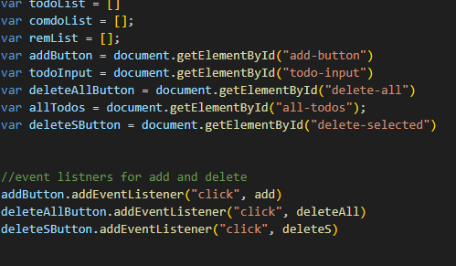

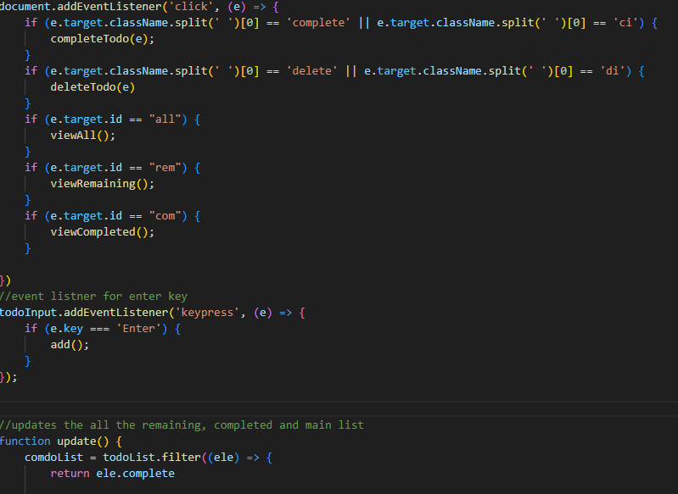

**Pros of a to-do list:**

1. You can better manage your daily tasks easily & efficiently.
2. Easily break your tasks into sub-tasks.
3. With projects, labels, filters, and priorities, you can tailor it to your personal workflow.
4. You can improve your productivity and measure the progress across each task.
5. You can easily share it with others.
6. Using to-do-lists, important tasks won’t be overlooked.

**Cons of a to-do-list:**

1. Interruptions and sudden changes in the projects or work can make your to-do-list vague and unclear.
2. It leads to stress if the list is long.
3. Lists without structure and prioritization can lead to confusion and inefficient use of time.
4. To-do lists aren’t always referred back to during the day, especially if they’re not in a dedicated space.

**Prioritizing tasks** on a to-do list is essential for effective time management and productivity. Here are some ways you can prioritize tasks on your to-do list:

**Urgency:** Consider the deadlines or time-sensitive nature of each task. Prioritize tasks that have impending deadlines or are time-critical.

**Importance:** Determine the significance and impact of each task. Focus on tasks that align with your goals, values, and long-term objectives.

**Value:** Assess the value or return on investment associated with each task. Identify tasks that will yield the most significant results or contribute to your overall success.

**Effort:** Evaluate the level of effort required for each task. Prioritize tasks that are challenging or require high concentration when you have the most energy and focus.

**Dependencies:** Take into account any dependencies between tasks. If a task relies on the completion of another task, prioritize them accordingly to ensure smooth workflow.

**Impact on Others:** Consider how your tasks may affect others. Prioritize tasks that support or benefit your team or stakeholders, fostering collaboration and achieving collective goals.

**Consequences:** Assess the potential consequences of not completing certain tasks. Prioritize tasks that may have negative repercussions or create bottlenecks if left unfinished.

**Personal Preference:** Consider your own preferences and working style. Prioritize tasks that you enjoy or find motivating, as this can increase your productivity and job satisfaction.

Remember, there is no one-size-fits-all approach to prioritization. Experiment with different methods and find what works best for you based on your specific circumstances and priorities.

**Advantages:**

**Organization**: A to-do list provides a structured way to organize your tasks and responsibilities. It allows you to capture all your tasks in one central place, making it easier to keep track of them and avoid forgetting important items.

**Prioritization**: A to-do list helps you prioritize tasks based on their importance and urgency. By assigning priorities or deadlines to tasks, you can ensure that you focus on the most critical ones first and manage your time effectively.

**Productivity**: Having a to-do list can boost your productivity by providing a clear roadmap of what needs to be done. It helps you stay focused and reduces the chances of getting sidetracked or overwhelmed by numerous tasks.

**Motivation and Progress Tracking**: Crossing off completed tasks on your to-do list provides a sense of accomplishment and motivation. It allows you to visually track your progress, which can be encouraging and create a positive feedback loop.

**Time Management:** A to-do list helps you allocate your time efficiently and avoid procrastination. By breaking down larger tasks into smaller, manageable steps, you can better estimate the time required for each task and allocate your time accordingly.

**Disadvantages:**

**Overwhelm**: If your to-do list becomes too long or cluttered, it can become overwhelming. Having an extensive list of tasks can make it challenging to prioritize or decide where to start, leading to feelings of stress or anxiety.

**Unrealistic Expectations**: Sometimes, individuals tend to overestimate what they can accomplish in a given time frame. If your to-do list is unrealistic or overloaded with tasks, you may end up feeling discouraged or frustrated by not being able to complete everything as planned.

**Lack of Flexibility**: A rigid to-do list may not leave room for unexpected tasks or changes in priorities. If new urgent tasks arise or circumstances change, it can be challenging to adjust your to-do list accordingly, leading to a sense of inflexibility.

**Dependency**: Some people may become overly reliant on their to-do list, to the point where they struggle to take action without it. While it's useful as a tool, it's important to develop the ability to prioritize and manage tasks without solely relying on a list.

**Neglecting Non-task Activities**: A to-do list typically focuses on tasks and responsibilities, which may lead to neglecting self-care, relaxation, or non-task-related activities. It's important to strike a balance between productivity and personal well-being.

**Result:**

Adding a task :-

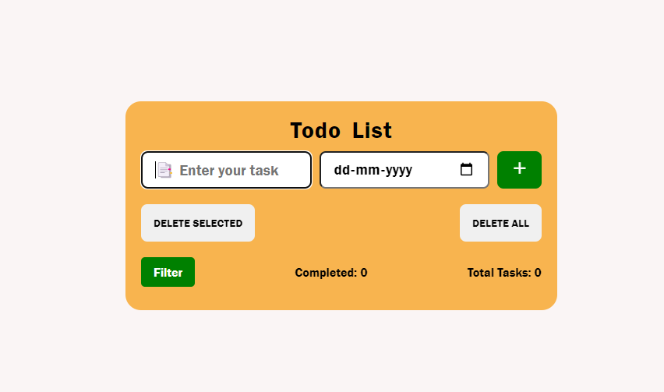

**Setting a date :-**

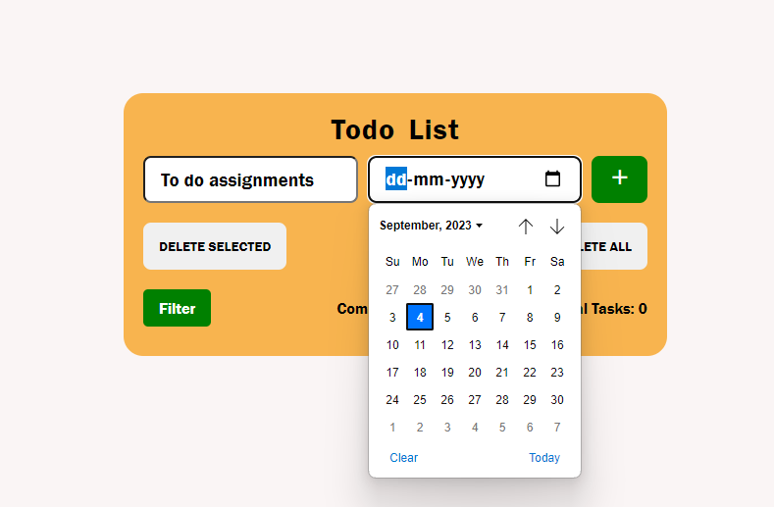

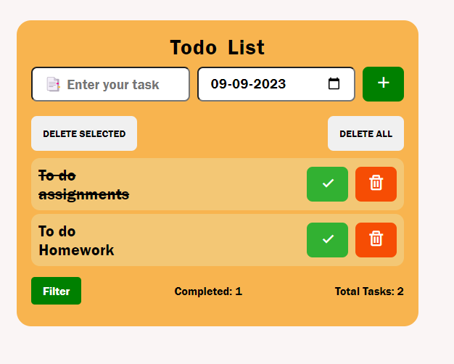

**Filter options:-**

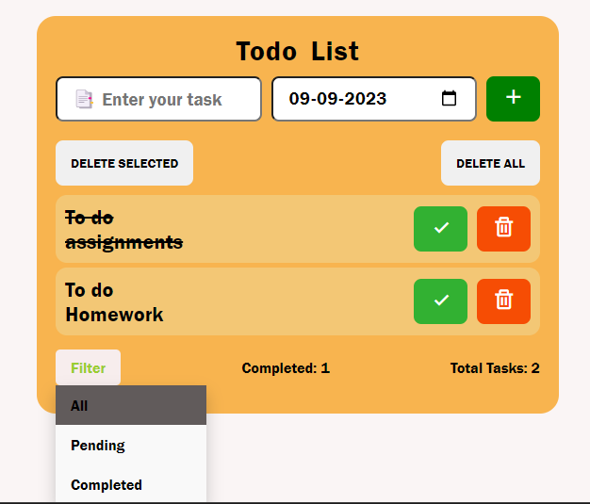

**Pending tasks:-**

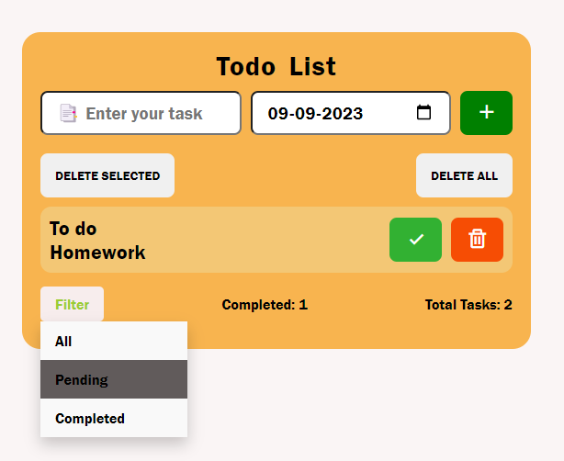

**Completed tasks:-**

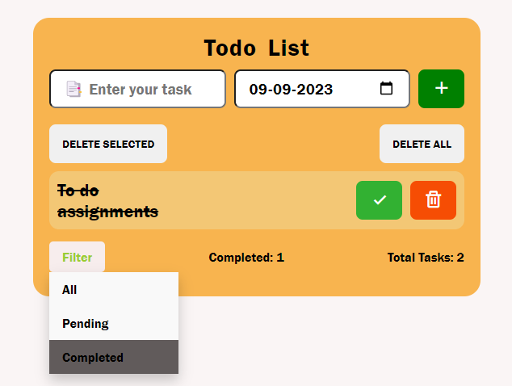

**Delete selected:-**

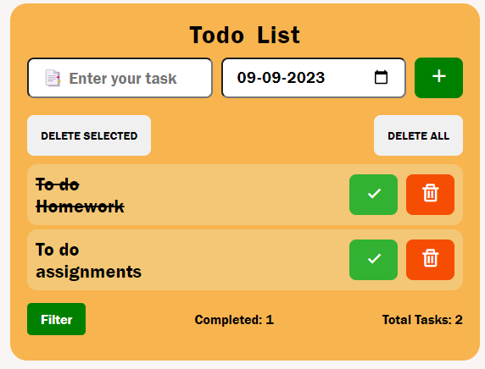

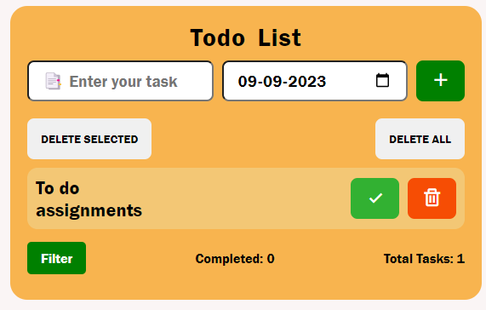

**Delete all:-**

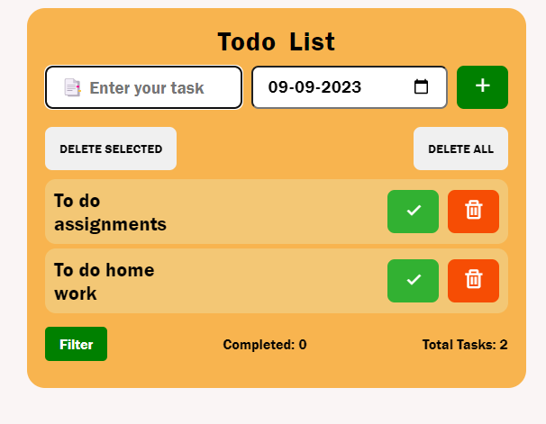

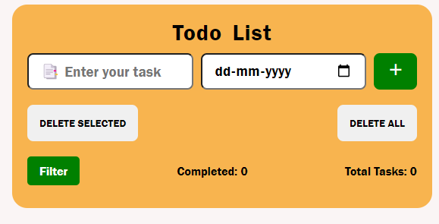

**Conclusion:-**

In conclusion, a to-do list can be a valuable tool for organizing and managing tasks effectively. It helps with task prioritization, productivity, accountability, and reducing stress. However, it's important to be mindful of its potential drawbacks, such as feeling overwhelmed, being inflexible, fostering procrastination, setting unrealistic expectations, and potentially neglecting other aspects of life. To make the most of a to-do list, it's crucial to strike a balance, adapt it to your needs, and use it as a helpful guide rather than a rigid mandate. By finding the right approach and incorporating flexibility, a to-do list can be a powerful ally in accomplishing your goals and maintaining a well-balanced life.